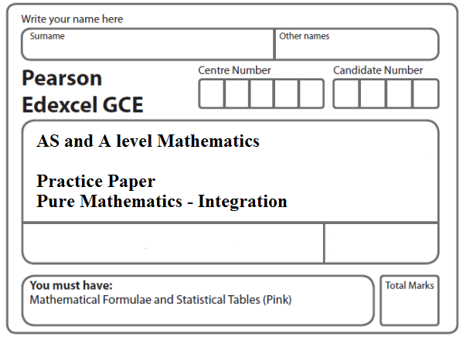
Instructions
- Use black ink or ball-point pen.
- If pencil is used for diagrams/sketches/graphs it must be dark (HB or B).
- Fill in the boxes at the top of this page with your name, centre number and candidate number.
- Answer all the questions and ensure that your answers to parts of questions are clearly labelled.
- Answer the questions in the spaces provided – there may be more space than you need.
- You should show sufficient working to make your methods clear. Answers without working may not gain full credit.
- Inexact answers should be given to three significant figures unless otherwise stated.
Information
- A booklet ‘Mathematical Formulae and Statistical Tables’ is provided.
- There are 14 questions in this question paper. The total mark for this paper is 100.
- The marks for each question are shown in brackets – use this as a guide as to how much time to spend on each question.
- Calculators must not be used for questions marked with a * sign.
Advice
• Read each question carefully before you start to answer it.
• Try to answer every question.
• Check your answers if you have time at the end.
• If you change your mind about an answer, cross it out and put your new answer and any working underneath.
1*. Find
$\int{\left(6x^{2}+\frac{2}{x^{2}}+5\right) dx}$,
giving each term in its simplest form.
(4)
(Total 4 marks)
___________________________________________________________________________

2*. Find

giving each term in its simplest form.
(Total 4 marks)
___________________________________________________________________________

3*. Find
giving each term in its simplest form.
(Total 4 marks)
___________________________________________________________________________

4. Use integration to find

$\int{\left(\frac{x^{3}}{6}+\frac{1}{3x^{2}}\right)} dx$,

giving your answer in the form a + b√3, where a and b are constants to be determined.
(Total 5 marks)
___________________________________________________________________________

5.
Figure 1

Figure 1 shows a sketch of part of the curve C with equation

, x ∈ ℝ

The curve C has a maximum turning point at the point A and a minimum turning point at the origin O.

The line l touches the curve C at the point A and cuts the curve C at the point B.

The x coordinate of A is –4 and the x coordinate of B is 2.

The finite region R, shown shaded in Figure 3, is bounded by the curve C and the line l.

Use integration to find the area of the finite region R.
(Total 7 marks)
___________________________________________________________________________

6*. , x > 0

Given that y = 37 at x = 4, find y in terms of x, giving each term in its simplest form.
(Total 7 marks)
___________________________________________________________________________

7*. A curve with equation y = f(x) passes through the point (2, 10). Given that
f ′(x) = 3x² − 3x + 5,
find the value of f(1).
(Total 5 marks)
___________________________________________________________________________

8*. A curve with equation y = f(x) passes through the point (4, 25).
Given that f ′(x) = $\frac{3}{8}$x² – $\text{10}x^{−\frac{1}{2}}$ + 1, x > 0,
(a) find f(x), simplifying each term.
(5)
(b) Find an equation of the normal to the curve at the point (4, 25). Give your answer in the form ax + by + c = 0, where a, b and c are integers to be found.
(5)
(Total 10 marks)
___________________________________________________________________________

9*. The curve C has equation y = f(x), x > 0, where
Given that the point P(4, –8) lies on C,
(a) find the equation of the tangent to C at P, giving your answer in the form y = mx + c,
where m and c are constants.
(4)
(b) Find f(x), giving each term in its simplest form.
(5)
(Total 9 marks)
___________________________________________________________________________

10*. A curve with equation y = f(x) passes through the point (4, 9).
Given that
f ′(x) = $\frac{3√x}{2}$ – $\frac{9}{4√x}$ + 2, x > 0,
(a) find f(x), giving each term in its simplest form.
(5)
Point P lies on the curve.
The normal to the curve at P is parallel to the line 2y + x = 0.
(b) Find the x-coordinate of P.
(5)
(Total 10 marks)
___________________________________________________________________________
11.

Figure 2

Figure 2 shows the line with equation y = 10 – x and the curve with equation y = 10x – x² – 8.
The line and the curve intersect at the points A and B, and O is the origin.
(a) Calculate the coordinates of A and the coordinates of B.
(5)
The shaded area R is bounded by the line and the curve, as shown in Figure 2.
(b) Calculate the exact area of R.
(7)
(Total 12 marks)
___________________________________________________________________________

12. (a) Find
$\int{\text{10}x(x^{\frac{1}{2}}−2)\begin{matrix} \\ dx\end{matrix}}$,
giving each term in its simplest form.
(4)

Figure 2

Figure 2 shows a sketch of part of the curve C with equation
y = 10x($x^{\frac{1}{2}}$ – 2), x ≥ 0.
The curve C starts at the origin and crosses the x-axis at the point (4, 0).
The area, shown shaded in Figure 2, consists of two finite regions and is bounded by the curve C, the x-axis and the line x = 9.
(b) Use your answer from part (a) to find the total area of the shaded regions.
(5)
(Total 9 marks)
___________________________________________________________________________
13.

Figure 3

Figure 3 shows a sketch of part of the curve C with equation
y = x(x + 4)(x – 2).
The curve C crosses the x-axis at the origin O and at the points A and B.
(a) Write down the x-coordinates of the points A and B.
(1)
The finite region, shown shaded in Figure 3, is bounded by the curve C and the x-axis.
(b) Use integration to find the total area of the finite region shown shaded in Figure 3.
(7)
(Total 8 marks)
___________________________________________________________________________

14.
Figure 3

Figure 3 shows a sketch of part of the curve with equation

.

The finite region S, bounded by the x-axis and the curve, is shown shaded in Figure 3.

(a) Find
.
(3)
(b) Hence find the area of S.
(3)
(Total 6 marks)

TOTAL FOR PAPER: 100 MARKS

