**1** Figure 1 shows part of the curve with equation . The shaded region is bounded by the curve and the *x*-axis. The region is rotated 2π radians about the *x*-axis to generate a solid of revolution

Find the exact volume of solid generated. Leave your answer in the form , where *a* is a rational number to be found. **(4 marks)**

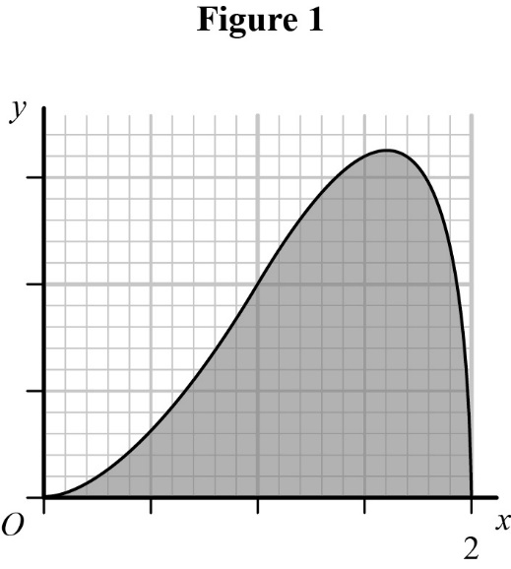

**2** Figure 2 shows the curve with equation . The shaded region is bounded by the curve and the line *x* = 4. The region is rotated 2π radians about the   
*x*-axis to generate a solid of revolution. Find the exact volume of the solid generated. Leave your answer in the form , where *a* and *b* are rational numbers to be found. **(5 marks)**

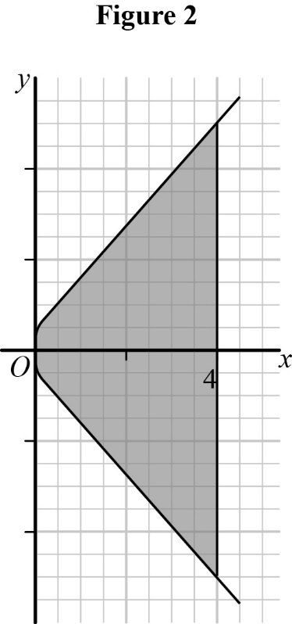

**3** Figure 3 shows a vase with a base width of 8 cm and a height of 12 cm. The edge of the vase is modelled by the equation , ⩽⩽, as shown in Figure 4. The vase is formed by rotating the shape through 360° about the *y*-axis.

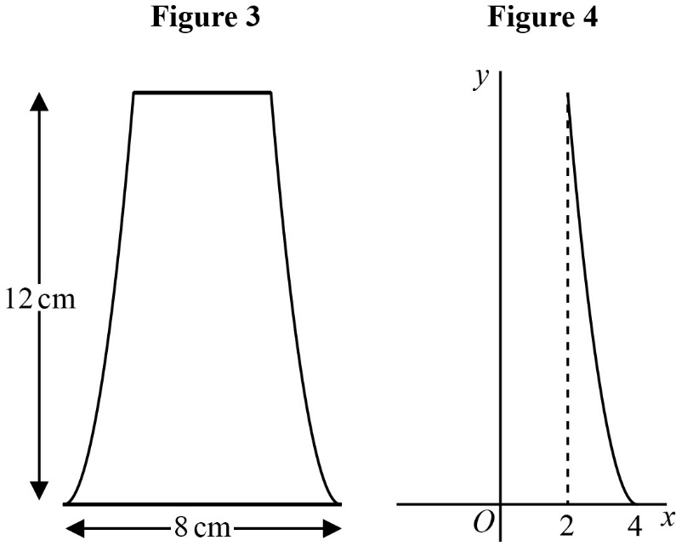

Find the maximum capacity of the vase. Leave your answer in the form , where *a* is a rational number to be found. **(6 marks)**

**4** Figure 5 shows the shaded region *R* is bounded the curve , ⩽⩽, and the straight line with equation , ⩽⩽, the *y*-axis and the line  
 *y* = 3. Find the exact volume of the solid generated when this region is rotated through 2π radians about the *y*-axis. Leave your answer in the form , where *a* is a rational number to be found. **(8 marks)**

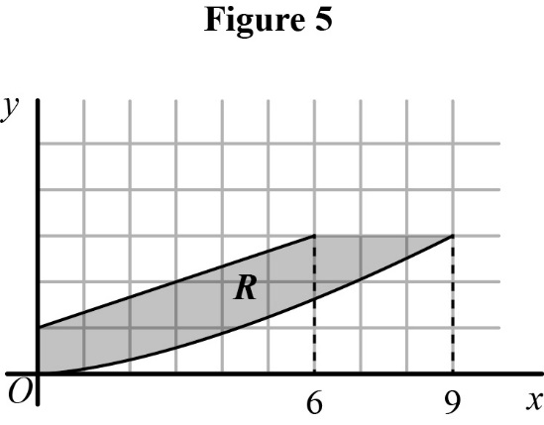

**5** Figure 6 shows part of an ellipse with equation  inside a cylinder with a diamater of 10 cm and a height of 10 cm. The shaded region is rotated 360° about the *y*-axis to generate a solid of revolution. Find the exact volume of solid generated. Leave your answer in the form , where *a* is a rational number to be found. **(7 marks)**

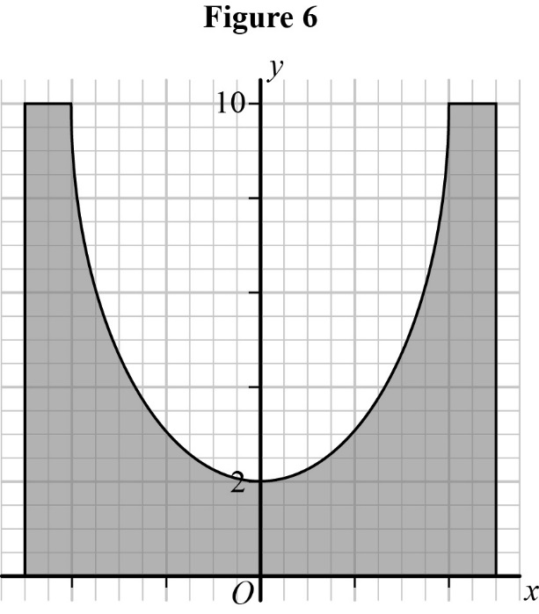

**6** Figure 7 shows a rubber flotation device. The dimensions of the flotation device are shown in the figure. Figure 8 shows a scale model of the flotation device bounded by curves with equations  and . The flotation device is formed by rotating the shaded region through 2π radians about the *y*-axis.

**a** Find the volume of the model. **(7 marks)**

**b** Hence find the volume of the flotation device. **(2 marks)**

It was later discovered that the maximum capacity of air in the flotation device was .

**c** Using this information and the correct answer from part **b**, evaluate the model,   
explaining your reasoning. **(1 mark)**

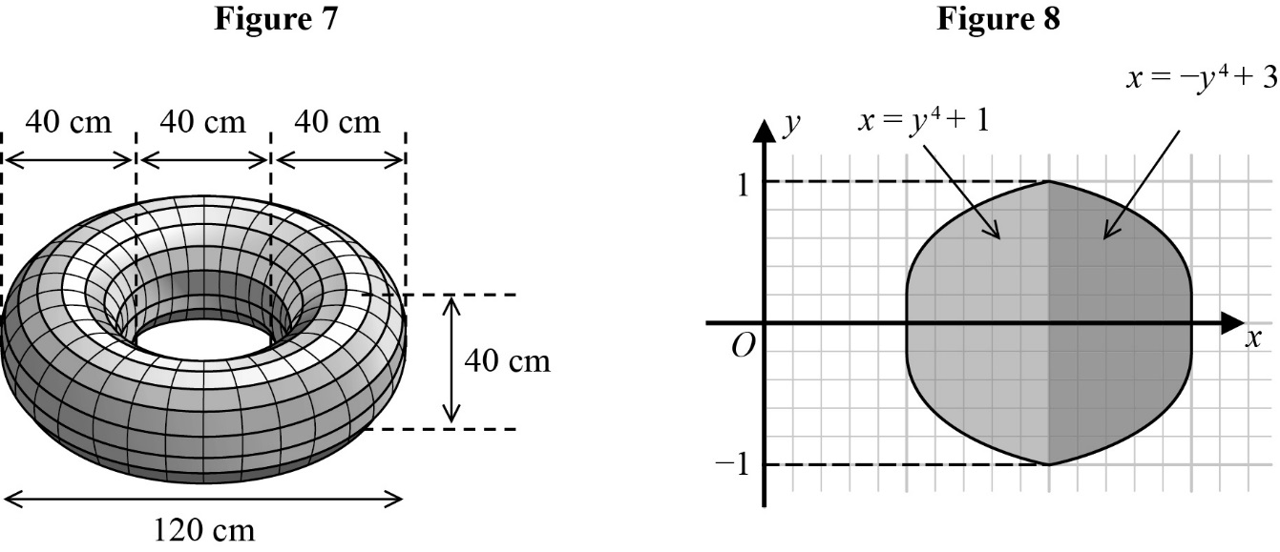

**7** A candlestick has base diamater 8 cm and height 28 cm, as shown in Figure 9. A model of the candlestick is shown in Figure 10, together with the equations that were used to create the model.

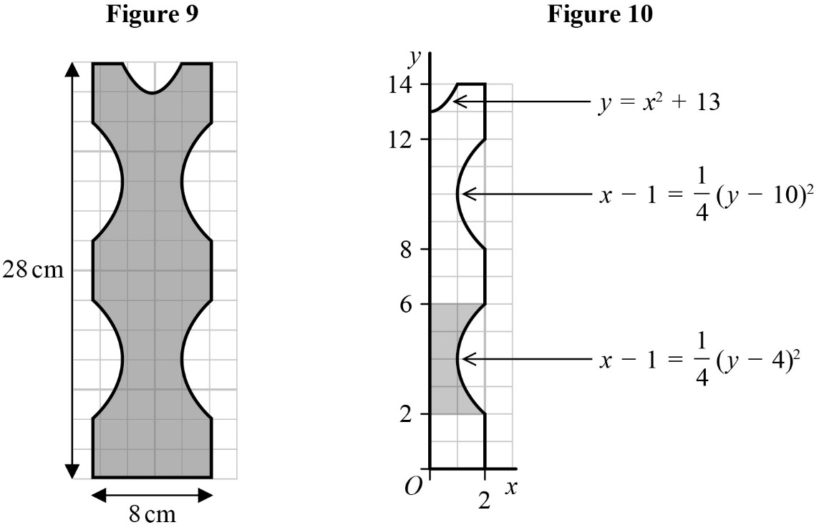

**a** Show that the volume generated by rotating the shaded region (in Figure 10)   
2π radians about the *y*-axis is  **(4 marks)**

**b** Hence find the volume of metal needed to create the candlestick. **(6 marks)**