

**NAME:**

BTEC LEVEL 3 NATIONAL EXTENDED CERTIFICATE

(Year 1 Course Code: 3;HP4)

(Year 2 Course Code: 4;HP4)

BTEC HOSPITALITY & EVENTS

**Course Handbook 2020**

**CONTENTS**

|  |  |
| --- | --- |
| Page 3 | Introduction to the HLT department and staff details |
| P4 | Expectations of you/HLT Code of Conduct |
| P5 | What you can expect of your teachers |
| P6 | Health & Safety/Equal Opportunities/Disability Policy  Educational Visits |
|  |  |
| P7 | How Will I Be Taught? |
| P8 | Approach to “Remote Learning” during COVID 19 |
| P10 | Course overview |
|  |  |
| P11 | Student Scheme of Work Year 1 |
| P14 | Overview of Year 2 |
| P15 | Assessment Criteria/Unit Summaries |
|  |  |
| P19  P21 | T&T Assessment Policy (including grading system, how to submit coursework)  Student reviews/ARGs/Predicted grades, Key checkpoints throughout the year |
| P24 | 50:50 help and advice |
| P25 | Working out your study periods |
| P26  P27 | And finally…  Appendices |

**Introduction to the HOSPITALITY, LEISURE & TOURISM department (HLT).**

We are thrilled that you have decided to study the BTEC Level 3 Hospitality course. The hospitality industry is hugely diverse and offers the potential for exciting and unique future career opportunities all over the world. As well as hotel and catering businesses, more recently managing events of all different themes of sizes has become a key part of the industry.

This course covers a range of topical aspects relating to the industry as well as helping people to become occupationally ready to take up employment in a range of jobs in both the public and private sectors, in places such as hotels, restaurants, pubs and events venues; not just in the UK but also all over the world. This can follow either directly after achieving this qualification, or via the stepping-stone of Higher Education at Universities or Colleges.

The purpose if this guide is to provide you with a range of information and advice to help you organise your programme of study, learn independently, and equip you with important information about the HLT department and how it can support you.

HLT is a well-established department within Godalming College, which has offered course in Hospitality, Leisure Studies and Travel/Tourism for close to 30 years. Currently we are running BTEC Level 3 courses in Hospitality and Tourism and we pride ourselves on not only providing high-level education in these industries (with great results), but also in preparing our students for the world of work by developing a variety of other skills.

The HLT Department is situated on the ground floor of the 400 block (English and Modern Languages), with two dedicated teaching rooms, complete with 21 fully networked PCs in each. The HLT office (room 515) is in the nearby sports hall block – this is where you can find staff during most lunchtimes.

The teaching team are experienced teachers who have relevant experience within the travel and tourism industry. They are very enthusiastic about their subject and are fully committed to providing a high quality education in a caring and supportive environment. Their knowledge of the industry is used to promote a detailed and extensive learning environment as well as supporting you with your studies.

**Teaching Staff:**

Seb Jefferies (Teacher)

Helen Sharp (Teacher).

Jim Shepherd (Head of HLT Department/Course leader).

**Our Director of Faculty (Humanities and Social Sciences/Arts and Sciences):**

Debbie Hagger (Biology Department).

**CENTRE NUMBER: 64395**

**COLLEGE TELEPHONE: 01483 423526**

**HLT DEPARTMENT OFFICE TELEPHONE: 01483 411282**

Along with the names above, the following departments and places will be useful whilst studying on the course:

**The ILC** – your go-to place to complete work and independent study outside of lessons. The Silent Study area provides an area to work individually, whilst the library contains an excellent selection of wider reading. Make sure that you have familiarised yourself with the ILC when you start the course

**The Exams Office** – For any questions, you have about your exam entries, exam timetable or re-marks and script requests.

**Learning Support** – For any extra support or advice, you need to help you study in general. If you are struggling to organise and manage your workload; need help refining your essay-writing technique; help with revision; or if you think you might be entitled to any exam concessions, learning support are the people to talk to. We strongly recommend that you use the “drop-in” sessions at the study centre (top floor of the LRC). Anyone can go there to get work checked by support staff and it is used by top grade students as well as those that are finding the work challenging.

**Careers** – when you start to think about your options after college, whether university or employment based, careers can give you advice on where to apply and help in producing a personal statement.

**ExpecTations**

**HLT Department Code of Conduct.**

We seek to maintain an atmosphere of mutual respect between all those in the classroom, and we aim to do all we can to promote and support learning. The industries that we are studying require staff who can cooperate and work as teams, often under pressure. This should be reflected in the way we behave towards each other and our approach to work.

This means that in all lessons:

1. Everyone should arrive punctually to all lessons.

Arrive in time for the start of the lesson, preparing for the start of the lesson quickly and quietly and not distracting others or starting conversations that do not relate to the lesson.

Do not bring food or drinks to the lesson – these should be finished in time for the start of the lesson. We will not allow you to finish these off.

Turn off your phones and put these away (preferably into bags – out of sight/out of mind).

2. Students should come to every lesson with the correct equipment and homework, as specified by the teacher.

Part of your College student contract is to be prepared and submit work on time to the best of your ability.

Equipment includes memory sticks, pens, class notes/folders, books – it does not include mobile phones and headphones. If using your own laptop in lessons, you are still required to follow the College’s IT policy and only use the laptop for work purposes.

3. There is no talking or noise of any kind made whilst the teacher is talking to the whole class, or whilst a student is speaking in a whole class situation.

If you have a question, please raise your hand and wait for the teacher to address you.

Respect the fact that part of the teacher’s job is to talk to the class and some students will struggle to hear/concentrate/understand if there are interruptions.

4. We should all treat others with respect at all times.

During lesson time, when speaking to staff and other students, communicate in a calm, civil manner.

Do not discuss other individuals (staff or students) with anyone else during lesson time.

This includes the use of social media and via electronic communication.

5. Students should actively participate in lessons and show commitment to their studies.

When completing coursework tasks, the internet should only be used for work purposes. Talking can distract other people around you – it is not fair to disrupt the learning of others.

A positive attitude and work environment can help you to learn and improve your grade.

**What can you expect of your teachers?**

1. **To deliver structured and engaging lessons** – your teachers will deliver lessons designed to challenge your understanding whilst also helping you to gradually build up your knowledge and skills. These lessons will follow the scheme of work, a version of which you can see in this handbook. Some of your lessons will also be used for coursework assignment work and controlled assessments.
2. **Regular assessment and feedback** – in addition to your benchmark assessments (four in the first year and three in the second) in your exam unit your teachers will regularly set you exam-style questions to give you opportunities to practice and improve. Feedback will be given on standardised sheets, which include the relevant mark scheme and clear developmental targets.
3. **Structured weekly work** – you should expect to be given a significant amount of work to do by your teachers each week. You will be given guidance on how long this should take and completed work will be checked and/or taken in.
4. **Additional support** – your teachers will be happy to provide extra help outside of lessons either informally, by responding to emails, Microsoft teams, or more formally through departmental workshops. Workshops are the best opportunity to receive additional help and work best when students come to lunchtime sessions with a specific area of confusion or set of questions to be answered. This year’s workshops are on Monday and Thursday lunchtimes.

**Health & Safety**

The Department endorses the College Health & Safety Policy. The tutors will carry out risk assessments to maintain a safe working environment with minimum risk to the students and themselves. The presentation of the course topics is not normally associated with specific hazards but your tutors will brief you should the need arise. Any visits associated with your course are also covered by risk assessments.

Students have a duty of care and are expected to follow the general College Health & Safety Guidelines displayed in each room and in the student diary, to ensure their own safety and that of others.

**Equal Opportunities**

The Department will follow the College Equal Opportunities Policies, which aim to:

* treat everyone with respect as an individual;
* create a climate in which students feel valued and are encouraged to develop their skills, abilities, qualities and interests;
* value the race, colour, gender, sexual orientation, social class, religion, culture, ability and age of every student;
* develop a community in which tolerance, respect, courtesy, sensitivity and understanding are encouraged;
* encourage students to achieve their potential and to raise their level of achievement.

**Disability Equality**

Information on students with disabilities is taken from the application form and notes from interviewers. This will be added to in the course of the academic year. An Inclusion register is produced by Learning Support and distributed to all staff. The College’s Equal Opportunities Committee has responsibility for establishing and implementing the Disability Equality Scheme.

For more information about all the key Godalming College policies, visit [www.godalming.ac.uk/about_us/publications/](http://www.godalming.ac.uk/about_us/publications/)

**EDUCATIONAL VISITS**

Over the next two years, depending on the situation regarding COVID 19, you will be involved in the active planning of various educational visits. These will provide you with an opportunity to study the industry first hand, while collecting research and evidence for your assignments. In the past we have been to a variety of destinations both home and abroad, visiting many different types of providers. You will be given adequate warning of these trips and when parental permission and payment is to be made by. Payment can be made on Godalming online through wise-pay, or by cash/card at the College finance office. There might be financial support available from the college should you require it. Please see your Personal Tutor or Val Jones in Student Support for further details.

These visits are **non-compulsory** but we strongly advise you to attend, as this will help with your knowledge of the industry and also allow you to interact with others and learn more about yourself. In the past, the residential visit planned for year two has cost between £600 and £950.

Work will be set for completion during the trip and while we wish you to enjoy yourself on the visit, health, safety and security must be maintained at all times and is our number one priority. For each visit, we will make clear our expectations regarding behaviour and attitude and you will be asked to sign a code of conduct. In order to continue to provide educational visits we have to ensure the safety of all and you play a major part in this process.

**HOW WILL I BE TAUGHT?**

In the department, we will provide you with a variety of different working styles. These range from traditional teaching, group activities, individual and group presentations, individual researching, educational visits, work placement, individual tutorials plus IT sessions where you will be writing up your assignments. We have designed a programme that will be both educational and stimulating. You have a major part to play in this process. The group activities are designed to allow you to explore issues with others and not to fill in time. The more you contribute, the more you gain from the activity, and the more you learn. This will then, in turn, result in a higher grade for you. We actively encourage students to ask sensible and related questions. Please ask if you do not understand something. This is part of our job and you can bet that someone else is thinking the same.

In all lessons, we expect a high level of professionalism and a positive attitude. You can also expect that from us as well! Please remember that you have chosen to be here and to study this subject. Help us to help you gain the most from the next year. You will spend the next year as a group, completing many tasks together, visiting many places together. Therefore get to know one another, you will be spending 4½ hours a week in the same class and hopefully become good friends, as many past students have done before you. There will be some students from non-partner schools, who might not know anyone in the group. Please try to make these students feel welcome and included.

**Approach to remote teaching and learning**

Following the closure of schools and colleges in March 2020, teachers and students have adapted to a new environment of remote teaching and learning. How ‘remote’ this is depends on the wider context of COVID-19, but the department has clear plans, and expectations of its students, in each of the scenarios below.

1. ***Normal Opening: The College is open as normal; all students attend and follow a full, face-to-face timetable***

In this situation, the department would run lessons, as normal and all of the expectations of students and teachers on the page before would apply

1. ***Blended Learning: students will receive a mixture of physical and remote lessons, attending college physically one week and remotely the other***

The department will continue to offer high quality lessons in this scenario although the exact nature of teaching and learning may vary depending on what content is being covered. Students should expect a mixture of:

* **Streamed lessons** – when appropriate, lessons including half of the class will be streamed live through Microsoft Teams to the other half of the class learning from home
* **Recorded content** – tutorials, demonstrations, presentations etc. will be pre-recorded for students to watch and complete a set of follow-up tasks
* **Structured independent work –** students may be longer project-style work, or work that is made up of several structured tasks and asked to work on this independently for a period of time, during which their teacher will be available for support
* **Preparation work** **–** class time may be used to set students independent work in the form of research or pre-learning to prepare them for a specific live lessons, which will then be used to assess students’ level of understanding of the work they have completed.
* **Homework** – students will also be expected to complete homework tasks

1. ***Remote Learning: students will receive remote lessons and assessment will be conducted remotely***

In the event that college is not open for physical lesson, teaching and learning will move online through the combined use of Microsoft Teams and Godalming Online. The specific nature of each week’s learning will vary depending on what is being covered, but students should expect a mixture of:

* **Live lessons through Microsoft Teams** – this is a fantastic platform that allows classes to video-call, watch presentations, take part in Q&A, group work, 1-1s all in real-time. Teams lessons will be the main part of remote teaching and learning but may take a slightly different form or length than physical lessons to help students engage fully. For example, a 1.5 hour physical lesson might translate to a 30-45 minute Teams lessons, made up of a brief teacher-led presentation and class Q&A, followed by 45 minutes of structured independent work, during which time the teacher conducts 1-1s with students
* **Online submissions** – students will upload work regularly to help their teacher monitor their progress and offer support when needed. This will be done through the ‘Assignments’ feature on Teams or through Godalming Online
* **Remote Workshops** – in addition to remote lessons, department workshops will continue remotely to provide students with extra points in the week to get 1-1 help on content, homework or remote learning in general

**Expectations of students in scenario 2&3 –** if students find themselves learning remotely or in a mixture of physical and remote lessons, then the department has clear expectations of how they should work in this environment. The department has considerable experience in delivering content remotely and key to this is students remaining engaged, establishing a clear working routine and communicating effectively with staff. More specifically, it is expected that students will:



* Attend all remote lessons unless told otherwise by their teacher
* Actively take part in remote lessons e.g. contribute questions and answers, take part in group work, turn webcams on (with the background blurred) when asked to by their teacher
* Submit all work via Godalming Online or Microsoft Teams by the deadline set
* Communicate regularly with their teachers, either as part of scheduled 1-1s or more informally to discuss work or any problems they might be having. This will be through Email or Teams.

To identify where your remote strengths and weaknesses might be, complete the specific department audit below. This is made up of the essential skills you would need to learn in a remote or blended environment.

|  |  |
| --- | --- |
| **Remote Learning Skills Audit that you need to master to succeed on this course** | ***Tick*** |
| Log on to Office 365 using your college details (in college and at home) |  |
| Open Microsoft Teams and find a class team |  |
| Join a lesson on Teams and post a comment |  |
| Download the Teams app on your phone |  |
| Upload or attach documents in Teams |  |
| Save documents on OneDrive |  |
| Access your OneDrive files at home |  |
| Share documents, PowerPoints etc. without attaching them to emails |  |
| Access Godalming Online course pages and download files |  |
| Upload work onto Godalming Online |  |
| Access E-textbooks needed on the course |  |
| Log on to any magazines or websites needed on the course |  |
| Access E-stream to watch films/documentaries/pre-recorded content |  |



*[](https://www.google.co.uk/url?sa=i&url=https%3A%2F%2Flogotyp.us%2Flogo%2Fmicrosoft-teams%2F&psig=AOvVaw2Wl1l6bVS-gskR2jhCsLQD&ust=1594130388988000&source=images&cd=vfe&ved=0CAIQjRxqFwoTCNDg_8_kuOoCFQAAAAAdAAAAABAD)*There are many places you can go to get help with the skills listed above.

To begin with, speak to your teachers to get help with the basics of using Microsoft Teams or Godalming Online. This can be done at the start of the year through departmental surgeries and through workshops. A good idea would be to bring the completed audit above to a workshop and go through this with your teacher to fill in any gaps.

The IT Department are also available to offer support that is more technical or if you run into a problem your teacher cannot resolve. If in college, IT can be found on the top floor of the 300s. Also, have a look at the IT Helpdesk on Godalming Online, which has help on using features such as Office 365. Finally, IT are also contactable via [ITsupport@godaming.ac.uk](mailto:ITsupport@godaming.ac.uk)

If you are concerned about how to organise your time and working habits during a period of remote learning, then speak to your tutor for ideas and techniques to work independently. The Learning Support Department are also available to discuss specific concerns or individual learning needs further.

**Course Overview**

|  |  |  |  |
| --- | --- | --- | --- |
| **YEAR ONE** | **Unit 1: The Hospitality Industry** | **Written coursework assignments** | **1/6 of your final grade** |
| **Unit 2/3: Customer Service** | **Written coursework assignments AND practical demonstration of customer service skills.** | **1/6 of your final grade** |
| **Unit 21: Managing Events** | **Written coursework assignments (including concept files for 2 event proposals)** | **1/6 of your final grade** |
|  |  |  |  |
| **YEAR TWO** | **Unit 26: Hospitality Industry Project** | **Written research project, with formal presentation of findings.** | **1/6 of your final grade** |
| **Unit 21: Personal Selling and Promotion** | **Written coursework assignments AND practical demonstration of personal selling skills/designing promotional material.** | **1/6 of your final grade** |
| **Unit 22: Planning and Running an Event** | **Compiling an event plan, and then running/evaluating this event.** | **1/6 of your final grade** |

**Student scheme of work**

Below is a summary of how you will be taught the different units of the course and how this fits into the approximately 66 weeks of teaching time over the two years of your BTEC course. You will also see the key assessment points given below. It is important that you know when these are so that you can organise your coursework and work I other subjects. An important idea to understand when looking at this student scheme of work is that the course flows consistently over two years. The units you study in the first year are as ‘difficult’ as those you will look in your second year. You need to treat all work in the same way and apply yourself fully throughout. Also, consider that the May half term in the first year is, in reality, the mid-point of the course not the summer holiday. This time will go quickly so make sure you understand the structure of the course fully and get any help when it is needed.

|  |  |  |  |
| --- | --- | --- | --- |
|  | **BTEC HOSPITALITY - YEAR 1** | | |
| **Week** | **Unit 1 - Exam** | **Unit 9 - Coursework** | **Assessment** |
| **Start of term/L6 Enrolment** | | | |
| **L6 Enrolment** | | | |
| 1 | Unit 1.1: P1 Explaining the scale and diversity of the Hospitality Industry | |  |
| 2 | Unit 1.1: P1 Levels of Service/Customer Types | |  |
| 3 | Unit 1.1: P1 Types of Ownership/Current Trends/Scale of the Industry | |  |
| 4 | Unit 1.1: P3 Student research – identifying/background research businesses to be used for 1.1 assignment | |  |
| 5 | Unit 1.1: P3/M1 – Organisational Structures | | Assignment 1.1 Set |
| 6 | Unit 1.1: D1 – Linking scale of businesses to the products/services that they offer. | | Working on Assignment 1.1 |
| *Half Term - 19thth – 30th October (2 weeks)* | | | |
| 7 | 1.1 Assessment week – completion of assignment tasks/official submission of assignment 1.1. | | Coursework Assignment 1.1 first submission this week.  **Benchmark 1: Assignment 1.1 marked work.** |
| 8 | Unit 1.2: P2/M2 – Classification systems used in Hospitality | | Assignment 1.2 Set |
| 9 | 1.2 Assessment week – completion of assignment tasks/official submission of assignment 1.2 | | Coursework Assignment 1.2 first submission this week. |
| 10 | Unit 1.3: P4/M3 – Support Functions Finance/Customer Service | |  |
| 11 | Unit 1.3: P4/M3 – Support Functions Marketing/Human Resources | |  |
| 12 | Unit 1.3: D2 – Evaluating effectiveness of support functions at a chosen business. | | Assignment 1.3 set |
| 13 | 1.3 Assessment week – working on assignment tasks | | Working on Assignment 1.3 |
| *Christmas Holiday - 21st December – 1st January* | | | |
| 14 | Unit 21.1: P1 - Introduction to event types/features. | | Coursework Assignment 1.3 first submission this week.  **Benchmark 2 – Unit 1 grade** |
| 15 | Unit 21.1: P2 - Identifying tasks involved in the management of events | |  |
| 16 | Unit 21.1: P3 - Producing event proposals | |  |
| 17 | Unit 21.1: P3 – Producing Event proposals ctd… | |  |
| 18 | Unit 22.1: P4/M1 – Skills/Attributes required for events organisation. | | Assignment 21.1 set |
| 19 | Unit 22.1: D1 – Evaluating Event proposals | | Working on Assignment 21.1 |
| *Half Term - 25th February – 19th February* | | | |
| 20 | Unit 21.2: P5 – Considerations for planning/liaison for large-scale events. | | Coursework Assignment 21.1 first submission this week. |
| 21 | Unit 21.2: M2 – Comparing the planning/liaison of 2 large events | | Assignment 21.2 set |
| 22 | 21.2 Assessment week – working on assignment tasks | | Working on Assignment 21.2 |
| 23 | Unit 21.3: P6 – Safety/Security/Crowd Management at different types of events | | Coursework Assignment 21.2 first submission this week. |
| 24 | Unit 21.3: P6 – Safety/Security/Crowd Management at different types of events | |  |
| 25 | Unit 21.3: M3/D2: Compare/Evaluate P6 – Safety/Security/Crowd Management at different types of events | | Assignment 21.2 set |
| *Easter Holiday - 2nd April – 16th April* | | | |
| 26 | 21.3 Final Assessment week – completion of assignment tasks/official submission of assignment 21.3 (and U21 resubs) | | Coursework Assignment 21.1 first submission this week. |
| 27 | Unit 3.1: P1/M1- Communication Skills/Analysing Communication methods | | **Benchmark 3 – Unit 21 grade** |
| 28 | Unit 3.1: P1 – Personal Presentation Skills | |  |
| 29 | Unit 3.1: D1 – Evaluating/proposing improvements to communication/presentation (at a chosen business) | | Assignment 3.1 set |
| 30 | Unit 3.1 Assessment Week | | Coursework Assignment 3.1 first submission this week. |
| 31 | Unit 2.1: P1/P2/P3/P4/M1 – Role of the supervisor/organisational standards/support processes for staff | | Assignment 2.1 set |
| *Half Term31st May – 4th June* | | | |
| 32 | Unit 2.2: P5/P6/P7/P8/P9/P10/M2 – Staff development and Training. | | Coursework Assignment 2.1 first submission this week.  Assignment 2.1 set |
| 33 | Unit 2.3: P11/P12/P13/P14/P15/M3 – Monitoring and improving performance/corrective actions. | | Coursework Assignment 2.2 first submission this week.  Assignment 2.3 set |
| 34 | Unit 2: D1 – The effect of changing expectations on Customer Service delivery | | Coursework Assignment 2.3 first submission this week.  D1 assignment work set |
| 35 | Unit 3.2: Practical Customer Service Skill Demonstration Assessments – Role Plays/Let’s Celebrate | | D1 work due this week  **Benchmark 4: Unit 2/3 progress.** |
| 36 | Unit 3.2: Practical Customer Service Skill Demonstration Assessments – Role Plays/G2G | |  |
| 37 | Unit 3.2: Practical Customer Service Skill Demonstration Assessments – Role Plays/Open Evening | | 3.2 Practical Logbook deadline  Student Review 2 and Predicted Grade Available |

**BTEC HOSPITALITY – YEAR 2 OUTLINE 2021/2022 (Detailed Plan to follow).**

|  |  |  |  |
| --- | --- | --- | --- |
| Dates | Assessments/Activities | | |
|  | Jim’s Lessons | | Helen’s Lessons |
| September 2021 | Unit 26 – Hospitality Industry Related Research Project  26.1 Sign Off P1: Devise 3 project proposals then finalise project choice (Summer work).  26.2 Sign Off P2/M1: Plan the project (and devise research methods). | | |
| October 2021 – December 2022 | Unit 26 (Project ctd…)  26.3 Undertake and write up project research (fortnightly meetings with Jim). | Unit 19 – Personal Selling and Promotion.  19.1 Personal Selling & Promotion Methods (Jim/Helen)  19.2 Research into promotion used in 2 businesses (Jim/Helen) | |
| January – February 2022 | 26.3 Undertake and write up project research (fortnightly meetings with Jim). | 19.3 Designing promotional material (Jim)  19.4 Demonstrating Personal Selling skills (Jim) | Unit 22 – Event Planning and Organisation.  22.1 Researching different types of events (Helen).  22.2 Presenting event proposals/selecting event (Helen). |
| March – April 2022 | Unit 26 (Project ctd…)  26.4 Evaluating the project (including formal presentation of finding) (Jim) | | 22.3 Planning the Event (Helen). |
| April – May 2022 | 22.3 Running the Event (Helen/Jim).  22.4 Evaluating the event (Helen/Jim). | | |

Students should aim to finish the course by May 13th, 2022.

**Assessment**

When starting the course, it is important to know how the course is assessed and what you need to do to get as many marks as possible for each unit. You will be assessed through internally assessed coursework units. The next few pages provide a summary of the assessment criteria (set by our exam board) appropriate to each unit that you will study.

**UNIT 1 THE HOSPITALITY INDUSTRY (YEAR 1)**

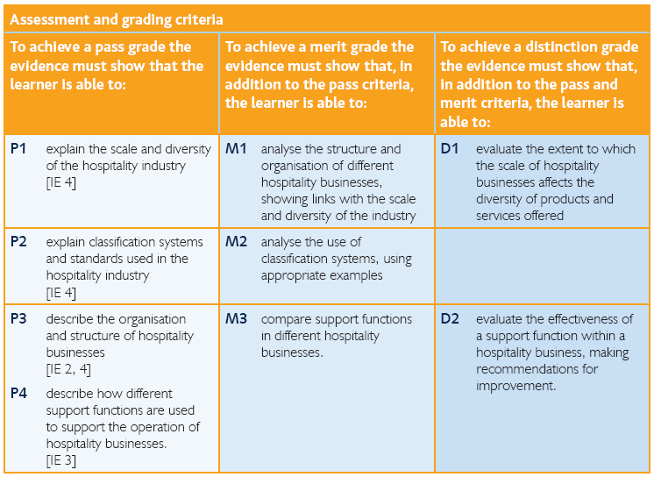

**UNIT 3 - PROVIDING CUSTOMER SERVICE IN HOSPITALITY (YEAR 1)**

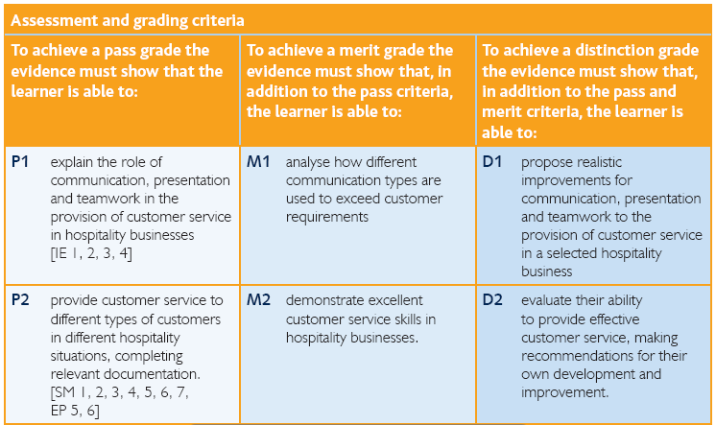

**UNIT 2 – PRINCIPLES OF SUPERVISING CUSTOMER SERVICE PERFORMANCE IN HOSPITALITY (YEAR 1)**

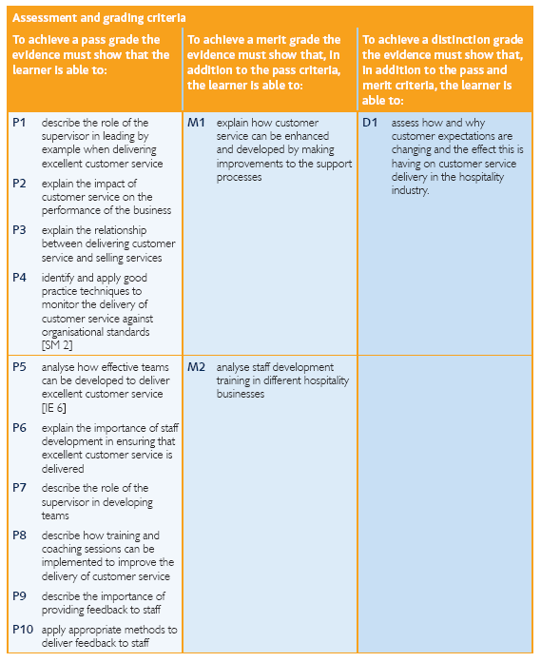

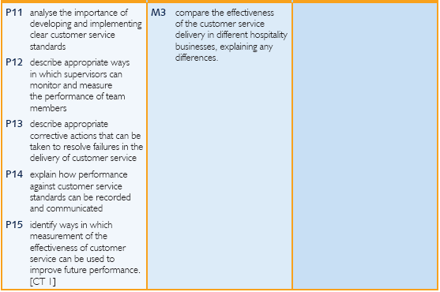

**UNIT 21 – EVENTS ORGANISATION IN HOSPITALITY (YEAR 1)**

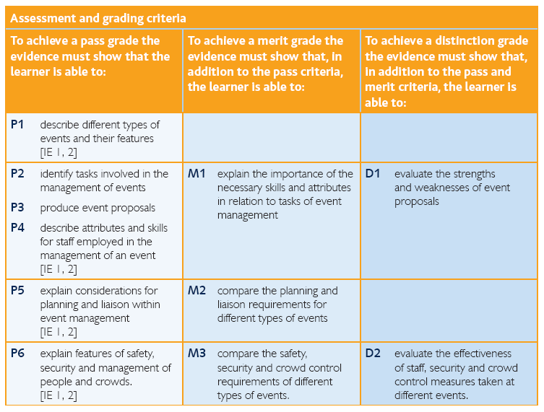

**UNIT 22 – PLANNING & MANAGING AN EVENT (YEAR 2)**

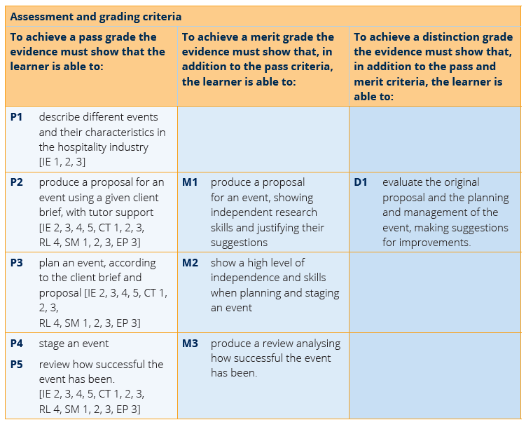

**UNIT 19 – PERSONAL SELLING & PROMOTION IN HOSPITALITY (YEAR 2)**

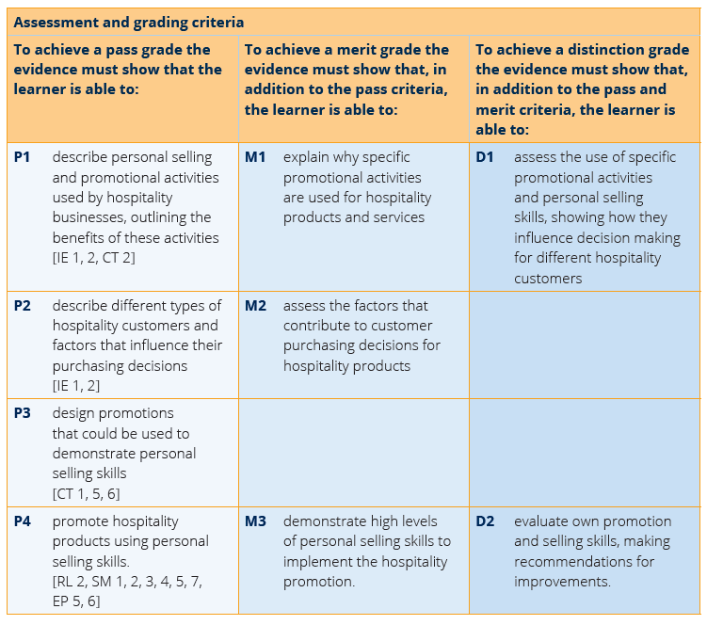

**UNIT 26 – HOSPITALITY INDUSTRY RELATED PROJECT (YEAR 2)**

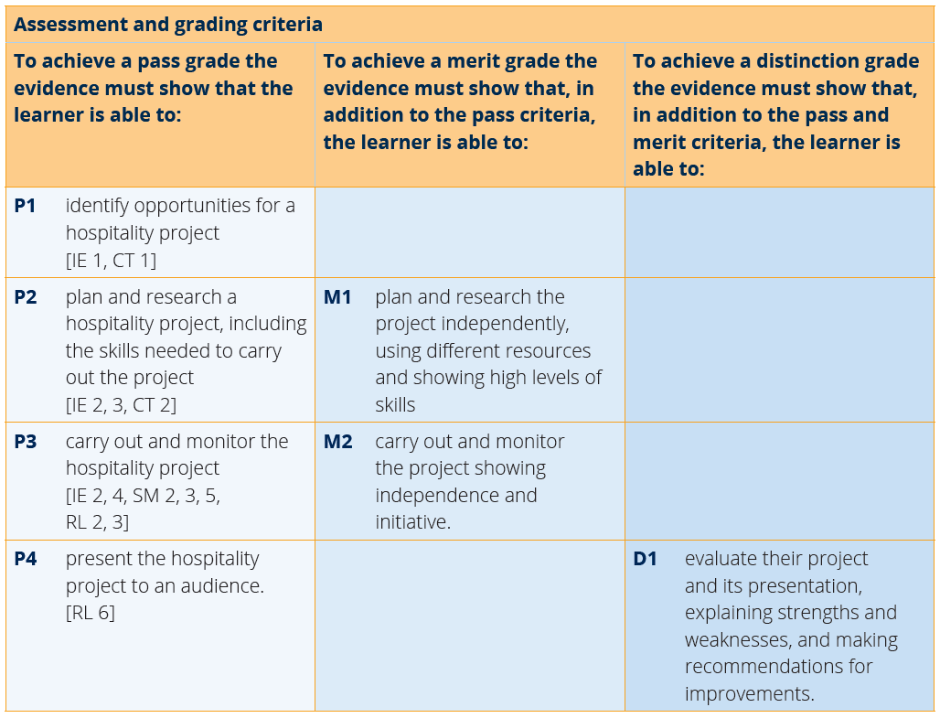

**BTEC HOSPITALITY**

**Assessment Policy 2019-2021**

Updated May 2020 for Covid-19 Situation

**The Importance of Feedback and Learning outside the Classroom – ’50:50’**

As you aware, your Hospitality BTEC course ais assessed through coursework assignments and practical activities…in other words, there are no exams. We therefore set your work differently from your other A level subjects, but if you want to be successful in your BTEC course we cannot emphasise enough the importance of completing work we set both during assignment workshop lessons **AND** outside of your lessons (either at home, during your non-timetabled periods during the College day or in our lunchtime workshops). You are timetabled for 4 hours 30 minutes of lesson time for each BTEC subject. We recommend that you spend **AT LEAST** another 4 hours 30 minutes per week devoted to your BTEC coursework tasks, to ensure you meet official deadlines with good quality evidence. This time should obviously be spent preparing and compiling your coursework but during this time, we would also expect you to access additional resources such as books, TV/film documentaries, relevant magazines and publications, all of which will help you to learn and understand your subject(s) and enhance the quality of your coursework.

Most of your lessons (2/3) will be with the Lead Subject Tutor who will be responsible for formalised 1-2-1s, writing your Student Reviews, seeing your parents at parents evening and for writing Action Plans. In the first year of the course, your Lead Tutor will be assessing each of the 3 units that you will complete. In Year 2, one of the 3 units will be delivered and assessed by your other tutor (with the lead tutor assessing the other 2).

The way we give feedback for the work that you produce on your BTEC course falls into 2 categories: Informal and Formal.

The pre-assessment tasks (that we call “classwork”) that you are set will be marked by your teacher, with lots of informal feedback – both written and verbal (through 1-2-1s). These tasks and the feedback help to prepare you for (and lead into) your official graded coursework assessments. When we come to assessing you official coursework, you should now be familiar with the BTEC submission/assessment rules, stating that we can only give limited formal, written feedback. For your first official submission, this written feedback will either explain how you have satisfied/met the criteria **OR** outline improvements/additional information that you will need to add for an official resubmission. This is all recorded on an assessment record sheet that is returned to you with your original first submission work. At this stage, it is vital that you understand our feedback, so we encourage you to discuss this with us. If a resubmission is required, you will be given a new deadline to re-submit the improved work by. This process is summarised in the diagram on Page 28 (Appendix 1).

**Overall Assessment/Grading**

At the end of the two years, students will have completed 6 units: 3 Units in Year 1 + 3 Units in Year 2

**GRADING:** Each unit has three levels of criteria – pass, merit and distinction.

Pass = Describe, List, Research, Demonstrate.

Merit = Explain, Assess, Develop.

Distinction = Evaluate, Justify, Analyse.

To achieve a **PASS** for a unit (**70 points**), your work must meet all of the requirements of the pass criteria.

To achieve a **MERIT** for a unit (**80 points**), your work must meet all of the requirements of the pass and the merit criteria.

To achieve a **DISTINCTION** for a unit (**90 points**), your work must meet all of the requirements of the pass, merit and distinction criteria.

Your score for each unit is then added up to make your final grade:

|  |  |
| --- | --- |
| **Total Points** | **Overall Grade** |
| 400-459 | Pass |
| 460-499 | Merit |
| 500-519 | Distinction |
| 520 and above | Distinction* |

**Crucial point – be aware!!**

To get a pass/merit/distinction grade in a unit you have to get the pass/merit/distinction in **EVERY** assignment of that unit. **For example, in Unit 1 there are 3 assignments, 1.1, 1.2 and 1.3.** **To get a Merit in Unit 1 you must satisfy all the P and M criteria in ALL of those assignments.**

**Types of Assessment – so to recap…**

Classwork:

Classwork is set and must be handed in on the set deadline. This work helps you to prepare for your official assessed coursework assignments. This work should also be completed both during class time AND during your 50:50 time outside of lessons.

If submitted on time- You will receive detailed written/verbal feedback within 10 days to help your assignment.

If not submitted on time- You will receive no feedback and will have to attempt your assignment without proper guidance.

Assignments

Assignments must be completed in the set format (you should not simply submit your improved classwork) and submitted by the deadline.

How to submit your assignment:

* 1. Print off a paper copy of your work, to hand in during the stated “hand-in window”. This will usually be during a Monday or Thursday lunchtime workshop session.
  2. If requested, for example during the period of remote learning from March 20th – July 2020, upload your work to the area for that particular assignment on Godalming Online by the required deadline.

If submitted on time - You will have your work marked and graded and you will be granted a resubmission if necessary (receiving formal outline feedback on the improvements that need to be made to meet the criteria).

If not submitted on time - You will have no further feedback on this work. You must submit the assignment by the resubmission deadline to receive a grade.

Resubmissions

If granted a resubmission you must use the guidance given to improve your assignment one final time. This must be submitted by the resubmission deadline to receive your final grade.

How to submit your resubmission:

1. Print off a paper copy of your resubmission work, to hand in during the stated “resubmission hand-in window”. This will usually be during a Monday or Thursday lunchtime workshop session.
2. If requested, for example during the period of remote learning from March 20th – July 2020, upload your work to the area for that particular assignment on Godalming Online by the required resubmission deadline.

If submitted on time- Your work will be graded and you will hopefully have improved on your first/original assignment attempt. This will give you your final grade for the assignment.

If not submitted on time- Your grade will not improve from that of your first/original assignment. If you have not submitted your assignment or resubmission on time then your assignment will be marked ‘Unclassified’ and you may not be able to achieve your qualification.

Please note: if you are unable to meet official deadlines for genuine reasons beyond your control, you can apply for a deadline extension, please let your tutor know immediately. If this is the case, you will need to see your tutor to collect an official coursework deadline extension form (see Appendix 2 Page 29)

As long as you satisfy the conditions for an extension, a new deadline will be re-negotiated and you should then follow the hand-in process as stated above.

**Other Considerations**

LATE POLICY: In line with the ‘College Assessment Policy’, the department are under no obligation to provide feedback to a student who does not meet the internal deadlines for work set. Please be warned that a failure to meet the final coursework deadline is the equivalent to missing the exam and it will be recommended that the student should be removed from the course.

PLAGIARISIM: Plagiarism is submitting another person’s written work as one’s own original work or using someone else’s idea without referencing the source or using pictorial work without permission or referencing the source. If there is a suspicion of plagiarism, the Head of Department and Senior Tutor will be informed and a meeting will take place. If a student is found guilty, they will be subject to disciplinary action by the College and the awarding body will be informed. Students should be aware that the College is subscribed to software designed to detect plagiarism (see Appendix 3 on Page 30).

**Benchmark Checkpoints (Half-Termly):**

With 3 units studied in each of the 2 years (6 in total), this generally means that you will complete one unit per term. Unlike your A level subjects where you will sit benchmark assessments at regular intervals throughout the course, BTEC courses have “continual assessment” so your unit grades build up over the 2 years, contributing to your overall grade at the end of the course. We do, however, closely monitor your progress through each unit and record a “benchmark” score at the same time as other subjects. This helps you to recognise if you are working at, above or below our expectations, and therefore take appropriate actions (if needed) to get back on track or maintain your progress. This information feeds into your students review (see below) and will be discussed with you during a 1-2-1.

**Tracking your Progress: Student Reviews, Action Plans and Parents Evenings**

The College’s policy is to deal with the student first but we also report to your parents at regular intervals to let them know how you are progressing and to inform them of what our expectations are through four Student Reviews (Reports) spread throughout the two years at College and also four parents evenings.

If the department feel you are under-performing based on evidence such as benchmark grades and your approach to learning in between these periods, then your Lead Subject Tutor may place you onto a Formal Department Action Plan and we will formally write to your parents after a 1-2-1 with yourself and to try and get you back on track in a supportive way

**Student Review 2, the ARG and Predicted Grades**

At the end of the first year (June 2020), your Lead Tutor will have a 1-2-1 to discuss your Annual Review Grade or ARG and also finalise your Predicted Grade which might be used for UCAS applications for University and other destinations.

The ARG is determined by your Lead Tutor in communication with your other teacher and will rely on the following evidence:

1. **Benchmark Checkpoints Performance Grades (1 to 4).** This year, since Benchmark 3 and 4 (based on your performance in the second 2 Units of Year 1) have been carried out remotely under the current Covid-19 scenario, although still valid, they will be taken into consideration alongside other factors like your ‘Approach to Learning’ before and after lockdown to signal your academic potential.
2. **Approach to Learning (before 20th March 2020):** How you engaged in your learning, evidenced by attendance, punctuality, ability to meet set deadlines with quality work, how you have sought out extra support via workshops and your overall communication with your teachers. Your final grade for Unit 1 (Benchmark 2) will also be considered.
3. **Approach to Learning (after 20th March 2020):** How you were engaging in your learning remotely, evidenced by the ability to meet weekly deadlines with quality work, attendance at any remote lessons (unless previously communicated to state your unavailability) and communication with your teachers via Email and/or Microsoft Teams.

The ARG plays a key part in determining the context in which you progress to the second year. Students who receive a Distinction* - Pass grade are encouraged to continue with their studies into the 2nd year. However for students who receive a “Below Pass” as their ARG, it suggests that for whatever reason they have struggled with the transition from Level 2 Courses (GCSE) to the BTEC course. This will be evidenced by poor performances throughout their benchmarks and an inconsistent or poor approach to learning in their student reviews and via formal Action Plans. Students who receive a “Below Pass” Grade we would not recommend to continue with the course and they would need to speak to a Senior Tutor about alternative pathways.

The College adopts a consistent and optimistic approach to predicting grades to ensure that they are both aspirational and achievable. A predicted grade is what we believe a student is likely to achieve by the conclusion of their course in positive circumstances and the predicted grade provides universities and colleges with some understanding of a student’s academic potential alongside their Personal Statement and a written Reference from their Personal Tutor.

The ARG is important in forming the basis for the predicted grade as well but the predicted grade will also be aspirational for the students’ ambitions although it must remain realistic and cannot be based on the idea that only now will the student start to work harder in the second year!

**Unit grading, Benchmark Checkpoints, Student Reviews (Reports) 2020-22**

Below is an overview of all the key assessment checkpoints

|  |  |  |
| --- | --- | --- |
| **CHECKPOINT** | **DATE** | **DETAILS** |
| **Benchmark 1 Checkpoint** | Oct 2020 | Unit 1 coursework progress – first assignment (1.1) graded (Pass, Merit, Distinction). |
| **Parents Evening (For All)** | Nov 2020 | **Meetings with your parents to discuss how you have settled in and transferred from GCSE to Level 3 BTEC learning based upon:**   1. **Approach to learning** (how you are engaging in your learning, evidenced by attendance, punctuality, ability to meet classwork/assignment deadlines with quality work, how you have sought out extra support via workshops and your overall communication with your teachers) 2. **Performance Grade** in Benchmark 1 (from assignment 1.1) and performance since then. |
| **XMAS BREAK** |  |  |
| **Benchmark 2 Checkpoint** | Jan 2021 | Final grade for Unit 1 coursework (having completed all unit 1 assignments -1.2/1.3). |
| **Student Review 1** | Jan 2021 | **A review of your progress in the first term (12-13 weeks of teaching) after a 1-2-1 with your Lead Tutor:**   1. **Performance grade (Fail/Pass/Merit/Distinction)** based on Unit 1 final grade. 2. **Approach to Learning** (how you are engaging in your learning, evidenced by attendance, punctuality, ability to meet weekly deadlines with quality work, how you have sought out extra support via workshops and your overall communication with your teachers). |
| **Parents Evening (Targeted)** | Mar 2021 | **Meetings with your parents primarily where teachers may have a concern about your progress since Student Review 1 in January.** |
| **EASTER BREAK** |  |  |
| **Benchmark 3 Checkpoint** | May 2021 | Your Unit 21 grade will be used to provide a benchmark grade for your progress on the course so far. |
| **Benchmark 4 Checkpoint** | July 2020 | Your Unit 2/3 grades will be used to provide a benchmark grade for your progress on the course so far. Research work for Unit 26/Year 2 work will be set over the summer holidays. |
| **Student Review 2** | July 2020 | **A review of your progress for the academic year (30-35 weeks of teaching) after a 1-2-1 with your Lead Tutor**   1. Approach to Learning 2. Performance Grade (Annual Review Grade or ‘ARG’ – performance for whole year (see notes above in main doc.) 3. Predicted Grade (for final end of course grade). |
| **SUMMER BREAK** |  |  |
| **Benchmark 5 Checkpoint** | Oct 2021 | Year 2: Work completed for Unit 26 will be used to provide a benchmark grade, to see if you are on track for your predicted grade. |
| **Parents Evening (All)** | Oct 2021 | **Meetings with your parents to discuss how you have settled in to the second phase of learning:**   1. **Approach to learning** (how you have engaged since Student Review 2 including completion of summer work and the first five weeks of teaching – deadlines met, engagement in class and communication with teacher) 2. **Performance** with reference to your Unit 4 coursework mark. 3. **How to support you:** Discuss how parents can further support you and what is coming up in this year. |
| **Benchmark 6 Checkpoint** | Dec 2021 | Unit 19 progress – first assignment (19.1) graded. |
| **Student Review 3** | Dec 2021 | **A review of your progress for the academic year since last Student Review (July) after a 1-2-1 with your Lead Tutor**   1. Approach to Learning 2. Overall Performance Grade (based upon benchmark 6) compared to Predicted Grade |
| **XMAS BREAK** |  |  |
| **Benchmark 7 Checkpoint** | Mar 2021 | Unit 9/26 final grades and Unit 22 progress – first assignment (22.1) graded. |
| **Student Review 4** | Mar 2021 | **A review of your progress for the academic year (30-35 weeks of teaching) after a 1-2-1 with your Lead Tutor (see above)**   1. Approach to Learning 2. Overall Performance Grade (based upon benchmark 7 ) compared to Predicted Grade |
| **Parents Evening (Targeted)** | Apr 2021 | **Meetings with your parents primarily where teachers may have a concern about your progress since Student Review 4.** |
| **EASTER BREAK** |  |  |
| **Final**  **Checkpoint** | May  2021 | **Unit 22 (event) final grade leading into calculation of final overall qualification grade (reported to BTEC).** |

**50:50 HELP & ADVICE**

Key to your success whilst studying in the HLT Department is the level of effort and work you put into your subjects outside of lessons. Remember, the college’s expectation is that you match every hour of class time with an hour of independent study – **50:50**. This will include completing **structured homework** tasks set by your teachers but will also require you to **work independently**; finding ways to consolidate and extend your understanding. To help you to do this, the list below gives some ideas or activities to consider each week.

**Consolidate your weekly work *(Suggested time = 1.5 hours per week)***

Go over your lesson materials and handouts from that week’s Unit 1 exam lesson making sure that all activities have been finished in detail. If you have been reading articles or sources, go over these highlighting key points and adding annotations to the margins. When you have looked at a new concept or period, produce a simple mind-map to summarise the key information ready for future revision.

**To help you develop into a strong independent learner the following can also help you:**

**Books** Regular consolidation of content throughout the two years of the BTEC course is important. This means you are able to check your subject knowledge and consolidate understanding as you progress. There are a number of books, which cover many areas that we study. These are available to borrow from the library and are always available for class use. We have a course textbook, copies of which are available to borrow within the department. There are online versions of this book – with a link on GOL (see below).

**Godalming Online (GOL)** The BTEC Hospitalitysiteis constantly updated and has plenty ofresources broken down by unit and assignment. Most presentation materials from lessons are available as well as case studies, articles and industry reports. Keep an eye on the “current issues” section of our GOL site, where we upload interesting news stories that affect the travel and tourism industries, as and when they happen.

**Real world Hospitality news** Watching and discussing the daily news (and how this impacts on hospitality) will enhance understanding and will be able to show awareness of contemporary events in your writing. Having the BBC app on your phone is a quick an easy way to check in with the news for breaking stories that help you see the hospitality industry in action.

**Radio and TV** There are a number of good travel/tourism programmes that are often shown on TV watch out on the schedules for programmes that are of interest. Watching these helps you to understand the industry in action, as well as the importance of key areas such as customer service. Examples include:

* The Hotel Inspector.
* 4 in a Bed.
* Ramsey’s Kitchen/Hotel Nightmares.
* Amazing Hotels: Life beyond the Lobby.
* Mystery Diners (the food network).

**Use all the resources available to you in college** As well as resources available to you in the Department make sure you check out the resources available in the ILC. The HLT section is well stocked. Outside of lesson time, the department also has an open door policy, whereby you can ask any member of staff for help and guidance if you need it. ***For any query about the course read the Student Handbook***

**WORKING OUT YOUR WEEKLY STUDY PERIODS**

It is often helpful to plan when you will undertake your weekly private study. We recommend that you plan when and where you will do all your private study for all courses and stick to it. Tell your family and friends your plan so they know and don’t disturb you. You must then stick to it. This is the best way to get the grades you want and to have less stress.

|  |  |  |  |  |  |  |  |  |  |
| --- | --- | --- | --- | --- | --- | --- | --- | --- | --- |
|  |  | **Break** |  |  |  | **Lunch** |  |  | **7.00 – 10.00** |
| **M** |  |  |  |  |  |  |  |  |  |
| **T** |  |  |  |  |  |  |  |  |  |
| **W** |  |  |  |  |  |  |  |  |  |
| **T** |  |  |  |  |  |  |  |  |  |
| **F** |  |  |  |  |  |  |  |  |  |
| **S** |  |  |  |  |  |  |  |  |  |
| **S** |  |  |  |  |  |  |  |  |  |

1. First start by filling in your college timetable
2. Fill in your part-time employment commitments
3. Fill in your other regular commitments (sports clubs, TV programmes or when you eat etc)
4. Fill in when you want to go out or have time off
5. The rest is when you are free to do private study. If you prefer to study during the day, then put in Hospitality work during the day. Make sure you plan private study time for all subjects

Now you have a plan, stick to it!

AND FINALLY…..

We hope that you enjoy the next two years, make good friends, enjoy many experiences and gain the grades that reflect your effort and ability. Good attendance, time-management, meeting deadlines and effort will make your life at college easier and less stressful.

The departmental web site contains much more information. It is currently in the process of being updated and if you wish to contribute articles, photos or stories, then you can add these to the student section which we will be creating. If you find a good web site that will help with your work, please share this with the teaching staff so that we can update our information.

Also on the web site, you will find the tracking grid that you can fill in to see how well you are doing on the course. In addition, there is a template time-planner-an example is contained at the end of this pack. You should print these off to help you plan your weekly work schedule. We will help you to organise your time as we go through the course. However, it is your responsibility to do the work and keep up to date

We will always have time for you, so if you have any questions, concerns or problems then just see us. We hope you enjoy learning about the travel and tourism industry and also learning about yourself!

**APPENDICES**

APPENDIX 1 – COLLEGE SUBMISSION POLICY FLOW CHART (Page 31)

APPENDIX 2 – COURSEWORK EXTENSION FORM (Page 32)

APPENDIX 3 – PLAGIARISM POLICY (Page 33)

**APPENDIX 1 – COLLEGE SUBMISSION POLICY FLOW CHART**

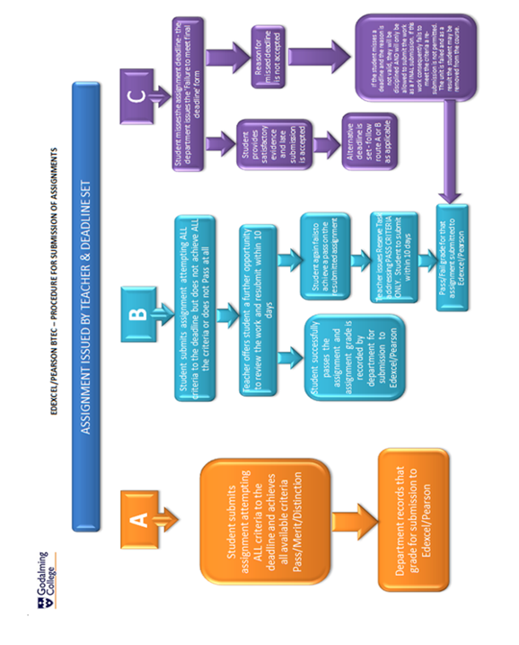

**APPENDIX 2 – COURSEWORK EXTENSION FORM**

**APPLICATION TO EXTEND A COURSEWORK DEADLINE**

Student’s Name: Set:

Personal Tutor’s Name:

What subject do you need an extension for? ……………………………………………………

What was the original deadline? What is the date you will hand work in?

…………………………………. …………………………………………...

Reason for application:

*(Please state justifiable reason such as, medical problem, accident, unforeseen family circumstance etc. Please note problems related to computer equipment will* ***not*** *be accepted as a valid reason for an extension)*

Please state below the evidence you will provide to verify the above:

Student Signature: Date:

Parent / Guardian Signature: Date:

Senior Tutor Signature: Date:

Assistant Principal Teaching and Learning: Date:

*When your form has been signed by the three members of College staff above, it should be returned to the Head of Department concerned. A decision will be made and sent to you about your application*

**APPENDIX 3 – HLT PLAGERISM POLICY**

**Plagiarism**

What is plagiarism?

Plagiarism is attempting to pass off other people’s work and ideas as your own.

Plagiarism can include:

* copying from another learner copying from books or the internet
* paraphrasing
* subcontracting the work to someone else
* submitting the same piece of work for two different purposes

Why is plagiarism wrong?

* It is fundamentally dishonest
* Learners who commit plagiarism are seeking an unfair advantage over other learners
* Learners who commit plagiarism are devaluing the value of the qualification they seek
* It is disrespectful to their Assessors, and a betrayal of their trust

What are the consequences of plagiarism?

* Learners who commit plagiarism learn far less than those who do not
* Assessment procedures are compromised if the work submitted is not the learner’s own
* Assessors are unable to form correct decisions on the progress of individual learners
* It may result in legal action due to infringement of copyright laws
* It may be penalised by failure in one or more components of a course
* It could be unfairly interpreted as professional incompetence on the part of the Assessor.
* You could face disciplinary action as stated in the Godalming College disciplinary procedure (Senior Tutor/Assistant Principal Warnings or Exclusion).

Why does plagiarism happen?

There are many reasons. You may…

* not understand what is meant by plagiarism, because it has never been explained to you
* not believe plagiarism to be wrong: you download music, video clips and games all the time
* not understand the concept of individual ownership of ideas and words
* have misconceptions about the ownership of electronic material
* struggle to differentiate between intellectual property rights and common knowledge
* regard the conventions of academic documentation as unimportant or irrelevant to them
* lack referencing skills, and therefore are unable to record and cite sources correctly
* lack the study skills, research skills and writing skills needed to produce the work required
* not know how to adapt published literature sources so that they do not require citation
* Regard plagiarism as a short cut to success.

How do Godalming HLT department help minimise the risk of plagiarism?

* We have clear policies and procedures re plagiarism and other forms of academic misconduct
* You should develop concepts of individual ownership of ideas and words, the ownership of electronic material and the difference between ‘intellectual property’ and ‘common knowledge’
* We provide instruction in study skills, research skills, writing skills, time management skills and the use of a suitable referencing system to record and cite sources correctly
* We insist upon the use of referencing bibliographies from day one
* We act as a team, with every Assessor rigorously applying centre policies on referencing and bibliographies
* We avoid the use of highly generic assignments and, instead, produce contextualised tasks that require the learner to research in depth and individually analyse and evaluate their findings
* We include an authenticity statement with every assignment brief: learners must sign and date the authenticity statement to acknowledge that the work produced is their own and that they understand the penalties that will be imposed on learners who do submit plagiarised work
* We provide learners with opportunities to discuss any problems they may encounter, support them at each step and provide them with the resources they need to do the work properly
* We ensure that learners are not overloaded by providing them with an assessment schedule, agreed by all of the course team, and then ensure that the team adheres to the schedule.