**AQA AS AND A LEVEL LAW Name :**

**Study Pack 2**

**RELEVANT TO A LEVEL PAPER 3**

**RULE OF LAW**



**CONTENT:**

Understanding of the constitutional doctrine of the rule of law and its application to law making, the legal system and substantive law:

* no person shall be sanctioned except in accordance with law
* equality before the law
* fairness and clarity.

The Rule of Law - **What is it?** <https://www.youtube.com/watch?v=Cu3hjLyTI88>

(See Chapter 2 – pages 8-11 LAW AQA Textbook Martin & Price)

|  |  |
| --- | --- |
| **Rule** | **Law** |
| Definition  ‘Rule’ has several meanings- in this context ‘rule’ has the meaning:  the power, control, supremacy or authority over something. I.e. Ruler, sovereign.. | Definition:  The body of rules (in the *other* meaning the word! ie orders / requirements) recognised as regulating the actions of citizens enforceable by penalties. |
| In order for the Rule of Law to operate, the Law iit needs to be the supreme authority and command the respect of citizens so that they will recognise and obey it .  What qualities / characteristics do you think the Law (including the Law making and Law enforcement bodies) must have? | |

The Constitutional Reform Act 2005

***s1 The rule of law***

*This Act does not adversely affect—*

*(a)the existing constitutional principle of the rule of law, or*

*(b)the Lord Chancellor's existing constitutional role in relation to that principle.*

Key aspects of the Rule of Law; The Rule of Law is not one thing, it is a concept, a collection of ideas and principles. Together they make up the doctrine of the Rule of Law.



1.Equality before the Law

‘Everyone is subject to the law’ and no one is above it.

Do you think anyone in the UK should not be able to be sued?

Do you think anyone in the UK should not be able to be prosecuted for committing a criminal offence?

Who is the most famous / rich/ powerful person you can think of in the UK, who has been prosecuted?

2. No one may be sanctioned except in accordance with the Law.

“The powers of the State are limited by its laws”.

What does this mean?

|  |
| --- |
|  |

Discuss and think about what it would mean if this were not the case. C

|  |
| --- |
|  |

How can the organisations of the ‘state’ be challenged?

* By Judicial Review proceedings through the Courts. See also Delegated Legislation.
* 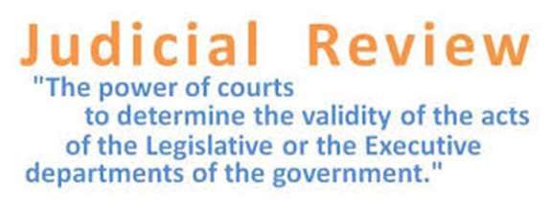

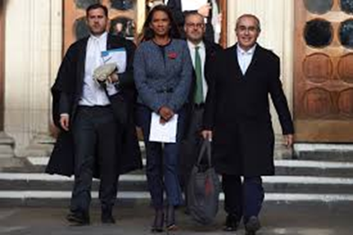

What Rule of Law issues were raised by the two cases brought by Gina Miller (in 2016 and 2019) before the Supreme Court?

Which one was most directly connected to Brexit?

|  |
| --- |
|  |

3. **Fairness and Clarity of the enforcement of the administration of Laws**

**Fairness in terms of WHO enforces the Law:**

This requires the bodies that ensure Law is complied with to be :

1. independent , and
2. impartial

Clarity:

This requires the administration and enforcement of the Law to be understood and accessible to all

This independence and impartiality requires there to be a separation of powers.

What are the three main bodies of power in the UK?

Which body is mainly responsible for the enforcement of Laws?

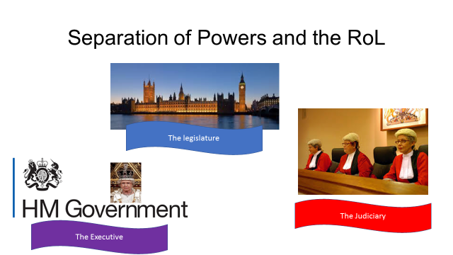

The primary role of the Legislature (Parliament) is to:

|  |
| --- |
|  |

The primary role of the Executive (government) is to:

|  |
| --- |
|  |

The primary role of the Judiciary (Judges) is to:

|  |
| --- |
|  |

How does the British constitution ensure the independence of the judiciary?

The **Constitutional Reform Act 2005 s3** guarantees continued judicial independence.

**S3 Guarantee of continued judicial independence**

1)The Lord Chancellor, other Ministers of the Crown and all with responsibility for matters relating to the judiciary or otherwise to the administration of justice must uphold the continued independence of the judiciary.

Discuss why this is so important (i.e. what might the consequences be if the judiciary were not free to act independently of government and other influences)?

|  |
| --- |
|  |

When Judges make a decision in a case, what are they bound by?

|  |
| --- |
|  |

**Fairness in terms of HOW the laws should be enforced**

How crimes are investigated and prosecuted?

How should a trial be conducted?

How long it should take for a dispute to be resolved?

Should the decision of the court ( or other tribunal) be final ?

Getting legal help to bring or defend a claim (access to justice).

<https://www.channel4.com/news/government-overruled-on-employment-tribunal-fees>

We will cover this area in more detail when we study the Criminal and Civil courts topics and Access to Justice and Funding topic.

**4. There must be a fairness and clarity in the processes for law making**

**Who** makes the laws:

**Legislation** (Statutes and Acts)

These are made by both houses of Parliament.

Is it fair that the House of Commons is the main law-making body? What are the arguments in favour and against this?

|  |
| --- |
|  |

Is it fair that the House of Lords also approves and can reject laws?  What are the arguments in favour and against this?

|  |
| --- |
|  |

<http://www.ucl.ac.uk/constitution-unit/research/parliament/house-of-lords/lords-defeats>

[ttps://www.gov.uk/government/publications?publication_filter_option=consultations](https://www.gov.uk/government/publications?publication_filter_option=consultations)

[https://www.legislation.gov.uk](https://www.legislation.gov.uk/).

**The Common Law**

This is made by Judges using the system of precedent.

Do you think Judges should be allowed to make the Law?

See Judicial precedent Study Pack

Is the Law making the process fair and clear?

What would you expect a fair process in making and deciding on new laws to involve? Consider in terms of the following;

|  |
| --- |
| Involving the public in law making?  Who should have the opportunity to put forward proposals for new laws?  What care / scrutiny should be taken in passing laws?  How clearly should laws be expressed?  How should new laws be made known? |

We will cover this area in more detail when we study the Parliamentary Law-making topic and Delegated Legislation topic.

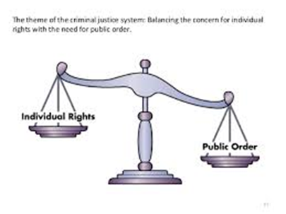5. **Fairness and clarity of the substantive laws**

This means the laws themselves must be fair/just.

Broadly, just laws are aimed at protecting and balancing people’s legitimate entitlements or rights.

Laws should be **prospective** :

not r**etrospective** : ).

Why is this?

* See the War Crimes Act 1991
* R v R 1991 marital rape case.

|  |
| --- |
| What fair laws do you know of that protect the following citizens’ rights?   1. To cross the road safely 2. To get their money back if goods are faulty 3. To receive compensation if they suffer food poisoning in a restaurant 4. To retain your own property 5. To use force against an intruder in your home 6. To only have sex with your consent 7. To vote |

We will cover this area in more detail when we study the substantive areas of Tort Criminal and Contract law