**Godalming College**

Booklet Checked by: _____________

Grade: U/S 1 2 3

Comment: _______________________________________________________________________________________________________________________________________________________

**Sociology Department**

TRENDS IN CRIME AND OFFENDING:

CRIME STATISTICS, ETHNICITY & GENDER

[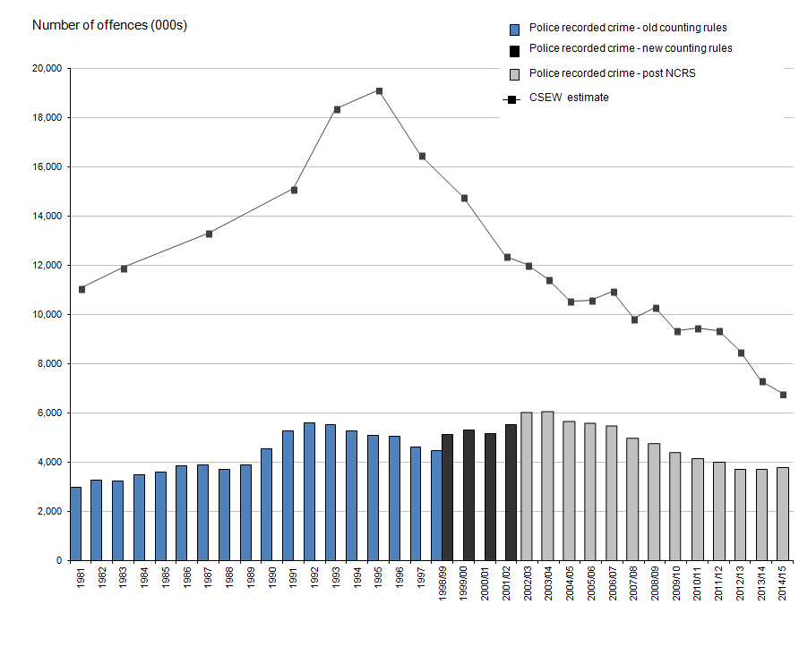](http://www.google.co.uk/url?sa=i&rct=j&q=&esrc=s&source=images&cd=&cad=rja&uact=8&ved=0ahUKEwjA0ZO1z-vOAhVIVhQKHUbpAOgQjRwIBw&url=http://www.ons.gov.uk/ons/rel/crime-stats/crime-statistics/year-ending-march-2015/index.html&psig=AFQjCNHmU0r3xaZ8QUkJFbdbYkprxpCvQg&ust=1472731711097560)

**WORKBOOK 6**

Crime & Deviance (Paper 3)

|  |  |  |
| --- | --- | --- |
| Name: | Set: | Group: |

In this booklet you will:

* Understand different types of crime statistics and their data collection techniques.
* Be able to identify the difference between reported and recorded crime.
* Changes in the recording of crime by the police and criminal justice system.
* Identify differences in the official statistics relating to the offending and victimisation of different ethnic groups.
* Explore reasons for the differences in offending and victimisation of different ethnic groups.
* Identify reasons why women appear to commit less crime than men and reasons for the small increase in female violent crime.
* Identify reasons why men commit more crime than women.

**CRIME STATISTICS**

**Read and complete the various activities from pp.39-46 of *Sociology AQA A-Level Year 2,* Chapmam (a copy of which can be found below).**

|  |  |
| --- | --- |
| **Crimes may be unreported** |  |
| Why this is important | Examples of crimes likely to fall into this category |
| Crimes may be undiscovered |  |
| Why this is important | Examples of crimes likely to fall into this category |
| Clear up rates are often low |  |
| Why this is important | Examples of crimes likely to fall into this category |
| Individuals may fail to report crimes to the police |  |
| Reasons for this | Examples of crimes likely to fall into this category |
| The Police may fail to record a crime |  |
| Reasons for this | Examples of crimes likely to fall into this category |

**Summary: Strengths and Weaknesses of the use of official crime statistics for sociologists.**

|  |  |  |
| --- | --- | --- |
|  | **For** | **Against** |
| **Practical Issues** |  |  |
| **Ethical Issues** |  |  |
| **Validity** |  |  |
| **Reliability** |  |  |
| **Representativeness** |  |  |

**ETHNICITY AND CRIMINALISATION**

**Reading: pp.480-486 Browne, pp.385-396 Haralambos 8th edition.**

**What do we mean by race?**

**Racism?**

**Ethnicity?**

Coretta Philips and Ben Bowling (2002) argue that the issue of ‘race’ and crime returned to public attention in the 1970s because of the consistent pattern of Afro-Caribbean people being over-represented in the prison population in the UK. This is a pattern that has be maintained ever since.

**Key questions:**

> How do we explain these ethnic differences in criminalisation?

> Is it because some ethnic groups are more likely to offend in the first place- and if so, how do we explain such differences? How do we avoid sounding racist when trying to form such explanations?

> Or is it because the criminal justice system is racist or discriminates against ethnic minorities?

**OFFENDING**

Evidence for offending can be gathered through official police and criminal justice system statistics, self-report studies and victimisation studies.

The Black population make up just over 3.1% of the population, but they make up 8.9% of the prison population.

**1) Official statistics:**

The Ministry of Justice in 2013, reported that compared to white people, black people were:

* Over twice as likely to be cautioned by the police.
* Around three times more likely to be arrested.
* If arrested, more likely to be charged, remanded in custody and face court proceedings than to receive a caution.
* More likely, if found guilty, to receive a custodial (prison) sentence and for a longer term.
* Five times more likely to be in prison (which has increased from 4 times as likely in 2011).

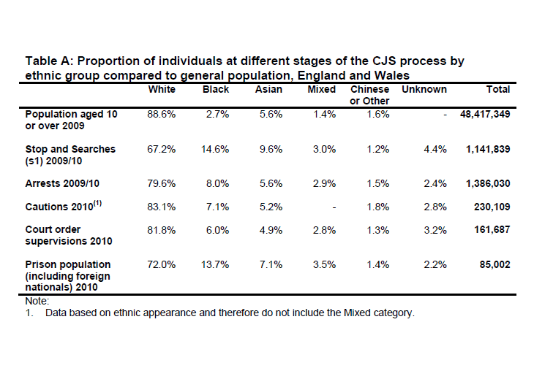

Exam practice for research methods:

Outline and explain two disadvantages of using official statistics [10 marks]

[Remember you need to address theoretical issues. You may need to do some additional research e.g. pp.169-171 Webb]

**2) Victim Surveys:**

Victim surveys like the Crime Survey ask individuals to say what crimes they have been victims of in the last twelve months. They show the following about ethnicity:

* Black people are significantly over-represented among those identified by victims as offenders.
* A great deal of crime is intra-ethnic – that is that it takes places within, rather than between ethnic groups.

Limitations of victim surveys:

* Rely on the victim’s memory. Philips and Bowling believe white victims might ‘over-identify’ blacks – saying the offender was black even when they are not sure.
* Only cover personal crimes, which only make up a 5th of all crimes.
* Exclude the under 10s.
* The exclude crimes against organisations e.g. businesses, so can tell us nothing about white collar or corporate crime.
* The chances of being a victim are not just linked to ethnicity. Philips and Bowling argue a higher proportion of ethnic minority groups live in inner-city areas, where rates of victimisation are generally higher.

Exam practice for research methods:

Outline and explain two disadvantages of victim surveys [10 marks]

[You may need to do some additional research e.g. pp.163-166 Webb]

**3) Self-Report Studies**

Ask people to disclose their own dishonest and violent behaviour.

The last major self-reported study of ethnicity and offending in Britain was carried out in 2005 and had a sample of more than 10,000 respondents.

> The highest rate of offending where found among ‘whites’, with 42% admitting an offence during their lifetime.

> Compared to 39% of ‘Mixed’ ethnicity.

> 28% ‘Black’

> 21% ‘Asian’

The data therefore suggests some bias in the criminal justice system because whites appear more likely to offend than blacks.

[Home Office]

What problems might there be with using self-report studies?

EXAM PRACTICE FOR RESEARCH METHODS

Item: Some sociologists favour using quantitative research methods such as structured interviews and questionnaires. These two methods are similar in many ways. Both use a fixed list of questions, often with pre-set, pre-coded answer categories, and both are relatively quick to complete. Their differences mainly come from how they deliver the questions- either face-to-face or in written form. However, interpretivists argue that quantitative methods impose the researcher’s views on respondents and do not allow them to express themselves in the way they would like to.

Applying material from the item and your knowledge, evaluate the claim that quantitative research methods may have many advantages, but they tell us little about what people really think and do [20 marks]

From the reading above and your additional research what conclusions can we make about the nature of offending and its links with ethnicity in the UK?

**EXPLAINING THESE PATTERNS: RACISM AND THE CRIMINAL JUSTICE SYSTEM**

Using the textbook sources stated at the beginning of this section carry out research on the following aspects that can help to explain these trends.

|  |  |
| --- | --- |
| **Issue** | **Relevant studies/contemporary evidence to support** |
| Black crime as resistance- Paul Gilroy (p.481-482 Browne, p.386 Haralambos 8ed). | |
| Black crime and scapegoating - Stuart Hall et al (p.482-483 Browne, p.386-388 Haralambos 8ed.) | |
| Evaluation of neo-marxist explanations | |
| Left realism - Lea and Young (p.483 Brown) | |
| Labelling – Reiner ‘canteen culture’ (p.484 Browne) | |
| Indirect racial discrimination | |
| Direct racism: Stop and search- explaining the patterns- Philips and Bowling (Browne p.484) | |
| Direct racism: institutional racism - Stephen Lawrence case (1993)/ Macpherson report (1999) – | |
| Arrests, charges and court proceedings (Browne, p.483) | |
| Convictions and sentencing, pre-sentencing reports, prison (Browne, p.485) | |
| Over representation in prison (Browne p.486) | |

**Victims**

Until recently the focus of the ‘ethnicity and crime’ debate has been largely on the over-representation of black people in the criminal justice system. However, since the murder of Stephen Lawrence and the subsequent Macpherson Report (1999) racist victimisation has become part of public focus.

What is meant by the term racist victimisation?

Information about racist victimisation from the Crime Survey and police-recorded statistics. They cover:

* Racist incidents: any incident perceived to be racist by the victim or another person.
* Racially or religiously aggravated offences- where the offender is motivated by hostility towards members of a racial or religious group.

Key trends:

> The police recorded 54,000 racist incidents in England and Wales in 2014/15- mostly to property or verbal harassment.

> Most incidents go unreported. The Crime Survey estimates there were around 89,000 incidents in 2014/15.

> The police recorded 38,000 racially or religiously aggravated offences in 2014/15, mostly harassment. 8,6000 people were prosecuted or cautioned in 2014 for these offences.

**Identify and explain two reasons for the apparent differences in the levels of victimisation for different ethnic groups [10]**

Questions to check your understanding: *(if you have made detailed notes, you should have all the answers for these, if not go back to a textbook).*

1. What is meant by criminalisation?
2. Explain what is meant by institutional racism?
3. Identity three ways in which is has been suggested there may be racism in the criminal justice system.
4. What theory of ethnicity and crime suggests there are real differences in the offending rates of different ethnic groups?
5. Outline the ways in which Hall et al explain the ‘moral panic’ over mugging.
6. Outline two criticisms of Gilroy’s idea that black criminality is a myth.
7. Evaluate the evidence for racism in the criminal justice system.
8. Identify two differences between the ideas of Lea and Young and those of Hall et al.

**GENDER AND CRIMINALISATION**

**Activity - Conduct some research using the current A-Level textbooks and internet sources, find out:**

Men are more likely to commit crime than women, what patterns are there in the crime statistics (consider different types of crime, victimisation etc.)

As offenders (p.105 Webb, p.487 Browne):

As victims (p.110 Webb, internet research):

**Key questions:**

* Do women really commit so few crimes, or are the crime figures an invalid picture of their offending?
* How can we explain why those women who do offend commit crimes?
* Why do males commit more crimes than females?

One key argument is that women actually commit more crimes than is reported but that women are more likely to be let off lightly. This is known as the ‘chivalry thesis’.

What do we mean by the term chivalry thesis?

Note down some supporting evidence for this thesis (p.490 Browne)

Using the textbook and powerpoint, which we will go through in class, make notes on the following (or on a separate piece of paper):

* Evidence against the chivalry thesis: Hales, Farrington and Morris
* Women being penalised: Walklate, Dobash and Dobash, relevant statistics.
* Double standards: Heidensohn, Carlen.

**Explaining female offending or lack of**

|  |  |
| --- | --- |
| **Explanation** | **Evidence to support** |
| Less detectable offences | |
| Functionalist sex role theory- p.488 Browne | Parsons |
| Evaluation | |
| Feminist approach: patriarchal control theory- p.488 Browne | Carlen |
| Evaluation | |
| Socialisation | Heidensohn |
| Evaluation | |
| Social control | |
| Feminist approach: Liberation thesis- p.491 Browne, p.401-402 Haralambos (8ed.) | Adler |
| Evaluation: | |

**Females and violent crime**

One trend in the official statistics that seems to support Adler’s liberation thesis is the increase in the arrest and conviction rates for the female perpetrators of violent crime.

Hand and Dodd (2009) argue between 2000-2008 police statistics show the number of females arrested for violence rose by an average of 17% each year. Similar results have been found in Canada, Australia and the USA.

**BUT**, Sharpe and Gelsthorpe note that net-widening police policies are producing a rise in the official statistics for females’ violent crime. There is a growing trend towards convicting females for low-level physical altercations.

Worall (2004) argues in the past girls’ misbehaviour was more likely to be seen as a ‘welfare’ issue whereas now it has been re-labelled as criminality.

So, if women are not actually committing more violent crime what could explain the criminalisation of females? One answer is that there has been a moral panic about girls, for example Burman and Batchelor (2009) point to media depictions of young women as ‘drunk and disorderly, out of control and looking for fights’.

Activity: Access Godalming Online. Read Archer’s *study Riot Grrrl and Raisin Girl: Femininity within the female gang, the power of the popular*.

**Male Offending**

Influenced by recent feminist and postmodernist ideas, sociologists have begun to take an interest in why men are more likely to commit crime.

|  |  |
| --- | --- |
| **Explanation** | **Studies** |
| Hegemonic masculinity- p.492 Browne | Connell (1987, 2005)  Messerschmidt (1993)  Lyng |
| Evaluation | |
| Postmodernity, masculinity and crime (p.112 Webb) | Winlow |
| Body capital (p.112 Webb) | Winlow |

**Exam Practice**

**Crime Statistics**

Outline three reasons why official statistics may not provide a valid picture of the pattern of crime in society [2 marks]

**Ethnicity**

Outline two reasons why members of some ethnic groups are more likely than others to receive custodial sentences [4 marks]

Item: The risk of being a victim of crime appears to vary by ethnic group, both in term of ‘ordinary’ crimes and racially motivated crimes. This is shown in victim surveys. Surveys are based on the assumption that people are aware of what is happening to them. All suspected crimes have to go through a process of being reported and investigated before they are officially categorised as a crime. The role of the police is crucial to this process.

Applying material from the Item, analyse two explanations of the apparent differences in the rates of victimisation of ethnic groups [10 marks]

Item: Official statistics suggest that there is a clear relationship between ethnicity and offending. These show black people and to a lesser extent Asians as being over-represented in the criminal justice system. In the view of some sociologists, this is because at each stage in the system, from policing through to sentencing, institutional racism distorts the picture of ethnic patterns of offending. However, left realists argue that there are real differences in offending rates and these differences can be explained in terms of factors such as relative deprivation and marginalisation.

Applying material from the Item and you knowledge, evaluate sociological explanations of the relationship between ethnicity and offending [30 marks]

Note: This question will need you to consider whether statistics represent reality or not. You will need to examine left realists’ views first and then compare and contrast with different theoretical views and types of statistics.

**Gender**

Outline two differences between the recorded patterns of male and female offending [4 marks]

Item A: Most criminals are men. The most consistent finding of research into crime in different societies and over many decades is that there is a clear link between crime and masculinity. However, the kind of crimes committed varies between different groups of men. So too does what counts as being a ‘real-man’ and the resources to achieve it. Changes over time in the economy and the employment structure – such as de-industrialisation, for example – may also affect men opportunities to express their masculinity.

Applying material from Item A, analyse two reasons why men commit crime [10 marks]

Item B: Official crime statistics indicate that there are significant gender differences in the commission of crime. Only about 20% of convicted offenders are female, and they are far less likely to commit homicide, carry out violent crime or be repeat offenders. However, some sociologists believe that these statistics underestimate the true extent and seriousness of female crime. They argue that the leniency of the criminal justice system may result in fewer girls and women ending up in the crime statistics than men.

Applying material from the Item and your knowledge, evaluate sociological explanations of female crime [30 marks]

Note: start with what the patterns of female offending actually are. Consider what official statistics tell us and whether they are supported by self-report or other studies. Examine functionalist and feminist explanations of why crimes are lower. Use Carlen’s study to examine the ‘exceptions’ who do offend. Bring in debates about whether the criminal justice system is still lenient towards women, or whether liberation has had an impact.