**Which crimes are least likely to be solved?**

By Danny Shaw Home affairs correspondent

* 17 October 2019
* [Share this with Facebook](https://www.bbc.co.uk/news/uk-49986849?fbclid=IwAR3Gaq_5-vPFrl3P0-XG2xGJD3FXUcBxX4pQXq_aY1JPqqsg76HKQgIcdpU)
* [Share this with Messenger](https://www.bbc.co.uk/news/uk-49986849?fbclid=IwAR3Gaq_5-vPFrl3P0-XG2xGJD3FXUcBxX4pQXq_aY1JPqqsg76HKQgIcdpU)
* [Share this with Twitter](https://www.bbc.co.uk/news/uk-49986849?fbclid=IwAR3Gaq_5-vPFrl3P0-XG2xGJD3FXUcBxX4pQXq_aY1JPqqsg76HKQgIcdpU)
* [Share this with Email](mailto:?subject=Shared%20from%20BBC%20News&body=https%3A%2F%2Fwww.bbc.co.uk%2Fnews%2Fuk-49986849)
* [Share this with Facebook](https://www.bbc.co.uk/news/uk-49986849?fbclid=IwAR3Gaq_5-vPFrl3P0-XG2xGJD3FXUcBxX4pQXq_aY1JPqqsg76HKQgIcdpU)
* [Share this with WhatsApp](https://www.bbc.co.uk/news/uk-49986849?fbclid=IwAR3Gaq_5-vPFrl3P0-XG2xGJD3FXUcBxX4pQXq_aY1JPqqsg76HKQgIcdpU)
* [Share this with Messenger](fb-messenger://share/?app_id=58567469885&redirect_uri=https%3A%2F%2Fwww.bbc.co.uk%2Fnews%2Fuk-49986849&link=https%3A%2F%2Fwww.bbc.co.uk%2Fnews%2Fuk-49986849%3FCMP%3Dshare_btn_me)
* [Share this with Twitter](https://www.bbc.co.uk/news/uk-49986849?fbclid=IwAR3Gaq_5-vPFrl3P0-XG2xGJD3FXUcBxX4pQXq_aY1JPqqsg76HKQgIcdpU)

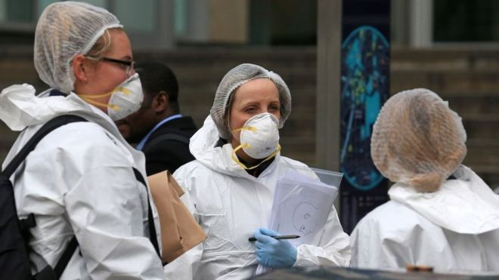Image copyright Getty Images

**In a perfect world, every crime would be solved and result in a just and proportionate penalty.**

However, in reality, most go unsolved and many are not even reported to police. So what is going on?

**Few crimes are solved**

In 2018-19, fewer than 8% of offences led to a suspect being charged or ordered to appear in court, and under 4% were dealt with outside court, by an on-the-spot fine, caution or community resolution, such as an apology or compensation.

When deciding if a suspect should be charged, police generally work with the Crown Prosecution Service (CPS), which prosecutes crimes in court on behalf of the state.

The two tests which must be met for the CPS to authorise charges are whether there is sufficient evidence for a realistic prospect of conviction and if a prosecution is in the public interest.

Charging rates - and overall detection levels - vary according to what type of crime it is.

Drugs offences are often discovered by the police through searches or raids, which is why charging rates are higher.

Most murders are detected because of the huge investigative effort that goes into solving them.

And the proportion of crimes that are "detected" - meaning they have been resolved in some way - has been falling continuously since 2015.

But offences such as robbery, where witnesses are needed, and sexual offences, which often revolve around the issue of consent, have far lower clear-up rates.

**Genuine increase in crime**

In England and Wales, we measure crime through the Crime Survey of England and Wales, and by counting offences that are reported to and recorded by police.

The Survey is seen as the better way of measuring long-term trends - its methods have remained consistent and it includes unreported offences.

Its results indicate an overall downward trend in offending over the past two decades, before stabilising in the past few years.

However, some crimes - such as murder, offences against businesses, and crimes against people aged under 16 - are not included in its main findings.

The Survey is also not regarded as being good at estimating less common crimes which cause the most harm, like stabbings and robbery.

Police data provides a more reliable measure of these crimes, which have shown a genuine increase.

Overall, the police figures [**show the number of offences logged by forces is up.**](https://www.bbc.co.uk/news/uk-50080236)

This is partly because more people feel comfortable approaching the police about under-reported crimes, such as sexual offences, and because police themselves are getting better at recording crime.

**Falling police numbers**

Police officers are central to the criminal justice system's smooth running as they:

* deal with crimes, disorder and anti-social behaviour
* help victims and identify suspects
* prepare cases for trial

The number of officers in the 43 England and Wales forces has fallen by about 20,000 since 2010, but the government is [**in the process of restoring those numbers**](https://www.bbc.co.uk/news/uk-49123319) by April 2023 in the most ambitious police recruitment drive in modern times.

There has also been a steep decline in the number of police community support officers and civilian staff, who provide vital back-up roles.

**Police officer numbers have fallen over past nine years**

Number of police officers, England and Wales

Source: Home Office, at March of each year

When officers are called to reports of a crime, they have several options, including resolving matters informally, issuing a warning, or making an arrest - which can lead to a charge.

But as officer numbers have dropped, arrests have gone down - for almost all crimes.

**Fewer prosecutions happening**

Detective work has been made more complex because of the mass of digital material from smartphones, computers and data storage devices.

A roughly 30% reduction in the CPS budget between 2011 and 2018 has also affected the volume of prosecutions and how quickly cases can be processed, though court success rates have improved.

Once a case goes to court, most crimes are dealt with by magistrates or district judges but serious offences are heard in the Crown Court, where defendants have the right to trial by jury.

Almost half of Magistrates Courts in England and Wales have been closed since 2010.

This is partly because of a government strategy to move some cases, such as low-level thefts and motoring offences, out of the court system, by extending the use of video links and virtual hearings conducted online.

**Fines most common punishment for crimes**

If a defendant admits the offence they are accused of, or is found guilty after a trial, a magistrate or judge will determine the most appropriate sanction.