01 Introduction to
Macroeconomics: Economic Toolkit
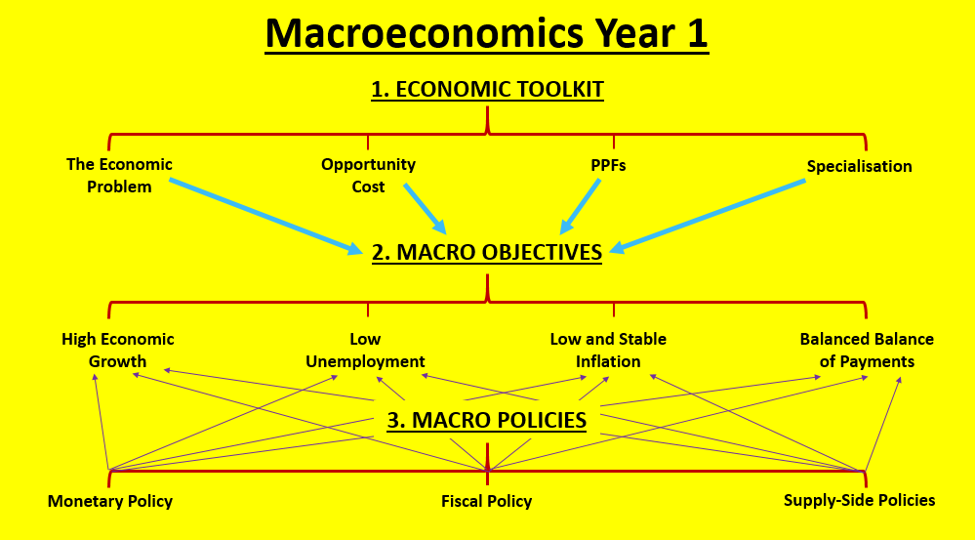

- What is Economics?
- Positive and Normative Statements
- Economics as a Social Science
- The Economic Problem
- Opportunity Cost
- Production Possibility Frontiers (PPFs)
- Specialisation and Division of Labour

a

What is Economics?

Microeconomics vs. Macroeconomics

There are two main strands of economics – microeconomics and macroeconomics. During A-Level Economics, Paper 1 examines ‘micro’, Paper 2 examines ‘macro’ and Paper 3 is a ‘synoptic assessment’ which combines the two.

Put simply, microeconomics is the study of individual markets, e.g. labour markets, whereas macroeconomics is the study of the entire economy as a whole e.g. studying the UK economy.

Activity: Decide whether the following events relate to MICRO or MACRO, write them below

- The price of oil falls due to an increase in supply caused by fracking in the US
- The rate of UK unemployment rises to 6%
- The UK increases the value of exports sold to India and China
- Energy price hikes impact the elderly adversely
- Average prices (inflation) have risen by 1% over the last year
- Annual house price growth in London falls to 8%
- The Chancellor of the Exchequer raises the top rate of income tax from 45% to 50%
- Another rise in the taxation on cigarettes

Micro | Macro

Extension: Add 2 events of your own to the MICRO and MACRO columns

b

Positive and Normative Statements

Positive Economics
Normative Economics

Involve facts, can be tested
Cannot be tested or verified

No need for a value judgement
Require a value judgement

Education spending increased by 10% last year
The Government should spend more on universities

Positive Statement | Statements that can be tested or rejected by referring to the available evidence and involve objective explanation.
Normative Statement | Statements that express a value judgement about what ought to be. They are subjective statements rather than objective statements
For example, statement 1 is positive whereas statement 2 is normative:
- A rise in consumer incomes will lead to a rise in the demand for new cars.
- The level of tax on cigarettes is too unfair and unfairly penalizes smokers.
Activity 1: i) In the space below, come up with your own example of one positive statement and one normative statement ii) test your learning partner!

Statement | Learning partners guess (positive/normative) | Correct/incorrect

Governments use value judgements to help make policy decisions

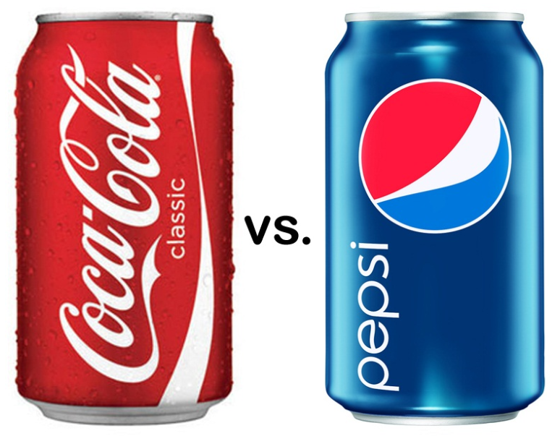

Activity 2: i) Coke v Pepsi - Which is better? Justify your choice below (there is no right or wrong answer)!

…………………………………………………………………………………………………………………

…………………………………………………………………………………………………………………

…………………………………………………………………………………………………………………

…………………………………………………………………………………………………………………

ii) Now EVALUATE to your argument (give balance by adding a different point of view)

However………………………………………………………………………………………………………

…………………………………………………………………………………………………………………

Governments have to make multiple decisions about the direction of economic policy. With such a wide range of decisions to make it is not possible for all these to be tested, if it is even possible to do so. Therefore policymakers have to use value judgements when constructing their policy decisions.

The political party in place could therefore make different policy decisions based on their own opinions and ideologies. In general Conservative governments have been more in favour of free markets and less Government intervention, whereas traditional (Old) Labour governments have a preference for state intervention and helping provide social protection for all.

Discussion: Different economists have different opinions. Discuss the following questions with your learning partner – what is your opinion? Does it vary from your partners?

- Should there be any tax placed on alcohol?
- Who should receive benefits from the Government? How much should they receive?
- Should Britain remain in the European Union?
- How much should the London Congestion Charge be and what area should it cover?
- Is it fair that footballers are paid more than nurses?
Notes Page


c

Economics as a Social Science

Unlike scientists, economists don’t have a laboratory in which they can conduct experiments that can be repeated under controlled conditions. As a result, economics involves a lot of normative statements, as opposed to positive statements that have been proved in a laboratory.

As you will see throughout your studies, people have different opinions (take Karl Marx and Milton Freidman, for example) which cause different schools of economic thought. Often, there is not one correct answer, but a whole range of options. As economists can’t run experiments in controlled conditions, economists make ‘models’ of the world based on assumptions that are made. Let’s consider a couple of situations….

Scenario A

A child day care center that is troubled by parents often arriving late to pick up their children. The day care center decided to introduce fines for parents who arrived late to collect their infants. In your own words, EXPLAIN what you think the ‘logically correct’ outcome of this policy would be.

Your Thoughts | Actual Outcome

Scenario B

Britain’s decision to leave the EU prompted an economic recession that has resulted in wage rates for part-time workers being slashed and a rise in the number of people who are unemployed. Will part-time workers now want to work more or less in response to the fall in their wage rate? EXPLAIN your answer.

Your Thoughts | Actual Outcome

d

The Economic Problem

The world has a limited number of resources (known as factors of production). These are classified as:

Activity 1: Complete the table below:
Factor of Production | Picture | Definition

Resources can also be classified as renewable and non-renewable:
- Non-Renewable Resources: are resources that will never be replaced once they are used e.g. coal, oil, copper
- Renewable Resources: are resources which can be used and replaced
e.g. solar power (the Sun), wind power (wind)

The Economic Problem

Although there are different types of economics (micro and macro) they are all trying to solve one thing. Governments, firms and consumers all suffer from the economic problem.

The Economic Problem = Needs, Wants & Scarcity
Task: write a list of 5 needs and 5 wants on the next page – what is the difference between them?

People have an unlimited number of wants (CDs, healthcare, houses, swimming pools etc.) and given there is only limited resources (factors of production) we cannot fulfil all these wants.

There are literally not enough resources in the economy to make all the goods and services we desire; this problem is called scarcity.

Activity 2: Describe the economic problem in 10 words max (use as few as possible)!
Notes Page

e

Opportunity Cost

Opportunity Cost

Make a Choice

Look at the following list of choices. Highlight the option you want and say what you gave up in each case.

Choice one | Choice two | Gave up (opportunity cost)
A night out with your friends | Visiting your grandmother on her birthday
Fund 10 patients to have dialysis for one year | Fund 1 patient to have a kidney transplant (expected to live 10 yrs)
Cut the top rate of income tax from 45% to 40% | Re-introduce EMA for all students whose parents have a joint income of £30,000 or less
Spend £2000 on a family holiday | Spend £2000 on a new roof

Due to scarcity in the economy we all have to make choices:
- Governments only have certain tax revenue to spend on the economy – should they spend on healthcare or defence?
- Firms only have a certain amount of finance with which to invest – should they buy a new factory to expand production or spend money researching new products?
- Consumers only have a certain amount of income with which to spend/save – should they spend on TV or save for a holiday?

Whenever choices are made there is always a cost of the alternative we gave up, this is called opportunity cost. More specifically the opportunity is the value of the second best alternative that cannot now be chosen.

Most goods are scarce and have an opportunity cost; these goods are called economic goods. Scarce resources are limited in supply and therefore choice need to be made about their use. However, some have no opportunity cost and these are called free goods; such as the air we breathe (unless we pollute it significantly).

- Example of an economic good:

- Example of a free good:

The Allocation of Resources

Economics is the study of how resources should be allocated – what choices should be made. More specifically any economy has to answer three questions:

- WHAT goods & services should be produced and in what quantity?
- HOW is the production of these going to be organised?
- FOR WHOM are the goods and services produced for?

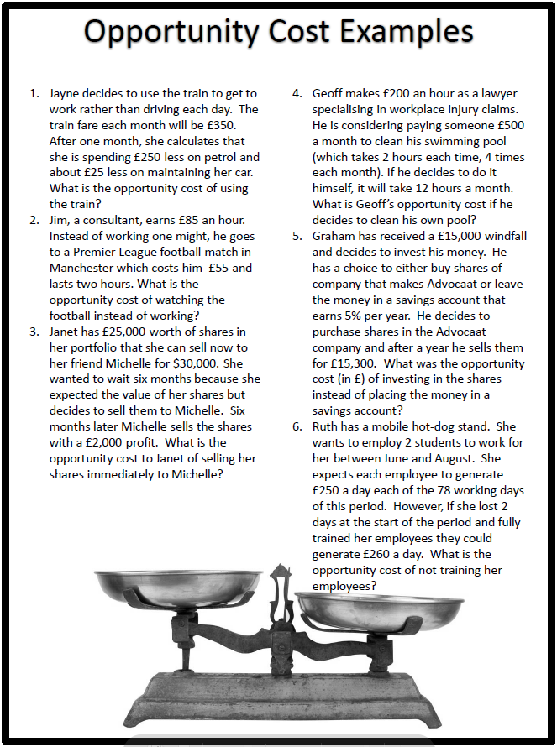

Notes Page

f

Production Possibility Frontiers

1. What are PPFs?

Production Possibility Frontier (PPF) | A PPF shows the…

N.B. This definition is very important and fairly detailed but all elements are important in order to get full marks for a definition in the exam.

2. The Production Possibility Frontier showing Efficiency / Inefficiency

C
K

- Activity 1: Mark on this PPF (showing the trade-off between producing consumer goods (C) and capital goods (K)), the following points:
A: an efficient allocation but producing only consumption goods
B: an efficient allocation but producing only capital goods
C: a different efficient allocation
D: an inefficient allocation with unemployed resources
E: an unfeasible allocation
F: an allocation that will benefit living standards in the long-run

3. The Production Possibility Frontier and Opportunity Cost

- When an allocation is inside the PPF there is no opportunity cost involved as there are unemployed resources which were previously not in use (and produce more of both goods).
- However, when an economy is operating efficiently on the frontier there are opportunity costs involved.

An example:

23
19
Q: An economy currently produces point A 11 cows and 23 tonnes of wheat (point A). What is the opportunity cost of producing 3 more cows?

A:

A
B

The Shape of the PPF and Opportunity Cost

- If the PPF were to be a straight line then the opportunity cost will be the same along the length of the line (like the diagram below).
- However, if the PPF is not a straight line and is ‘concave’ then the opportunity cost will vary (like the diagram above). The nearer to the extremes, the higher the opportunity cost.
Good X
40

Here the opportunity cost is constant
For every ‘Good Y’ that is produced, two ‘Good X’s need to be given up.

Good Y
20
0

- Challenge: Why is that the PPF curved and not straight?

………………………………………………………………………………………………………………………………………………………………………………………………………………………………………………………………………………………………………………………………………………………………………………………
4. Shifts in the Production Possibility Frontier & Economic Growth
- If the PPF shifts outwards then this shows an increase in the productive potential of the economy a.k.a. economic growth
- Economic growth means that the economy has grown in size in terms of what it can produce i.e. its productive potential has increased.
- Economic growth occurs if there is an increase in the quantity or quality of an economy’s factors of production (land, labour, capital and enterprise)
- PPFs can also shift inwards if there is a reduction in the quantity or quality of factors of production e.g. natural disasters.

Task: i) Illustrate economic growth on a PPF and ii) explain reasons why this may have occurred (you may want to do this on the notes page 15)

Cause of Growth | Impact on Factors of Production | Any downsides?
1. Spending on Education

2. Spending on Healthcare |  | Taxes may have to rise to pay for the increase in spending on healthcare.
3. Investment in capital goods by firms

4. Population increases | Causes an increase in the amount of labour and enterprise in the economy meaning that the economy has a larger ‘productive capacity’.

5. Movement along the PPF
- As we have just seen the PPF can shift outwards illustrating economic growth and can also shift inwards when resources in an economy are depleted e.g. through natural disasters.
- However, in order to move along the PPF there is no need for a change in the amount of resources (or factors of production).
- Instead, there is just a need for a reallocation of resource, with resources put to different resources. Governments or policymakers may reallocate resources to try and increase the welfare of citizens by meeting their needs more precisely.
- Remember, there will be an opportunity cost associated with any movement along the PPF.
Notes Page
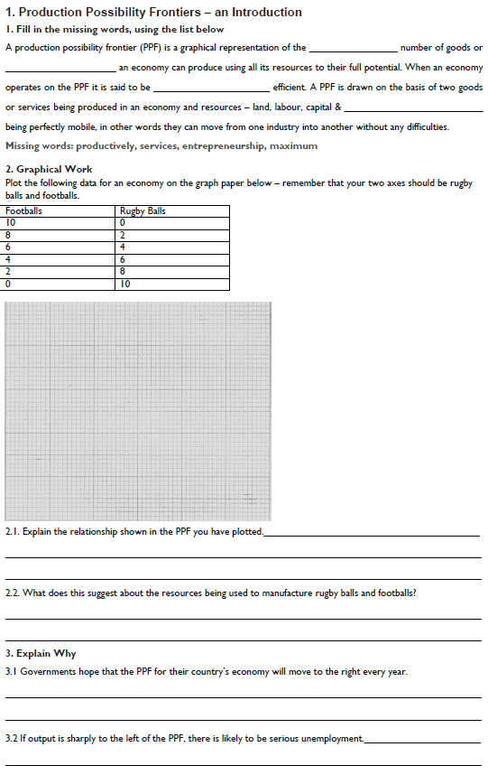
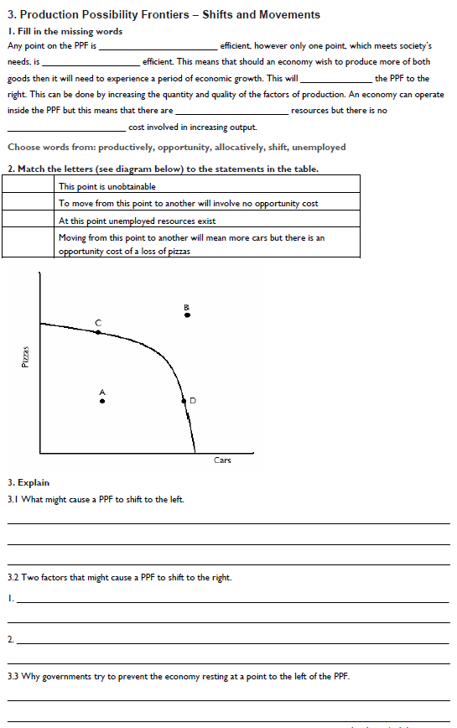

g

Specialisation & Division of Labour

Introduction

Everyday peope specialise in what they do best, Harry Kane plays for Totenham Hotspur whilst Boris Johnson runs the country. This seems a sensible idea and indeed is beneficial for the economy as resources (in this case labour) are being used effectively.

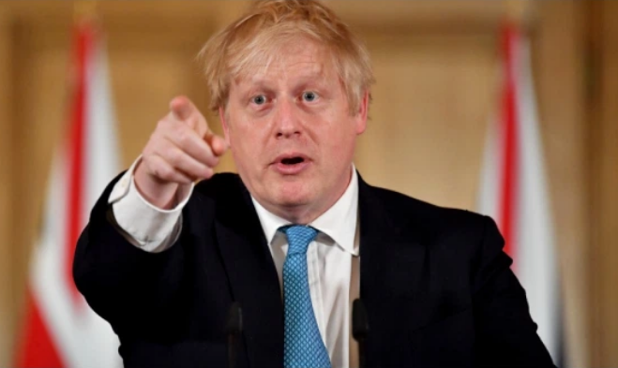
?

Point to Ponder

What if the roles were reversed?! Why would this be inefficient for the economy and the future success of England and Totenham Hotspur?

Specialisation
Division of Labour
Production

Labour Productivity

Specialisation makes economic sense as individuals, firms and economies are doing activities that they have an advantage in. This should mean that productivity increases due to the use of specialists and hopefully an increase in overall production. However, there is increased risk by economic agents specialising rather than diversifying. For example, an economy specialising in commodities will suffer if the market for commodities takes a downturn or a worker over-specialised in one type of work, which may no longer be needed in an economy.

Specialisation has been used to increase the efficiency of the production process; this is called division of labour. This idea was described by the grandfather of economics, Adam Smith when he described the benefits of division of labour at a pin factory.

Division of Labour Activity: Making Boxes!

- Round 1: No groups can specialise, expect team A!

Team | Amount of workers | Total output | Labour productivity
A
B
C
D

- What were the resources used in production?

Land
Labour
Capital
Enterprise

- Round 2: All teams can specialise!

Team | Amount of workers | Total output | Labour productivity
A
B
C
D

Notes Page
Benefits and Drawbacks of Specialisation

Activity: From the notes you made during the division of labour activity, create a mind-map to EXPLAIN the benefits and drawbacks of specialisation. You may wish to colour coordinate!

Division of Labour: Benefits and Drawbacks


Specialisation

These advantages and disadvantages could apply to other forms of specialisation, not just division of labour. For example, the UK specialising in financial services would hopefully allow higher productivity from specialising in one area and hopefully higher economic growth & living standards. However, they would face problems if demand for financial services fell and there is a chance of unemployment if this occurred.

The same arguments hold true for firms specialising in one product area rather than diversifying their product range. The firm should become more proficient at producing their product over time, therefore lowering costs and increasing profits. However, if demand falls for this product, the firm will see profits fall and could go out of business.
Extension 1: Henry Ford’s Model T
Watch the video clip about Ford’s Model T & answer the following questions
http://www.youtube.com/watch?v=RK-gVb5wKO0&feature=related

1. What happened to the price/cost of a car before and after Ford introduced his new working methods?

2. How did Ford operate his factories and organise his workers?

3. To what extent do you think that Ford’s ideas are still used in modern car production?

Extension 2: Adam Smith’s Pin Factory

To take an example, therefore, from a very trifling manufacture; but one in which the division of labour has been very often taken notice of, the trade of the pin-maker; a workman not educated to this business (which the division of labour has rendered a distinct trade), nor acquainted with the use of the machinery employed in it (to the invention of which the same division of labour has probably given occasion), could scarce, perhaps, with his utmost industry, make one pin in a day, and certainly could not make twenty. But in the way in which this business is now carried on, not only the whole work is a peculiar trade, but it is divided into a number of branches, of which the greater part are likewise peculiar trades. One man draws out the wire, another straights it, a third cuts it, a fourth points it, a fifth grinds it at the top for receiving the head; to make the head requires two or three distinct operations; to put it on, is a peculiar business, to whiten the pins is another; it is even a trade by itself to put them into the paper; and the important business of making a pin is, in this manner, divided into about eighteen distinct operations, which, in some manufactories, are all performed by distinct hands, though in others the same man will sometimes perform two or three of them.
I have seen a small manufactory of this kind where ten men only were employed, and where some of them consequently performed two or three distinct operations. But though they were very poor, and therefore but indifferently accommodated with the necessary machinery, they could, when they exerted themselves, make among them about twelve pounds of pins in a day. There are in a pound upwards of four thousand pins of a middling size. Those ten persons, therefore, could make among them upwards of forty-eight thousand pins in a day. Each person, therefore, making a tenth part of forty-eight thousand pins, might be considered as making four thousand eight hundred pins in a day. But if they had all wrought separately and independently, and without any of them having been educated to this peculiar business, they certainly could not each of them have made twenty, perhaps not one pin in a day; that is, certainly, not the two hundred and fortieth, perhaps not the four thousand eight hundredth part of what they are at present capable of performing, in consequence of a proper division and combination of their different operations.
Extract from Adam Smith, the Wealth of Nations

Extension Task: This is an extract from Smith’s famous pin factory example. In your own words explain Adam Smith’s method for increasing the production of pins. Would this work in the modern day?

Tick list of tasks you must complete to finish this module:
Do you understand Introduction to Macro? |  |  | ✓
Economic Problem Scarcity and Opportunity Cost
Can you explain the basic economic problem
List the three main economic agents
Understand the role of the three main economic agents and their incentives
Explain the term opportunity cost and the importance of choice in Economics
Use a PPF diagram to explain opportunity cost
Economic resources & the environment as a scarce resource
Define and categorise Economic Resources - the factors of production
Understand the rewards given to each of the factors of production
Understand why Economics is a social Science
Understand that Economics involves the study of society and the manner in which economic agents behave and influence the world around them.
You should be able to identify features of positive and normative statements
Production possibility curves and Economic efficiency
Understand what production possibility diagrams show and how they can be used
Confident Drawing and describing Production Possibility Diagrams
Confident Using PPF’s to show the maximum amount of goods and services an economy can produce given their set of resources
Confident Using PPF’s to show when resources are being allocated efficiently.
You should be able to understand the basis on which production possibility curves
are drawn, the significance of points inside, on and outside the boundary, plus their application
Students should also appreciate that not all points on the PPF are allocatively
efficient.
Specialisation and division of labour:
Understand what is meant by the term productivity and the importance of specialisation
Define and explain specialisation and the division of Labour
You should be able to demonstrate the advantages and disadvantages of the Division Of Labour and Specialisation
Understand the advantages of increased productivity and productive efficiency
Illustrate productive efficiency on relevant PPF diagrams
Help can be found in the following places … ?:
Read pages and answered the “mastered this topic questions” on Godalming Online
Watched recommended videos from Godalming online
Attended a support session in rm 206 (Mon, Wed and Fri 1300)

Read economics related news, and find articles on Demand, Supply & Equilibrium

