**Film Studies yr1**

Mise en Scene task

15mins

*The below answers need to be from films of your choice*. Individually or in pairs. Given an example of:

1. A symbolic or relevant prop.
2. 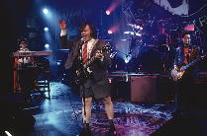A character making a symbolic / relevant costume change
3. 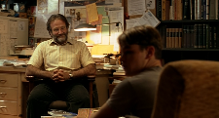A location that a character regularly inhabits- informs the audience something ‘about that character’
4. 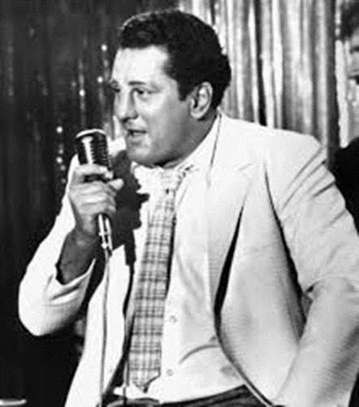A role an actor took on where he or she seemed to ‘embody’ the character.
5. Finally, a film with an overall ‘noteworthy look’.

