

**History: Democracy and Dictators**

**OCR Y318: Russia and its Rulers 1855-1964**

NAME:

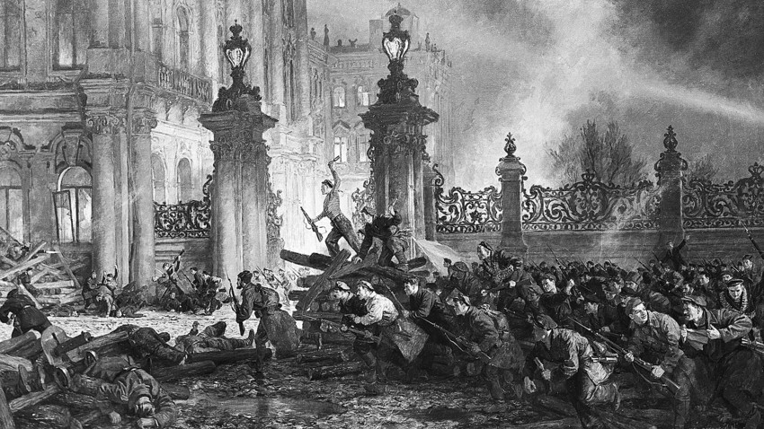**Introductory Booklet**

**Exam Board Content:**

This booklet covers the **key ideologies of autocracy, dictatorship and totalitarianism**, as well as providing you **an overview of the century** and introduction to Russia.

**Recommended reading:**

**Textbooks:**

* Andrew Holland, *Russia and its Rulers 1855-1964* (OCR textbook)
* Andrew Holland, *Russia and its Rulers 1855-1964* (My Revision Notes series – OCR revision booklet)
* Mike Wells and Nick Fellows, *Russia and its Rulers 1855-1964* (old OCR textbook – Heinemann series)

**History Today Articles:** ([www.historytoday.com](http://www.historytoday.com), login using username = godalming, password = history)

* John Etty, ‘Russia’s Climate and Geography’
* Daniel Beer, ‘Russia’s Managed Democracy’

**Books:**

* Lee, Stephen, *Russia and the USSR, 1855-1991*, chapter 1.

**An Introduction to Russia**

**Task:** Read the article below (from <https://www.politico.eu/article/vladimir-putin-russia-20-years-on-anniversary/>, 31 December 2019) and answer the questions that follow.

Updated 1/2/20, 4:51 AM CET

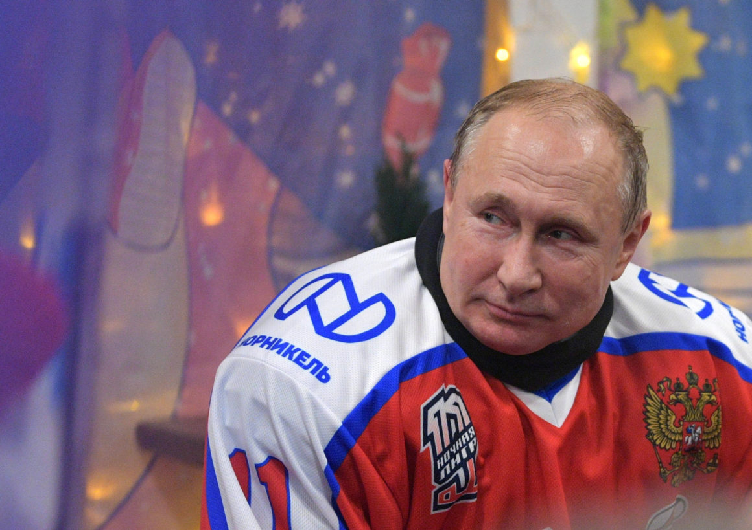

Russian President Vladimir Putin | Pool photo by Michael Klimentyev/EPA

MOSCOW — Boris Yeltsin had a reputation for the sensational and the unpredictable, from ordering tanks to shell a rebellious Russian parliament to [drunkenly hunting for pizza](https://www.history.com/news/bill-clinton-boris-yeltsin-drunk-1994-russian-state-visit) in Washington in his underwear. But he saved arguably his biggest surprise for last.

Twenty years ago this New Year’s Eve, with six months to go until the end of his final term, an ailing Yeltsin addressed Russia in a special noontime broadcast. “I am leaving. I have done all I could,” he said, his words slurred by ill health and alcohol abuse. “A new generation is coming. They can do more, and better.”

Later that night, as the Kremlin clock ticked down the final minutes of the 1990s, a dour-faced representative of that “new generation” appeared before the nation as Russia’s acting president.

“Like you, I intended this evening to listen to the New Year greetings of President Boris Yeltsin,” said Vladimir Putin, the former state security service chief who had been named prime minister just four months earlier. “But things turned out otherwise.”

**Life under Yeltsin had been a mixture of the surreal and the grotesque.** The Communist ideology that had dominated life for seven decades had been tossed onto history’s garbage dump, leaving Russians to adapt to a strange new beast called capitalism. It was a task many were simply not up to: Suicides rose, life savings were lost in wild pyramid schemes, and crime rocketed. State employees often went unpaid for months…

Putin knew what his fellow citizens craved. “Russians have had no sense of stability for the past 10 years," he told state television ahead of March 2000 presidential elections. “We hope to return this feeling.”

Over the next eight years, aided by rocketing prices for oil — Russia’s main export — Putin set about doing just that. By May 2008, toward the end of his second term in office, salaries were not only being paid on time, but they were higher than ever. The streets of major cities began to fill with advertisements for easy loans, and people long accustomed to frugality suddenly found they could afford foreign holidays, new cars and plasma-screen TVs.

Although political freedoms were being curtailed, independent media strangled, and money that should have been used to build up vital infrastructure simply siphoned out of the country, many Russians stayed silent. After all, it seemed churlish to complain about such things when you could spend two weeks a year at a Turkish Black Sea resort and then come back to your new home entertainment center…

* * *

**It was toward the end of his second term that the sale of Putin memorabilia** went overboard — shops were suddenly full of clocks, mugs and even wall rugs bearing his image. “Who buys a Putin wall rug?" I asked a woman at a market stall near Moscow. “Usually office workers, for their bosses,” she said.

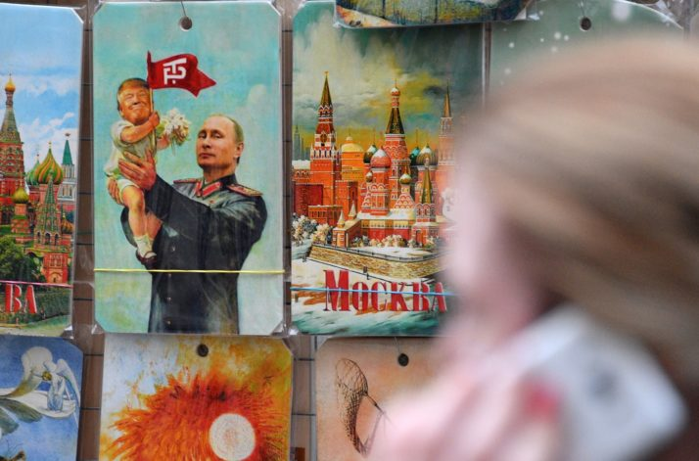

Vladimir Putin memorabilia on sale in Moscow | Mladen Antonov/AFP via Getty Images

“I want a man like Putin, full of strength / I want a man like Putin, who doesn’t drink / I want a man like Putin, who won’t offend me / I want a man like Putin, who won’t run away,” went the lyrics to an [infectious hit](https://www.pbs.org/soundtracks/stories/putin/) by a female pop duo. It was just the first of a number of pop and rap songs to eulogize the Kremlin strongman.

It became increasingly hard to escape Putinmania. On a trip to Tobolsk, in western Siberia, I met Minsalim, a wild-haired shaman who made a living by carving ornaments from mammoth tusks. The centerpiece of his collection was a tiny sculpture of Russia’s steely-eyed leader. “Putin saved Russia — like a Siberian hero of old,” Minsalim said.

In 2008, [Russia’s military defeated neighboring Georgia](https://edition.cnn.com/2014/03/13/world/europe/2008-georgia-russia-conflict/index.html) in a five-day war over the breakaway republic of South Ossetia. “Putin’s Plan for Russia is Victory!” read the propaganda posters in the months before fighting broke out, and for many Russians the military triumph in the South Caucasus was proof that the “national leader” was a man who kept his promises. His approval ratings soared to over 80 percent.

* * *

**Putin’s hold over Russian politics** throughout the 2000s was absolute. But as his second term of office hit the midway point, he had to make perhaps the most important decision of his presidency. The Russian constitution stated clearly that no president could serve more than two “consecutive” terms. But Putin had no plans to surrender power.

In May 2008, Putin shifted to the post of prime minister while [Dmitry Medvedev](https://www.politico.eu/article/how-do-you-solve-a-problem-like-dmitry-medvedev-vladimir-putin-russia/), his former election campaign manager, became president. For a short time, Medvedev, who portrayed himself as a reformer, was championed by Russia’s liberals, who were encouraged by his memorable, if clumsy, slogan: “Freedom is better than non-freedom.” In 2010, Medvedev enjoyed approval ratings that rivaled Putin’s.

As part of Medvedev’s much-heralded program of “modernization,” the Kremlin oversaw the reinvention of RIA Novosti, a state news agency, as a modern, censorship-free media outlet… This was no Kremlin propaganda outfit — RIA Novosti had total editorial independence and I spent my days interviewing opposition figures and listening to allegations of high-level corruption.

Yet despite Medvedev’s tentative reforms, no one was any under illusions as to who was pulling the most important strings. As Medvedev’s sole term drew to an end, he admitted that he would like to seek reelection, but the decision wasn’t entirely up to him… Instead, Putin made a return to the presidency in May 2012 for a third term. Once safely reinstalled in the Kremlin, Putin set about rolling back Medvedev’s meager reforms. In 2013, RIA Novosti was dismantled and the agency’s boss, Svetlana Mironyuk, dismissed…

* * *

**The Kremlin’s seizure of Crimea from Ukraine in March 2014** triggered an outbreak of aggressive nationalism. Putin, in a keynote speech, accused opposition politicians of being “national traitors,” a term that his critics noted had once been used by Adolf Hitler.

Suddenly, everyone in Russia wanted to talk politics. It became increasingly difficult to avoid getting sucked into heated discussions about the “fascist junta” in Ukraine — as Russian state media had taken to calling the new pro-Western government in Kyiv…

This atmosphere of unbridled nationalism was encapsulated perfectly by the [Night Wolves](https://www.politico.eu/article/putin-rap-and-night-wolves-russia-marks-5-years-in-crimea/), a motorcycle gang that received around €1 million in state funds to promote anti-Western ideas and “traditional” Russian values… The same year, Russian state television aired a 15-minute program extolling the virtues of life in North Korea…

* * *

**The anniversary of Putin’s second decade in power** has been accompanied by a tangible cooling of Russia’s passion for the ex-KGB officer… In May, Putin’s trust ratings fell to a 13-year low of just 31 percent as discontent simmered over an increase to the pension age, widespread poverty and relentless allegations of corruption against the political elite. Putin came to power promising stability, but his foes are increasingly drawing comparisons with Yeltsin’s “wild” 1990s.

In my trips across Russia, far fewer people seem willing to praise Putin and his policies. Instead, anger and disappointment are much more common… This year has also seen a dramatic uptick in protests over issues ranging from election fraud to [toxic garbage dumps](https://www.politico.eu/article/vladimir-putin-garbage-problem-russia-landfills/). The authorities are apparently so nervous that in September they deployed around a dozen armed officers to arrest a [Siberian shaman](https://www.politico.eu/article/alexander-gabyshev-anti-putin-shaman-warrior-who-spooked-the-kremlin/) who had vowed to magically expel Putin from office.

State-sponsored commemorations of the anniversary of Putin’s ascent to the presidency have been low-key. Indeed, state media has barely mentioned that it is now 20 years since Yeltsin handed over the keys to the Kremlin… Speculation has already begun that Putin is seeking to engineer a way to remain in power. Heading a Union State with neighboring Belarus could be one option, as could another stint as prime minister.

1. What characterised the Yeltsin years in Russia following the collapse of the Soviet Union and the introduction of capitalism?
2. What were the pros and cons of life in Russia during Putin’s first two terms in office?
3. Give some examples of ‘Putinmania’.
4. What examples are there of reform under Medvedev, and how did Putin roll these back at the beginning of his third term as president?
5. What evidence is there that Putin’s popularity is waning, and why?
6. Go to <https://www.theguardian.com/world/gallery/2019/aug/09/vladimir-putin-20-years-in-power-in-pictures> and scroll through the images on Putin. What type of image of Putin is being projected through the photographs? What might this tell you about Russian politics?

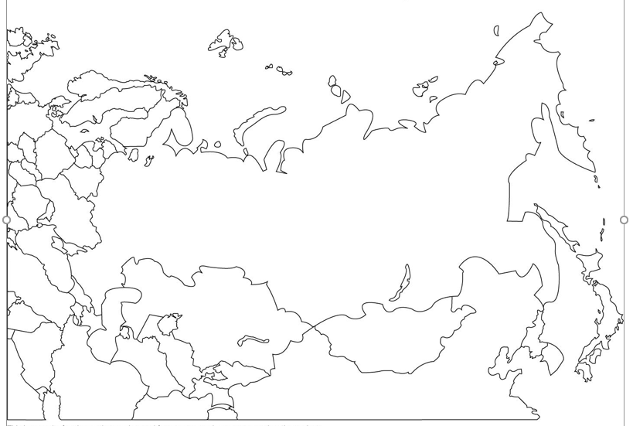

**Task:** Do some research into Russia’s geography then mark on the map on the previous p.6:

**The following cities:**

* Moscow
* St Petersburg
* Yekaterinburg
* Vladivostock
* Kiev
* Nizhny Novgorod
* Volgograd (was Stalingrad)
* Minsk

**The following geographical features:**

* The Ural Mountains
* Lake Baikal
* Volga river
* Caspian Sea
* Black Sea

**The following countries/regions:**

* Mongolia
* Kazakhstan
* Turkmenistan
* The Caucasus
* Ukraine
* Belarus
* Finland
* Baltic Republics
* Crimea

At the height of its power, the Russian Empire was the third-largest in history, and stretched across three continents (Europe, Asia and North America). The USSR (Soviet Union) consisted of the present-day countries of Russia, Georgia, Ukraine, Moldova, Belarus, Armenia, Azerbaijan, Kazakhstan, Uzbekistan, Turkmenistan, Kyrgyzstan and Tajikistan and occupied the Baltic States.

**What would be the challenges of governing an area such as this?**

**Timeline of Russian History 1855-1964**

**Task:** Research the events below and record them on the timeline.

Abdication of Nicholas II & formation of Provisional Government, Witte’s ‘Great Spurt’, De-Stalinisation, Social Democratic Workers’ Party formed, End of WW2 - Yalta and Potsdam Conferences, Death of Alexander III, Nicholas II became tsar, The Winter War, Khrushchev removed from power, New Economic Plan established, First Duma set up & Fundamental Laws passed, 1905 Revolution, Alexander II became tsar, February Revolution, October Revolution, Polish Revolt, First Five-Year Plan, Death of Stalin, Nazi-Soviet Pact, Assassination of Alexander II, Russian Civil War, The Emancipation Edict, Beginnings of Collectivisation, Treaty of Brest-Litovsk & end of WW1, Stalin controlled Party Congress and expelled main rivals, Beginning of Cold War, Crimean War, Invasion of the USSR by Nazi Germany, Great Terror, Outbreak of WW1, Russo-Japanese War, War Communism, Russian invasion of Hungary, Death of Lenin, Ukrainian famine (Holodomor)

|  |  |  |
| --- | --- | --- |
| **Year** | **Event** | **Notes** |
| **1853-56** |  |  |
| **1855** |  |  |
| **1861** |  |  |
| **1863** |  |  |
| **1881** |  |  |
| **1892-3** |  |  |
| **1894** |  |  |
| **1898** |  |  |
| **1904-5** |  |  |
| **1905** |  |  |
| **1906** |  |  |
| **1914** |  |  |
| **1917** |  |  |
| **1917-1921** |  |  |
| **1918** |  |  |
| **1921** |  |  |
| **1924** |  |  |
| **1927** |  |  |
| **1928-32** |  |  |
| **1929** |  |  |
| **1932-34** |  |  |
| **1936-38** |  |  |
| **1939** |  |  |
| **1939-40** |  |  |
| **1941** |  |  |
| **1945** |  |  |
| **1947** |  |  |
| **1953** |  |  |
| **1953-56** |  |  |
| **1956** |  |  |
| **1964** |  |  |

**Task:**  You will study four themes on the Russia course. They are:

* The Nature of Government
* The economy and society
* The impact of war and revolution
* The experience of Russia’s minorities

Colour-code the events on the timeline according to the four themes above.

**The Tsarist and Communist leaders, 1855-1964**

**Task:** In small groups research one of the following Russian leaders in the period we are studying. Produce a Powerpoint presentation no more than 4 slides long which covers: their background and suitability to govern, the dates of the period they ruled, the key events of their rule, challenges faced during their time in power, some of their key domestic policies whilst in office, how they fell from power. *P.5-9 of the Holland textbook would be a good starting point for your research.*

|  |  |
| --- | --- |
| **Alexander II**  Image result for alexander II |  |
| **Alexander III**  Image result for alexander III |  |
| **Nicholas II**  Image result for nicholas II |  |
| **Vladimir Lenin**  Image result for lenin |  |
| **Joseph Stalin**  Image result for stalin |  |
| **Nikita Khrushchev**  Image result for khrushchev |  |

**Task:** Use the research above, along with Wells and Fellows (p.8-11). Which one of the rulers between 1855 and 1964 was best prepared, both by their experiences before taking power and by their abilities, to rule Russia?

1. Consider what experience and qualities would have been important.
2. Break these down into distinct factors – experience of government, education etc.
3. Award each of the rulers a mark between one and five for each factor.
4. Make a judgement i.e. decide who would gain the highest marks overall.
5. Explain briefly why the ruler of your choice could be seen as the best qualified /strongest of the rulers between 1855 and 1964 on the basis of the criteria chosen.

**Ideologies: Autocracy, Dictatorship and Totalitarianism**

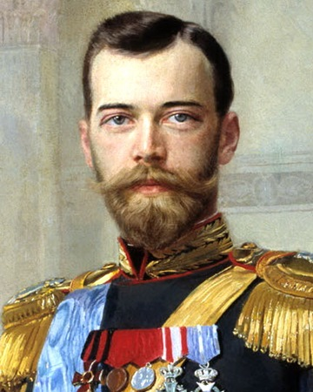

**1855-1917: Autocracy**

From 1855 to 1917, Russia was governed as an **autocracy.** Tsars had **absolute power** which was said to be ordained by God. All Russians had to obey the will of the tsar or suffer punishment. There were 3 strands to tsarist autocracy, according to the historian J.N. Westwood:

* The tsar expected ‘willing and total submission of his subjects’. The tsar was not required to be accountable to the people through elections.
* The tsar had a paternalistic duty to protect his subjects and was supported in this role by the **Russian Orthodox Church.**
* Autocracy was seen as a practical necessity given the vastness and diversity of the Russian Empire. **Liberal democracy and constitutional government were seen as being potentially disastrous** for Russia because it would have led to too many people demanding different policies.

**Task 1:** Use the factfile on p.12 of Holland to take a few notes on who Konstantin **Pobedonostsev** was and what he stood for.

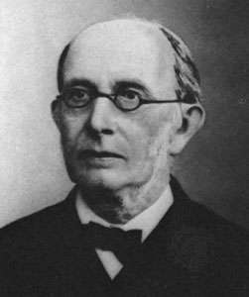

**Task 2:** Use the information on p.11-14 of Holland to create a summary of the different attitudes towards autocracy from the different Tsars in our period. In one colour highlight any evidence of **change** in the attitude of the tsars towards autocracy, and in a second colour highlight any evidence of **continuity** in their attitudes.

**Nicholas I (1825-1855)**

**Alexander II (1855-1881)**

**Alexander III (1881-1894)**

**Nicholas II (1894-1917)**

**Key Question:** How accurate is it to say that all the tsars of this period were motivated by an unwavering belief in autocracy?

**1917-1928: Dictatorship and Marxism-Leninism**

**Dictatorship** means absolute rule, usually by one person, with no legal, political, economic or social restrictions. The Russian concept of dictatorship was partly derived from the writings of **Karl Marx and Friedrich Engels**, whose ideas had begun to take root within the Russian intelligentsia by the 1880s.

The Marxist theory of revolution

Marxism-Leninism

A problem for Russian radicals was that Russia did not ‘fit’ the Marxist theory of revolution, in the sense that Marx predicted that the revolution would occur in advanced industrialised nations such as Germany and Britain. Russia was largely rural and ‘backward’ and therefore, according to Marx, not the sort of place where revolution would happen.

Lenin **interpreted the works of Marx** in his 1902 pamphlet *What is to be Done?* He argued:

* A **vanguard party** of dedicated revolutionaries would spread Marxist political ideas among the workers to **‘speed up’** the revolutionary process.
* A **Party Central Committee** could govern in the interest of workers until the latter were ready to take control themselves – this was Lenin’s interpretation of the ‘dictatorship of the proletariat’.

Essentially, Lenin argued that Marx’s theory of worker control of the means of production, distribution and exchange could be speeded up.

**Task 3:** Use p.15 of Holland (the ‘key terms’ box) to add to your glossary at the end of the booklet. Try to phrase your definitions in your own words.

**Task 4:** Use Holland p.16-18 to answer these questions.

1. Why did Lenin think that Marxism would be impossible in Russia? What experiences at the end of the nineteenth century had shown him this?
2. What was Lenin’s interpretation of the dictatorship of the proletariat and how did it affect the RSDLP (the Russian Social Democratic Workers’ Party, formed in 1898 – the Russian Marxists)?
3. What evidence was there of continuing ideological debates within the Bolshevik Party after the 1917 Revolution?

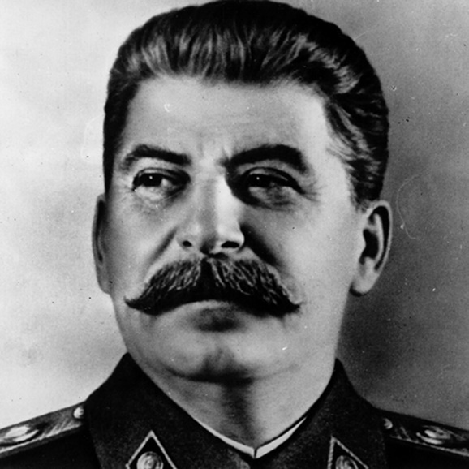**1928-1953: Totalitarianism**

After Lenin’s death in 1924, a power struggle ensued within Russia. By 1927, it was Stalin who had emerged victorious. Stalin’s years in power were ones of **totalitarianism**: the USSR was a centralised form of dictatorial government that controlled every aspect of the behaviour of the citizens of the state.

***Marxism-Leninism-Stalinism*** refers to Stalin’s version of Marxism-Leninism and consisted of:

* A **command economy** centred on **Five-Year Plans**, which would set production targets for Soviet industry, and **collectivisation** of agriculture. This was rooted in his belief that the ‘base’ of society could only be permanently changed by utilising a particular type of ‘superstructure’.
* A personalised form of control in the form of a dictatorship centred on a **cult of personality.** This was rooted in his belief that that the ‘superstructure’ had to be highly personalised in order to prevent damaging infighting.

Historians have explained this shift from a Lenin-style dictatorship to totalitarianism in a number of different ways:

* Some suggest that Stalin’s ideas, particularly about the economy, provided a **practical solution** to the Soviet Union’s problems.
* Some believe that Stalin manipulated Marxism-Leninism to suit his own **megalomania**, as evidenced by the cult of personality.
* Some suggest that Stalin was **continuing the work of Lenin** – who had already reinterpreted Marxism by establishing the Party Central Committee and the Cheka (secret police).

Whatever the reason for the move towards a totalitarian state, the result was repression and terror on a scale that was unprecedented in Russia.

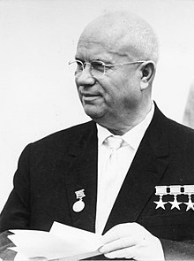

**1956-1964: Khrushchev and De-Stalinisation**

Following Stalin’s death in 1953 a further power struggle ensued between four rivals: **Malenkov, Beria, Khrushchev** and **Voroshilov**. Divisions between the four men over Russia’s future meant that collective leadership became impossible. Khrushchev was to emerge victorious, and he embarked on a process of **‘de-Stalinisation’**, initiated at the Twentieth Party Congress in 1956 in the so-called **‘Secret Speech’**. Khrushchev made the following criticisms of Stalin:

* He had never been accepted by Lenin as a potential leader.
* He had created a state that was unprepared for military conflict in 1941.
* He had committed a range of unforgivable crimes against his people.
* He had committed misdemeanours against ‘outsiders; who should have been embraced by the Soviet leadership.

Consequently, de-Stalinisation led to: the **release of political prisoners from labour camps** (the Gulags); a **relaxation of censorship**, including the publication of literature that had criticised Stalin by writers such as Pasternak and Solzhenitsyn; and the **erosion of the legacy of the cult of personality** (for example, Stalingrad was renamed Volgograd and Stalin’s body was removed from the Lenin mausoleum).

It is important to recognise that despite the moves towards de-Stalinisation, Khrushchev still removed rebellious politicians at will, and used physical force when necessary to maintain Soviet power (for example, tanks were sent in to Hungary in 1956 to crush rebellion). Therefore, like the ‘reformist’ Alexander II, Khrushchev also **did not intend to move too far from authoritarian rule**. The one-party, one-leader state was to remain intact.

**Autocracy, Dictatorship and Totalitarianism: Summary and Comparison**

Read the statements below and decide where they fit in to the Venn diagram. Add the number of the statement into the relevant space.

1. Belief in the need for absolute control.
2. Justification for rule was based on divine right (God’s will).
3. Saw representative government as a threat because it diluted absolute power.
4. Upheld by the cult of the personality and command economy.
5. Based on the Marxist theory of revolution.
6. Associated with the ideas of Konstantin Pobedonostsev.
7. Used repression to maintain control.
8. Saw representative government as a threat because parliaments were bourgeois.
9. Reluctance to allow openness and proliferation of freedoms.
10. Upheld by the Orthodox Church.
11. Justification for rule was based on the nature of the proletariat and historical inevitability.
12. Reform was used as a way of maintaining the authoritarian state.
13. Based on personalised power.

**GLOSSARY**

|  |  |
| --- | --- |
| **Autocracy** |  |
| **Bolshevik** |  |
| **Bourgeois** |  |
| **Capitalist economy** |  |
| **Collectivisation** |  |
| **Command economy** |  |
| **Communism** |  |
| **Cult of personality** |  |
| **Dictatorship** |  |
| **Dictatorship of the Proletariat** |  |
| **Labour theory of value** |  |
| **Marxism** |  |
| **Marxism-Leninism** |  |
| **Menshevik** |  |
| **Proletariat** |  |
| **RSDLP** |  |
| **Russian Orthodox Church** |  |
| **Superstructure** |  |
| **Totalitarianism** |  |
|  |  |
|  |  |

**NOTES PAGE**



HOMEWORK RECORD

HOMEWORK RECORD

|  |  |  |  |
| --- | --- | --- | --- |
| ***Date set*** | ***Details*** | ***Date due*** | ***Done?*** |
|  |  |  |  |
|  |  |  |  |
|  |  |  |  |
|  |  |  |  |
|  |  |  |  |
|  |  |  |  |
|  |  |  |  |
|  |  |  |  |
|  |  |  |  |