**1 a) 12 + 28 = ?**

i) 30 ii) 34 iii) 38 iv) 40 v) 48

**b) 49 ÷ 7 = ?**

i) 6 ii) 7 iii) 8 iv) 9 v) 10

**c) ½ + 1¼ = ?**

i) ¾ ii) 1½ iii) 1¾ iv) 2¼ v) 3

**d) 4 × 12 = 8 × ?**

i) 5 ii) 6 iii) 7 iv) 8 v) 9

**e) 16.5 + 25.25 – ? = 13.25**

i) 28.5 ii) 31.25 iii) 34.5 iv) 41.65 v) 44

**2 a)** You buy four items at £1.99, two at 98p and three at £1.75. You hand over a £20 note. How much change will you get?

**b)** What fraction of one litre is 250 ml?

**c)** What percentage of £50 is £2.50?

**d)** A designer travelling on business can claim 38.2p a mile on expenses. How much is she owed if she travels 625 miles?

**e)** You are flying to New York in December. New York is five hours behind British time and the flight lasts eight hours. If you leave at 11.15 am, what time will you arrive?

**f)** For your trip to the United States you need American dollars. You find that the exchange rate is $1.5 dollars.

1. How many dollars will you receive if you exchange £500?

**ii)** Last year your friend visited New York when the exchange rate was $1.8. She also exchanged £500. Did she receive more dollars than you or fewer – and by how much?

**g)** A security guard and his dog patrol the perimeter fence of a warehouse each evening. The building is 480 metres long and 300 metres wide and the fence is 80 metres out from the building on all sides. If the guard and his dog patrol the fence three times a night, how far will they walk?

**3 Lucy has obtained the following information about the sales of soft drinks from her local supermarket in the last week.**

|  |  |
| --- | --- |
| Day of week | Bottles sold |
| Monday | 100 |
| Tuesday | 120 |
| Wednesday | 120 |
| Thursday | 250 |
| Friday | 300 |
| Saturday | 350 |
| Sunday | 120 |

1. You need to turn information above into a bar chart.

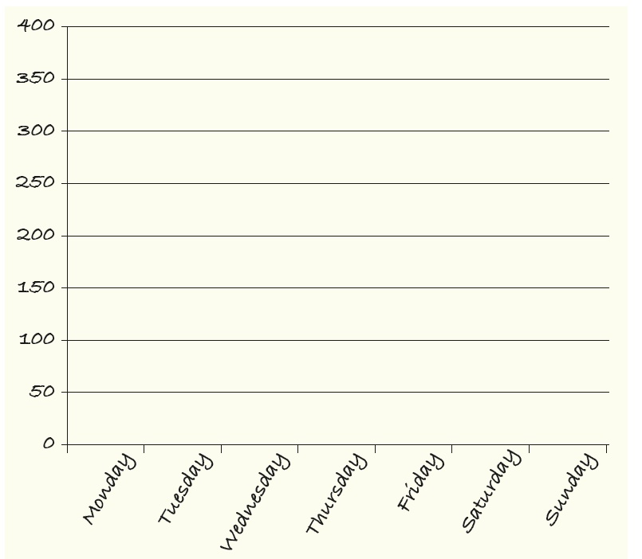

**B)**Which day has the best sales of soft drinks?

**C)**Which day has the worst sales of soft drinks?

**D)**Lucy knew that Thursday, Friday and Saturday were very hot summer days. How could this factor affect sales on these days?