Fuel costs rise in 2020 useful link

<https://www.telegraph.co.uk/business/2018/10/26/british-airways-owner-iag-suffers-profit-slip-fuel-costs-rise/>

[3](https://www.telegraph.co.uk/business/2018/10/26/british-airways-owner-iag-suffers-profit-slip-fuel-costs-rise/" \l "comments)

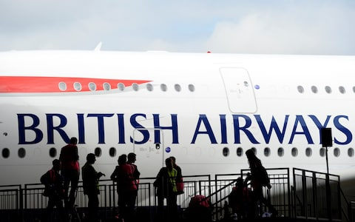

British Airways owner IAG added more flights and filled more seats on its planes

Rising fuel costs and currency exchange rates have dented profits at British Airways owner IAG in the three months to Sept 30.

The airline reported pre-tax profits of €1.42bn (£1.26bn) for its third quarter, down 0.4pc compared to the same period last year.

Revenue increased 8.5pc to €7.14bn, beating analyst predictions of €7.08bn as the company added more flights and filled more seats on its planes.

The FTSE 100 giant said that fuel costs rose 13.5pc, with fuel unit costs at constant currency up significantly at 13.6pc. The price of Brent crude touched $84 a barrel in September; though it has come off this high, it is still around 7pc higher than six months ago.

IAG shares rose more than 2pc in morning trade to 603.80p.

Mr Walsh, chief executive, said IAG would issue its third quarter interim dividend of 14.5 euro cents per share, up from 12.5 cents last year, while it completes its second €500m share buy-back programme.

“These were strong results despite significant fuel cost and foreign exchange headwinds. At constant currency, our passenger unit revenue increased by 2.4pc while non-fuel unit costs went down 0.7pc,” said Mr Walsh.

George Salmon of Hargreaves Lansdown, said: “The fly in the ointment is [that] solid progress on revenues is being undone by a sharp jump in operating costs. However, that’s really just a product of rising fuel costs, which are of course well out of IAG’s control.

"Take out the impact of higher fuel prices and unfavourable currency moves, and it becomes clear IAG is doing some pretty impressive work on underlying operating improvements. It’s confident it can keep this trend going too, which is clearly a good sign for investors.”

Mr Salmon added that business and leisure travel were both “sensitive to the fortunes of the wider economy” and that IAG remained vulnerable to any economic downturn surrounding Brexit.

The news comes [a day after British Airways admitted 185,000 additional sets of personal data may have been stolen](https://www.telegraph.co.uk/business/2018/10/25/british-airways-admits-185000-users-may-have-had-details-stolen/) from a cyber attack on its website last month.

BA has been working with specialist cyber forensic investigators and the National Crime Agency to investigate the data theft.

Data from 77,000 payment cards, including account numbers, expiry dates and card verification value (CVV) information has been accessed, while a further 108,000 people's personal details without CVVs have also been compromised.

Other information accessed included cardholder names, billing and email addresses.

British Airways stands to face a fine ranging from between £70m to £500m under new GDPR legislation.

Related Topics

* [Aviation](https://www.telegraph.co.uk/aviation/)
* [British Airways](https://www.telegraph.co.uk/british-airways/)
* [IAG](https://www.telegraph.co.uk/iag/)
* [airline industry](https://www.telegraph.co.uk/airline-industry/)
* [Show more](https://www.telegraph.co.uk/business/2018/10/26/british-airways-owner-iag-suffers-profit-slip-fuel-costs-rise/)