Learner A

Activity 1

Mamatone is the new name for a business owned, a small fitness business owned and managed by Natalie Parsons. Natalie started teaching fitness classes across North Yorkshire 12 years ago, but has found that the popularity of her zumba and body pump classeses has fallen due to the growth and availability of low-costs gyms in the area. Natalie has completed a course in post-natal fitness and is now qualified to teach these clasesses and also train other fitness instructors. She tends to train a close friend who has just completed a BTEC in Sport to work with her to design and teach the new MamaTone classes.

Natalie needs to set marketing aims for her business. She should set the following aims.

* To increase number of customers to MamaTone
* To increase brand awareness of MamaTone

I have research into the fitness industry for Natlaie and found out that the health and fitness industry in the uk has grown by 4.6% in 2016 and has seen an increase in the overall market value of 6.3% to an estimated £4.7bn. 1 in 7 people in the uk is a member of a gym. Low cost gyms have grown in the market, which now are 35% of the gyms. I have found this graph that shows that the estimated market size of the fitness industry. 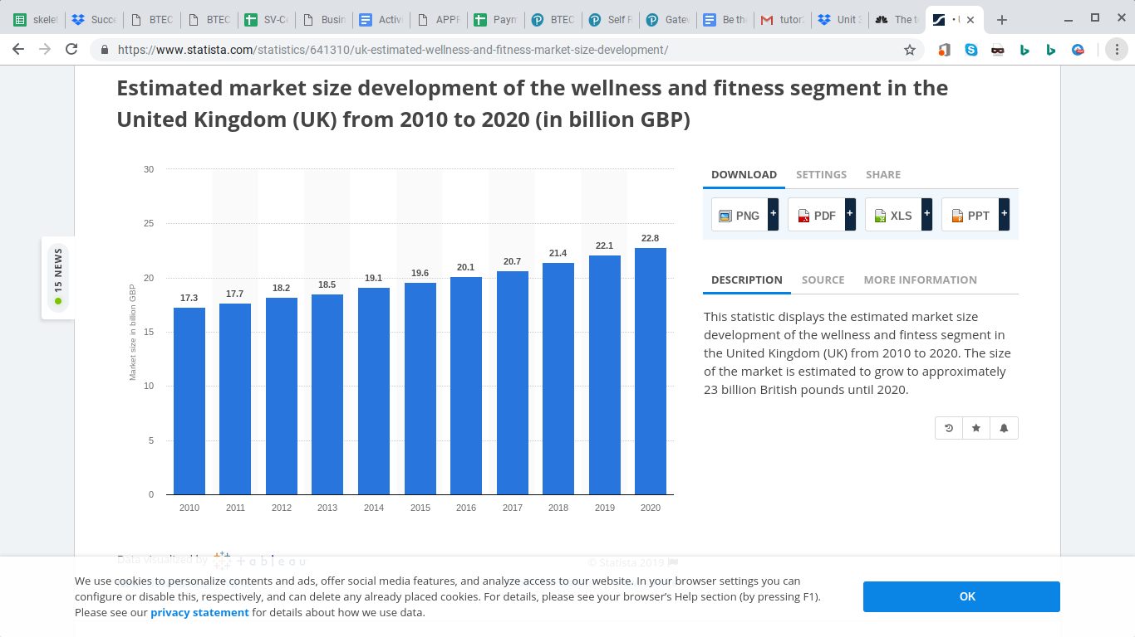

I’ve found out that people go to the gym for different reasons, 54% join to improve their fitness, 44% to lose weight 26% go to relax or de stress and 14% go to meet people. There are alot of different gyms and fitness instructors out there. There has been an increase in specialised fitness classeses and gyms that are becoming more popular in the uk. These include zumba class, fitness boot camps and spinning classes. In the market there are a lot of differnet types of gyms. Some like David Lloyd gyms are aimed at richer people. Here is some information about them.

We have 99 clubs in the UK and a further 15 across mainland Europe. We have approximately 570,000 members and employ 8.600 people, including an expert health and fitness team of over 2000 and more than 680 tennis professionals.

Across all of our clubs, we have over 180 swimming pools and offer more than 13,000 exercise classes every week. Our racquets facilities are unrivalled, with 1000 tennis courts, and more than 400 badminton and squash courts. We also offer outstanding coaching programmes for children and every week 25,000 children learn to swim and 16,000 learn to play tennis in our clubs. But we provide more than just amazing fitness facilities, we also have health and beauty spas, lounges with free Wi-Fi, crèches, nurseries and specialist sports shops.

Others are low cost gyms like easygym, which are aimed at lower income people. They account for 20% of the industry. Here is some information on easygym. “ ALL OF OUR GYMS ARE NO CONTRACT MEANING YOU ARE NOT TIED IN IF YOUR CIRCUMSTANCES CHANGE. CANCELLING A GYM MEMBERSHIP IS JUST AS EASY AS JOINING. WE OFFER FREE GROUP TRAINING – [PACK45](https://www.easygym.co.uk/pack45) – TO GIVE YOU THE OPPORTUNITY TO WORK OUT WITH AN ELITE TRAINER EACH TIME YOU VISIT THE GYM. FEMALES CAN TRAIN IN COMFORT AND PRIVACY IN OUR FULLY EQUIPPED 24/7 LADIES ONLY ZONES AT SELECTED GYMS. THESE AREAS ARE ONLY ACCESSIBLE TO FEMALES. ”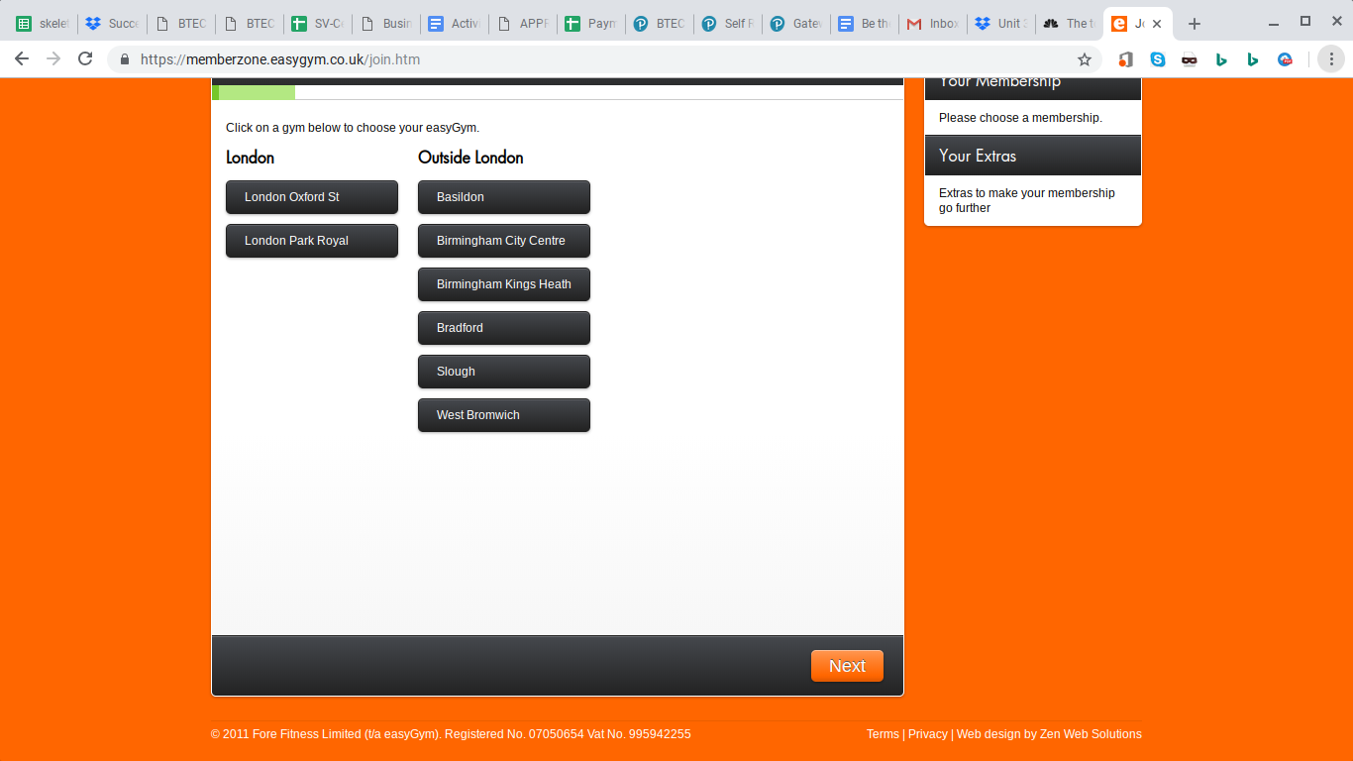

80% of Uk adults set themselves at least one health or fitness goal, yet only 12% currently use a gym. People of all ages use the gym and it both men and women go to the gym. Nuffield Health said 72-year-olds are their most frequent gym-goers, making an average of eight visits, while those in the 70-79 age bracket go 7.5 days a month on average.

Those aged 25-39 go an average of six times a month, while the 20-25 age group category makes slightly more visits at 6.5.

Men and women go to the gym for different reasons. For many men, "working out is a sport, and they do it because it's fun, it's competitive, and it's something that they've always done," says Lori Incledon, author of [*Strength Training*](https://www.webmd.com/fitness-exercise/features/build-muscle-better-health) *for Women.* "For women, fitness is a superficial issue. They do it because it will help them look better."

SWOT

|  |  |
| --- | --- |
| Strengths   * The industry has grown 4.6% in 2016 * 1 in 7 people in the Uk is a member of a gym * More people are looking for specialised fitness classes like zumba etc | Weaknesses   * Low cost gyms such as easygym have grown in popularity * There are a lot of people offering fitness classeses * There are a lot of mobile apps |
| Oportunities   * There are a lot of people in the Uk that want to get fit * 80% of uk adults set themselves health and fitness goals | Threats   * People might not want to use MamaTone * Natalie has not been successful so far as she has financial difficulties * There are already 13770 personal trainers in the uk so she might not get enough business. |

PESTLE

|  |  |
| --- | --- |
| Politics   * The UK is leaving the EU and we don’t know what will happen. * The government want us to visit the gym more - 150 minutes per week | Economics   * The minimum wage will go up on £8.21 and therefore people will have more money * The exchange rate had weakened and therefore imports are more expensive and exports are cheaper |
| Social   * 54% of people go to the gym to improve their fitness. 14% of people go to make friends * 25% of people are obese and 62% if adults are obese or overweight | Technological   * There is new gym equipment available such as computer screens for online sessions with trainers or 3D studios * The fitbit and other related products and apps have been introduced to help people to track their fitness |
| Law   * There are strict health and safety laws to follow such as the Health and Safety at Work Act * There are equality laws that mean gyms need to put special changing facilities in their gym for transgender people | Environment   * Air pollution in the uk, especially in cities has increased meaning exercising outside is not very healthy |

I think that Natalie should start up her business aimed at new mum’s and advertise to them, focusing on how they can get fitter and less overweight after having a baby. She needs to do something different to encourage them to come to her classes and not go to the gym. All the information I found was reliable as it came from good websites or the revision workbook and therefore I know the information is right. It is mostly valid as it is up to date and is about the gym and fitness industry.

Activity 2

Natalie has 2 options, do a pay as you go system where customers pay £4.50 per clas and drop into classes when they want to or have a class subscription system, where customers would need to sign up for 6 week programme, with a one-off fee of £25. I think that Natalie should off the first option where customers pay £4.50 per class and drop into classess. This is because she will get more customers that way as its cheaper and people will be more willing to come if they can just come when they want. I think that the product is a post-natal fitness programme, which is for ladies who have just had a baby. This will include classeses where they do things like yoga where they can take the baby along so they don’t need to get someone to look after it. This is because yoga is something ladies like to do to help them get fit and they need to look after there baby at the sametime. She will also need to think about exercises that the doctor says that ladies should do after having a baby and those they shouldn’t.

Natalie is going to run her business North Yorkshire, so she will need to think about what areas she will run it in so her customers can get there. She should look into look community halls or fitness centres that will let her run her classeses from there but she will need to she how much they will charge as they probably wont do it for free. She could also look for different parks or outside spaces to do her classes in but that might not be good for the baby.

She will also need to think about promotion - where and how to advertise it. She could put an advert in the local paper each week so that people will see it. Then the new mums will see it when they look in the paper each week as they have a lot of spare time looking after the baby. She could also create a website but this might cost quite a bit and take some time to set up but it might help as new mums might look on the internet for help to get fit. She could also produce some leaflets and push them through people’s letter boxes or put them in the local paper so people will see it and come or pass it on to the people they know who have had babies. She could also put a catchy advert on the radio which will get peoples attention when they are driving around or listening at home.

This is what I think she should do and what it will cost.

|  |  |
| --- | --- |
| Media | Cost |
| Newspaper adverts | £250 per ¼ page advert per week |
| Radio adverts (30 seconds) | £5,000 per week |
| Leaflets from vista print | £19.99 for 1000 leaflets |
| Website | Free |
| Posters | Free |

In total if she advertises for 12 weeks this will cost:

£3,000 for newspaper ads

£30,000 for radio adverts

£240 for leaflets

Total £33,240

She also need to think about the other 3 Ps, People, physical environment and process. People is her customers. They are women who have babies and are ages between 20 and 40 years old. They should be able to afford the classes each week but as it’s not very expensive they should be able to. Physical environment is where you will do and what it will be like. This is either in the fitness centre or the community centre and it should have posters up of the MamaTone. Process is about how the customers book onto the sessions and how they pay. They will just turn up to book onto sessions and pay when they arrive before the session.

Timescale

|  |  |  |  |  |  |  |  |  |  |  |  |  |
| --- | --- | --- | --- | --- | --- | --- | --- | --- | --- | --- | --- | --- |
| Media | 1 | 2 | 3 | 4 | 5 | 6 | 7 | 8 | 9 | 10 | 11 | 12 |
| Newspaper ads |  |  |  |  |  |  |  |  |  |  |  |  |
| Radio adverts |  |  |  |  |  |  |  |  |  |  |  |  |
| Leaflets |  |  |  |  |  |  |  |  |  |  |  |  |
| Website |  |  |  |  |  |  |  |  |  |  |  |  |
| Posters |  |  |  |  |  |  |  |  |  |  |  |  |

I think this is the best campaign for Natalie as it will help her reach the type of customers she is aiming at, in her budget of £35,000.