**The competition?**

**Iphoness.com – best augmented reality apps on iphone**

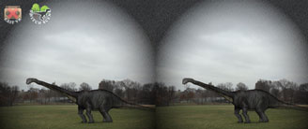

[Dinosaurs Everywhere](http://www.iphoneness.com/go/dino): brings dinosaurs back to life, allowing you to use your phone or a VR headset to see them all around you. 10 different dinosaur species are available

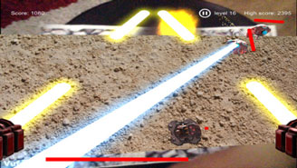[Drone Blaster](http://www.iphoneness.com/go/droneblaster): a game that involves moving around to dodge enemy lasers and collecting floating items in your path.

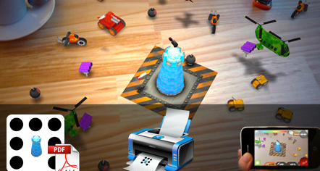[ARDefender](http://www.iphoneness.com/ardefender): into playing games much? This game blends your game with your reality, making your experience with it more fun. Game play is pretty decent too

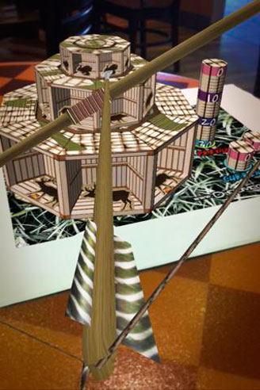

[Bowmaster](http://www.iphoneness.com/go/bowmaster): an AR archery game that lets you shoot at targets around you on your smartphone.

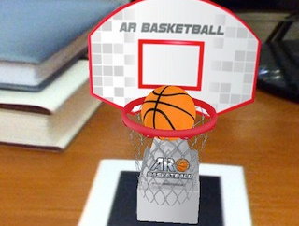[AR Basketball](http://www.iphoneness.com/arbasketball): turns your reality into a mini basketball court. All you need to play basketball is a piece of paper and your iPhone. This game’s augmented reality feature takes care of the rest.

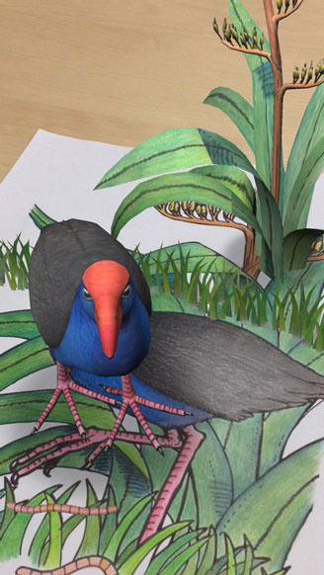

[Quiver](http://www.iphoneness.com/go/quiver): a 3D coloring app with AR to bring your children a more interactive experience. Your artwork is brought to life on your smartphone.