**https://www.tutor2u.net/business/reference/btec-national-unit-2-developing-a-marketing-campaign-the-market-for-vinyl-records-in-the-uk?utm_medium=email&utm_campaign=Business%20daily%20digest%20Thu%2026th%20April%202018&utm_content=Business%20daily%20digest%20Thu%2026th%20April%202018+CID_5624dcf16ab60b3036625881b6ad4c80&utm_source=CampMonitor&utm_term=BTEC%20National%20Unit%202%20Developing%20a%20Marketing%20Campaign%20-%20The%20Market%20for%20Vinyl%20Records%20in%20the%20UK%20Study%20notes%20Here%20is%20some%20summary%20market%20research%20information%20on%20the%20market%20for%20Vinyl%20Records%20in%20the%20UKUK recorded music industry overview**

The UK recorded music industry had a total value (revenue) of £839.4 million in 2017. This represented an increase of 10.6% on 2016.

Of this total market size of £839.4 million, **digital sales** (downloads and music streaming) accounted for £506.2m million (60%) of industry sales.

Physical sales (CDs and Vinyl) generated industry revenues of £310.5 million in 2017, a small rise of 2.4% on 2016. Physical music sales have declined significantly in recent years, In 2008, physical music sales were £758 million. The large fall in physical music sales is entirely due to the reduced popularity of the CD format.

**Market for vinyl records in the UK**

Vinyl records are part of the **"physical"** segment of music sales in the UK.

Physical comprises CD format and Vinyl.

As the chart below shows, volume sales of **vinyl records reached 4.1 million units in 2017**, the 10th consecutive year in which vinyl sales have grown, albeit from a low base.

By contrast, sales of CDs have continued to fall in recent years as music consumers have migrated to digital formats and music streaming services.

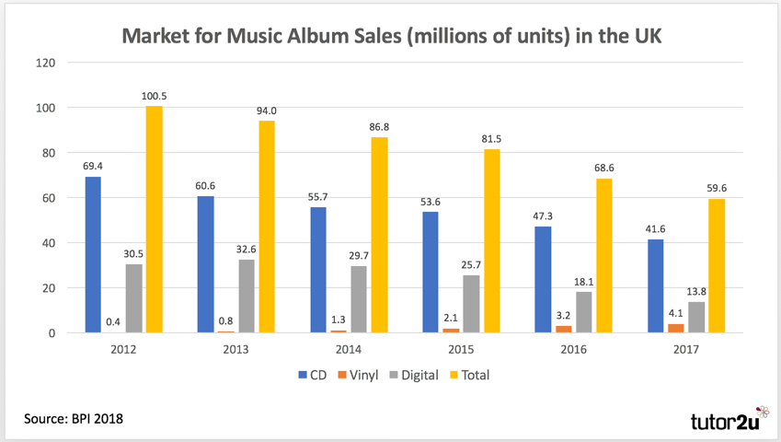Volume sales of Physical Music in the UK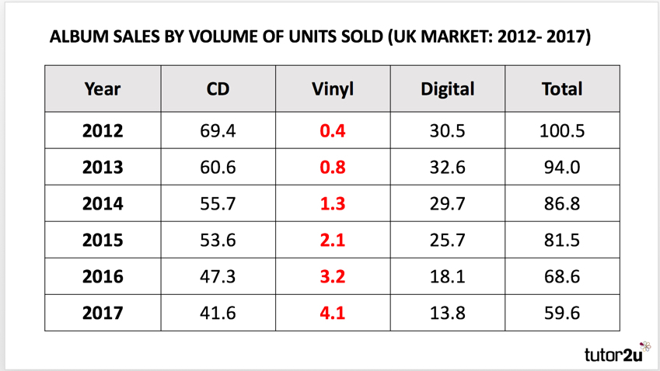Table of Physical Music Sales (Volume) in the UK

**Other key features of the UK vinyl record market that might be relevant to a marketing campaign:**

* The average price of a vinyl LP album in the UK in 2017 was £20.23. This compares to average prices of £8.39 for a CD and £7.14 for an album downloaded digitally.
* With volume sales of 4.1 million units, this suggests a **market size of around £80 million** in value terms
* Demand for vinyl records in the UK is **highly seasonal**. Demand is highest at Christmas because vinyl records are often given as gifts. 25.8% of vinyl sales in the UK were made in December in 2017.
* Most vinyl record customers are male (61% of the market)
* The largest segment of vinyl customers is aged between 45-54 (29% of the market)
* 64.6% of the 4.1 million vinyl records sold in 2017 contained "rock" music. The next largest segment was "Pop" (17.2%).
* The largest segment of accessories in the vinyl record market is for record "turntables". Sales of turntables in the UK grew to 296,000 units with a value of £30 million in 2017.
* In terms of retail distribution, around 8% of vinyl sales in the UK were made by supermarkets in 2017, with Sainsbury's having the largest market share (8% of vinyl sales). Sainsbury's sells a limited range of vinyl records in over 600 stores.
* There were 406 independent record stores trading in the UK during 2017, up from 293 stores in 2012. Over 200 of these stores take part in Record Store Day 2018 - a promotional campaign designed to raise awareness of the independent record store market.

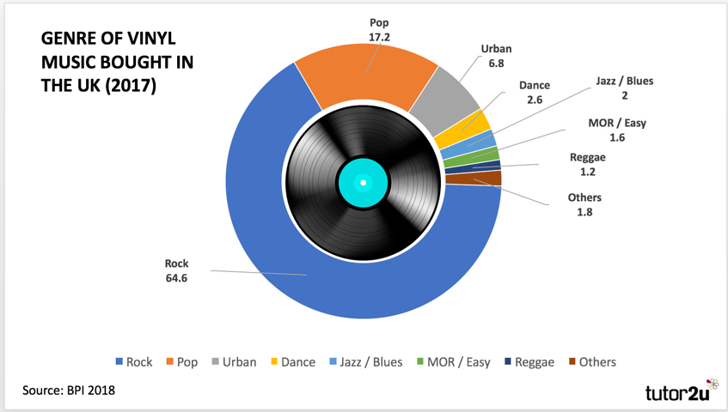Genres of Music on Vinyl Records Sold in the UK in 2017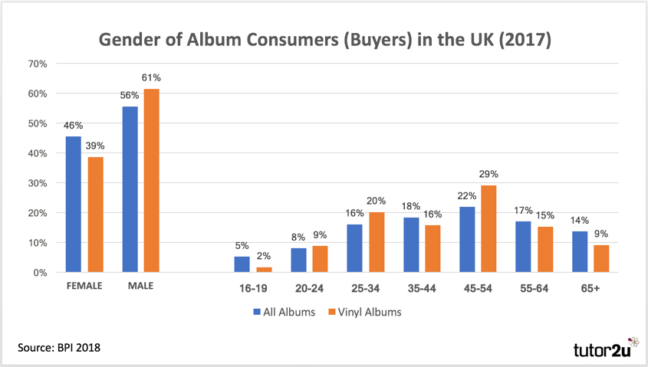Who Buys Vinyl Records in the UK?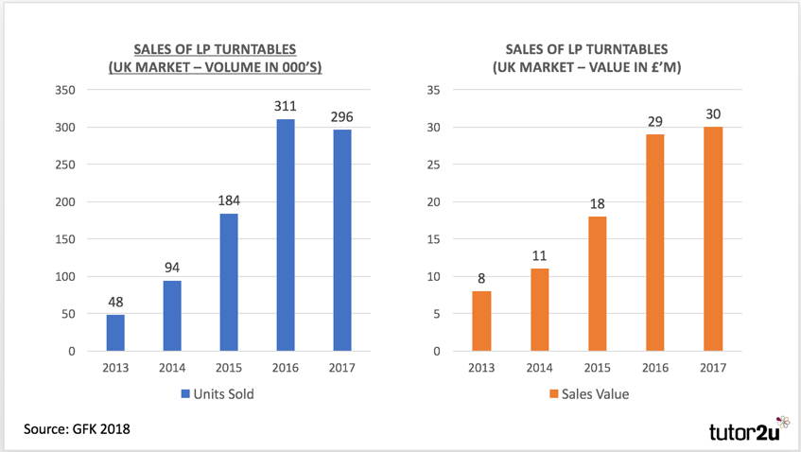The Market for Vinyl Turntables in the UK

**Useful links on the UK vinyl record market**

* [Best UK vinyl record shops to celebrate Record Store Day 2018](https://www.telegraph.co.uk/music/what-to-listen-to/vinyl-destinations-britains-best-record-stores/) (at The Telegraph)  
  Superb on some of the UK’s best record shops – what they are doing to raise their profile
* [A Vinyl Stocktake](https://www.bpi.co.uk/news-analysis/a-vinyl-stocktake/) (at BPI)  
  Useful analysis from the BPI of the UK vinyl record market
* [Indie record stores: Supermarkets welcome in the vinyl market](http://www.musicweek.com/brands/read/indie-record-stores-supermarkets-welcome-in-the-vinyl-market/068195) (at Music Week)  
  Supermarkets grow their share of the vinyl market