**Research links for Unit 2 Marketing May 2018 Paper**

**Getting started**

Use the Activity 1 and 2 templates as the structure for saving all your research information. Set up a PEST and SWOT table (or headings for paragraphs) and find information that can go in each section.

When you find any useful information in your research, save it and make sure you note down the source and the date – you will need to refer back to this in your justification at the end of Activity 1

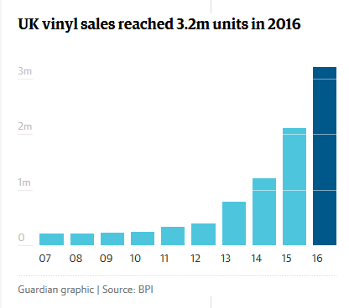**Good start –**

**The Guardian newspaper – check out all the available articles - eg**

<https://www.theguardian.com/world/2017/jun/29/sony-making-records-30-years-abandoning-vinyl>



**Another top tip – use the Tutor2U website – they are good for articles and also guidance on how to write Marketing Objectives, what a PEST and SWOT should look like etc**

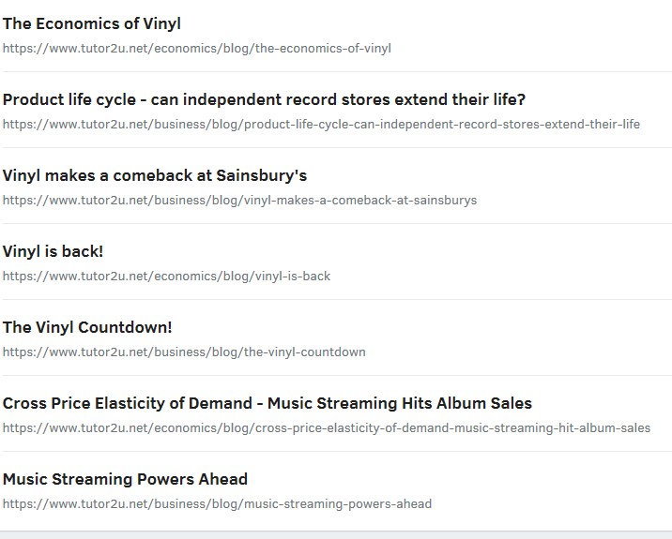**Tutor2U – go the Business section and type in ‘vinyl records’ into the search bar and the following articles should come up**