UNIT 2 Developing A Marketing Campaign

A1 Lesson 3

<http://www.segmentationstudyguide.com/wp-content/uploads/2015/02/market-segmentation-example-for-a-car.png>

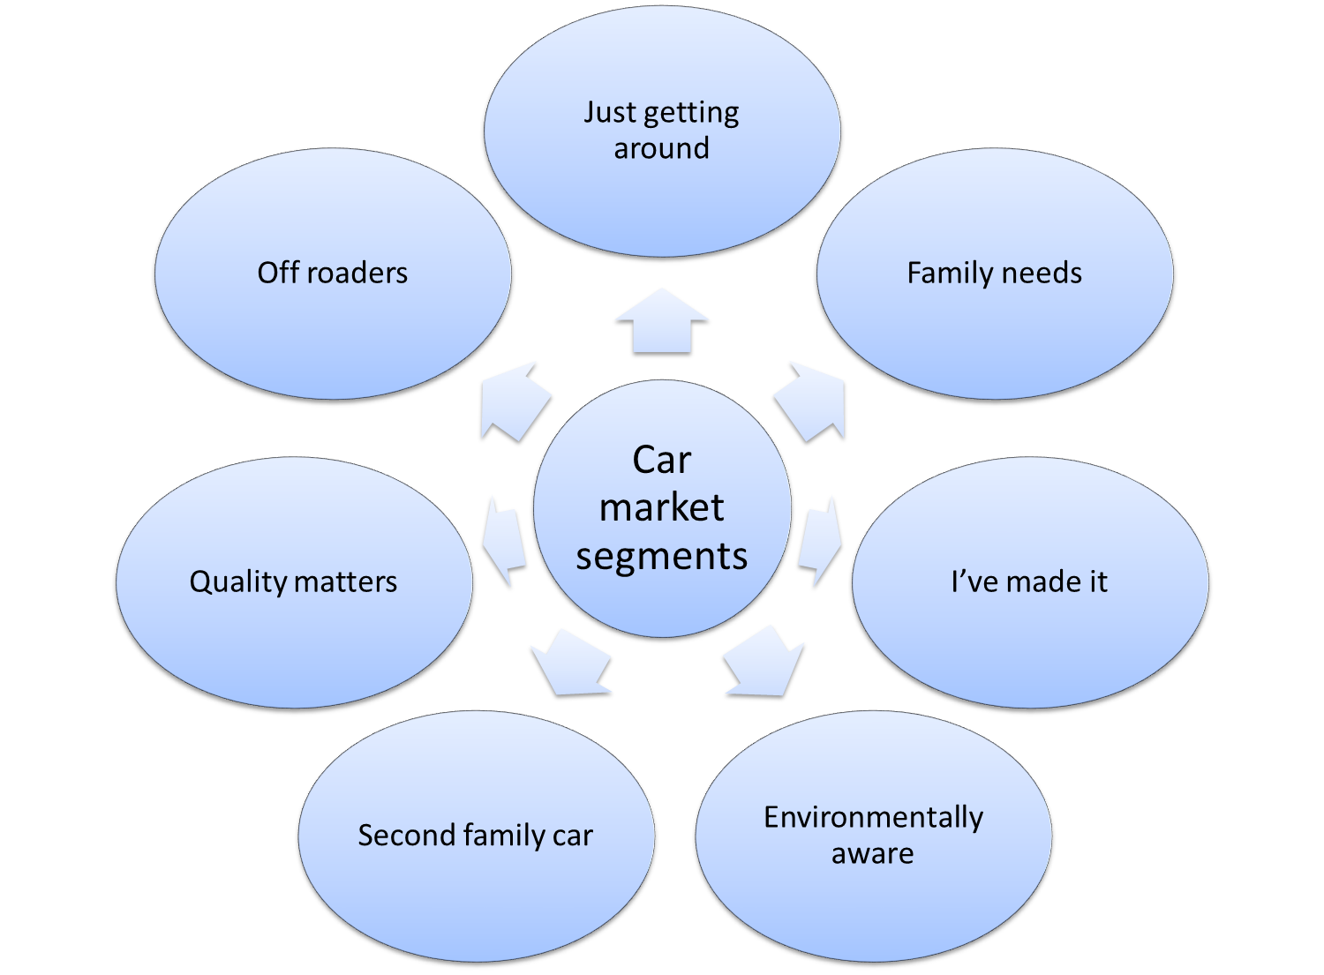

<http://www.segmentationstudyguide.com/understanding-market-segmentation/market-segmentation-examples/market-segmentation-example-drinks/>

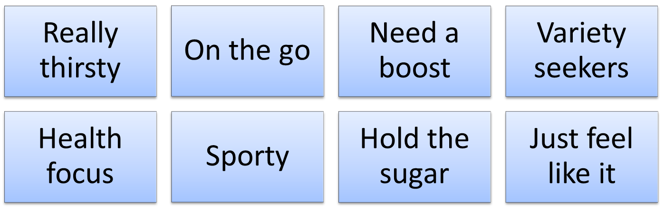

In this example of [market segmentation](http://www.segmentationstudyguide.com/understanding-market-segmentation/), the overall drink market has been considered. The overall drink market refers to any cold beverage, including: sodas, juice, energy drinks, milk-based drinks, water, sports drinks, and so on – but not alcohol products. While some of these product categories would be considered indirect competitors, they can be all clustered into the same overall market.

The purpose of this market segmentation example is to demonstrate that while consumers are all buying some form of beverage, their needs and situations are different across the market segments, which means that they are seeking different product benefits.

In this market segmentation example for drinks, eight different market segments have been identified. This example is using a mix of situational influences and primarily a benefit segmentation approach. There are eight market segments identified in this example, as follows:

* Really thirsty
* On the go
* Need a boost
* Variety seekers
* Health focus
* Sporty
* Hold the sugar
* Just feel like