Dairy Crest Adjustments Exercise

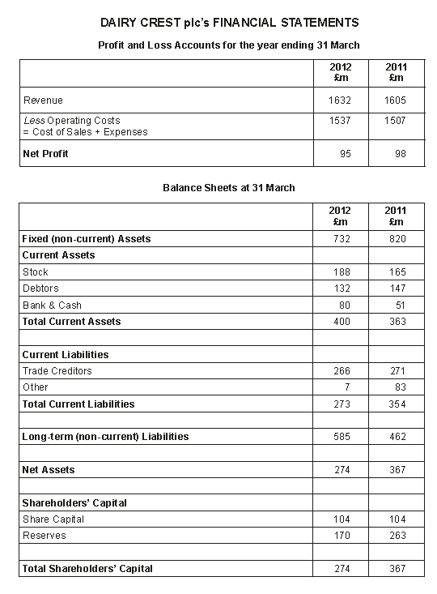

Adjust the above accounts to show the following:

1. In 2012, Dairy Crest had to pay rent in advance amounting to £2.5m.
2. Dairy Crest paid their staff one month in arrears. Their staff bill in 2011 was £60m and in 2012 it was £75m
3. Dairy crest has machinery and equipment that depreciated by £50m in 2011 and £53m in 2012.
4. In 2011 Dairy Crest had a £65m accrual with their suppliers.