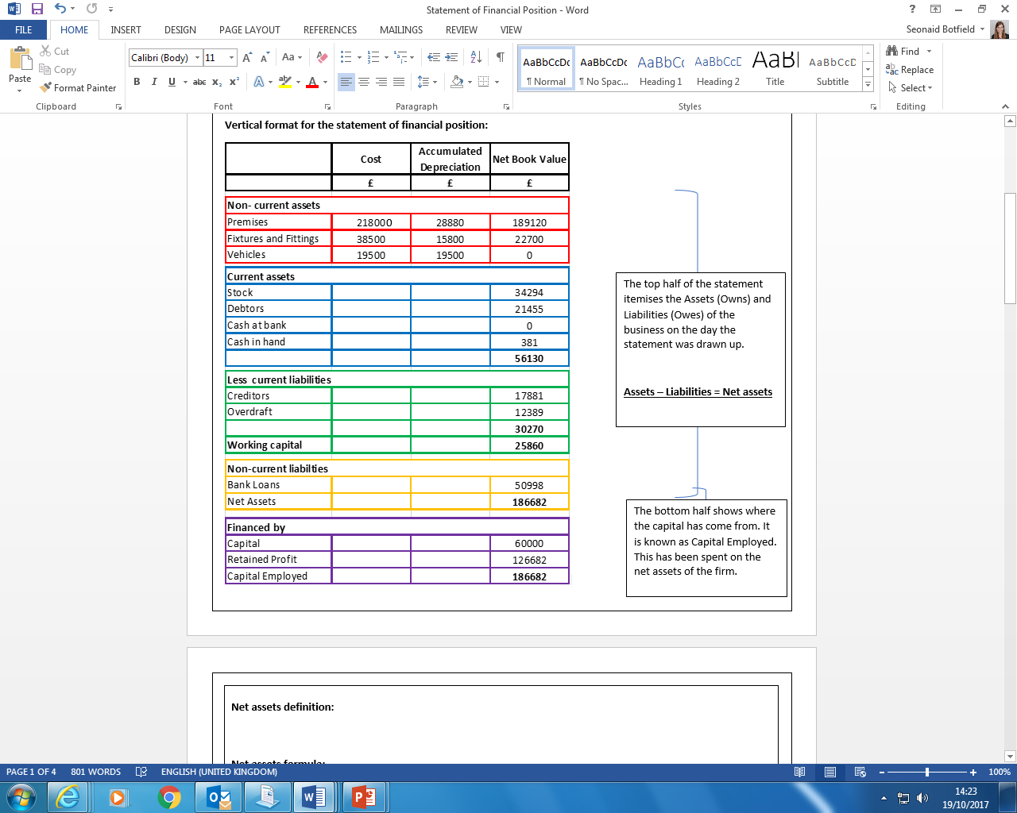Annotate the Balance Sheet. Make sure both forms of terminology are on the sheet. Add formula where relevant. Explain all terms. Show which numbers add together or are subtracted. Explain both types of Depreciation. Show which items on this Statement of Financial Position also appear on the Statement of Comprehensive Income (aka Income Statement or Profit & Loss)