BTEC National Business

Unit 3 Personal and Business Finance
Exam Practice Toolkit (12 Marks)

Teachers Notes

Exam Practice Toolkit

The 12 mark Exam Practice Pack contains a series of activities and resources to aid student’s revision, exam practice and development of the key examination skills necessary for the BTEC National Business Unit 3 Exam.
The pack has been designed to be used either as a full lesson solution or as independent activities to be integrated into lessons or provided as homework.
Contents:
 | Resource
1 | Lesson PowerPoint
2 | Student Workbook
3 | Practice 12 Mark Questions and Answers
4 | Worked Answers
5 | PeCAN – Paragraph template
6 | DJI – Evaluation template
7 | Self/Peer Assessment Marking Grid and Actvity
8 | PowerPoint Exam Skills – Sky Scraper Marking
9 | PowerPoint Exam Skills – Paragraph Paramedic
10 | PowerPoint Exam Practice – Musical Chairs

1 | Lesson PowerPoint | 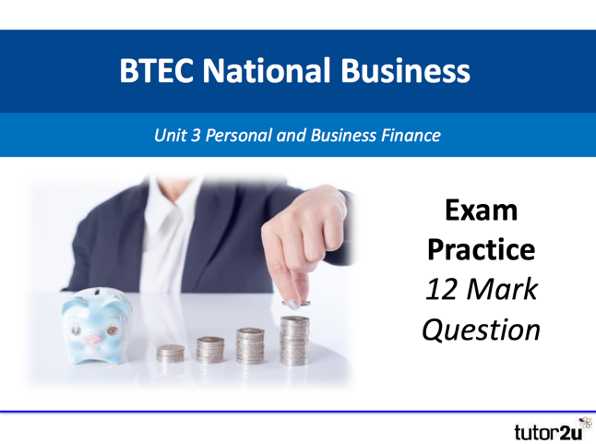
The Lesson PowerPoint brings together a series of activities to aid student’s revision and development of exam technique.

The Lesson PowerPoint includes:
- Unit 3 Content Blast using Calculation Countdown, MCQ blast and Give me 2 Team Challenge

- Getting to Grips with the Unit 3 exam and 12 mark Question

- Analysis of the skills required to succeed with activities using sample student responses

- Skill development
Using a Stepping Stones approach to build an argument.

- Paragraph Perfection using the PeCAN method

- Evaluation Excellence – The DJI method
- Paragraph Paramedic

2 | Student Workbook
 | The student workbook accompanies the Lesson PowerPoint. The workbook provides opportunities for the students to work through a number of activities independently, in pairs or in small groups.

3 | Practice 12 Mark Questions and Mark Schemes
The pack contains 20 x 12 mark practice questions, a mark scheme and suggested answers.
(10 for Section A and 10 for Section B)

4 | Worked Answers
 | Two worked answers with examiner annotation are provided for a Section A and Section B practice question. The two sample student answers show a level 1 and level 4 response. Opportunity to use the student responses as a “Be the Examiner” activity with the marking grid provided in the pack. What mark would you award? Or take a Paragraph Paramedic approach. What would you prescribe to make this level 1 answer healthier?

5 | PeCAN Paragraph template
A template designed to help students structure their perfect paragraph. This template is also useful for the Discuss (6 marks) Analyse, (8 marks) Assess (10 marks) questions.
Please note there is an A4 full answer template including the DJI evaluation template in the pack

6 | DJI Evaluation template
 | Students often struggle to do an effective evaluation. This DJI template helps students to structure their evaluative paragraph. An essential skill to master in the 12 mark question.

7 | Self/Peer Assessment Marking Grid
 | The marking grid, can be used with students as part of a peer marking exercise or to self assess their 12 mark answers. The grid encourages students to fully understand how the 12 mark question will be assessed. A peer marking activity is included in the pack .

8 | PowerPoint Exam Skills – SkyScraper Marking
 | An editable, holistic marking grid on PowerPoint. Useful to use with students as part of a “Be the Examiner, Peer Marking Activity”. Easy to set up, simply input the actual marks/levels awarded and use with students to check if their marking was accurate.

9 | PowerPoint Exam Skills – Paragraph Paramedic
An editable PowerPoint that presents students with a “poorly” paragraph.
It is a timed resource that requires students to identify the mistakes and recommend suitable medication to improve the health of the paragraph.

10 | PowerPoint Exam Practice – Musical Chairs
An alternative approach to practicing exam questions. Working in teams, they work on different question stations for timed periods, planning their answers. Whe the music starts, students move to the next station and continue with the planning.
Full teacher notes provided and PPT gives instructions, timings and music!

