**Unit 3:** Personal and Business Finance

Revision Booklet 3

**Learning Aim C:** Understand the purpose of accounting

Purpose of Accounting (C1)

Types of Income (C2)

Types of Expenditure (C3)

**Note:**

Unit 3: Personal and Business Finance contains six learning Aims

This Revision booklet only focuses on Learning Aim C.**Purpose of Accounting – C1**

**Revision Task 1:** Complete the table below, listing the four main purposes of accounting along with a corresponding brief description. The first purpose is completed for you.

|  |  |
| --- | --- |
| **Purpose of Accounting** | **Explanation** |
| **Record Transactions** | It is important for a business to record all its transactions so that it can make accurate tax returns, pay its suppliers on time and collect all income due to the business. |
|  |  |
|  |  |
|  |  |

**Revision Task 2 – Complete the crossword below containing key words for Learning Aim C, the Purpose of Accounting.**

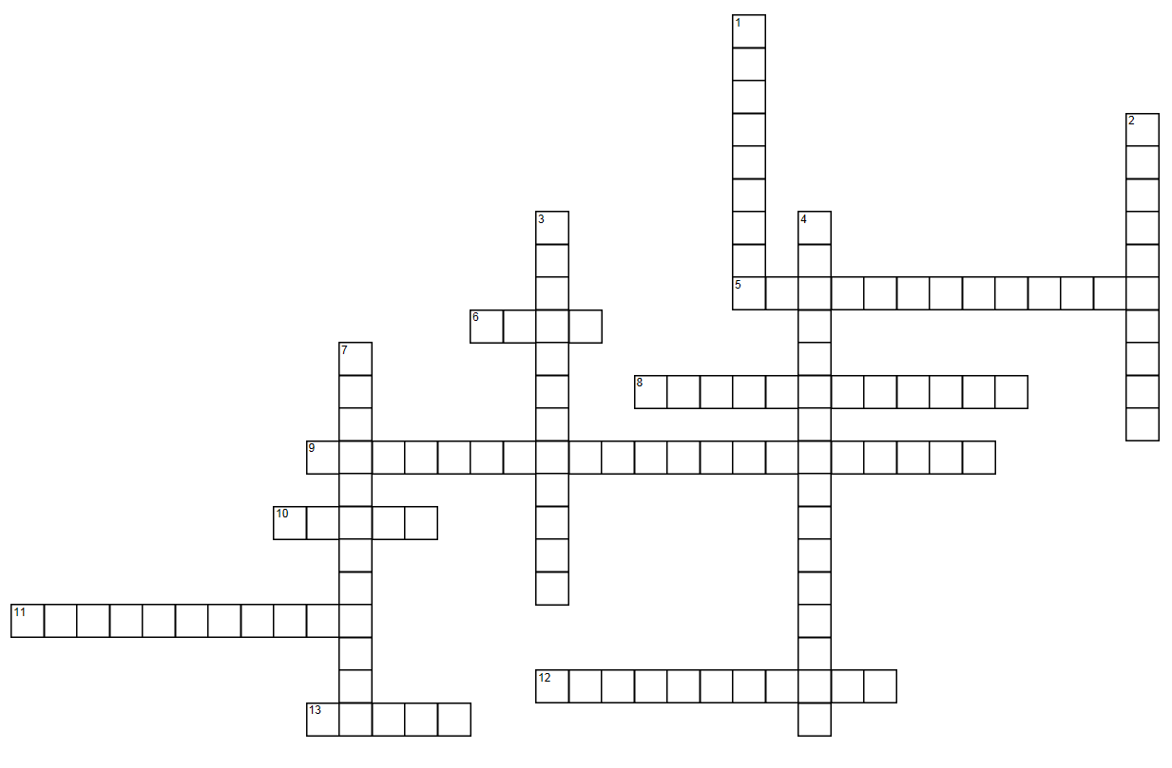

http://images.puzzle-maker.com/PNG/Space.png

|  |  |  |  |
| --- | --- | --- | --- |
|  | **ACROSS** | |  |
|  | 5 | Money the business owes to suppliers. |  |
|  | 6 | A British Government Department Responsible for the collection of all types of Taxes. |  |
|  | 8 | Quantity sold multiplied by the selling price. |  |
|  | 9 | Actions by a business which involve money entering or leaving the business. |  |
|  | 10 | When an individual acts illegally to obtain company money for personal gain. |  |
|  | 11 | Sales Revenue minus Cost of Goods Sold. |  |
|  | 12 | Large value items owned by the business which are likely to remain in the business for a long period of time, usually for one year or more. |  |
|  | 13 | Any item of value which is owned by an individual or business. |  |
|  | **DOWN** | |  |
|  | 1 | Gross Profit minus other expenses. |  |
|  | 2 | A fee paid to a salesperson in exchange for a service provided. It can be a flat fee or a percentage of the revenue or profit generated by the sale. |  |
|  | 3 | An accounting method used to spread the cost of an asset over its useful life. |  |
|  | 4 | Money owed to the business from sales made. |  |
|  | 7 | Assets bought from capital expenditure. |  |

**Revision Task 3:** Complete the table below providing descriptions for the different types of capital income.

|  |  |
| --- | --- |
| **Capital Income** | **Description** |
| **Loans** |  |
| **Mortgages** |  |
| **Shares** |  |
| **Owner’s Capital** |  |
| **Debentures** |  |

**Revision Task 4:** Complete the table below, describing five types of revenue income a business can receive. The first one is done for you.

|  |  |
| --- | --- |
| **Revenue Income E.G.** | **Description** |
| Sales | Money received from selling goods or services. These sales can be either cash or credit. |
| Rent Received |  |
| Commission Received |  |
| Interest Received |  |
| Discount Received |  |

**Revision Task 5:** Complete the missing words for the paragraph below:

Expenditure is ………………………….. spent by a business. It can be split into two categories …………………………………………………………………..and …………………………………………………………………. Non-current assets are a form of capital expenditure. They are owned by a business and will remain in the business for a …………………… period of time. They are recorded on the business’s statement of financial position or ………………………………………..sheet. Tangible assets are ones which can be ……………. and include things like machinery, premises and vehicles. …………………… assets are ones which cannot be touched and included things like goodwill, patents, brand names and trademarks.

Words to add

revenue expenditure Intangible touched reasonable money balance Capital Expenditure

**Exam Style Question:**

Q1. Describe Goodwill as a type of expenditure.

...........................................................................................................................

...........................................................................................................................................................................................................................................................

................................................................................................................................................

|  |
| --- |
| **Total for Question 2 = 2 marks** |

Q2. Describe Patents as a type of expenditure.

...........................................................................................................................

...........................................................................................................................................................................................................................................................

................................................................................................................................................

|  |
| --- |
| **Total for Question 2 = 2 marks** |

Q3. Describe Trademarks as a type of expenditure.

...........................................................................................................................

...........................................................................................................................................................................................................................................................

................................................................................................................................................

|  |
| --- |
| **Total for Question 2 = 2 marks** |

Q4. Describe Brand Names as a type of expenditure.

...........................................................................................................................

...........................................................................................................................................................................................................................................................

................................................................................................................................................

|  |
| --- |
| **Total for Question 2 = 2 marks** |

Q5. Outline what is meant by Depreciation.

...........................................................................................................................

...........................................................................................................................................................................................................................................................

................................................................................................................................................

|  |
| --- |
| **Total for Question 2 = 2 marks** |

**Revenue Expenditure is spending on day to day items on a regular basis. These are expenses which appear on the Profit and Loss Account (also known as Statement of Comprehensive Income).**

**Revision Task 6:** Complete the table below providing examples and corresponding definitions of revenue expenditure. The first one is done for you.

|  |  |
| --- | --- |
| **Revenue Expenditure E.G.** | **Definition** |
| Inventory | Most businesses will have to buy some form of inventory, such as raw materials or finished goods to sell on. |
|  |  |
|  |  |
|  |  |
|  |  |
|  |  |
|  |  |
|  |  |
|  |  |
|  |  |
|  |  |
|  |  |

**Exam Style Question:**

Dave has recently finished his studies at College and has decided to set up an online shop selling items on ebay. He will run the business from his bedroom and his parents will not charge him any rent or ask for any contributions to heating, water or local rates. He does not plan to hire any workers to help him start the business. The business will involve buying and selling old computer games. Dave plans to buy or rent a new mobile phone so he can update his shop quickly and respond to his customers whilst he is out and about.

Dave knows you studied Business at school and has asked you to provide him with some basic financial help.

Businesses such as Dave’s will have expenditure

Q6. Identify **two** types of **revenue expenditure** Dave will pay whilst running the business from his bedroom.

1...........................................................................................................................

....................................................................................................................................2. .......................................................................................................................

................................................................................................................................................

|  |
| --- |
| **Total for Question 2 = 2 marks** |

**REVISION PROGRESS CHECK**

You have now completed the tasks related to **Understanding the purpose of Accounting**– complete the table below and on the following page to identify content you are confident about and areas you want to revisit. This is the end of Learning Aim C**.**

|  |  |  |
| --- | --- | --- |
| **C Understand the purpose of accounting** | | |
| **C1 Purpose of Accounting** | | |
| **Checklist** | **Yes** | **No - must revise** |
| I understand the purpose of accounting is to:  Record transactions  Help manage the business (planning, monitoring, controlling)  Ensure compliance (prevent fraud, comply with laws)  Measure performance  Aid control (prevent fraud) |  |  |
| **C2 Types of Income** | | |
| **Checklist** | **Yes** | **No - must revise** |
| I understand Capital Income includes:  Loans  Mortgages  Shares  Owner’s Capital  Debentures |  |  |
| I understand Revenue Income includes:  Cash Sales  Credit Sales  Rent Received  Commission Received  Interest Received  Discount Received |  |  |

|  |  |  |
| --- | --- | --- |
| **C3 Types of Expenditure** | | |
| **Checklist** | **Yes** | **No - must revise** |
| I understand Capital Expenditure includes:  Tangible Assets (land, buildings and premises, machinery and equipment, vehicles, fixtures and fittings)  Intangible Assets (goodwill, patents, trademarks, brand names) |  |  |
| I understand Revenue Expenditure includes:  Inventory  Rent  Rates  Heating and lighting  Water  Insurance  Administration  Telephone  Postage  Stationery  Salaries  Wages  Marketing  Bank Charges  Interest Paid  Straight line depreciation  Reducing Balance Depreciation  Discount Allowed |  |  |