**Unit 3:** Personal and Business Finance

Revision Booklet 4

**Learning Aim D:** Select and evaluate different sources of business finance

Sources of Finance (D1)

**Note:**

Unit 3: Personal and Business Finance contains six learning Aims

This Revision booklet only focuses on Learning Aim D.**Sources of Finance – D1**

**Revision Task 1:** Complete the table below by adding the definitions for the internal sources of finance listed.

|  |  |
| --- | --- |
| **Internal Source of Finance** | **Explanation** |
| **Retained Profit** | Profit kept by the business from previous years to fund future projects. |
| **Net Current Assets** | Net Current Assets = Current Assets – Current Liabilities  It is the money the business have available to fund day to day expenditure. |
| **Sales of Assets** | Assets are large value items owned by the business such as vehicles, machines or property. Selling these items provide a cash injection into the business. |

**Revision Task 2:** Complete the table below by providing one strength and one weakness for each internal sources of finance listed.

|  |  |  |
| --- | --- | --- |
| **Internal Source of Finance** | **Advantages** | **Disadvantages** |
| **Retained Profit** | The business will not have to pay interest.  The cash is available immediately | This is only an option for an established business – new business will not have a reserve of retained profit.  Shareholders may not be happy as it will reduce the pot of money available to pay dividends (shareholders reward for investing).  Once the money has been used it cannot be used for other projects. |
| **Net Current Assets** | Encourages the business to manage its cash flow effectively. | May require the business to negotiate longer credit terms with its suppliers which may cause difficulties in the relationship.  May require the business to reduce credit terms for customers which can impact on this relationship.  The business may need to hold lower stock numbers and this may impact on the businesses ability to meet customers’ needs. |
| **Sales of Assets** | The business will have no interest to pay unlike a loan.  Helps dispose of assets which are no longer needed by the business.  Helps the business to reduce capital tied up in assets. | The business may not receive the true value of the assets especially if it sells the item quickly. It may have to accept a lower amount for a quick sale.  Selling the asset and leasing an alternative can be more expensive in the long run. |

**Revision Task 3 – Complete the crossword below containing key words for external sources of finance.**

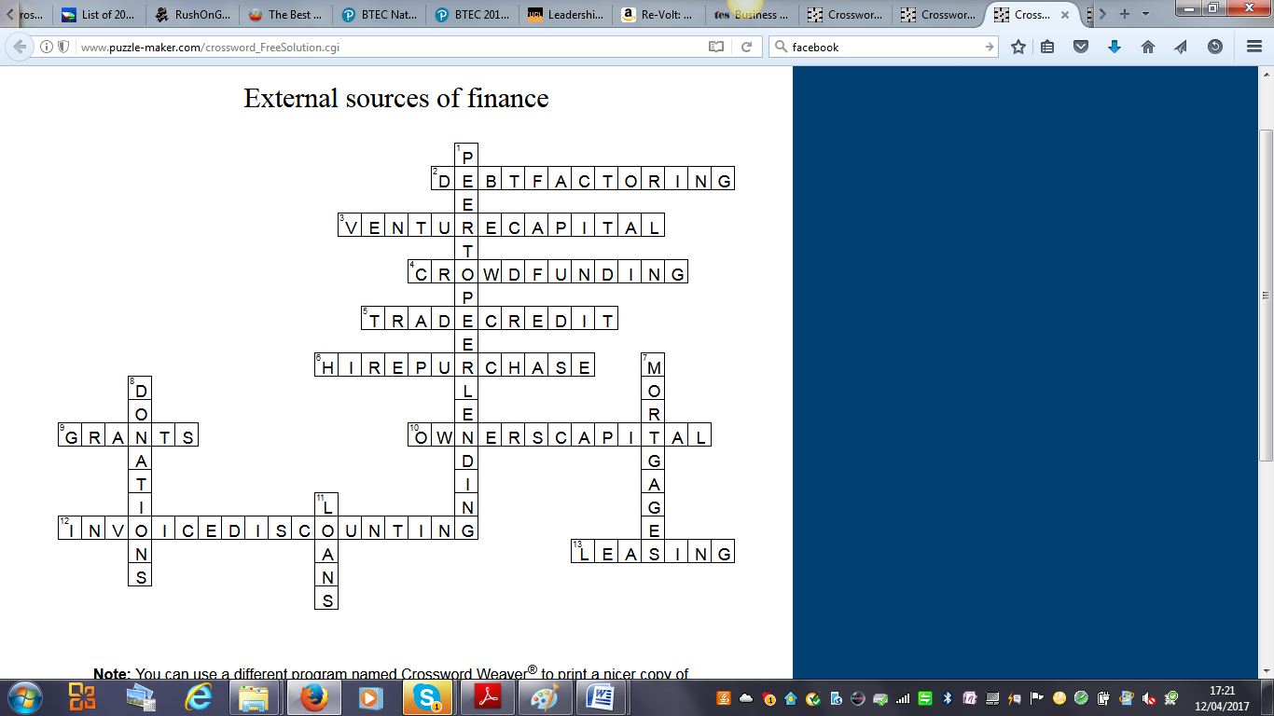

**Across**

2. When a business sells its debts to a third party in order to obtain cash quickly.

3. Investment provided by experienced entrepreneurs in return for a stake in the company.

4. Attracting investment from speculative investors. Each may invest relatively small amounts.

Once all these amounts reach the target level they are collected.

5. When suppliers allow customers to purchase a good or service and pay later.

6. Paying instalments to a company in order to use an asset. Once the last payment has been

made the business then owns the asset.

9. A lump sum provided to a business by the government or another organisation for a specific

purpose.

10. Money invested in the business from the owner's personal savings.

12. Reductions offered to customers making a product or service cheaper.

13. Paying instalments to a company in order to use an asset. Ownership of the asset always

stays with the supplier.

**Down**

1. When one business person lends money to another business person.
2. Long term loans usually lasting for 25 years. The loan is secured against an asset e.g. building.
3. Sums of money given voluntarily to a charity or social enterprise.
4. Money borrowed from a financial institution.

http://images.puzzle-maker.com/PNG/Space.png

|  |  |  |  |
| --- | --- | --- | --- |
|  |  | |  |
|  |  |  |  |
|  |  |  |  |
|  |  |  |  |
|  |  |  |  |
|  |  |  |  |
|  |  |  |  |
|  |  |  |  |
|  |  |  |  |
|  |  | |  |
|  |  |  |  |
|  |  |  |  |
|  |  |  |  |
|  |  |  |  |
|  |  |  |  |

**Revision Task 4:** Complete the table below by providing one strength and one weakness for each internal sources of finance listed.

|  |  |  |
| --- | --- | --- |
| **External Source of Finance** | **Advantages** | **Disadvantages** |
| **Owner’s Capital** | The business will have no interest payments to pay.  The owner will be more committed to the business due to their finances being tied up in the business. | The amount of money available is limited to the owner’s personal savings.  If there is more than one owner conflict may exist is one owner contributes less capital to the business. |
| **Loans** | The owner keeps control of the business.  The business knows how much the monthly repayments are and this helps the business plan. | The business will have to pay interest.  The business will have to make repayments even if the business is making a loss.  Loans are often secured against assets – this means they are at risk if payments are missed. |
| **Crowd-Funding** | Enables the business to obtain funds from a larger pool of individuals.  Interest is not paid as the business only reward the investor if it is successful. | There is some loss of ownership of the business as the investor will want a say in the running of the business.  No guarantee crowd funding will work |
| **Mortgages** | Can provide large sums of money to buy expensive assets.  The owner keeps control of the business. | Interest is charged on the mortgage.  Interest rates can increase as well as fall.  The mortgage is secured against assets – this means they are at risk if payments are missed.  The business will have to make repayments even if the business is making a loss. |
| **Venture Capital** | Experienced Business entrepreneurs will offer funding and mentoring.  Venture Capitalists are often risk takers and may be more willing to invest in new or high risk businesses as the rewards can be higher. | There will be some loss of ownership as the venture capitalist will influence the business decision making process.  Conflict can exist between the owners and the venture capitalist over the day to day running of the business. |
| **Debt Factoring** | Helps the business to collect debts from customers more quickly.  The debt factoring business will take the risk of collecting the bad debts. | The business will only receive a percentage of the debt owed rather than the full amount.  Can create problems in relationship with customers. |

|  |  |  |
| --- | --- | --- |
| **External Source of Finance** | **Advantages** | **Disadvantages** |
| **Hire Purchases** | Helps the business to spread the cost of owning an asset over a longer period of time – the business doesn’t have to pay the amount in one large sum. | The overall amount paid for the asset will be higher compared to buying the asset outright.  Only suitable for low cost assets e.g. vehicles or machines but not larger value items.  The business only owns the item once the final payment has been made. |
| **Leasing** | Helps the business to spread the cost of owning an asset over a longer period of time – the business doesn’t have to pay the amount in one large sum.  The leasing company will be responsible for maintaining the asset. | The overall amount paid for the asset will be higher compared to buying the asset outright.  The business never owns the asset. |
| **Trade Credit** | Helps improve cash flow by delaying payments to suppliers. | May lose discounts for prompt payment.  Only suitable for short term funding. |
| **Grants** | No need to repay  There are no interest payments | Business will have to meet strict conditions set by awarding body.  Application process can be lengthy and require lots of forms and evidence to be submitted. |
| **Donations** | No need to repay  There are no interest payments | Hard to obtain  Amounts likely to be small. |
| **Peer to Peer Lending** | Interest charged may be lower than other financial institutions. | Amounts available may be limited.  May cause problems in business relationships if repayments are missed. |
| **Invoice Discounting** | No need to repay  There are no interest payments | Usually only available if purchase is made with cash. |

**Exam Style Question:**

|  |  |  |
| --- | --- | --- |
| **Question Number** | **Answer** | **Mark** |
| **1** | Award **one** mark for any of the following up to a maximum of two marks:  Loan (1)  Crowd Funding (1)  Venture Capital (1)  Hire Purchase (1)  Leasing (1)  Grants (1) – but will have to meet criteria  Donations (1) – perhaps a friend could donate  Susan does not have any savings so no marks for Owner’s Capital  Mortgages are for larger value items – no marks  Debt Factoring is not an option as the business has not started and will not have any customers.  Trade Credits will not be suitable – no marks  Peer to Peer Lending – unlikely to know other entrepreneurs  Invoice Discounting will not be suitable – no marks | **2** |

|  |  |  |
| --- | --- | --- |
| **Question Number** | **Answer** | **Mark** |
| **2** | Award **one** mark for any of the following up to a maximum of two marks:  Mortgages (1)  Venture Capital (1)  Owner’s Capital (1) – possibly but would probably need to be combined with another source  Loan, Crowd Funding, Hire Purchase, Leasing, Grants, Donations  Debt Factoring, Trade Credits, Peer to Peer Lending ,Invoice Discounting will not be suitable as unlikely to provide enough funds – therefore no marks | **2** |

|  |  |  |  |
| --- | --- | --- | --- |
| **Question Number** | **Indicative Content** | | **Mark** |
| **3** | * **Trevor has no savings so cannot afford to buy the computer and hardware outright.** * **Leasing will give Trevor the flexibility as he can choose to end the lease agreement by providing notice.** * **Trevor will know the amounts he has to pay each month which will help with financial planning.** * **The lease company will be responsible for maintaining and repairing the computer and hardware if any problems occur.** * **Trevor can update his computer every 12 months by changing his lease agreement.** * **Leasing will help with cash flow for Trevor’s business – most new businesses struggle with cash flow in the first few months.** | | **(6)** |
| **Level** | **Mark** |  | |
|  | **0** | No rewardable material | |
| **1** | **1-2** | * Demonstrates isolated knowledge and understanding of relevant information; there may be major gaps or omissions. * Provides little evidence of weighing up of competing arguments / pros and cons in context; discussion likely to consist of basic description of information. * Meaning may be conveyed but in a non-specialist way; response lacks clarity and fails to provide an adequate answer to the question. | |
| **2** | **3-4** | * Demonstrates accurate knowledge and understanding of relevant information with a few gaps or omissions. * Discussion is partially developed, but will be imbalanced. Evidences the weighing up of competing arguments / pros and cons in context. * Demonstrates the use of logical reasoning, clarity, and appropriate specialist technical language. | |
| **3** | **5-6** | * Demonstrates accurate and thorough knowledge and understanding of relevant information; any gaps or omissions are minor. * Displays a well-developed and balanced discussion, demonstrating a thorough grasp of competing arguments/pros and cons in context. * Logical reasoning evidenced throughout response which is clear and uses specialist technical language consistently. | |

**REVISION PROGRESS CHECK**

You have now completed the tasks related to **Select and evaluate different sources of business finance** complete the table below and on the following page to identify content you are confident about and areas you want to revisit. This is the end of Learning Aim D**.**

|  |  |  |
| --- | --- | --- |
| **D Select and evaluate different sources of business finance** | | |
| **D1 Sources of Finance** | | |
| **Checklist** | **Yes** | **No - must revise** |
| I understand the short term and long term advantages, disadvantages of the following sources of finance:  Retained Profit (Internal)  Net Current Assets (Internal)  Sale of Assets (Internal)  Owner’s Capital (External)  Loans (External)  Crowd-funding (External)  Mortgages (External)  Venture Capital (External)  Debt Factoring (External)  Hire Purchase (External)  Leasing (External)  Trade Credit (External)  Grants (External)  Donations (External)  Peer to Peer Lending (External)  Invoice Discounting (External) |  |  |