**Unit 3:** Personal and Business Finance

Revision Booklet 4

**Learning Aim D:** Select and evaluate different sources of business finance

Sources of Finance (D1)

**Note:**

Unit 3: Personal and Business Finance contains six learning Aims

This Revision booklet only focuses on Learning Aim D.**Sources of Finance – D1**

**Revision Task 1:** Complete the table below by adding the definitions for the internal sources of finance listed.

|  |  |
| --- | --- |
| **Internal Source of Finance** | **Explanation** |
| **Retained Profit** |  |
| **Net Current Assets** |  |
| **Sales of Assets** |  |

**Revision Task 2:** Complete the table below by providing one strength and one weakness for each internal sources of finance listed.

|  |  |  |
| --- | --- | --- |
| **Internal Source of Finance** | **Advantages** | **Disadvantages** |
| **Retained Profit** |  |  |
| **Net Current Assets** |  |  |
| **Sales of Assets** |  |  |

**Revision Task 3 –** Complete the crossword below containing key words for external sources of finance.

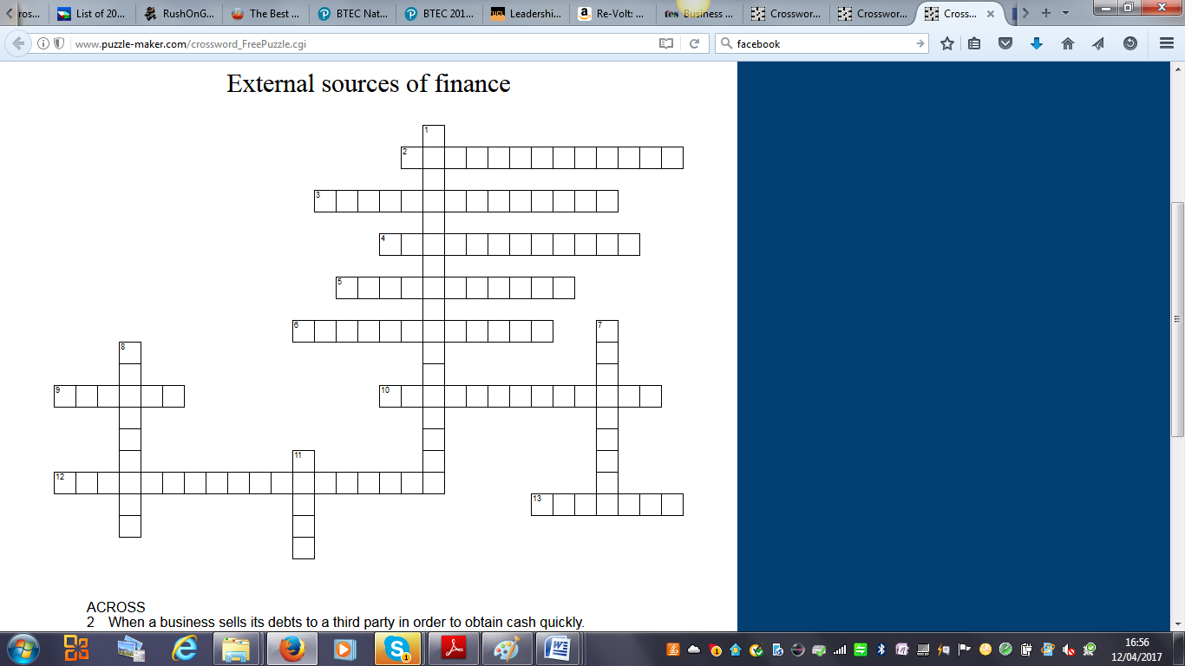

|  |  |
| --- | --- |
|  |  |
|  |  |
|  |  |
|  |  |
|  |  |
|  |  |
|  |  |
|  |  |
|  |  |
|  |  |
|  |  |
|  |  |
|  |  |
|  |  |
|  |  |

**Across**

2. When a business sells its debts to a third party in order to obtain cash quickly.

3. Investment provided by experienced entrepreneurs in return for a stake in the company.

4. Attracting investment from speculative investors. Each may invest relatively small amounts.

Once all these amounts reach the target level they are collected.

5. When suppliers allow customers to purchase a good or service and pay later.

6. Paying instalments to a company in order to use an asset. Once the last payment has been

made the business then owns the asset.

9. A lump sum provided to a business by the government or another organisation for a specific

purpose.

10. Money invested in the business from the owner's personal savings.

12. Reductions offered to customers making a product or service cheaper.

13. Paying instalments to a company in order to use an asset. Ownership of the asset always

stays with the supplier.

**Down**

1. When one business person lends money to another business person.
2. Long term loans usually lasting for 25 years. The loan is secured against an asset e.g. building.
3. Sums of money given voluntarily to a charity or social enterprise.
4. Money borrowed from a financial institution.

**Revision Task 4:** Complete the table below by providing one strength and one weakness for each internal sources of finance listed.

|  |  |  |
| --- | --- | --- |
| **External Source of Finance** | **Advantages** | **Disadvantages** |
| **Owner’s Capital** |  |  |
| **Loans** |  |  |
| **Crowd-Funding** |  |  |
| **Mortgages** |  |  |
| **Venture Capital** |  |  |
| **Debt Factoring** |  |  |

|  |  |  |
| --- | --- | --- |
| **External Source of Finance** | **Advantages** | **Disadvantages** |
| **Hire Purchases** |  |  |
| **Leasing** |  |  |
| **Trade Credit** |  |  |
| **Grants** |  |  |
| **Donations** |  |  |
| **Peer to Peer Lending** |  |  |
| **Invoice Discounting** |  |  |

**Exam Style Question:**

Susan has recently finished her studies at College and has decided to set up an online shop selling mobile phone accessories on ebay. She will run the business from her bedroom but needs to buy a computer and printer before she can start the business.

Susan knows you studied Business at school and has asked you to provide her with some basic financial help.

Q1. Identify **two** sources of finance Susan could use to fund her business start up.

1...........................................................................................................................

....................................................................................................................................2. .......................................................................................................................

................................................................................................................................................

|  |
| --- |
| **Total for Question 2 = 2 marks** |

**Exam Style Question:**

Maria owns a Spanish restaurant which she has run as a sole trader for the last five years. An opportunity has arisen for Maria to expand the business by buying a new property in a new shopping development in a nearby town. The cost of buying the property and installing all the required equipment is £350,000.

Maria knows you studied Business at school and has asked you to provide her with some basic financial help.

Q2. Identify **two** sources of finance Maria could use to fund her business expansion.

1...........................................................................................................................

....................................................................................................................................2. .......................................................................................................................

................................................................................................................................................

|  |
| --- |
| **Total for Question 2 = 2 marks** |

**Exam Style Question:**

Trevor has recently finished his degree in Website Design. He has now decided to start a business designing websites. Trevor has no significant savings and still has some loans outstanding from his studies.

To start the business Trevor needs a computer with various graphic hardware extras. In order to stay competitive it is essential that Trevor updates his hardware every 12 months.

Having researched various different funding sources Trevor is considering leasing to obtain the equipment.

Q3. Discuss the benefits of leasing computers for a business such as Trevor’s.

..........................................................................................................................................................................................................................................................................

.....................................................................................................................................

..........................................................................................................................................................................................................................................................................

.....................................................................................................................................

..........................................................................................................................................................................................................................................................................

..................................................................................................................................... ..........................................................................................................................................................................................................................................................................

.....................................................................................................................................

..........................................................................................................................................................................................................................................................................

.....................................................................................................................................

|  |
| --- |
| **Total for Question 3 = 6 marks** |

**REVISION PROGRESS CHECK**

You have now completed the tasks related to **Select and evaluate different sources of business finance** complete the table below and on the following page to identify content you are confident about and areas you want to revisit. This is the end of Learning Aim D**.**

|  |  |  |
| --- | --- | --- |
| **D Select and evaluate different sources of business finance** | | |
| **D1 Sources of Finance** | | |
| **Checklist** | **Yes** | **No - must revise** |
| I understand the short term and long term advantages, disadvantages of the following sources of finance:  Retained Profit (Internal)  Net Current Assets (Internal)  Sale of Assets (Internal)  Owner’s Capital (External)  Loans (External)  Crowd-funding (External)  Mortgages (External)  Venture Capital (External)  Debt Factoring (External)  Hire Purchase (External)  Leasing (External)  Trade Credit (External)  Grants (External)  Donations (External)  Peer to Peer Lending (External)  Invoice Discounting (External) |  |  |