## **UNIT 2 INDUCTION WEEK CLASS TASK 1**



*Welcome to Unit 2 of the BTEC Extended Certificate in Health and Social Care*

**Task 1 is all about getting to know you!**

Please prepare a two-minute presentation for your first class session.

The presentation will be all **about you** and can include some or all of the following information:

* Your name and 3 interesting facts about yourself that you would like to share (favourite book, music, holiday destination, job you would like to do etc..)
* Most interesting film or tv programme you watched during lockdown
* What interests you about continuing to study health and social care
* What are you looking forward to learning for this unit (look at the Unit Specification)
* What did you particularly enjoy learning in year one
* The job roles that you are most interested in learning about
* Skills that you have that would be useful in a health and social care role or setting.
* Study skills and life skills that you want to improve and develop this year and when applying for jobs in the future
* Any other information
* A picture of yourself (optional!)

 

You can be as creative as you like using pictures and words to create a poster or a PowerPoint presentation (no more than 4 slides).

Be ready to share your presentation with the group at your first teaching session.

Good luck!

***Yasmin (Health and Social Care Teacher)***

## **UNIT 2 INDUCTION WEEK CLASS TASK 2**

* **Read through the Unit 2 Specification**
* **Then go to the Essential Content Section of the unit 2 specification**
* Read the Essential Content Areas A1, B1, B2 and C1
* Summarise in your own words below what you think each of these areas of learning are about: We will be focusing on these four areas for the first part of this term so it is important that you become familiar with the content to be studied.

**A1 – My summary of this area**

**C1 – My summary of this area**

**B1 – My summary of this area**

**B2 – My summary of this area**

## **UNIT 2 INDUCTION WEEK CLASS TASK 3**

One of the 6 values essential in health and social care is good **communication**. Effective communication includes developing good listening skills.

Here is a link to the 6Cs in health and social care: <https://www.england.nhs.uk/6cs/wp-content/uploads/sites/25/2015/03/introducing-the-6cs.pdf>

**Read this article and reflect below what you found interesting about this article.**

**How relevant are listening skills in a health and social care setting?**

## **ARTICLE: How fine-tuned are your listening skills? Counsellors Laura Harley and Beverley Hills share their top tips to become a more active listener**

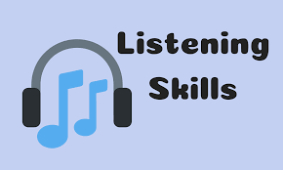 

We all like to think we’re good listeners, but when the moment arrives do we deliver? If you’ve ever found yourself glancing at your phone, planning ahead, or interjecting with personal experiences, then the chances are you haven’t been listening as closely as you think.

Listening without judgement can be even trickier. We all have opinions, and when approached by a friend or colleague, we may assume they’re looking for a solution when this isn’t actually the case. Sometimes, we just want to share – and to feel truly heard – without expectation or judgement. But is being a good listener a natural talent, or something we can all improve?

### **What is active listening?**

Active listening is all about focusing on, and engaging with, what is being said, paraphrasing the discussion, and reflecting this back – all without offering judgement or advice. Through active listening, we can help others to feel heard and valued. Over time, this can improve our relationships, by showing we are both attentive, and care about what others have to say.

### **Why is it important to be a good listener?**

“Have you ever chatted to someone and felt your words were just not sinking in?” counsellor [Beverley Hills](https://www.counselling-directory.org.uk/counsellors/beverley-hills) says, explaining why it’s so important to develop our listening skills. “They may be playing with their hair or phone. This is called passive listening; they are not really paying attention, and it leads to you feeling diminished, and unimportant – it shuts you down. Active listening is a skill all counsellors learn in order to ensure the client feels heard.”

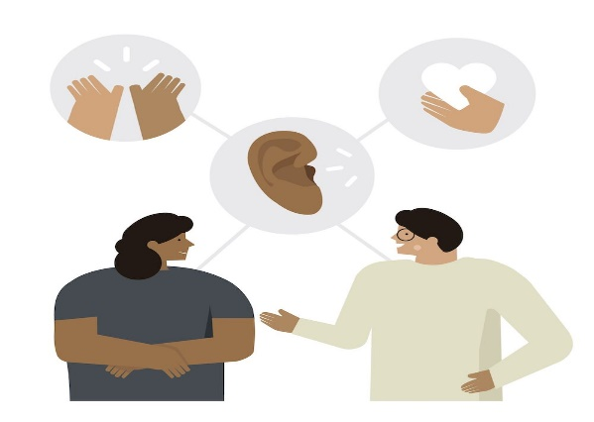

ILLUSTRATION | ROSAN MAGAR

### **How to be a better listener**

### According to online counsellor [Laura Harley](https://www.counselling-directory.org.uk/counsellors/laura-harley), when it comes to learning how to be a better listener, practise is key.

“Supportive listening is a skill which we become better at the more we practise it,” Laura says. “When we hear a loved one describe something emotive, it can be hard to keep our judgements out of the conversation – naturally, we have personal ideas around the things we have been taught to feel ashamed of or embarrassed by – but crucially, supportive listening is about the other person, not us.”

When we’re able to hear what other people have to say without allowing our personal opinions, or biases to affect the conversation, we demonstrate our skills as a good listener. We may feel a certain way about a situation, however it may not be an appropriate time to share our thoughts or feelings.

Ensuring we give the person our full attention is an important part, Beverley explains. “This can be conveyed by, among other things, [putting down your phone](https://happiful.com/how-to-stop-your-phone-from-affecting-your-relationships/), keeping eye contact, paraphrasing what’s just been said, and nodding in agreement so the speaker feels heard, understood, validated.

“So many times people appear to be listening, but instead they are formulating their own replies, ready to interject when there is a pause. Instead, let the silence continue until the speaker gives you a verbal or non-verbal clue that they are ready to continue – they may look up at you and smile, ask if you understand their viewpoint, or even cry. Whatever they do it’s their time, their space in which they can be heard.”

**Not everyone is looking for a solution. Sometimes, they just want to be heard. I think that’s something that we can all empathise with**

But why is it important to become comfortable with silence during conversations?

“What’s happening in this silence is you are giving the speaker time to think, to reflect, to add, to be,” says Beverley. “Think of the silence as a bit of breathing space, helping the speaker reframe.”

It’s good to remember that people reach out to speak with us for all manner of reasons. Not everyone is looking for a solution. Sometimes, they just want to be heard. I think that’s something that we can all empathise with.

### **5 quick tips to get you started**

• **Listen for non-verbal cues** – pay attention to body language, tone of voice, facial expressions, and gestures.  
• **Don’t interrupt** – hold any questions or attempts to relate until they’ve finished talking.  
• **Give feedback** – nod, make noises that encourage them to continue, and avoid fidgeting.  
• **Paraphrase and reflect** – summarise what the other person has said to ensure you are understanding, and show that you’re listening.  
• **Don’t offer a solution or opinion** – unless asked! If in doubt, ask if they want to vent or hear suggestions.

*Reference: Happiful Magazine (accessed: 2 September 2020)*

**Reflection on the article:**

………………………………………………………………………………………………………………………………………………………………………………………………………………………………………………………………………………………………………………………………………………………………………………………………………………………………………………………………………………………………………………………………………………………………………………………………………………………………………………………………………………………………………………………………………………………………………………………………………………………………………………………………………………………………