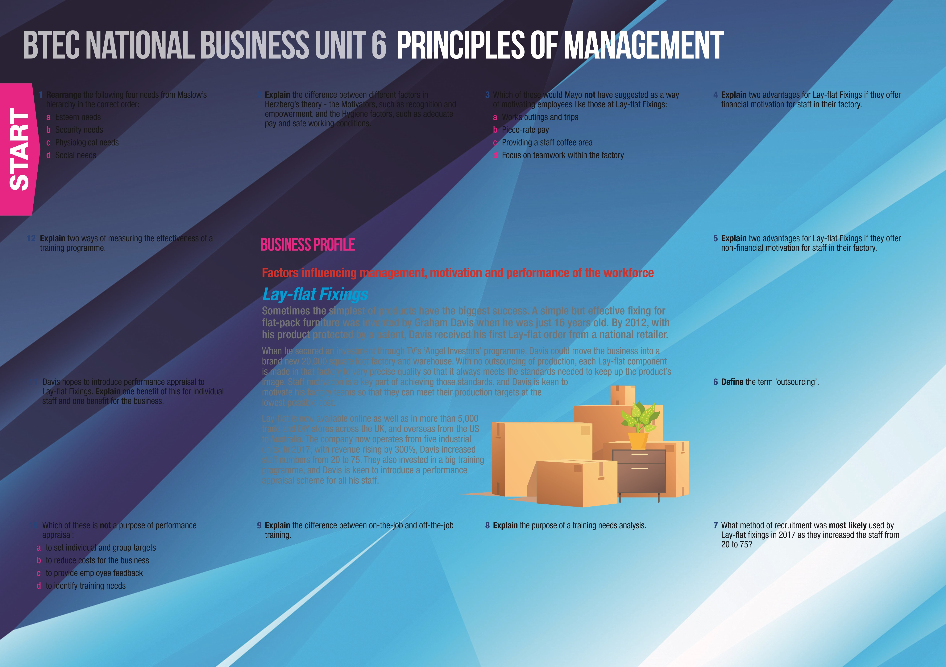

Principles of ManagemenT suggested answers

|  |  |  |  |  |  |  |  |
| --- | --- | --- | --- | --- | --- | --- | --- |
| |  | | --- | | 1 *a Esteem needs d Social needs b Security needs c Physiological needs* | | |  | | --- | | 2 *Motivators are factors that would directly motivate employees to work harder).*  *Hygiene factors would de-motivate employees if not present but would not in themselves actually motivate employees to work harder.* | | |  | | --- | | 3 *b Piece-rate pay (this comes from Taylor’s Scientific Management).* | | |  | | --- | | 4 *Helps to set goals for level of output; provides an extrinsic reward for achieving a task; may encourage staff to stay with the business (e.g. pension or subsidised meals/travel.* | |
| |  | | --- | | 12 *Improvements in performance eg fewer complaints or defects in output; greater productivity; better quality output/more repeat sales.* | | |  | | --- | | EXTENSION ACTIVITY  Now you have checked your answers to the consolidation questions, complete the extension activity below. | | |
| |  | | --- | | 1 Identify the key motivation and performance issues for Lay-flat Fixings. | |  | | |
| |  | | --- | | 5 *Greater job satisfaction leading to loyalty; improved working relationships; encourages responsibility and team work.* | |
| |  | | --- | | 11 *Benefit for staff: recognition for efforts; motivation; individual focus on performance and achievements; opportunity to discuss work-related issues; opportunity to plan for career progression.*  *Benefit for the business: time to focus on each member of staff; opportunity to match individual progress/performance with business objectives; identification of training and development needs.* | |
| |  | | --- | | 6 *Giving the contract for certain functions of the business to outside suppliers e.g. accounting, customer service.* | |
| |  | | --- | | 2 Write a report for Graham Davis, recommending a suitable method of performance appraisal for the skilled factory staff manufacturing the small metal fixings made by Lay-Flat. Your report should identify the factors which will make performance appraisal effective, and explain how it could help to motivate the staff. | | |
| |  | | --- | | 10 *b to reduce costs for the business.* | |
| |  | | --- | | 7 *External recruitment would be needed.* | |
| |  |  |  | | --- | --- | --- | | 9 *On-the-job training – employees are trained in the workplace by a supervisor or colleague; low cost; bad habits may be passed on; production may be slower until skills are learned.*  *Off-the-job training – takes place at college or other training centre away from the workplace; higher cost; may be more professional; trainee is not producing output for the business at the time of training.* |  | 8 *To identify the skills needed to achieve business objectives, existing skills in the workforce and skills gaps, and to determine training needs to fill those gaps.* | | | |