**Enterprise**

**Needs, wants and identifying opportunities**

**Key Terms**

|  |  |
| --- | --- |
| Enterprise |  |
| SME |  |
| Entrepreneur |  |

**Needs and Wants**

|  |  |
| --- | --- |
| Needs |  |
| Wants |  |

**Note**– needs and wants are not fixed, they change over time as income increases and population changes.

**Identifying opportunities**

Opportunities occur for entrepreneurs when a ***market need***/want exists to create a product or service that isn’t already available, or find one that can be improved.

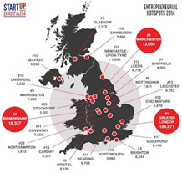This market need is preferably one that has not yet been targeted or not yet been targeted effectively. Therefore, a new entrepreneur wanting to start and run a successful business will need to find a product or service that isn’t already available, or one that can be improved on.

*Can you identify any business growth trends for 2020?*

According to the Department of BIS [*Business, Innovation and Skills*] data, 99% of all UK businesses are defined as ‘small’ (i.e. they have between 0 and 49 employees).

Interestingly, this 99% of businesses is responsible for 47% of all private sector employment in the UK and around one third of all turnover created by private enterprise.

The number of people deciding to startup businesses on their own has increased each year since 2000, despite the recession. The Government estimates that the total number of business entities increased from 3.5m to 4.9m between 2000 and 2013.(WJEC Topic Notes)

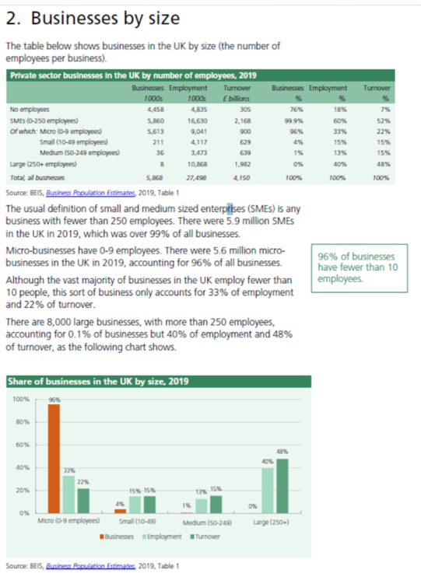

**Activities:**

1. Identify 3 features of a successful start up.

|  |
| --- |
|  |

1. In a short paragraph, explain how SMEs contribute to the economy.

|  |
| --- |
|  |

3. Using the computer to carry out research, identify and investigate at least two SMEs in your local area. Choose a business that you are interested in.

Find out:

* Is the business successful? Analyse why / why not?
* The inputs (factors of production) that are required to meet the needs and wants of customers.
* How could the business be improved?

|  |
| --- |
|  |

**Plenary**

*“Big businesses make the headlines, so why bother about the growth of small businesses?”*

Do you think this statement undervalues the importance of SMEs to the UK economy?

Justify your response (back it up! Why? Why not?)

|  |
| --- |
|  |

**Prep work for next lesson:**

1. Read the Enterprise notes on Godalming Online.

Highlight key information and make additional notes on the following:

* Why people start their own business
* Identifying business opportunities

Your notes should be a summary and therefore no more than one side of A4.

**50/50 idea:**

Read   
[*Enterprise and Entrepreneurs Reading and Questions.pdf*](https://online.godalming.ac.uk/mod/folder/view.php?id=64536)

You will find this on the Enterprise page in Business Opportunities.

Scroll down and click on 50/50 resources.

Open the business review readings folder.

Read the article and answer the questions.