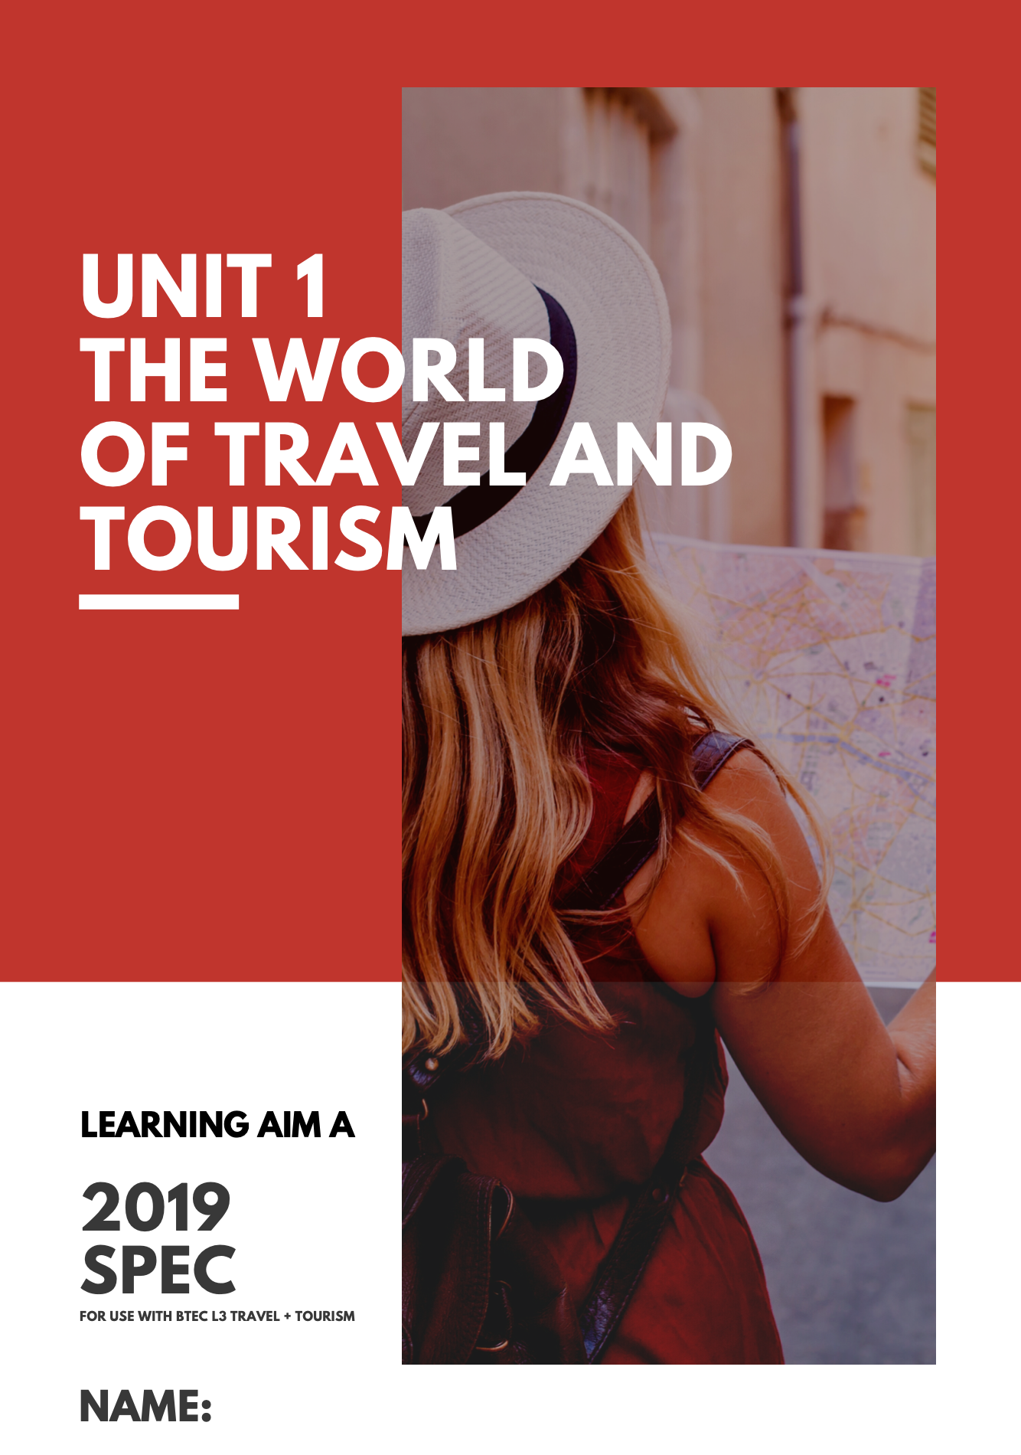

WHAT IS TOURISM?

TOPIC A1 – TYPES OF TOURISM

WHAT DO THE FOLLOWING TERMS MEAN?

DOMESTIC TOURISM:

Example:

OUTGOING/OUTBOUND TOURISM:

Example:

INCOMING/INBOUND TOURISM:

Example:

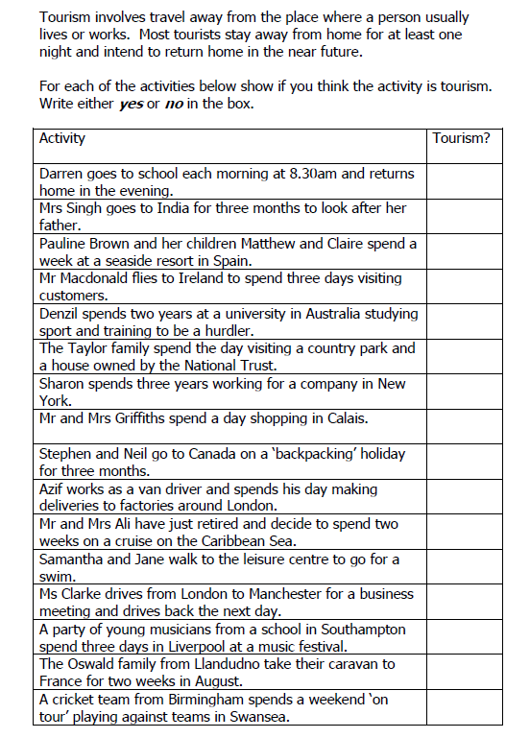

REVISION/WHAT I NEED TO KNOW FOR THE EXAM:

Types of Tourism

You must know the meaning of the following terms and understand the differences between them.

Domestic Tourism

Outbound Tourism

Inbound Tourism

You must be able to recognise and give examples of each type of tourism.

