TOPIC A3 – TYPES OF TRAVEL & TOURISM CUSTOMER

WHY DO T&T ORGANISATIONS NEED TO KNOW WHO THEIR CUSTOMERS ARE?

WHY DO THEY NEED TO KNOW THE PURPOSE OF A CUSTOMER’S TRIP?

You need to understand following types of tourism customers, and how/why their needs may vary depending on the purpose of their trips.

Firstly, let’s make sure you understand the different customer types:

INDIVIDUALS/COUPLES:

Examples of travel?

FAMILIES (with a range of ages and structures):

Examples of travel?

GROUPS:

Examples of travel?

CORPORATE TRAVEL:

Examples of travel?

CUSTOMERS WITH SPECIFIC REQUIREMENTS:

Examples of travel?

Complete the table below – for each example decide what type of customer they are and the type of travel they are undertaking.

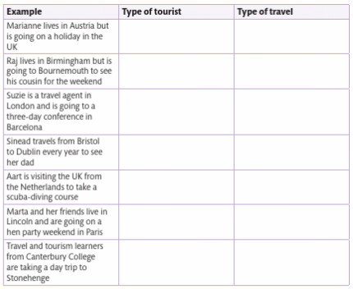

Let’s start thinking about the specific areas of needs that tourists may have:

Access/Transport

Pricing

Accommodation

Facilities

Activities/Attractions

Food/Drink

Information

Complete the table below, summarising the needs that tourism organisations should consider when dealing with each customer type:
 | Access/Transport | Pricing | Accommodation | Facilities | Activities/Attractions | Food/Drink | Information
Individual/ Couple
Families
Groups
Corporate Travellers
Customers with special requirements

Look back at your induction homework, and the holiday that you planned.
Write an explanation of how the different elements of the holiday MEET THE NEEDS OF THE CUSTOMER that you were planning for:

REVISION/WHAT I NEED TO KNOW FOR THE EXAM:

These are the different types of travel and tourism customers that you need to be aware of for your exam:

- Individuals and couples,
- Families with a range of ages and structures
- Groups, educational, senior citizens, special interest
- Corporate travellers
- Customers with specific requirements – different languages or cultures, specific needs – visual, hearing or mobility.

