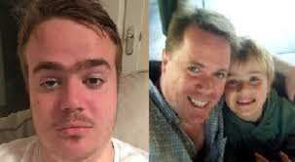 **JONTY BRAVERY**

**ATTEMPTED MURDER at the TATE MODERN**

**See News Clip Below**

**JUNE 2020**

<https://www.youtube.com/watch?v=B2VYvApH1v4>

