# Godalming College Physics Department

# WORKING WITH EXPERIMENTAL DATA PACK

Contents

WORKING WITH EXPERIMENTAL DATA 1

Definitions 2

Uncertainty 7

Quoting uncertainties 8

Repeat Readings 12

Combining uncertainties 14

Calculating and Combining Uncertainties Practice 15

Graphs 20

Plotting 20

Lines of best fit 21

Calculating Gradients 24

y=mx+c analysis 25

Drawing tangents 26

Recording Data 27

Many thanks to N.Dwyer for the use of practice material within this pack

## Definitions

**Independent variable**

This is the variable you control and choose how you alter.

**Dependent variable**

This is the variable you measure as a result of changing the one you control.

Identify the independent variable in each of these situations:

|  |  |
| --- | --- |
| **Measurement** | **Independent variable** |
| A series of readings of current and voltage for a resistor are taken. The voltage is adjusted and the corresponding current read each time. |  |
| A series of masses is placed on a spring and the length of the spring is measured |  |
| A ray of light is shone into a glass block and a set of angles of incidence and angles of refraction are measured |  |
| Laser light is passed through a set of double slits. The separation of the slits is measured. The fringe separation is measured for different separations of the double slits and the screen. |  |

The time for a pendulum to execute 20 swings is taken three times for a range of lengths.

**Q1.** Which column in this set of experimental results for this contains the independent variable?

|  |  |  |  |  |
| --- | --- | --- | --- | --- |
| l/m | 10T1/s | 10T2/s | 10T3/s | 10Tav/s |
| 1.310 | 22.94 | 23.07 | 22.65 | 22.89 |
| 1.075 | 20.77 | 20.91 | 20.63 | 20.77 |
| 0.903 | 18.91 | 18.88 | 19.24 | 19.01 |
| 0.814 | 18.21 | 18.15 | 18.12 | 18.16 |
| 0.736 | 17.27 | 17.26 | 17.06 | 17.20 |
| 0.647 | 16.19 | 16.21 | 15.90 | 16.10 |
| 0.553 | 14.87 | 15.02 | 15.01 | 14.97 |
| 0.477 | 13.93 | 13.91 | 13.93 | 13.92 |
| 0.367 | 12.15 | 12.06 | 12.22 | 12.14 |
| 0.305 | 11.29 | 11.08 | 11.11 | 11.16 |

**Random error**

Random errors occur all the time when you take readings. There is no obvious pattern to them and they are as likely to be too low as too high. Repeating and averaging readings reduces the effect of random error.

**Systematic error**

This is an error that is inbuilt. Sources of systematic error can include the environment, methods of observation or instruments used. For example using a badly manufactured rule on which the centimetre markings were in fact only 9mm apart or an ammeter that consistently reads too low. These cause readings to differ from the true value by a consistent amount each time a measurement is made.

Systematic errors cannot be dealt with by simple repeats. If a systematic error is suspected, the data collection should be repeated using a different technique or a different set of equipment, and the results compared.

**Zero error**

This is when an instrument does not read zero when it is supposed to. You should always check that a micrometer for example, reads zero when the jaws are closed. Over-tightening a micrometer can easily cause a zero error to develop. If the zero is not correct then the readings taken must be corrected for the zero error.

**Q2**. Identify the type of error that has occurred in each of these cases:

|  |  |  |
| --- | --- | --- |
| **Measurement** | **Type of error** | **Possible reason** |
| A range of values are obtained for a fixed length of a copper wire measured using a metre rule |  |  |
| The reading for the current through a wire is 0.74A higher for one student, whilst the others all obtain similar values |  |  |
| Thermometers placed in the same beaker of water show different temperature readings |  |  |
| A mass of a beaker shows different values on different balances |  |  |
| A set of readings are taken for the distance between a gamma source and a detector. Both the gamma source and the detector have a cover on which makes it difficult to know exactly where the source is and where the detecting element is |  |  |
| A number of students obtain data to plot a force-extension graph for a spring. Some of the graphs do not pass through zero and show a force applied for zero extension |  |  |
| The time for 20 oscillations of a pendulum is determined 3 times. All the readings are similar but not identical |  |  |
| The diameter of a piece of 32SWG copper wire measured with a micrometer is consistently significantly lower than it should be |  |  |
| A set of readings are taken with a micrometer. When the jaws are closed it reads 0.04 mm below zero |  |  |

**Reliability**

Reliable means that you should get a consistent value every time a measurement is repeated. The value may not be identical but it should be within acceptable limits.

**Anomalous results**

This are results that do not fit with the rest. They are noticeably (not just a little bit) different from the rest. These are values in a set of results, which are judged not to be part of the variation caused by random uncertainty.

**Q3**. Identify the anomalous values in each row of this table

|  |  |  |  |
| --- | --- | --- | --- |
|  | **A** | **B** | **C** |
| 1 | 4152 | 2996 | 4018 |
| 2 | 935.5 | 925.8 | 926.7 |
| 3 | 80.1316 | 80.1324 | 80.1466 |
| 4 | 2229 | 2011 | 1610 |
| 5 | 3.767 | 3.763 | 3.751 |
| 6 | 27145 | 25157 | 26017 |
| 7 | 9104.32 | 10529.45 | 9160.97 |

|  |  |
| --- | --- |
| Row number | Column letter for the anomaly |
| 1 |  |
| 2 |  |
| 3 |  |
| 4 |  |
| 5 |  |
| 6 |  |
| 7 |  |

**Q4**. For this table, for each row, calculate the mean from all the values given, then calculate it ignoring any values you consider anomalous.

|  |  |  |  |  |  |
| --- | --- | --- | --- | --- | --- |
| **1** | **2** | **3** | **4** | **Mean** | |
| All values | Excluding anomalies |
| 63.10 | 62.97 | 62.53 | 62.99 |  |  |
| 465.98 | 463.40 | 466.96 | 155.56 |  |  |
| 3.61 | 7.39 | 3.55 | 3.64 |  |  |
| 73.71 | 70.98 | 74.19 | 72.38 |  |  |
| 2.058 | 1.566 | 2.078 | 1.787 |  |  |
| 416 | 402 | 189 | 986 |  |  |
| 700653 | 739762 | 742471 | 726161 |  |  |
| 2670887 | 2670901 | 2669942 | 2670733 |  |  |
| 110.4 | 260.1 | 1044.2 | 488.8 |  |  |

Which set of means comes from the more reliable data?

**Accuracy**

An accurate measurement is one from correctly used well-calibrated instruments with no systematic errors and is also related to the uncertainty in the measurement. Accuracy refers to how near a measurement is to an accepted standard. This means you must be able to look up a standard value in a data book for comparison. If there is no standard value then you cannot comment on the accuracy of your measurement.

**Precision/Sensitivity**

The precision or sensitivity of an instrument is the smallest non-zero measurement you can make with it. Precise/sensitive readings are not necessarily accurate – they may all be higher or lower than they should be. Precision/sensitivity refers to the ability of an instrument to distinguish between very close values. It is the smallest difference that it can reliably measure, and is normally the smallest interval on its scale.

If you have a set of values given to you then you normally take the precision/sensitivity to be ± smallest division shown. E.g. an ammeter reading is stated as 5.432 A. You would take the precision/sensitivity to be ± 0.001 A. (Note the use of ±).

**Q5**. If *T* represents the true value, which of the graphs below represents:

A. Precise and accurate?

B. Precise but not accurate?

C. Accurate but not precise?

D. Neither accurate nor precise?

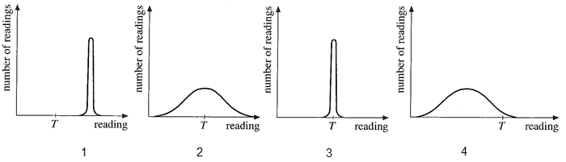

Explain how you identified which graph(s) represented a set of accurate readings.

Explain how you identified which graph(s) represented a set of precise readings.

**Q6**. Some students perform an experiment in which they measure the acceleration due to gravity. They measure the height a ball falls from to the nearest mm and they measure the time to the nearest 0.01s. They obtain a value of 9.62 ms-2. A data book gives a value of 9.81 ms-2 for this.

What is the precision/sensitivity of:

The height measurement ………………………………………………………………

The time measurement…………………………………………………………………

Can the accuracy of the measurement be determined? ……………………………….

**Q7.** Some students measure the length of a rod they find lying around in the laboratory using a metre rule graduated in cm.

What is the precision/sensitivity of:

The length measurement………………………………………………………………..

Can the accuracy of the measurement be determined? ………………………………..

**Q8.** Some students determine the density of a cup of coffee using a measuring cylinder graduated in cm3 and a balance reading to 0.01g.

What is the precision/sensitivity of:

The volume measurement ……………………………………………………………

The mass measurement…………………………………………………………………

Can the accuracy of the measurement be determined? ……………………………….

**Q9.** Some students determine the Young Modulus of Brass. They measure the length of the wire using a measuring tape graduated in cm, the extension using a scale measuring to the nearest 0.1 mm, the diameter using a micrometer measuring to 0.01mm. The masses were found to be within 10g of their stated value. They obtained a value of 9.8 x 109 Pa. A data book gives the value of the Young Modulus of Brass as 1.0 x 1010 Pa.

What is the precision/sensitivity of:

The length measurement ………………………………………………………………

The extension measurement……………………………………………………………

The diameter measurement ……………………………………………………………

The mass measurement…………………………………………………………………

Can the accuracy of the measurement be determined? ……………………………….

## Uncertainty

No instrument is perfect. There is always an uncertainty in the measurement you take. Measurements are seldom absolutely identical – they usually vary a little. Uncertainly depends on:

* The precision of the instrument used – its smallest division
* The manufacturing tolerance it was made to
* Your judgement when you take a reading
* The procedure used e.g. whether readings are repeated

What you use for the percentage uncertainty depends on the situation:

Start Here

Different multiple readings of the same thing

Single reading (possibly in a series) or identical multiple readings

Find the range and divide by two

Determine the sensitivity of the instrument (smallest scale division)

Pick the biggest of the two

Determine the sensitivity of the instrument (smallest scale division)

This is the uncertainty, Δx

Calculate the % uncertainty

% uncertainty = uncertainty x 100

average value

This is the instrument uncertainty, Δx

Calculate the % uncertainty

% uncertainty = uncertainty x 100

value

### Quoting uncertainties

When you quote the uncertainty of an instrument, you quote ± smallest division in all cases.

There is also the added complication of considering whether what you are recording is regarded as a reading or a measurement. A selection (not exhaustive) of these is in the table below.

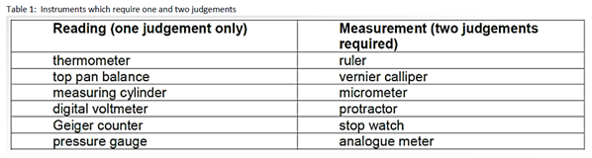

***The quoted uncertainty is the same for both readings and measurements, BUT the value you use to calculate the % uncertainty is different.***

When calculating % uncertainties (also sometimes called % errors in the readings/measurements) you use:

± half the smallest division for a reading:

% uncertainty for a reading = ± half the smallest division x 100

average value

± the smallest division for a measurement:

% uncertainty for a measurement = ± smallest division x 100

average value

There is nothing intuitive about this and the **only way** to get better at applying this rule correctly is to practice doing uncertainties frequently in **every** practical report.

Let’s deal first of all with the case where you have a single value given or all the readings are identical.

**Q10.**

|  |  |
| --- | --- |
| I/A | V/V |
| 0.393 | 1.379 |
| 0.316 | 1.392 |
| 0.283 | 1.396 |
| 0.196 | 1.414 |
| 0.138 | 1.428 |
| 0.128 | 1.431 |
| 0.092 | 1.438 |
| 0.085 | 1.438 |

Based on the data given

|  |  |
| --- | --- |
| Quantity | Uncertainty |
| I |  |
| V |  |

**Q11.**

Slit separation, s = 0.1 mm

|  |  |
| --- | --- |
| D/m | w/mm |
| 0.200 | 1.28 |
| 0.220 | 1.44 |
| 0.240 | 1.58 |
| 0.260 | 1.59 |
| 0.280 | 1.68 |
| 0.300 | 1.95 |

Based on the data given

|  |  |
| --- | --- |
| Quantity | Uncertainty |
| s |  |
| D |  |
| w |  |

**Q12**. A student measures the diameter of some glass beads and obtains the following values:

|  |  |  |  |
| --- | --- | --- | --- |
| **Repeat** | 1 | 2 | 3 |
| **Diameter/mm** | 2.22 | 2.22 | 2.22 |

Use the information in the flow chart and the table of readings/measurements to help you.

State the uncertainty in the diameter

Calculate the percentage uncertainty (%U) in the diameter.

**Q13**. A digital electrical meter is set to the 200 mA range.

What is the uncertainty in a reading on this ammeter and the % uncertainty when it reads

(a) 2.6 mA?

Uncertainty =

% uncertainty =

(b) 14.3 mA?

Uncertainty =

% uncertainty =

**Q14.** A student measures the mass of a beaker of water to be 342.03g.

(a) What was the precision/sensitivity/resolution of the instrument?

(b) Is the mass value regarded as a reading or a measurement?

(c) What is the uncertainty in the value?

(d) What is the % uncertainty?

**Q15.** A student measures the length of a piece of wire to be 26.4 cm.

(a) What was the precision/sensitivity/resolution of the instrument?

(b) Is the length value regarded as a reading or a measurement?

(c) What is the uncertainty in the value?

(d) What is the % uncertainty?

**Q16.** A student measures the width of a can using Vernier callipers and obtains a value of 260.03 mm

(a) What was the precision/sensitivity/resolution of the instrument?

(b) Is the width value regarded as a reading or a measurement?

(c) What is the uncertainty in the value?

(d) What is the % uncertainty?

**Q17.** A student measures the temperature of a beaker of water with two different thermometers. One graduated in °C reads 35°C and the other graduated in 0.5°C reads 35.5°C

(a) What was the precision/sensitivity/resolution of the instruments?

The one graduated in °C

The one graduated in 0.5°C

(b) Is the temperature value regarded as a reading or a measurement?

(c) Which thermometer has the better precision/resolution?

(d) What is the uncertainty in the 35°C value?

(e) What is the % uncertainty for this value?

**Q18.** A student measures the temperature of a beaker of water firstly before and after adding an ice cube. The readings are 43°C and 37°C.

(a) What was the temperature change?

(b) What was the precision/sensitivity/resolution of the instruments?

(c) Is the temperature difference a reading or a measurement?

(d) What is the uncertainty in the temperature difference value?

(e) What is the % uncertainty?

### Repeat Readings

Now let’s turn to cases in which multiple (repeat) readings are taken ***for the same data point*** and are non-identical. The range is the difference between the highest and lowest values obtained.

**Q19.** The table below records the height a ball rebounds to when it is dropped onto the floor from the same initial height four times. The height was determined by eye using an extended metre rule arrangement behind the ball.

|  |  |  |  |  |
| --- | --- | --- | --- | --- |
| **Repeat** | 1 | 2 | 3 | 4 |
| **Height/m** | 1.23 | 1.32 | 1.27 | 1.22 |

There are two things to look at here:

the uncertainty we can see in the instrument/measuring device used to record the height and the range.

Is this a reading or a measurement (see p8)?

State the uncertainty due to the measuring device used.

Calculate the range for these results

Which one is largest?

Which therefore do you state as the uncertainty you were going to use?

Calculate the % uncertainty in the measurement (refer back to the flow chart on p7)

**Q20.** A student measures the diameter of a piece of wire 4 times and obtains the following values:

d/mm 0.55 , 0.56, 0.57, 0.55

(a) Is the diameter value regarded as a reading or a measurement?

(b) What was the precision/sensitivity/resolution of the instrument?

(c) What was the range for these values?

(d) Which should you use for the uncertainty - precision/sensitivity/resolution or the range?

(e) Calculate the average diameter of the wire

(f) What is the % uncertainty?

**Q21.** A student measures the time for ten oscillations of a pendulum three times for ten different lengths.

Remember the range refers specifically to readings taken for the same data point so it refers to the entries in a row of this table where the times have been repeated before averaging.

|  |  |  |  |  |
| --- | --- | --- | --- | --- |
| **l/m** | **10T1/s** | **10T2/s** | **10T3/s** | **10Tav/s** |
| 1.310 | 22.94 | 23.07 | 22.65 | 22.89 |
| 1.075 | 20.77 | 20.91 | 20.63 | 20.77 |
| 0.903 | 18.91 | 18.88 | 19.24 | 19.01 |
| 0.814 | 18.21 | 18.15 | 18.12 | 18.16 |
| 0.736 | 17.27 | 17.26 | 17.06 | 17.20 |
| 0.647 | 16.19 | 16.21 | 15.90 | 16.10 |
| 0.553 | 14.87 | 15.02 | 15.01 | 14.97 |
| 0.477 | 13.93 | 13.91 | 13.93 | 13.92 |
| 0.367 | 12.15 | 12.06 | 12.22 | 12.14 |
| 0.305 | 11.29 | 11.08 | 11.11 | 11.16 |

For the row in red (5th row down where

l = 0.736m)

(a) What is the average time for ten oscillations at this length?

(b) What is the uncertainty in 10T?

(Think about precision/sensitivity/resolution and the range)

(c) What is the % uncertainty in 10T for this data point?

### Combining uncertainties

Percentage uncertainties should be combined using the following rules, where, for example %Ua means the % uncertainty in a:

|  |  |  |
| --- | --- | --- |
| **Combination** | **Operation** | **Example** |
| **Adding or subtracting values** | Add the absolute uncertainties  Δa = Δb + Δc | Object distance, *u* = (5.0 ± 0.1) cm  Image distance, *v* = (7.2 ± 0.1) cm  Difference (*v* – *u*) = (2.2 ± 0.2) cm |
| **Multiplying values** | Add the percentage uncertainties  %U a = %Ub + %Uc | Voltage = (15.20 ± 0.1) V  Current = (0.51 ± 0.01) A  Percentage uncertainty in voltage = 0.7%  Percentage uncertainty in current = 1.96 %  Power = Voltage x current = 7.75 W  Percentage uncertainty in power = 2.66 %  Absolute uncertainty in power = ± 0.21 W |
| **Dividing values** | Add the percentage uncertainties  %Ua = %Ub + %Uc | Mass of object = (30.2 ± 0.1) g  Volume of object = (18.0 ± 0.5) cm3  Percentage uncertainty in mass of object = 0.3 %  Percentage uncertainty in volume = 2.8 %  Density = 30.2 = 1.68 gcm-3  18.0  Percentage uncertainty in density = 3.1 %  Absolute uncertainty in density = + 0.05 gcm-3 |
| **Power rules** | Multiply the percentage uncertainty by the power  %U a = c × %Ub | Radius of circle = (6.0 ± 0.1) cm  Percentage uncertainty in radius = 1.6 %  Area of circle = πr2 = 20.7 cm2  Percentage uncertainty in area = 3.2 %  Absolute uncertainty = ± 0.7 cm2  (Note – the uncertainty in π is taken to be zero) |

Note:

Absolute uncertainties (denoted by Δ) have the same units as the quantity.

Percentage uncertainties (denoted by %U) have no units.

Uncertainties in trigonometric and logarithmic functions will not be tested in A-level exams.

### Calculating and Combining Uncertainties Practice

(Courtesy of N. Dwyer)

**Q22** Complete the table*.*

|  |  |  |  |  |  |  |
| --- | --- | --- | --- | --- | --- | --- |
| **Variable** | **Reading 1** | **Reading 2** | **Reading 3** | **Mean Value** | **Uncertainty** | **% Uncertainty** |
| *A* | 121 | 118 | 119 |  |  |  |
| *B* | 599 | 623 | 593 |  |  |  |
| *C* | 3.3 | 3.6 | 3.2 |  |  |  |

**Q23**. What would be the percentage error in the following quantities?

|  |  |  |  |
| --- | --- | --- | --- |
|  |  |  |  |
|  |  |  |  |
|  |  |  |  |

**Q24** Complete the table.

|  |  |  |  |  |  |  |
| --- | --- | --- | --- | --- | --- | --- |
| **Variable** | **Reading 1** | **Reading 2** | **Reading 3** | **Mean Value** | **Uncertainty** | **% Uncertainty** |
| *D* | 17 | 17 | 17 |  |  |  |
| *E* | 42.5 | 42.8 | 42.1 |  |  |  |
| *F* | 3.60 | 3.28 | 3.73 |  |  |  |
| *G* | 757 | 714 | 739 |  |  |  |

**Q25**. What would be the percentage error in the following quantities?

|  |  |  |  |
| --- | --- | --- | --- |
|  |  |  |  |
|  |  |  |  |
|  |  |  |  |
|  |  |  |  |

**Q26.** Complete the table.

|  |  |  |  |  |  |  |
| --- | --- | --- | --- | --- | --- | --- |
| **Variable** | **Reading 1** | **Reading 2** | **Reading 3** | **Mean Value** | **Uncertainty** | **% Uncertainty** |
| *H* | 58205 | 58309 | 58193 |  |  |  |
| *I* | 82.3 | 81.4 | 82.8 |  |  |  |
| *J* | 1985 | 1988 | 1980 |  |  |  |
| *K* | 43 | 19 | 27 |  |  |  |

**Q27.** What would be the percentage error in the following quantities?

|  |  |  |  |
| --- | --- | --- | --- |
|  |  |  |  |
|  |  |  |  |
|  |  |  |  |
|  |  |  |  |

**Q28.** Complete the table.

|  |  |  |  |  |  |  |  |
| --- | --- | --- | --- | --- | --- | --- | --- |
| **Variable** | **1** | **2** | **3** | **4** | **Mean Value** | **Uncertainty** | **% Uncertainty** |
| *L* | 11.49 | 11.56 | 11.63 | 10.53 |  |  |  |
| *M* | 385 | 322 | 408 | 328 |  |  |  |
| *N* | 2736 | 2729 | 2743 | 2643 |  |  |  |
| *O* | 5101 | 5108 | 5003 | 5098 |  |  |  |
| *P* | 125 | 137 | 167 | 142 |  |  |  |
| *Q* | 6124 | 6118 | 6510 | 6123 |  |  |  |
| *R* | 3.29 | 3.29 | 3.29 | 3.29 |  |  |  |
| *S* | 4589 | 4606 | 4644 | 4596 |  |  |  |
| *T* | 417 | 488 | 460 | 456 |  |  |  |
| *U* | 1.506 | 3.061 | 3.085 | 1.513 |  |  |  |
| *V* | 274 | 333 | 338 | 277 |  |  |  |
| *W* | 33.46 | 33.45 | 33.96 | 33.65 |  |  |  |

**Q29.** What would be the percentage error in the following quantities?

|  |  |  |  |
| --- | --- | --- | --- |
|  |  |  |  |
|  |  |  |  |
|  |  |  |  |
|  |  |  |  |
|  |  |  |  |
|  |  |  |  |
|  |  |  |  |
|  |  |  |  |
|  |  |  |  |
|  |  |  |  |
|  |  |  |  |
|  |  |  |  |

**Q30.** A student measures the diameter of a wire to be 0.37 mm using a micrometer.

(a) What was the precision/sensitivity/resolution of the instrument used?

(b) Is the diameter reading regarded as a reading or a measurement?

(c) What is the uncertainty in the value?

(d) Calculate the cross-sectional area of the wire

(e) What is the % uncertainty in the area?

**Q31**. A student measures the potential difference across a wire to be 2.72 V and the current through it to be 0.12 A.

(a) Calculate the resistance of the wire

(b) Calculate the % uncertainty in each of the readings

Potential difference:

Current:

(c) What is the % uncertainty in the resistance value?

**Q32**. A student measures 5 fringe separations (5w) to be 12.45 mm

(a) What was the precision/sensitivity/resolution of the instrument?

(b) Is the 5 fringe separation value regarded as a reading or a measurement?

(c) What is the uncertainty in the value of 5w?

(d) What is the % uncertainty for this value?

They also recorded the distance between the double slit and the eyepiece to be 65.0 cm

(e) What was the precision/sensitivity/resolution of the instrument?

(f) Is this distance value regarded as a reading or a measurement?

(g) What is the uncertainty in the value?

(h) What is the % uncertainty for this value?

The slit separation was given as 0.10 mm.

(i) What does this imply you should take as the uncertainty?

(j) What is the % uncertainty for this value?

(k) Calculate the wavelength of the light used.

(l) What is the % uncertainty for this value?

**Q33**. A student measures the length of a wire to be 1.23 m, its resistance to be 0.32 Ω and its diameter to be 0.22 mm.

(a) Calculate the resistivity of the wire

(b) Calculate the % uncertainty in each of the readings

Length of the wire

Resistance

Diameter

(c) What is the % uncertainty in the value of the resistivity that you have calculated?

**Q34**. Some students determine the Young Modulus of Brass. They measure the length of the wire to be 2.02m, the diameter to be 0.46m and the extension to be 3.9 mm, for an applied mass of 2.50 kg.

(a) Calculate the value this gives for the Young Modulus

(b) Calculate the % uncertainty in this value based on the data given

What does this give for the upper and lower limits of the value obtained?

(c) Is the value in the Data Book of 100GPa included in this range?

(d) Based on your answer to (c), would you say the value obtained was accurate?

## Graphs

### Plotting

* Points should be marked with a cross so that they can still be seen when the line is drawn
* Points should occupy more than half of the graph paper in both directions

**Q35.**

|  |  |  |  |  |  |  |  |  |
| --- | --- | --- | --- | --- | --- | --- | --- | --- |
| **x axis** | 0.28 | 0.32 | 0.36 | 0.40 | 0.44 | 0.48 | 0.52 | 0.56 |
| **y axis** | 1.54 | 1.82 | 2.36 | 2.39 | 2.54 | 2.90 | 3.30 | 3.60 |

* Plot these points on the grid below:
* Draw a line of best fit on the graph. First decide if any points are anomalous, then draw the best fit line (can be straight or a curve) through the points. The line does not have to pass through any of the points and the points above the line should be counterbalanced by the points below the line e.g. 3 above, 3 below.

### Lines of best fit

**Q36**. Draw a line of best fit for each of the graphs below. (Courtesy of N. Dwyer)

When plotting a graph:

* Points should be marked with a cross so that they can still be seen when the line is drawn
* Points should occupy more than half of the graph paper in both directions
* Scales should be in multiples of 2, 5 and 10.
* Axes should be labelled with the quantity and the unit (if appropriate). This should be in the format F/N for example where F is a force measured in Newtons
* Never force the line to do through the origin just because you expect it to. The best fit line should be based on the points plotted

**Q37.** What is wrong with each of the following graphs?

(a)

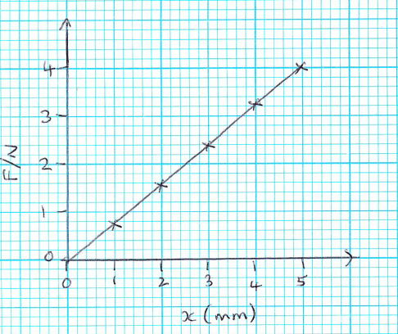

(b)

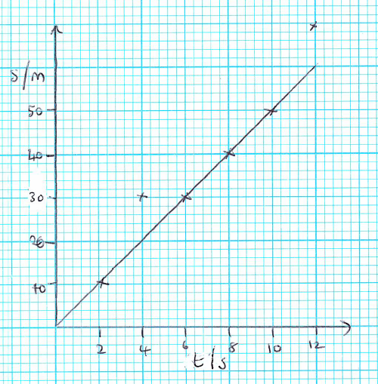

(c)

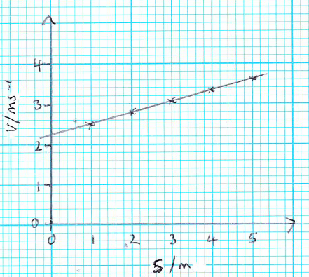

(d)

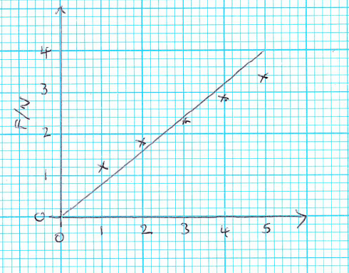

(e)

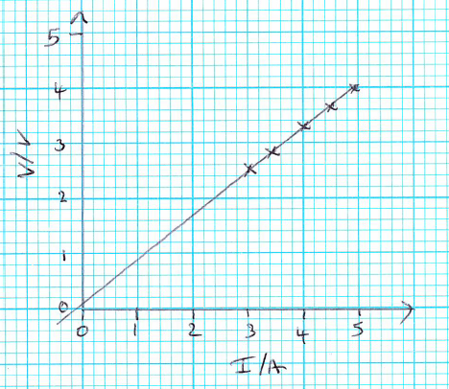

(f)

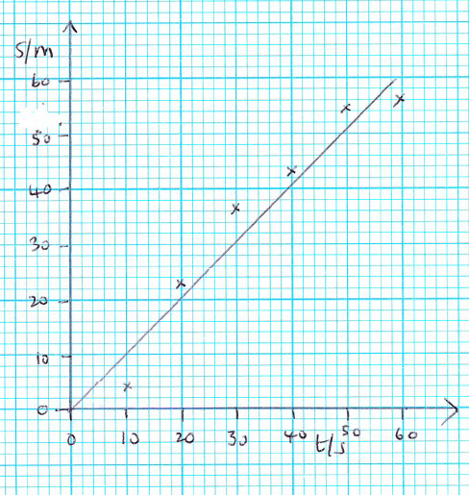

(g)

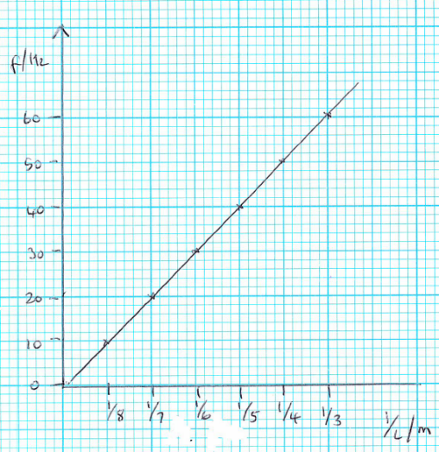

(h)

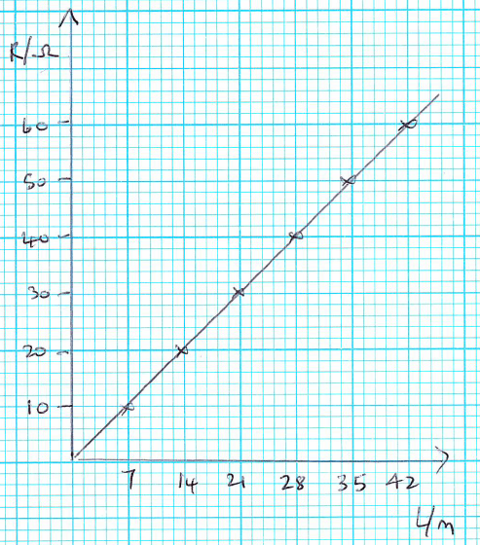.

### Calculating Gradients

**Q38.** Calculate the gradients of the graphs below. Work out the equation for the line. (Courtesy of N. Dwyer).

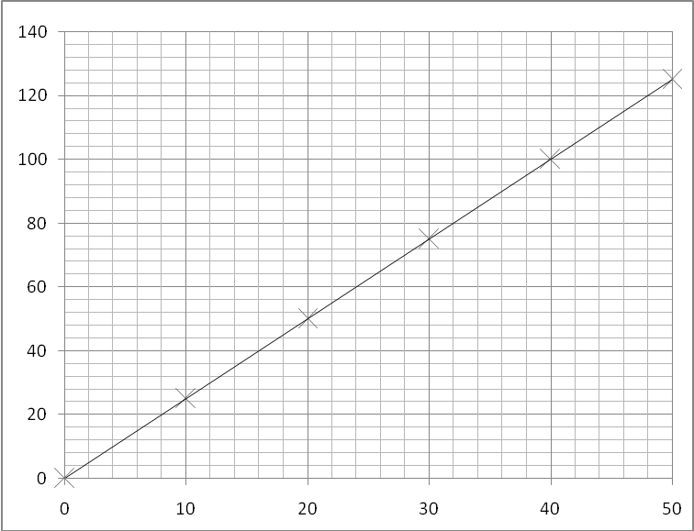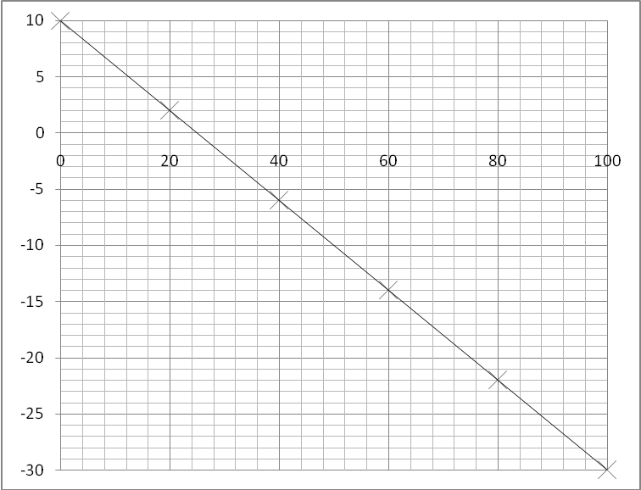

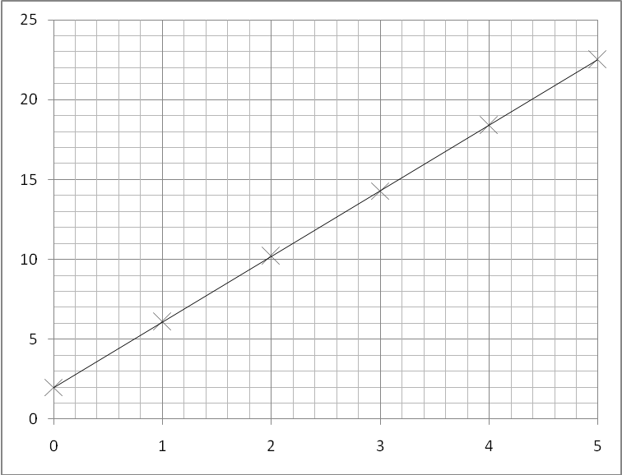

### y=mx+c analysis

**Q39**. Complete the table below. (Courtesy of N. Dwyer).

|  |  |  |  |  |
| --- | --- | --- | --- | --- |
| **Equation** | **Graph** | **Rearranged Equation** | **Gradient** | **Intercept** |
|  | y plotted on the y axis |  | *m* | *c* |
| x plotted on the x axis |
|  | y axis = *I* |  |  |  |
| x axis = *V* |
|  | y axis = *t* |  |  |  |
| x axis = *Q* |
|  | y axis = *l* |  |  |  |
| x axis = *R* |
|  | y axis = *V* |  |  |  |
| x axis = *I* |
|  | y axis = *EK* |  |  |  |
| x axis = *f* |
|  | y axis = 1*/v* |  |  |  |
| x axis = *m* |
|  | y axis = *m* |  |  |  |
| x axis = *EP* |
|  | y axis = 1*/λ* |  |  |  |
| x axis = *f* |
|  | y axis = *a* |  |  |  |
| x axis = 1*/t* |
|  | y axis = *v2* |  |  |  |
| x axis = *s* |
|  | y axis = *v* |  |  |  |
| x axis = *s* |
|  | y axis = *λ* |  |  |  |
| x axis = *w* |
|  | y axis = *T2* |  |  |  |
| x axis = *l* |
|  | y axis = *T*2 |  |  |  |
| x axis = *m* |
|  | y axis = *V* |  |  |  |
| x axis = *Q* |
|  | y axis = *R3* |  |  |  |
| x axis = *A* |
|  | y axis = *T* |  |  |  |
| x axis = *V* |

### Drawing tangents

**Q40**. Draw tangents to the lines (Courtesy of N. Dwyer).

1. At the following values along the x-axis: 225, 360, 630 and 1035

**Q41.** Draw a tangent to the line and calculate its gradient at the following x-axis values:

(b)2.0 and 3.9 (c) 1.5 and 3.0

(d)2.2 and 4.0 (e) 1.6 and 3.4

## Recording Data

Most frequently, the data you record will be presented neatly in a table.

* The table should be enclosed
* Columns should have the quantity and the unit (if appropriate). This should be in the format F/N for example where F is a force measured in Newtons
* Correct symbols or names should be used in the headings
* Data should be recorded to a consistent number of s.f.
* Data should reflect the the precision/sensitivity/resolution of the instrument used for measurement
* Constant values may be listed separately above the table

**Q42.** Transfer the following messy data into the correct format in a logical order, completing all the additional table columns as well. Pay attention to the significant figures.

30.6 cm with no mass on

50g 31.5 cm, 100g, 33.3 cm, 300g, 40.3cm

150g, 35 cm, 200g, 36.8 cm, 250g, 38.5cm, 350g, 42cm, 400g, 43.5g

|  |  |  |  |  |  |
| --- | --- | --- | --- | --- | --- |
| Mass/g | Mass/kg | F/N | Rule reading/cm | Extension/cm | Extension/m |
|  |  |  |  |  |  |
|  |  |  |  |  |  |
|  |  |  |  |  |  |
|  |  |  |  |  |  |
|  |  |  |  |  |  |
|  |  |  |  |  |  |
|  |  |  |  |  |  |
|  |  |  |  |  |  |
|  |  |  |  |  |  |

**Q43**. What is wrong with this table?

|  |  |
| --- | --- |
| D (cm) | W (mm) |
| 20 | 1.12 |
| 25.0 | 1.3 |
| 32 | 1.4 |
| 40.6 | 1.78 |

**Q44**. What is wrong with this table?

|  |  |  |  |
| --- | --- | --- | --- |
| V/V | Ampage/I | Ampage/I | Ave. ampage/I |
| 2.0 | 1.0 | 1.1 | 1.05 |
| 4.0 | 2.2 | 2.2 | 2.2 |
| 6.0 | 3.0 | 3 | 3 |
| 8.0 | 4.1 | 4.3 | 4.15 |