Cost curves in Economics

- The Law of Diminishing returns
- Marginal costs, Total costs ,Average costs , Variable costs & Fixed cost
- The relationship between Cost curves and Product curves
- Revenue curves (total, marginal and average)
- Profits – normal and super normal

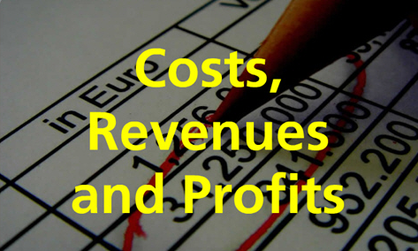

The Law of Diminishing Returns

Definitions (D) and Assumption (A)
The Law of Diminishing (A) – we assume we are working under short run conditions.
The short run (D) – The time period in which only some variable may change. The time period in which a firm cannot add to existing stock of fixed factors. So more employees might be put to work with the same stock of equipment.
The long run (D) – In contrast, in the long run, inputs of all factors of production may be changed.
Variable factors of production (D) (sometimes simply called variable factors) – Are those factors of production that can be varied in quantity in the short run. Raw material or component inputs are an example.
Fixed factors of production (D) – are the resource inputs to a production process, the quantity of which cannot be altered in the short run. In other words, the quantity of the factor employed does not change with the level of output.

Activity 1: complete the table below.
Workers  (variable) | Land  (fixed) | Capital  (fixed) | Total product  (tonnes/potatoes) | Marginal physical product  (tonnes/potatoes) | Average physical product  (tonnes/potatoes)
1 | 6 acres | 2 tractors | 10 tonnes | 10 | 10
2 | 6 acres | 2 tractors | 30 tonnes
3 | 6 acres | 2 tractors | 58 tonnes
4 | 6 acres | 2 tractors | 93 tonnes
5 | 6 acres | 2 tractors | 128 tonnes
6 | 6 acres | 2 tractors | 158 tonnes
7 | 6 acres | 2 tractors | 182 tonnes
8 | 6 acres | 2 tractors | 199 tonnes
9 | 6 acres | 2 tractors | 205 tonnes
10 | 6 acres | 2 tractors | 205 tonnes
11 | 6 acres | 2 tractors | 190 tonnes

Definitions
- Marginal physical products: the addition to total product which results from employing one more unit of a variable factor i.e the last workers output.

- Average physical product = total product / amount of variable factored employed

Law of Diminishing returns: Occurs when, as a producer adds more of a variable factor of production to a fixed quantity of other factor of production, the output increase but less than proportionately.

Extension activity

Capital | Labour | Total product
10 | 1 | 8
10 | 2 | 24
10 | 3 | 42
10 | 4 | 60
10 | 5 | 70
10 | 6 | 72

- Calculate the average and marginal product at each level of labour input.
- Draw the total, average and marginal product curves on a graph
- At what level of output do (i) diminishing marginal returns and (ii) Diminishing average returns set in.

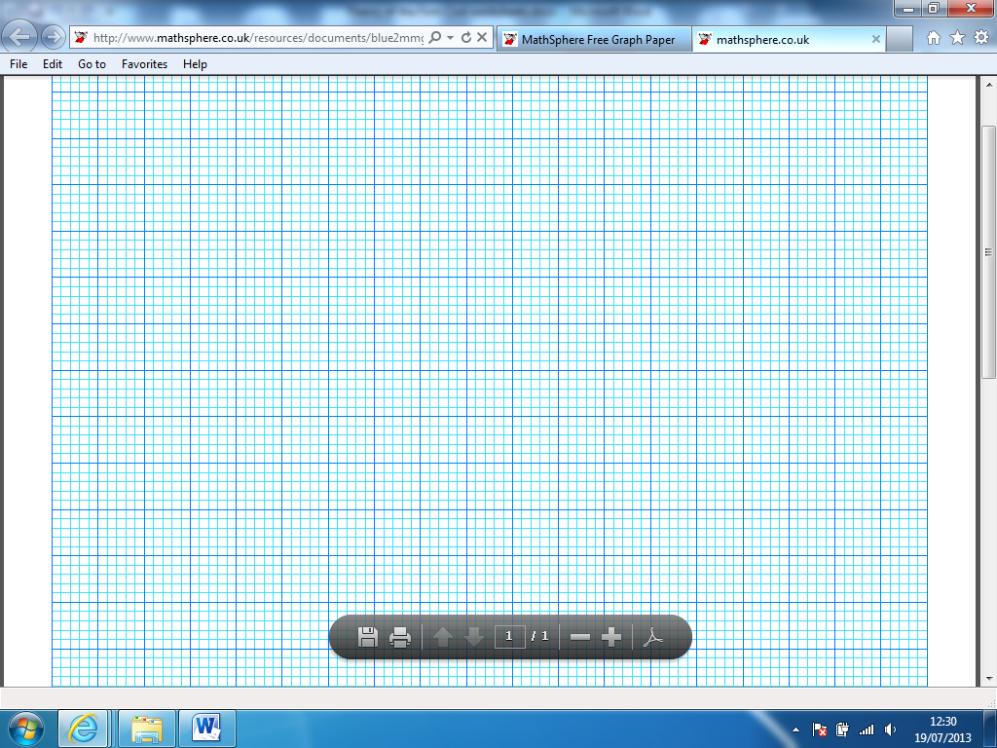
notes

Costs curves (continued)

Starter
- The short run is the period where all factors of production are free to vary (T/F)
- The Marginal Physical Product is the addition to total product (output) that occurs from employing an additional fixed factor of production (T/F)
- The Marginal Physical Product is the addition to total product (output) that occurs from employing an additional variable factor of production (T/F)
- Average physical product = total product (output)/ amount of fixed capital employed (T/F)
- The long run refers to a period of time no less than 18 months (T/F)

Useful formula:
Average total Cost = (variable costs + fixed costs)/output = Total costs/ output
Total costs = (average cost x output)
Average fixed cost = Total fixed cost/ output
Average variable costs = total variable costs/output

Activity 2: Complete the table below.
Output | Fixed costs | Variable costs | Total costs | Average total costs
0 | £55 | £0
1 |  | £15
2 |  | £30
3 |  | £45
4 |  | £60
5 |  | £75
6 |  | £100

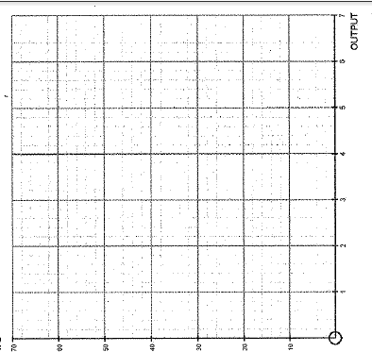
Activity 2.1: Using the graph paper draw the
average total cost (ATC) curve from the data above.

Marginal costs – The marginal cost is the cost of producing one extra unit. It is the amount added to the total costs of production by the next unit of output. It is calculated by taking the total cost and deducting the total cost of the previous unit.

Activity 3: calculate the total costs, average total costs and marginal costs at each level of output.

Output | Fixed costs | Variable costs | Total costs | Average Total costs | Marginal costs
0 | £100 | £0
1 | £100 | £60
2 | £100 | £80
3 | £100 | £100 | £200
4 | £100 | £120 | £220

Activity 3.1: Use the data in the table above to draw:
- Fixed costs curve
- Total costs curve

Notes

Activity 4:
- Complete the table below column 4 – 9
1 | 2 | 3 | 4 | 5 | ₆ | 7 | 8 | 9 | 10
Capital | Labour | Total physical product  (output) | Total variable  cost | Total fixed  Costs | _{Total costs} | Average variable costs | Average fixed costs | Average total costs | Marginal costs
10 | 0 | 0
10 | 1 | 20
10 | 2 | 54
10 | 3 | 100
10 | 4 | 151
10 | 5 | 197
10 | 6 | 230
10 | 7 | 251
10 | 8 | 260

Note: Assuming that capital costs £100 per unit and labour costs £200 per unit.
Extension activity:
- Complete column 10
- At which amount of labour employed does diminishing returns sets in.
- What is the average cost of producing the 145th unit of the good
- What is the marginal cost of producing the 250th unit of the good
- Draw the average and marginal costs curves in the space provided below.
notes

Plenary: It’s important to think about the process of your own learning (meta cognition). Try and establish what it is that you find confusing about this topic and write it in the space below.
Note: There is nothing more irritating to a teacher when they ask what is it you find confusing about this topic to hear “All of it !!”

The relationship between costs curves

Starter: Complete the table below by writing a definition and formula for each of the terms below:-

Term | Definition | Formula
Total Revenue

Average Revenue

Marginal Revenue

Profits

Loss

Total costs

Average costs

Marginal costs

Notes:

Activity 1: Using the diagram below to explain the relationship between the average cost curve and the marginal cost curve.
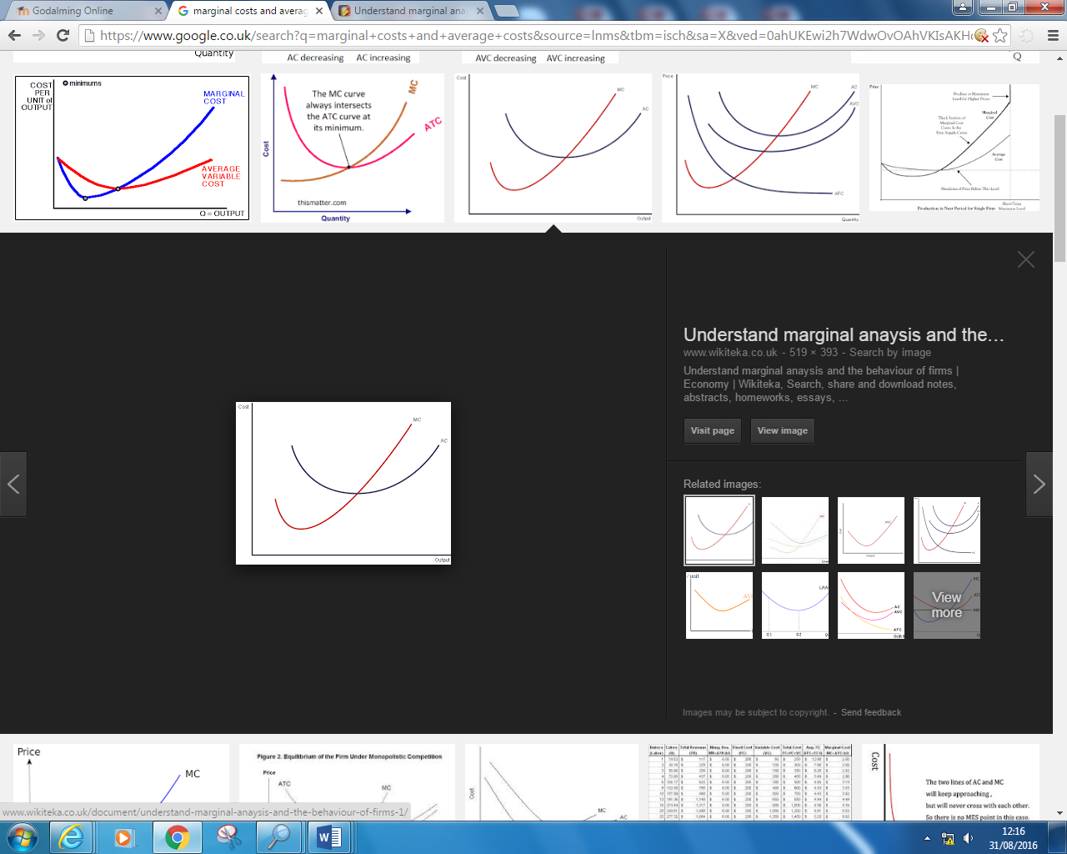
Question.
When MC>AC what is happening to AC?

When MC<AC what will happen to AC?

At what point does the marginal cost curve intersect with the average cost curve?

Extension
Why does the marginal cost curve fall and then start to rise?
Hint: Think about MPP

Explain the relationship between average costs and marginal costs
Hint: Use the information garnered from the answers above)

……………………………………………………………………………………………………………………………………………………………………………………
……………………………………………………………………………………………………………………………………………………………………………………
……………………………………………………………………………………………………………………………………………………………………………………
……………………………………………………………………………………………………………………………………………………………………………………
……………………………………………………………………………………………………………………………………………………………………………………
……………………………………………………………………………………………………………………………………………………………………………………
……………………………………………………………………………………………………………………………………………………………………………………
……………………………………………………………………………………………………………………………………………………………………………………
……………………………………………………………………………………………………………………………………………………………………………………
Why does the Marginal cost curve at first decrease as output increases and then begin to increase as output expands beyond a certain point?
Activity
- Complete the missing cells in table 1 below
- Why does the Marginal cost curve at first decrease as output increases and then begin to increase as output expands beyond a certain point? Write your answer in the space provided overleaf.
(Hint 1: Think about the rate at which output is going up and think about the rate at which costs are rising, to understand this you need to understand the concept of increasing and decreasing returns to a variable factor)
(Hint 2: look at Fig 2 below at what point does marginal product start to fall and at what point does marginal costs start to rise)
(Hint 3: Compare the rate at which costs are rising compared to the rate at which output is going up

Table 1
Labour (£) Variable factor | Total Costs | Marginal cost | Output | Marginal Physical product
1 | £100 |  | 10
2 | £200 |  | 25
3 | £300 |  | 50
4 | £400 |  | 65
5 | £500 |  | 75
Note: In the table above it is assumed that each additional unit of labour costs the same as the previous unit.

Fig 2
Extension activity
- Annotate the diagram opposite to show where diminishing marginal returns set in.

Use a pencil to mark the point where on the Marginal Product curve and the marginal cost curve where diminishing marginal returns would start to occur

- Annotate the diagram opposite to show where diminishing average returns set in.

Use a pencil to mark the point where, on the Average Product curve and the average cost curve, diminishing marginal returns would start to occur

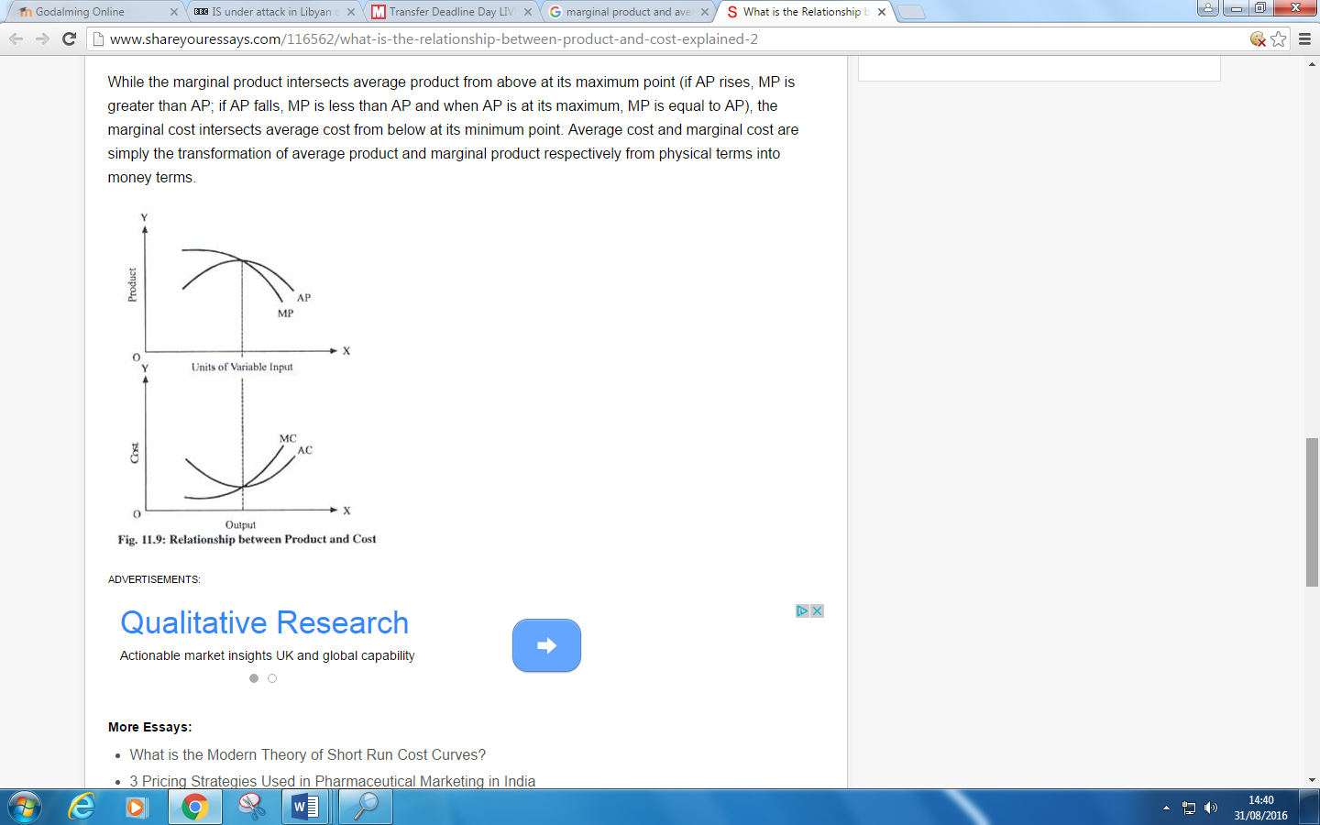

Why does the Marginal cost curve at first decrease as output increases and then begin to increase as output expands beyond a certain point?
Or
Explain why the average cost curve (and the marginal cost curve) are U shaped? (At first average costs and marginal costs decrease as output expands and then at a certain level of output bot begin to increase … why?)
……………………………………………………………………………………………………………………………………………………………………………………
……………………………………………………………………………………………………………………………………………………………………………………
……………………………………………………………………………………………………………………………………………………………………………………
……………………………………………………………………………………………………………………………………………………………………………………
……………………………………………………………………………………………………………………………………………………………………………………
……………………………………………………………………………………………………………………………………………………………………………………
……………………………………………………………………………………………………………………………………………………………………………………
……………………………………………………………………………………………………………………………………………………………………………………
……………………………………………………………………………………………………………………………………………………………………………………..
…………………………………………………………………………………………………………………………………………………………………………………….
……………………………………………………………………………………………………………………………………………………………………………………

The distinction between the law of returns and returns to scale.

Revenue curves

Definitions
Revenue – The receipts of money from the sale of goods or services over a period of time such as a week, a month or a year.
Total revenue – The amount of money received from the sales of goods/services at a particular output level. For example a car manufacturer sells 100 cars at £10,000 each will deliver revenue of £1,000,000.
Average revenue – Is the average receipt per unit sold. It can be calculated by diving total revenue by output.
Marginal revenue – is the receipt from selling one extra unit of output.

Quick task
Type of revenue | Formula
Total revenue

Average revenue

Marginal revenue

Different revenue curves can be drawn under different assumptions about average revenue. One assumption is that a firm receives the same price for each unit sold.

Activity 1
Sales | Average revenue £ | Total revenue £ | Marginal revenue £
1 | 5 | 5 | 5
2 | 5 | 10 | 5
3 | 5 | 15 | 5
4 | 5 | 20 | 5
5 | 5 | 25 | 5
6 | 5 | 30 | 5
7 | 5 | 35 | 5
8 | 5 | 40 | 5
9 | 5 | 45 | 5
10 | 5 | 50 | 5

- Draw the total revenue curve on the graph paper below
- Draw the average and marginal revenue curves on the graph paper below

(c) When the average revenue is constant what do we know about the elasticity of demand for the good?
(d) What is the more common name given to the term average revenue?

…………………………………………………………………
…………………………………………………………………
…………………………………………………………………
…………………………………………………………………
…………………………………………………………………

Extension activity: Explain from what you have learned in Economics during unit 1 why average and marginal revenues remaining constant is often counter to economic theory

In traditional economic theory it is an underlying principle that for most goods, in the vast majority of markets, firms will only be able to sell more of the good if it lowers the price. In this case the average revenue will decrease as the number of units of the good increases.

Sales | Average revenue | Total revenue | Marginal revenue
1 | 30 | 30 | 30
2 | 27 | 54 | 24
3 | 24 | 72 | 18
4 | 21 | 84 | 12
5 | 18 | 90 | 6
6 | 15 | 90 | 0
7 | 12 | 84 | -6
8 | 9 | 72 | -12
9 | 6 | 54 | -18
10 | 3 | 30 | -24

Activity 2:
- What is the price of the good if the firm only sells one unit?
- If the firm reduces the price of the good to £12 how many additional units of the good can be sold (from the first sale)
- When the average revenue received decreases with the number of sales, what happens to the Elasticity of demand for the good?
It becomes more ______________________________
- Explain what it means if the marginal revenue earned from sales of the good become negative (see table above).
…………………………………………………………………………………………………………………………………………………………………………
…………………………………………………………………………………………………………………………………………………………………………
…………………………………………………………………………………………………………………………………………………………………………
…………………………………………………………………………………………………………………………………………………………………………
…………………………………………………………………………………………………………………………………………………………………………
Activity 3

Sales (millions of units) | Price | Average revenue | Total revenue | Marginal revenue
1 | 20
2 | 18
3 | 16
4 | 14
5 | 12
6 | 10
7 | 8
8 | 6
9 | 4
10 | 2

- Calculate (a) total revenue and (b) marginal revenue at each level of sales from 1 million to 10 million
- Use the spaces below to draw the total revenue curve and the average and marginal revenue curve.

Total revenue Average revenue and marginal revenue

Extension activity: What is another name for the Average revenue curve ___________________________

Finchfield Cycles

Finchfield Cycles is a UK company based in Leeds which sells bicycles. In recent years, with a growing trend towards healthier living, exercise and cycling to work, demand for its bicycles has grown considerably. Five years ago, sales were 10,000 a year. Today they are 20,000. Despite selling at £400 each, there is a long waiting list for the bicycles due to bottlenecks in production.
The company’s sales director has been researching different pricing strategies. He estimates they could sell 25,000 a year not have to drop their prices. To push sales beyond 25,000 a year would require some easing of prices. He estimates that the company could sell 30,000 a year at £360 but a move to 35,000a year would have to see prices drop to £320 and sales of 40,000 a year would probably need a price of £280.
An alternative strategy would be to segment the market. Currently around half of all sales go overseas and they are sold at the same price per unit as home sales. The overseas sales, the sales director believes, are more price sensitive. He estimates that over the sales range 10,000 to 20,000, price elasticity of demand is 4. In contrast, price elasticity of demand for home sales is estimated to be 2 for the equivalent range.

- (a) From the data, assuming no bottlenecks in production and no differential pricing, what does the sales director believe would be total sales at a price of (i) £400 (ii) £360 (iii) £320 (iv) £280?
(b) From the data, draw an accurate (i) total revenue curve (ii) average revenue curve (iii) marginal revenue curve.
(c) Calculate the Price elasticity of demand between the four price points, assuming that the higher price is the initial price.
Write your answers here

Profits

Profits are the difference between revenue and costs. The firm will make the greatest profits when the difference between total cost and total profits is greatest. This is shown in table 1. Total revenue is shown in the third column. Profit is the difference between the two. At low levels of production, the firm will make a loss. The BREAK EVEN point, where total revenue is equal to total costs is 3 units of output. Thereafter profits increase as output increases.
Table 1
Output | Total revenue | Total cost | Profits
1 | 25 | 35 | -10
2 | 50 | 61 | -11
3 | 75 | 75 | 0
4 | 100 | 90 | 10
5 | 125 | 106 | 19
6 | 150 | 123 | 27
7 | 175 | 148 | 27
8 | 200 | 182 | 18
9 | 225 | 229 | -4

- Why would the firm choose not to produce just 2 units of the goods?
- What level of output are profits maximized?
- In the table above where is the breakeven point?
- What other objectives might a firm have besides profit maximization?

Normal and abnormal profits
Normal profits are the amount of profit that a firm needs to earn to ensure to keep the factors of production in their present use. Alternatively, if a firm is making a level of normal profits this is just enough profit for the firm to continue making the goods that they are already making, enough to incentivize the entrepreneur to carry on with whatever business they are engaged.
If the firm failed to earn normal profits it would cease to exist in the long run. The firm’s resources would be put to better use producing other goods and services where a normal profit could be earned.

Abnormal profit or Super Normal Profit (SNP) – also called Pure profit or Economic profit
This is the profit that is earned over and above normal profit.
Activity 1
Output | Marginal revenue | Marginal cost | Addition to total profits
1 | 25 | 35
2 | 25 | 26
3 | 25 | 14
4 | 25 | 15
5 | 25 | 16
6 | 25 | 18
7 | 25 | 25
8 | 25 | 34
9 | 25 | 47

The table shows that if one unit of the good is produced then the cost incurred by producing that good is £35 however the revenue earned by selling the good is £25. This means that the firm’s profits will be -£10 if it produces 1 unit of the good.

Activity 1
- Complete the last column.
- At what level of output is the extra profit per unit of output highest
- At what level of output is total profits highest? Explain your answer.
- Explain why a profit maximizing firm would not produce 8th unit of output
Extension activity
- What condition is necessary for firm’s profits to be maximized (look at the table above)?
- Why would a profit maximizing firm produce the 7th unit of output, instead of stopping at 6
notes

Economists assume that total cost include the element of normal profit !
This means that where Total cost = total revenue, normal profits are being earned. (go back and look at questions 1 & 2 from the last extension activity)
Sotherefore if total revenue is greater than total costs, Super normal profits are being earned.

Profit maximizing level of output
The profit maximizing level of output occurs when MC = MR. At this point the firm has extracted the most amount of profits from all the previous units of output.
Using the diagram below explain why point B (where MC=MR), is the output level that produces the highest amount of profit (the profit maximizing output level). During your explanation, indicate why a firm would not want to operate at point A or point C
……………………………………………………………………………………………………………………………………………………………………………………
……………………………………………………………………………………………………………………………………………………………………………………
……………………………………………………………………………………………………………………………………………………………………………………
……………………………………………………………………………………………………………………………………………………………………………………
……………………………………………………………………………………………………………………………………………………………………………………
……………………………………………………………………………………………………………………………………………………………………………………

A
C
B

Appendix 1
Answers to activity 4 ( Cost curves cont)
1 | 2 | 3 | 4 | 5 | ₆ | 7 | 8 | 9 | 10
Capital | Labour | Total physical product  (output) | Total variable  cost | Total fixed  Costs | _{Total costs} | Average variable costs | Average fixed costs | Average total costs | Marginal costs
10 | 0 | 0 | 0 | 1000 | 1000 | 0 | - | - | -
10 | 1 | 20 | 200 | 1000 | 1200 | 10.0 | 50.0 | 60 | 10
10 | 2 | 54 | 400 | 1000 | 1400 | 7.4 | 18.5 | 25.9 | 5.9
10 | 3 | 100 | 600 | 1000 | 1600 | 6.0 | 10.0 | 16 | 4.3
10 | 4 | 151 | 800 | 1000 | 1800 | 5.3 | 6.6 | 11.9 | 3.9
10 | 5 | 197 | 1000 | 1000 | 2000 | 5.1 | 5.1 | 10.2 | 4.3
10 | 6 | 230 | 1200 | 1000 | 2200 | 5.2 | 4.3 | 9.6 | 6.1
10 | 7 | 251 | 1400 | 1000 | 2400 | 5.6 | 4.0 | 9.6 | 9.5
10 | 8 | 260 | 1600 | 1000 | 2600 | 6.8 | 3.8 | 10 | 22.5

- The point at which diminishing returns sets in is when the 4th unit of labour is hired.
- The average cost of producing the 145th unit of the good is £11.9
- The marginal cost of producing the 250th unit of the good is £9.5

Appendix 2: Home work (Complete question 1 to 5)
Question 1
1 | 2 | 3
Output (per week) | Total cost | Marginal costs per unit of output
1 | 400 | 400
2 | 500
3 | 800
4 | 1400
5 | 2200

Question 2
Table 1
Output | Total fixed costs | Total variable  costs | Total  costs | Average fixed costs | Average variable costs | Average  costs | Marginal costs
0 | 40
1 |  | 6
2 |  | 11
3 |  | 15
4 |  |  | 60
5 |  |  | 66

- Complete the table above, calculating the missing figures

Question 3
Table 2
Labour | Total physical product
1 | 20
2 | 45
3 | 60
4 | 70

The table above shows how total physical product changes as the number of units of labour changes with a fixed quantity of capital. The cost of the capital employed is £200. The firm can employ any number of workers at a constant wage rate per unit of labour of £50.
What is the value of:
- Total fixed costs
- Total variable costs
- Total costs
- Average fixed costs
- Average variable costs
- Total average costs
- Marginal costs

If the firm employs:-
- 1 unit of labour
- 2 units of labour
- 3 units of labour
- 4 units of labour

Question 4 (Diminishing marginal returns)

Capital | Labour | Total product | Marginal product | Average product
10 | 0 | 0 | 0 | 0
10 | 1 | 20 | 20 | 20
10 | 2 | 54
10 | 3 | 100
10 | 4 | 151
10 | 5 | 197
10 | 6 | 230
10 | 7 | 251
10 | 8 | 234

- Complete the table above
- From the data identify at what point diminishing returns sets in
- From the data identify where the firm is experiencing increasing returns
- Explain what is happening to output as the number of workers increases from 7 to 8

Question 5
Capital | Labour | Total product
10 | 1 | 8
10 | 2 | 24
10 | 3 | 42
10 | 4 | 60
10 | 5 | 70
10 | 6 | 72

- Calculate the average and marginal product at each level of labour input.
- Draw the total, average and marginal product curves on a graph
- At what level of output do (i) diminishing marginal returns and (ii) Diminishing average returns set in.

Appendix 3: Revenue

Sales (millions of units) | Price | Average revenue | Total revenue | Marginal revenue
1 | 20 | 20 | 20 | 20
2 | 18 | 18 | 36 | 16
3 | 16 | 16 | 48 | 12
4 | 14 | 14 | 56 | 8
5 | 12 | 12 | 60 | 4
6 | 10 | 10 | 60 | 0
7 | 8 | 8 | 56 | -4
8 | 6 | 6 | 48 | -8
9 | 4 | 4 | 36 | -12
10 | 2 | 2 | 20 | -16

Answers to questions 1-5
Calculating costs exercise

Answers to question 1
1 | 2 | 3
Output (per week) | Total cost | Marginal costs per unit of output
1 | 400 | 400
2 | 500 | 100
3 | 800 | 300
4 | 1400 | 600
5 | 2200 | 800

Answers to question 2
Table 1
- Complete the table above, calculating the missing figures
Output | Total fixed costs | Total variable  costs | Total  costs | Average fixed costs | Average variable costs | Average  costs | Marginal costs
0 | 40 | - | 40 | - | - | - | -
1 | 40 | 6 | 46 | 40 | 6.0 | 46 | 46
2 | 40 | 11 | 51 | 20 | 5.5 | 25.5 | 5
3 | 40 | 15 | 55 | 13.3 | 5.0 | 18.3 | 4
4 | 40 | 20 | 60 | 10.0 | 5.0 | 15.0 | 5
5 | 40 | 26 | 66 | 8.0 | 5.2 | 13.2 | 6

Answers to Question 3

Units of labour | Total physical product | Total fixed cost | Total variable cost | Total cost | Average fixed cost | Average variable cost | Average total cost | Marginal costs
1 | 20 | 200 | 50 | 250 | 10 | 2.5 | 12.5 | 12.5
2 | 45 | 200 | 100 | 300 | 4.4 | 2.2 | 6.7 | 2.0
3 | 60 | 200 | 150 | 350 | 3.3 | 2.5 | 5.8 | 3.3
4 | 70 | 200 | 200 | 400 | 2.9 | 2.9 | 5.7 | 5.0

Question 4 (Diminishing marginal returns)
Answers

Capital | Labour | Total product | Marginal product | Average product
10 | 0 | 0 | 0 | 0
10 | 1 | 20 | 20 | 20
10 | 2 | 54 | 34 | 27
10 | 3 | 100 | 46 | 33
10 | 4 | 151 | 51 | 38
10 | 5 | 197 | 46 | 39
10 | 6 | 230 | 33 | 38
10 | 7 | 251 | 20 | 36
10 | 8 | 234 | -17 | 29

Question 5

Capital | Labour | Total product | Marginal product | Average product
10 | 1 | 8 | 8 | 8
10 | 2 | 24 | 16 | 12
10 | 3 | 42 | 18 | 14
10 | 4 | 60 | 18 | 15
10 | 5 | 70 | 10 | 14
10 | 6 | 72 | 2 | 12

- See answers above
- See diagram
- i) Diminishing marginal returns set in when the 5th units of labour are employed
ii) Diminishing average returns set in when 5th units of labour are employed

.

.

.

.

Appendix 2
1 | 2 | 3 | 4 | 5 | ₆ | 7 | 8 | 9 | 10
Capital | Labour | Total physical product  (output) | Total variable  cost | Total fixed  Costs | _{Total costs} | Average variable costs | Average fixed costs | Average total costs | Marginal costs
10 | 0 | 0
10 | 1 | 20
10 | 2 | 54
10 | 3 | 100
10 | 4 | 151
10 | 5 | 197
10 | 6 | 230
10 | 7 | 251
10 | 8 | 260

Activity
Note: Assuming that capital costs £100 per unit and labour costs £200 per unit.
- Complete columns 4-9 above
Extension activity: Complete column 10.

1 | 2 | 3 | 4 | 5 | ₆ | 7 | 8 | 9 | 10
Capital | Labour | Total physical product  (output) | Total variable  cost | Total fixed  Costs | _{Total costs} | Average variable costs | Average fixed costs | Average total costs | Marginal costs
10 | 0 | 0
10 | 1 | 20
10 | 2 | 54
10 | 3 | 100
10 | 4 | 151
10 | 5 | 197
10 | 6 | 230
10 | 7 | 251
10 | 8 | 260

.

