Fiscal policy
Name:

and

Supply-side policy
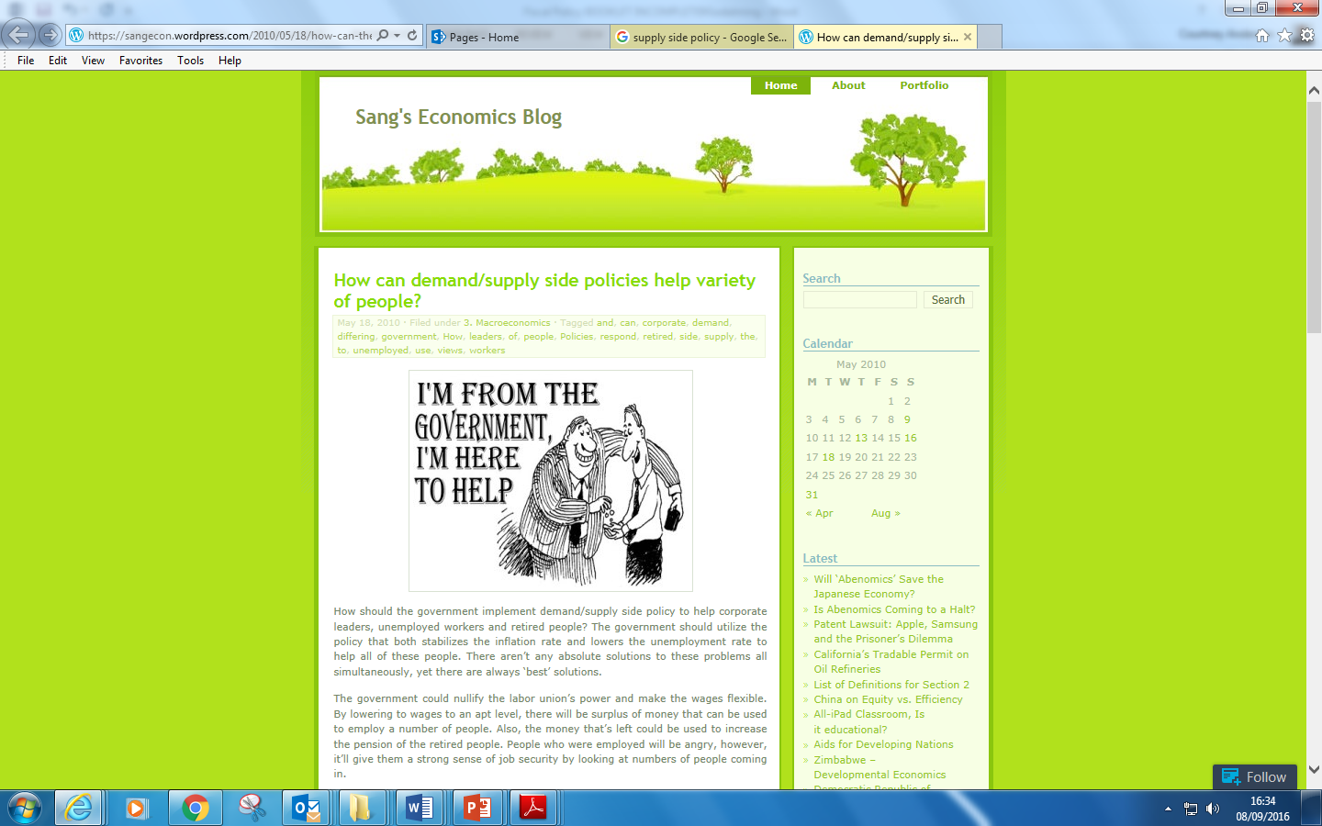

Fiscal Policy

Specification
Content
- Fiscal policy involves the manipulation of government spending, taxation and the budget balance.
- Fiscal policy can have both macroeconomic and microeconomic functions.
- How fiscal policy can be used to influence aggregate demand.
- How fiscal policy can be used to influence aggregate supply.
- How government spending and taxation can affect the pattern of economic activity.
- The types of and reasons for public expenditure.
- Why governments levy taxes.
- The difference between direct and indirect taxes.
- The difference between progressive, proportional and regressive taxes.
- The principles of taxation, such as that taxes should be equitable.
- The role and relative merits of different UK taxes.
- The relationship between the budget balance and the national debt.
- Cyclical and structural budget deficits and surpluses.
- The consequences of budget deficits and surpluses for macroeconomic performance.
- The significance of the size of the national debt.
- The role of the Office for Budget Responsibility.

Other information

Students should be able to assess the economic significance of changes in the level and distribution of both public expenditure and taxation.
They should be able to discuss the issue of the budget balance and be able to evaluate the possible economic consequences of a government running a budget deficit or budget surplus.
They should be able to assess the impact of measures used to rebalance the budget.

Starter 1: Answer the questions below and grade your answer 1 to 5: (1 =excellent: 5= poor)

- What is Fiscal Policy?

…………………………………………………………………………………………………………………………………………………………………………

…………………………………………………………………………………………………………………………………………………………………………

- What is expansionary Fiscal policy?

…………………………………………………………………………………………………………………………………………………………………………

…………………………………………………………………………………………………………………………………………………………………………

- What are the aims of Fiscal Policy?

…………………………………………………………………………………………………………………………………………………………………………

Starter 2: Decide if the following statements are true or false. (Circle the correct answer)
(BE PREPARED TO EXPLAIN YOUR ANSWER)

- In any given year government spending must equal the total amount of tax that a government collects. (T/F)
- VAT raises the largest amount of tax revenue for the government (T/F)
- Countries have a budget deficit when Government Spending is less than Tax receipts (T/F)
- The National debt is another word for the Public debt (T/F)
- The biggest spending Government Department is welfare (T/F)
- Government spending is usually split into two broad categories, current spending and capital spending
(T/F)
- In the UK consumption as a proportion of GDP is 30% (T/F)
- Fiscal Policy can only affects the Aggregate demand curve (T/F)
- Fiscal policy is the primary tool for controlling inflation in the economy (T/F)
- VAT is an example of a specific tax (T/F)
Extension activity
- The multiplier is defined as the speed at which money circulates around the economy (T/F)
- A budget deficit is where a country imports more than it exports (T/F)
- A budget deficit means that the national income of the economy is falling (T/F)
- The government can only measure the growth of the economy by changes in real GDP (T/F)
- In economics we assume that progressive taxes encourage people to work harder (T/F)

Fiscal policy Stretch and Challenge
Extension activity: Write an explanations for the event that caused the outcome in the boxes below (see the title – increase in firm’s cost). Draw a diagram that is appropriate for each event. Then write an explanation that links the two events. Note: The events of diagram one occur before those of diagram two.
NB: There is more than one possible explanation to the events in the diagram.
Scenario one: An increase in wages /cost pushes inflation.
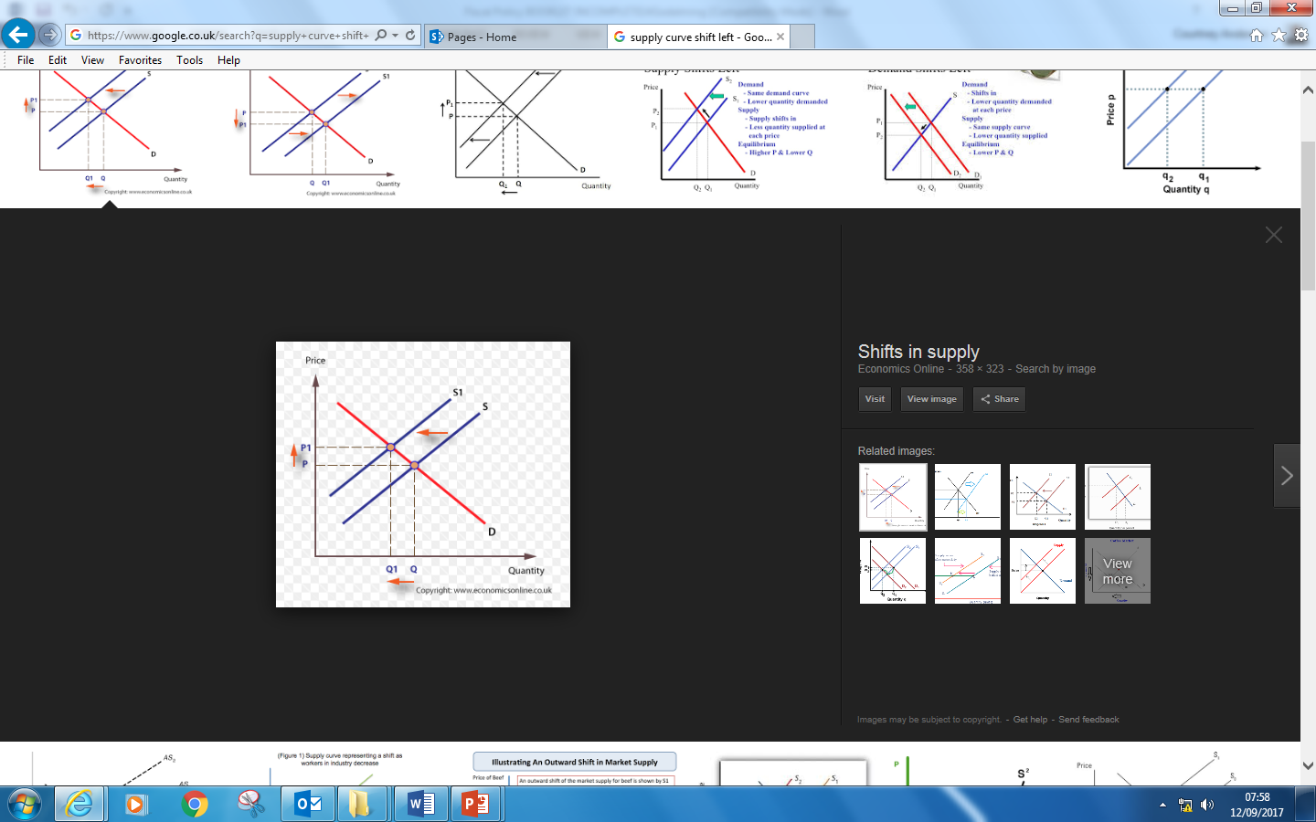
Example answer:
There has been an increase in trade union power which has pushed up wages. This means there has been an increase in firm’s costs which could in turn lead to cost push inflation.
Scenario two: An increase in population/ an increase in Aggregate Demand

Write you answer here:
…………………………………………………………………………………………………………………………………………………………………………………………………………………………………………………………………………………………………………………………………………………………………………………………………………………………………………………………………………………………………………………………………………………………………………………………………………………………………………………………………………………………………………………………………………………………………………………………………………………………………………………………………………………………………………………………….

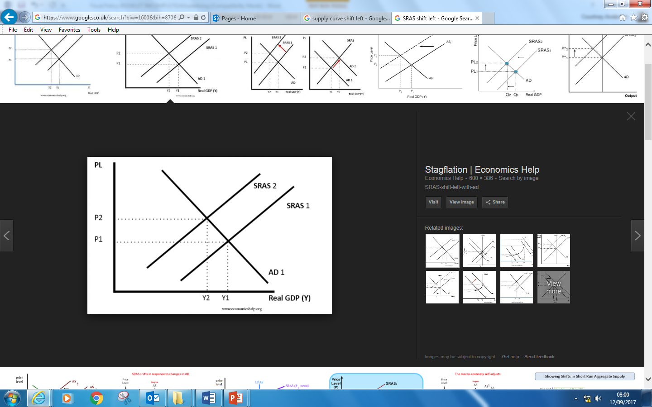
- Title: Increase in firm’s wages

2. Title: Cost push inflation

- Title: Increase in Population
2. Title: Increase in Aggregate demand

.

Hint: Increases in the Population may affect the demand and/or the supply-side of the economy.

Extension activity 2: For each of the scenarios below show the effects on an AD-AS diagram. And explain your answer.

Scenario 1: In a given fiscal year Public spending rises to £800bn whilst tax receipts are reduced to £600bn.
Diagram

Explanation
………………………………………………………………………………………………………………………………………………………………………………………………………………………………………………………………………………………………………………………………………………………………………………………………………………………………………………………………………………………………………………………………………………………………………………………………………………………………………………………………………………………………………………………………………………………………………………………………………………………………………………………………………………………………………………………………………………………………………………………………………………………………………………………………………………………………………………………………….

Scenario 2: A Government cuts income tax by £10bn whilst at the same time reducing government spending by £10bn.
Diagram
Explanation
………………………………………………………………………………………………………………………………………………………………………………………………………………………………………………………………………………………………………………………………………………………………………………………………………………………………………………………………………………………………………………………………………………………………………………………………………………………………………………………………………………………………………………………………………………………………………………………………………………………………………………………………………………………………………………………………………………………………………………………………………………………………………………………………………………………………………………….

Scenario: The economy experiences the long run impacts of a fall in unemployment benefits
Diagram
Explanation…………………………………………………………………………………………………………………………………………………………………………………………………………………………………………………………………………………………………………………………………………………………………………………………………………………………………………………………………………………………………………………………………………………………………………………………………………………………………………………………………………………………………………………………………………………………………………………………………………………………………………………………………………………………………………………………………………………………………………………………………………………………………………………………………………………………………………………………………………………………………………………………………….

Balanced budget fiscal expansion
This concept has become a major topic of conversation in the debate over the economic effects of fiscal austerity in many countries in the European Union and beyond. Put simply, a balanced budget fiscal expansion occurs when a change in government spending is matched by an equal change in taxation so that there is a neutral effect on the annual fiscal deficit but with the hope that real national income will expand.
Central to the concept is that the fiscal multiplier effects of say a £10bn rise in government spending are higher than the negative multiplier effects of an equivalent £10bn rise in taxes

Discussion – Do you think this argument has much merit?
………………………………………………………………………………………………………………………………………………………………………………
………………………………………………………………………………………………………………………………………………………………………………
………………………………………………………………………………………………………………………………………………………………………………
………………………………………………………………………………………………………………………………………………………………………………
………………………………………………………………………………………………………………………………………………………………………………
………………………………………………………………………………………………………………………………………………………………………………
………………………………………………………………………………………………………………………………………………………………………………
………………………………………………………………………………………………………………………………………………………………………………

(Hint: Think you can only do two things with money … spend it … or save it !!! )

Activity 1: Draw and label the trend rate of economic growth, the actual growth rate, the output gaps and the 4 phases of the economic cycle.
Real GDP

Time

Complete the table below to show what is happening in the economy. Using the following terms “increasing / decreasing/ high /low”

 | Boom | Recession | Slump | Recovery
Output

Inflationary pressure

Unemployment

Welfare payments

Tax Revenue

Automatic Stabilisers
Automatic stabilisers include changes in tax revenues and government spending that occur automatically as the economy moves through the business cycle

- Tax revenues: When the economy is expanding rapidly, tax revenue increases which takes money out of the circular flow of income and spending

- Welfare spending: When the economy is growing, the government does not have to spend on means-tested welfare benefits such as unemployment benefits

- Budget balance and the circular flow: A fast-growing economy tends to lead to a net outflow of money from the circular flow. Conversely during a slowdown or a recession, the government normally ends up running a larger budget deficit.

Activity 2:

Country A has recently decided to introduce taxes and welfare spending. In the space below a business cycle diagram with the :-

- Actual rate of growth before automatic stabilisers were introduced.
- Actual rate of growth before automatic stabilisers were introduced.

Use the same diagram for both drawings.

Your attempt

Activity 2 (Cont)
- Explain the impact that automatic stabilisers have on the business cycle (specifically the actual rate of economic growth)
…………………………………………………………………………………………………………………………………………………………………………
……………………………………………………………………………………………………………………………………………………………………………
……………………………………………………………………………………………………………………………………………………………………………
……………………………………………………………………………………………………………………………………………………………………………
……………………………………………………………………………………………………………………………………………………………………………
……………………………………………………………………………………………………………………………………………………………………………
……………………………………………………………………………………………………………………………………………………………………………
……………………………………………………………………………………………………………………………………………………………………………
……………………………………………………………………………………………………………………………………………………………………………

- List some factors that might determine the effectiveness of automatic stabilisers in reducing the amplitude of the business cycle.
……………………………………………………………………………………………………………………………………………………………………………
……………………………………………………………………………………………………………………………………………………………………………
……………………………………………………………………………………………………………………………………………………………………………

- Explain how one of the factors that you have identified (above 2d) increases/decreases the effects on the business cycle.

..................................................................................................................................................................................
..................................................................................................................................................................................
..................................................................................................................................................................................
..................................................................................................................................................................................
……………………………………………………………………………………………………………………………………………………………………………
……………………………………………………………………………………………………………………………………………………………………………
..................................................................................................................................................................................

Type of Government Spending | Definition
Transfer | Welfare payments made available through the social security system including the Jobseekers’ Allowance, Child Benefit, State Pension, Housing Benefit, Income Support and the Working Families Tax Credit. The main aim of transfer payments is to provide a basic floor of income or minimum standard of living for low income households. And they allow the government to change the final distribution of income.
Current | Spending on state-provided goods & services that are provided on a recurrent basis - for example salaries paid to people working in the NHS and resources for state education and defense. The NHS is the country’s biggest employer with over one million people working within the system!
Capital | Includes infrastructure spending such as new motorways and roads, hospitals, schools and prisons. This investment spending adds to the economy’s capital stock and can have important demand and supply side effects in the long term.

Public spending (Government spending)
What are the main reasons for Government spending?
1.
2.
3.
4.

What are the Macroeconomic and Microeconomic benefits of public spending?
Macroeconomic benefits | Microeconomic benefits
Hint: Can Fiscal Policy affect Productive potential? Can Fiscal Policy help influence the business cycle?  Can Fiscal Policy help Unemployment that is not Demand deficient? | Hint: Think about the services Government provides, Could any other organisation provide some of the services Government provides? How might Government spending affect poorer households?

Fiscal Policy

Activity 3

The Coalition government came to power outlining a plan to close the Budget deficit in 4 years. To do this they announced a series of changes to UK tax structure and cut the overall amount of Government spending. With the aim of closing the £91bn deficit. Using the Government spending data (2012 – 2013) decide how you would close the budget deficit in 1 year.

In the table below briefly outline the changes you would make to Government spending and taxation.

Government Spending (£bn) | Taxation (£bn)
Total - | Total -

1. Prepare a clear argument for how you would balance the budget and why you would do it in this way.

2. Your presentation should evaluate the positive and negative consequences of your actions.

Notes

Concerns about rising public sector spending

Doubts about the efficiency of the public sector
- Waste – not all funding improves front line services
- Increased cost of administration
- Higher wage inflation in the public sector

Higher government spending has to be paid for
- Prospect of rising taxation
- Increased budget deficit
- May crowd out the private sector of the economy

Other concerns over higher government borrowing

- Push up long-term rates of interest and therefore create some “crowding-out effects” on the private sector of the economy

- Increases accumulated national debt which increases the future interest payments which burdens future generations of taxpayers

- Inter-generational equity issues involved with budget deficits –each generation should meet the costs of the benefits they derive from current government spending

Concerns about rising public sector spending
Crowding out
Activity 4: Read the extracts below and answer questions 1 & 2
BBC director general Mark Thompson has dismissed claims that the BBC is crowding commercial rivals out of the media market. He also rejected suggestions that the BBC's radio stations, including Radio 1 and Radio 2, were a factor in the dismal performance of the commercial radio sector.
'I do not believe that switch in share to BBC radio is the main issue for commercial radio's problems.'
Thompson said questions had to be asked of commercial radio's own management and investment in talent. He said the rise of online advertising was far more significant to the health of commercial radio than the BBC. Thompson said that R1 and R2 were strong and distinctive services and that presenters such as Chris Moyles and Jonathan Ross were different from anything commercial radio could offer.
Thompson said it was not in the BBC's long-term interest to damage commercial media companies. 'The BBC doesn't want to steal other people's lunch. Don't assume there's a thin mask with Public Value Test on it and behind it there's this plan to rape and pillage the rest of the sector.' Broadcast magazine, 2006

In Osbornomics, crowding out is both the explanation for the mess the UK is in, and the key to how we get out of it. In his budget speech this June, the chancellor described the state as "crowding out private endeavour". That is, the government uses resources – tax money, workers, even loans – which should go towards businesses. His remedy is simple: take the boot of the public sector off the neck of the private sector by slashing the size of the state and cutting taxes. That will enable businesses to grow and, hey presto, you have a flourishing economy Guardian 5th October 2010

- “That is, the government uses resources – tax money, workers, even loans – which should go towards businesses”. How do the factors identified in italics negatively affect the growth of private firms.
- What do you think is meant by the term ‘crowding out’?

Concerns about rising public sector spending

What is Resource crowding out?
The “crowding-out hypothesis” is an idea that became popular in the 1970s and 1980s when free-market economists argued against the rising share of GDP being taken by the public sector. The crowding out view is that a rapid growth of government spending leads to a transfer of scarce productive resources from the private sector to the public sector where productivity might be lower

http://www.youtube.com/watch?v=PHaMaQ5271o

Activity: Watch the video and answer the following questions

Write your answers in the space provided.

- How much does the BBC receive in public funding?
- List the news organisations that the BBC competes with ( list a minimum of 6 organisations)
- How do the activities of the BBC impact on other firms in the media sector (e.g BskyB)
- Give some examples of the costs of providing new (Newspapers, Radio or TV)
- What is a Hypothecated tax? Write a definition.
- How are Media organisations, other than the BBC funded?
- What economic arguments can it be suggested could be used for maintaining the current government funding of the BBC? (Hint: what type of good might BBC executives suggest the BBC is?)
- Given the definition of resource crowding given above, explain how the activities of the BBC might lead to resource crowding out. (Hint: Think of possible examples of the BBC and resource crowding out)
- In the space below draw a diagram that shows resource crowding out. (Hint: Use a PPF diagram .. how will you label the axis)

Write your answers to Q1 – 8 in the space below

…………………………………………………………………………………………………………………………………………………………………………

…………………………………………………………………………………………………………………………………………………………………………

…………………………………………………………………………………………………………………………………………………………………………

…………………………………………………………………………………………………………………………………………………………………………

…………………………………………………………………………………………………………………………………………………………………………

…………………………………………………………………………………………………………………………………………………………………………

…………………………………………………………………………………………………………………………………………………………………………

…………………………………………………………………………………………………………………………………………………………………………

…………………………………………………………………………………………………………………………………………………………………………

…………………………………………………………………………………………………………………………………………………………………………

…………………………………………………………………………………………………………………………………………………………………………

…………………………………………………………………………………………………………………………………………………………………………

…………………………………………………………………………………………………………………………………………………………………………

…………………………………………………………………………………………………………………………………………………………………………

…………………………………………………………………………………………………………………………………………………………………………

…………………………………………………………………………………………………………………………………………………………………………

…………………………………………………………………………………………………………………………………………………………………………

…………………………………………………………………………………………………………………………………………………………………………

…………………………………………………………………………………………………………………………………………………………………………

…………………………………………………………………………………………………………………………………………………………………………

…………………………………………………………………………………………………………………………………………………………………………

…………………………………………………………………………………………………………………………………………………………………………

…………………………………………………………………………………………………………………………………………………………………………

…………………………………………………………………………………………………………………………………………………………………………

Activity 5

- Explain why resource crowding out may not occur (Hint: what if an economy is not operating on the PPF?)

(Create your argument using a minimum of 6 logical chains of analysis)

…………………………………………………………………………………………………………………………………………………………………………

…………………………………………………………………………………………………………………………………………………………………………

…………………………………………………………………………………………………………………………………………………………………………

…………………………………………………………………………………………………………………………………………………………………………

…………………………………………………………………………………………………………………………………………………………………………

…………………………………………………………………………………………………………………………………………………………………………

…………………………………………………………………………………………………………………………………………………………………………

…………………………………………………………………………………………………………………………………………………………………………

…………………………………………………………………………………………………………………………………………………………………………

…………………………………………………………………………………………………………………………………………………………………………

…………………………………………………………………………………………………………………………………………………………………………

…………………………………………………………………………………………………………………………………………………………………………

(Hint: Think .. how much of a nations resources are being used when the economy Is not operating on the PPF)

Concerns about rising public sector spending

Financial Crowding Out

The theory of financial crowding out is an important way of explaining how a budget deficit can lower the levels of private sector investment in an economy.

If the government runs a big budget deficit, it will have to sell debt to the private sector and getting individuals and institutions to purchase the debt may require higher interest rates. A rise in interest rates may then crowd-out private investment and consumption, offsetting the fiscal stimulus

Activity 6: Answer question 1- 7 below.
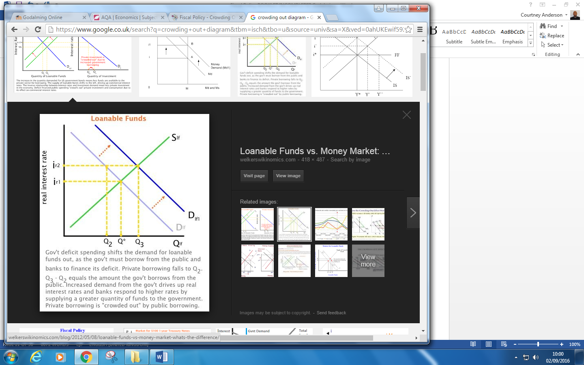

- Which institutions provide loanable funds?

………………………………………………………………………………………………………………………………………………………………………………

………………………………………………………………………………………………………………………………………………………………………………

- Which institutions demand loanable funds?

………………………………………………………………………………………………………………………………………………………………………………

………………………………………………………………………………………………………………………………………………………………………………

- Explain why the demand for loanable funds curve slope downwards from left to right

…………………………………………………………………………………………………………………………………………………………………………

…………………………………………………………………………………………………………………………………………………………………………

…………………………………………………………………………………………………………………………………………………………………………

…………………………………………………………………………………………………………………………………………………………………………

- Explain why the supply of loanable funds curve slope upwards from left to right

…………………………………………………………………………………………………………………………………………………………………………

…………………………………………………………………………………………………………………………………………………………………………

…………………………………………………………………………………………………………………………………………………………………………

…………………………………………………………………………………………………………………………………………………………………………

- Explain why an increase in the budget deficit causes an increase in the demand for loanable funds?

………………………………………………………………………………………………………………………………………………………………………

………………………………………………………………………………………………………………………………………………………………………

…………………………………………………………………………………………………………………………………………………………………………

……………………………………………………………………………………………………………………………………………………………………….

...............................................................................................................................................................................

...............................................................................................................................................................................

- Explain why an increase in the demand for loanable funds causes interest rates to rise?

………………………………………………………………………………………………………………………………………………………………………………

………………………………………………………………………………………………………………………………………………………………………………

………………………………………………………………………………………………………………………………………………………………………………

………………………………………………………………………………………………………………………………………………………………………………

………………………………………………………………………………………………………………………………………………………………………………

………………………………………………………………………………………………………………………………………………………………………………

………………………………………………………………………………………………………………………………………………………………………………

………………………………………………………………………………………………………………………………………………………………………………

- How do firms in the private sector respond to the increase in interest rates? Why?

………………………………………………………………………………………………………………………………………………………………………………

………………………………………………………………………………………………………………………………………………………………………………

………………………………………………………………………………………………………………………………………………………………………………

……………………………………………………………………………………………………………………………………………………………………………………

……………………………………………………………………………………………………………………………………………………………………………………

Extension activity: Can you think of any reasons why Financial crowding out may not occur? Write your answer in the space below.

(Hint: Do all firms need to borrow to invest? Consider the gradient of the Loanable funds diagram)

………………………………………………………………………………………………………………………………………………………………………………

………………………………………………………………………………………………………………………………………………………………………………

………………………………………………………………………………………………………………………………………………………………………………

………………………………………………………………………………………………………………………………………………………………………………

………………………………………………………………………………………………………………………………………………………………………………

………………………………………………………………………………………………………………………………………………………………………………

………………………………………………………………………………………………………………………………………………………………………………
notes

Other approaches to crowding out
Rational Expectations View
- According to a school of economic thought that believes in ‘rational expectations’, when the government sells debt to fund a tax cut or an increase in expenditure, a rational individual will realise that at some future date he will face higher tax liabilities to pay for the interest repayments (on the bonds sold)
- Thus, he/she should increase his savings as there has been no increase in his permanent income
- The implications are clear. Any change in fiscal policy will have no impact on the economy if all individuals are rational. Fiscal policy in these circumstances may become ineffective.

Do you understand the argument above? (Circle)

YES
NO

Extension activity: Stretch and Challenge

Explain why the above rational expectations theory argument may be invalid

………………………………………………………………………………………………………………………………………………………………………

………………………………………………………………………………………………………………………………………………………………………

…………………………………………………………………………………………………………………………………………………………………………

……………………………………………………………………………………………………………………………………………………………………….

...............................................................................................................................................................................

...............................................................................................................................................................................
CROWDING IN

An economic principle in which private investment increases as debt-financed government spending increases. This is caused by government spending boosting the demand for goods, which in turn increases private demand for new output sources, such as factories. This is in contrast to crowding out.
Other aspects of crowding in

Dr Marianna Muzzucato (“The Entrepreneurial State”)

In her 2013 book (The Entrepreneurial state) Marianna argues that the idea of the State as a static bureaucratic organization only needed to ‘fix’ market failures, leaving dynamic entrepreneurship and innovation to the private sector, is wrong. She outlines a number of case studies across different sectors, including biotech, pharmaceuticals and clean technology, to show that the high-risk investments are being made by the state before the private sector gets involved. In a chapter examining the iPhone, she outlines how the technologies that make it ‘smart’ – the internet, GPS, its touchscreen display and the voice-activated SIRI– were all Government funded.

http://www.ted.com/talks/mariana_mazzucato_government_investor_risk_taker_innovator?language=en
Watch the TED talk above and make notes in the space below.

Notes

Government Borrowing

- The public-sector net cash requirement (PSNCR) is how much the government needs to borrow each financial year

- The national debt is the total amount of borrowing undertaken by the government that has not yet been repaid.

Benefits of a rising budget deficit

(1) A budget deficit might be caused by cyclical factors which will unwind at later stages of the economic cycle
(2) Government borrowing helps to stabilise aggregate demand during a downturn (it is a form of Keynesian demand management) – it is an important tool of “counter-cyclical” policy
(3) Borrowing to finance capital investment is perfectly legitimate – because it adds to the economy’s stock of capital and can support long-term growth (i.e. an increase in LRAS)
(4) Crowding-out theorists have it wrong, some government borrowing is self-financing and crowding out is rarely if ever anything close to 100%
(5) The UK government rarely has a problem finding people to buy their debt
(6) A rise in the budget deficit could lead to Crowding in !!!!

Evaluate the case for a government setting fiscal policy to reduce the size of the national debt  (25 marks)  KN | Your comments  (What skills are being demonstrated?)
National debt is the accumulated debt of the government and state-owned enterprises yet to be repaid. The stock of debt has risen in many countries. In 2018 Japan had a gross national debt of 237% of GDP, Greece 174% and Italy 133% contrasted with Germany (56%) and the UK (87%).  App  One reason why a government might target a fiscal surplus in a bid to reduce the national debt is that rising debt can lead to slower economic growth. This can be explained in part by “crowding out theory”which argues that increased government spending & borrowing then increases the demand for loanable funds which increases interest rates. If interest rates rise, then this might cause a contraction in planned capital investment by private sector businesses because borrowing costs have become more expensive. As a result, weaker investment causes a fall in aggregate demand and also has a negative effect on a country’s productive capacity and trend growth. Cutting the national debt and improving the government’s credit rating might therefore help keep interest rates lower and help encourage consumption & investment from the private sector.  However although the national debt has increased in many countries including the UK and Japan, it is important to assess the underlying causes. For the UK for example, much of the steep increase in debt from 2010 through to 2016 happened because of the bail-out of some banks and also a decision by the UK government to allow the automatic stabilisers of fiscal policy to work during the post-crisis recession. Without that initial fiscal stimulus, alongside deep cuts in monetary policy interest rates, there was the real risk of a deflationary depression in the UK. There is no automatic relationship between the size of national debt and a country’s GDP growth prospects. Indeed, Keynesian economists argue that state borrowing to fund infrastructure whilst adding to debt in the short run – helps improve trend growth and will create extra tax revenues in the medium term.  A second argument in favour of fiscal austerity policies designed to control borrowing and eventually cut the national debt is that very high levels of debt cost billions of extra pounds in interest payments as the debt is serviced. In the US for example, the annual interest on the debt is nearly $500 billion. In the UK, with national debt approaching 90% of GDP, around 5% of government spending goes on interest payments which amounts to over £800m a week. Fiscal conservatives believe that this imposes a large opportunity cost on the Government since there is less available to spend on education, health and other public services. They also argue that, if the debt was lower, not only would interest payments fall, but that in the medium term, scaling back the debt allows for reductions in direct and indirect taxes which will then have a positive effect on aggregate demand and long-run aggregate supply. Fiscal conservatives favour a smaller state with much less government spending, borrowing and debt.  However the scale of debt payments depends on the yield on government bonds, and in the case of the UK and Japan, the current nominal yield on ten year debt is less than 2 percent. This means that – in real terms – the real interest rate on new debt is effectively zero. In this situation, Keynesian economists critique the idea of crowding out and counter argue that increased investment in social house, transport and healthcare has a strong fiscal multiplier effect which generates higher incomes and tax revenues in the future, thereby cutting debt.  In conclusion, the government owes £1.8 trillion, up from about £1 trillion in 2009/10. Debt is stabilising at around 85% of UK GDP. How strong is the case for cutting government spending or raising taxes to reduce the size of the debt? In recent years the interest payment that the UK government has had to pay on its debt has been low and furthermore much of the increase in the national debt was necessary to stabilise the economy after the financial crisis of 2008/9. It could be argued therefore that without higher levels of borrowing and increases to the National debt the UK economy could have experienced a significant fall in long run growth rates. | Knowledge - Definition of National Debt  Application – Use of data

Answer the following questions by annotating the text above and writing your comments in the column provided.

- Use the following abbreviations (Kn – Knowledge, App – Application, An – Analysis, Ev – Evaluation) to annotate the text above. For example where you see Economic knowledge being demonstrated write ‘Kn’ by the side of it (see example)
- Highlight the 4 skills being demonstrated during the essay. Use a different coloured highlighter pen to make clear what skill is being shown.
- How many chains of analysis did the first point have?
- How many evaluative comments were made in the first point?
- How many chains of analysis did the second point have?
- How many evaluative comments did the second point have?
- How good did you think the points of analysis and evaluation were? Write your comment in the right hand column above.

TASK:

In the space provided below plan the following essay. You must have 3 main points and each point must be evaluated at least twice (If there isn’t enough space to write your plan in the space below use a separate sheet of A4 paper!)

‘The level of public sector spending grew from 37% of GDP in 1997, to over 45% of GDP in 2008. To what extent do you regard such an expansion of government spending as being beneficial to the UK economy?’ (25 marks)

Your plan must include

Introduction – identify the key terms that you will define.
1st point – This must be telegraphed in one sentence.
Example: It could be argued that an increase in public sector spending, from 37% of GDP in 1997 to 45% in 2008, could lead to higher interest rates and so therefore financial crowding out in the economy.
Evaluation: write an evaluative comment for the 1st point that you raise
2nd point – This must be telegraphed in one sentence.
Evaluation: write an evaluative comment for the 2nd point that you’ve raised
3rd point - This must be telegraphed in one sentence.
Evaluation: write an evaluative comment for the 2nd point that you’ve raised

NOTE: 1. DO NOT WRITE AN INTRODUCTION OR A CONCLUSION 2. DO NOT WRITE OUT YOUR POINTS IN FULL!!!

‘The level of public sector spending grew from 37% of GDP in 1997, to over 45% of GDP in 2008. To what extent do you regard such an expansion of government spending as being beneficial to the UK economy?’ (25 marks)

Cyclical v Structural Budget Deficits and Surpluses
Cyclical reasons

For many countries a rising budget deficit is the inevitable result of experiencing a recession or a sustained period of slow growth. In a downturn, revenue flows fall from direct and indirect taxes whilst at the same time, the government is required to pay more out in welfare benefits such as the means-tested income support, unemployment benefits and other welfare handouts. Therefore, part of a fiscal deficit may be the consequence of the automatic stabilisers at work. These are the tax and government spending changes that happen automatically at different stages of the business cycle. The governments of most developed countries are prepared to allow the automatic stabilisers to work through because, when their economy recovers, the cyclical component of a fiscal deficit will diminish, indeed in an economic boom, the government may run a budget surplus.

Structural reasons

For some countries, fiscal deficits seem an almost permanent feature, rarely is the government able to find enough tax revenue to cover the annual spending budgets. What structural problems / issues might lead to persistent fiscal deficits?
- High levels of tax avoidance and tax evasion - the deliberate evasion of tax is illegal - in some countries governments are less effective than they might be in countering shadow markets where no tax is paid or in tracking down agents who are not paying the tax that is due.
- High levels of income and wealth inequality - some economists argue that highly unequal societies also end up with a worsening fiscal position for the government. The uber-rich are liable for higher taxes in a progressive system (and top rate taxpayers in the UK clearly pay a high % of total revenues) but they also have an incentive to use all of the legal tax avoidance schemes open to them. At the bottom end of the labour market, if millions of people are in low-paid, insecure work, many will not earn enough to pay much in tax and even more may remain dependent on top-up welfare benefits, adding to the pressure on government spending.
- Demographic pressures - these can affect the fiscal position too, for example an ageing population will cause an increase in government spending on the state pension; a fast-growing population (perhaps boosted by net inward migration) will also put more pressure on the government to fund essential public and merit goods.
- Government inefficiency - if the state sector is relatively less efficient in supplying public services, then value for money will be lower and more will have to be spent in total to provide the cover that people need. Free market economists favour a smaller government sector with many activities out-sourced or privatised to the private sector to supply.
- High levels of government subsidy / financial support - over time, total government spending can rise because of the many competing demand placed upon politicians and the effects of lobbying by (often influential / powerful) pressure groups. In some countries, public spending is bloated by very generous systems of farm / food / energy subsidies that are politically hugely difficult to remove. The state might also get locked into providing financial support for loss-making businesses and industries such as airlines.

Activity 7: Explain one cyclical factor and one structural factor behind the UKs budget deficit:
………………………………………………………………………………………………………………………………………………………………………………………………………………………………………………………………………………………………………………………………………………………………………………………………………………………………………………………………………………………………………………………………………………………………………………………………………………………………………………………………………………………………………………………………………………………………………..……………………………………………………………………………………………………………………………………………………………………………………………………………………………………………………………………………………………………………………………………………………………………………………

Fiscal Policy (The micro and macro-economic significance of Taxation)

“In this world nothing can be said to be certain, apart from Death and Taxes” Benjamin Franklin (1706-1790)

What are the main objectives of the UK tax system?

1. Funding Government spending: Government must raise finance for their various expenditures. They are able to borrow money up to a certain extent, but the majority of the finance must come from taxation, in order to avoid inflationary pressure.

2.Managing the economy as a whole: Taxation can be used to influence the UK’s macroeconomic performance. The government may alter taxes and their rates in order to influence economic growth, inflation, unemployment and, to a lesser extent, the balance of payments. Governments also appreciate that reducing certain taxes can lead to important microeconomic supply-side improvements.

3. Redistribution of income: If a government judges the distribution of income to be unfair, or inequitable, it may levy taxes to reduce the income and wealth of some groups in society, in order to boost the income and wealth of other groups.

4. Correcting market failure: At a microeconomic level, the UK government often uses taxes to improve the workings of the markets. For example taxes on cigarettes may be used to reduce the consumption of a demerit good.

Direct and Indirect taxes

:Two broad category of tax.

Direct | Indirect
Direct taxes are levied on the income of an individual or organisation | Indirect taxes are taxes on spending.

Activity 8:

Which of these taxes are indirect and which are direct taxes?
- Income tax b) National insurance contribution c) inheritance tax
d) corporation tax e) capital gains tax f)council tax g)VAT h) excise duties

The principles of taxation

In making an assessment of whether a tax is ‘good’ or ‘bad’ from an economic point of view a useful starting point is Adam Smiths Canons of Taxation, by which he argues that a good tax satisfies the following conditions:-

1. Economical: A tax should be simple and cheap to collect, so that the revenue is maximized compared to the cost of collection.

2. Equitable: Tax should be fair and based on the taxpayer ability to pay.
3. Convenient: The payment method and timing should be convenient to the taxpayer.
4. Certain: Taxpayers should understand how the system works and should be clear about, when, how and what to pay. Taxes should also be difficult to evade.
5. Efficient: An efficient tax system meets its aims whilst minimising negative distortions such as reducing individual incentives to work or for firms to invest.
6. Flexible: The structure and rates of taxation must be capable of easy alteration in response to changing economic conditions.

Activity 9:

The world’s largest shipping lines may stop using UK ports because of the ‘light dues’ they have to pay. These are effectively a hypothecated tax on the use of harbour facilities. The revenue are used to pay for the £73m of costs that are needed to pay for the upkeep for lighthouses, buoys and beacons around Britain’s shores. Ships calling at British shores have to pay up to £16,000 per visit. In other European countries, lighthouses are funded out of general taxation such as income tax and VAT.

A report commissioned by the independent Light Dues Forum, a lobby group set up by 21 shipping lines, say that UK jobs might be lost because of light dues . Employment at ports could suffer UK manufacturer could shift production could shift to the continent to be nearer to cheaper ports. This could, for example, cost some of the 800,000 jobs in the UK motor industry. The report compares port costs in Britain and the Continent, including light dues, port dues and towage, piloting and line handling. Although other costs are less in the UK, light dues outweigh other savings.

Source adapted from the Times 30/12/2003.

  - Using your knowledge of what makes a good tax. Discuss whether the UK government should abolish light dues and pay the cost of light houses, buoys and beacons out of general taxation.

…………………………………………………………………………………………………………………………………………………………………………………………

…………………………………………………………………………………………………………………………………………………………………………………………

…………………………………………………………………………………………………………………………………………………………………………………………

…………………………………………………………………………………………………………………………………………………………………………………………

…………………………………………………………………………………………………………………………………………………………………………………………

…………………………………………………………………………………………………………………………………………………………………………………………

…………………………………………………………………………………………………………………………………………………………………………………………

Keyword: Hypothecation

This means that taxes are raised for a particular purpose, that is they are earmarked for a specific use. In the last decade, for example, the government has announced that a large proportion of tobacco duty would be used by the NHS to tackling smoking related problems.

Arguments for indirect taxation

- Flexibility :Indirect taxes can be changed more easily than direct taxes, since direct taxes can be changed once a year at the time of the budget.
- Influencing spending patterns: tax changes are arguable effective in changing the overall pattern of demand for particular goods or services, by changing relative prices.
- Correcting externality: Indirect taxes can correct the spillover effects of economic transactions, for example ‘making the polluter pay’ by ‘internalising’ the external costs of production and consumption.
- Incentive effect:Indirect taxes have less impact upon individual work leisure choices. Therefore, governments could levy higher indirect taxes to allow a reduction in direct taxation.
- Choice:People have a choice about whether to buy products that attract indirect taxes whereas direct taxes inevitably leave people with less of their take-home pay in their pockets, plus they are hard to avoid.

Arguments against indirect taxation

- Distribution effects:The regressive nature of many indirect taxes means that they can make the distribution of income more unequal
- Inflationary effects: Increases in indirect taxation can trigger cost push inflation, and a subsequent rise in expectations of inflation.
- Crime: High levels of indirect taxation create incentives to avoid them

Progressive Tax – means that the proportion of a person’s income paid in tax increases as income increases.

Regressive Tax – means that the proportion of tax falls as income increases

Proportional Tax –the proportion of income paid in tax remains the same as income increases.

Task

Decide which of the Tax regimes you prefer. Explain your answer in the space below.

Income | Tax A  (% tax paid at each level of Income) | Tax B  (% tax paid at each level of Income) | Tax C  (% tax paid at each level of Income)
£0 - £10,000 | 0 | 20 | 20
£10,001 - £20,000 | 10 | 20 | 15
£20,001- £50,000 | 20 | 20 | 12.5
£50,001 - £100,000 | 30 | 20 | 10
£100,001 - £200,001 | 50 | 20 | 5

- Using the definition on the provided (Regressive, Progressive and Proportional) decide which tax regime is most applicable.

- Which tax system do you prefer? Explain your answer in the space below.

…………………………………………………………………………………………………………………………………………………………………………………

…………………………………………………………………………………………………………………………………………………………………………………

…………………………………………………………………………………………………………………………………………………………………………………

…………………………………………………………………………………………………………………………………………………………………………………

…………………………………………………………………………………………………………………………………………………………………………………

- Assuming an economy operates the tax regime A (in the table above), calculate the total amount of income tax that a worker would pay if they earned £50,000 pa.

Note: In under Tax system A the tax threshold (personal allowance) – the amount of money that you have to earn before you start paying tax – is £10,000)

……………………………………………………………………………………………………………………………………………………………………………

……………………………………………………………………………………………………………………………………………………………………………

……………………………………………………………………………………………………………………………………………………………………………

……………………………………………………………………………………………………………………………………………………………………………

……………………………………………………………………………………………………………………………………………………………………………

……………………………………………………………………………………………………………………………………………………………………………

Extension activity:

- Calculate how much income tax would be paid on a salary of:-

- £10,000 pa
- £20,000 pa
- £80,000 pa

Type | Income (£) | Tax rate (£)
Basic | 0 - £33,500 | 20%
Higher | £33,500-150,000 | 40%
Additional | Over £150,000 | 45%

*Personal allowance - £11,500

Possible exam questions

Explain how budget deficits in an economy might help to influence the rate of inflation in that economy. (June 2012)(15 marks)

Explain possible economic reasons for changes in the level and distribution of government expenditure. (June 2010)(15 marks)

The level of UK Public Sector spending grew from 37% of GDP in 1997 to over 45% in 2008.
To what extent do you regard such an expansion of the public sector as beneficial to the UK economy? (Jan 10)(25 marks)

Using the data and your knowledge of economics, to what extent do you agree that cuts to direct taxation would benefit growth and living standards in the UK? Justify your answer (25 mark)

Plenary

What have you learned in today’s lesson? What are you still finding a little confusing?

…………………………………………………………………………………………………………………………………………………………………………………………

…………………………………………………………………………………………………………………………………………………………………………………………

…………………………………………………………………………………………………………………………………………………………………………………………

…………………………………………………………………………………………………………………………………………………………………………………………

…………………………………………………………………………………………………………………………………………………………………………………………

SUPPLY SIDE POLICIES
Specification
The difference between supply-side policies and supply-side improvements in the economy.

• How supply-side policies can help to achieve supply-side improvements in the economy.
• How supply-side policies, such as tax changes designed to change personal incentives, may increase the potential output of the economy and improve the underlying trend rate of economic growth.
• How supply-side policies can affect unemployment, the rate of change of prices and UK external performance, as reflected in the balance of payments on current account.
•The role of supply-side policies in reducing the natural rate of unemployment.
•Free market supply-side policies include measures such as: tax cuts, privatisation, deregulation and some labour market reforms.
• Interventionist supply-side policies include measures such as: government spending on education and training, industrial policy, subsidising spending on research and development.
• Supply-side policies can have microeconomic as well as macroeconomic effects.

Additional information
Students should recognise that supply-side changes in the economy often originate in the private sector, independently of government, eg through productivity improvements, innovation and investment. Students should recognise that supply-side policies can involve government intervention to deal with market failures such as short termism, as well as policies to improve economic incentives and the operation of markets.

What are Supply side policies?
……………………………………………………………………………………………………………………………………………………………………………………………………………………………………………………………………………………………………………………………………………………………………………………………………………………………………………………………………………………………………………………………………………………………………………………………………………………………………………………………………………………………………………………………………………………
Many Supply side improvements come from the private sector, not just from government policy changes Firms look to increase productivity to reduce their own costs in order to remain competitive or increase profits. The role of the government is to promote the ideal conditions in which supply side improvements can flourish
The position of the Aggregate Supply curves depends on the quantity and quality of factor inputs and on the efficiency with which those factors are utilised. Supply-side improvements therefore focus on affecting the determinants of AS in order to shift the LRAS curve to the right.

Draw the effects of Supply Side policy from the Keynesian and Classical perspectives

Supply-side Policies
Listed below are policies usually associated with improving the productive capacity of the Economy:-

Market based measures
Labour market measures
  - Lower rates of income tax *
  - Reducing state benefits*
  - Improved education and Training*
  - Trade Union reforms*
Product market measure
  - Privatisation and Deregulation*
  - Tougher Competition policy*
  - Lower rates of Business Taxes*
  - Allowing tax relief on Capital spending
  - Opening up the economy to overseas trade and investment

Interventionist policies
  - Regional policy assistance in depressed areas *
  - Increase in infrastructure spending*
  - Tax incentives and welfare reforms can encourage more people into work (see labour market measures)
  - A commitment to a fair minimum wage / living wage to improve work incentives
  - Some case for selective import controls to allow domestic industries to expand

Activity: On the Worksheet provided explain how each of the supply side policies listed above will lead to an improvement in the supply side capacity of the economy.
It’s crucial that you’re able to properly explain the mechanism by which supply-side policies work. You’re ability to perform well in the exam will depend to a large extent on how clearly and accurately you can explain economic theory.

Explain how lowering income tax may be viewed as a supply-side policy:-
Incorrect explanation
“As income tax is lowered the amount of disposable income that workers have will increase. All things being equal this will lead to an increase in the amount of consumer spending. As consumer spending is a large proportion of Aggregate demand then an increase in consumer will increase the demand for goods and services. The increase in aggregate demand will result in a higher demand for goods and services and so therefore firms will be incentivised to increase their output. The resultant increase in Aggregate Supply means that lowering income tax is a supply side policy.
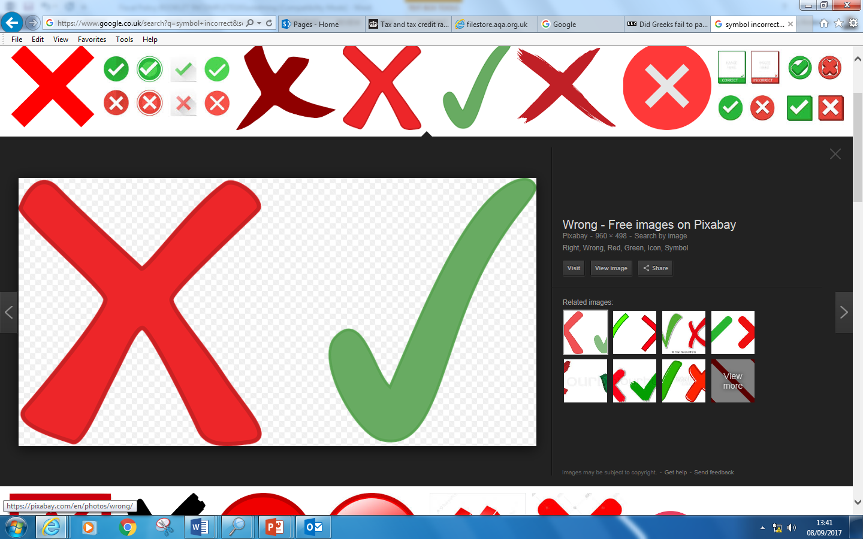

Discussion: In your groups explain why the explanation above is incorrect.
Once you’ve had your discussion write a correct explanation in the space below:-

………………………………………………………………………………………………………………………………………………………………………
………………………………………………………………………………………………………………………………………………………………………
………………………………………………………………………………………………………………………………………………………………………
………………………………………………………………………………………………………………………………………………………………………
………………………………………………………………………………………………………………………………………………………………………
………………………………………………………………………………………………………………………………………………………………………
………………………………………………………………………………………………………………………………………………………………………
………………………………………………………………………………………………………………………………………………………………………
………………………………………………………………………………………………………………………………………………………………………
………………………………………………………………………………………………………………………………………………………………………
………………………………………………………………………………………………………………………………………………………………………
Quick question – How many chains of analysis do you have in your explanation … count them up

Labour Market measures explained ….
Explain how a fall in income tax will increase the productive capacity of an economy (shift the LRAS to the right)?
  - A fall in the rate of income tax should act an incentive for existing workers to work even harder. This is because workers will keep a higher proportion of their wages/salaries as their incomes rise (disposable income rises). The increased incentive to work will mean that workers are likely to have much higher rates of labour productivity. If we assume that the size of the labour force remains constant this will mean that the potential output in the economy has increased. Lowering income tax therefore leads to an increase in the productive capacity of the economy.

  - A fall in the rate of income tax should act as an incentive for workers that are not part of the labour force - e.g people receiving unemployment benefits - to enter the labour market. The increased supply of workers will increase the size of the workforce. Consequently as the size of the workforce increases firms will be able to increase the output of goods and services. The increase in the size of the workforce has led to an increase in the productive capacity of the economy.

Your turn
Explain how a reduction in unemployment benefits will increase the productive capacity of the economy (shift the LRAS to the right)
……………………………………………………………………………………………………………………………………………………………………………………
……………………………………………………………………………………………………………………………………………………………………………………
……………………………………………………………………………………………………………………………………………………………………………………
……………………………………………………………………………………………………………………………………………………………………………………
……………………………………………………………………………………………………………………………………………………………………………………
……………………………………………………………………………………………………………………………………………………………………………………
……………………………………………………………………………………………………………………………………………………………………………………
Hint: What effect might these changes have on aggregate demand? What might it depend on? Can you think of any unfortunate side effects ? what impact might the changes have on the PSNCR?
Explain how an improvement in education and training will increase the productive capacity of the economy (shift the LRAS to the right)
……………………………………………………………………………………………………………………………………………………………………………………
……………………………………………………………………………………………………………………………………………………………………………………
……………………………………………………………………………………………………………………………………………………………………………………
……………………………………………………………………………………………………………………………………………………………………………………
Explain how trade union reforms will increase the productive capacity of the economy (shift the LRAS to the right): Use the words in the hint box to help you build up an answer)
Reducing trade Union power will mean that employers are able to increase productivity by employing more capital. The increased use of capital may mean that less workers are required. With less power trade unions wouldn’t be able to resist the capitalisation of the firm. Firms would therefore benefit from an increase in productivity and output would increase. If this were to happen throughout industry then the economy would see an increase in it’s productive capacity
Reducing trade union power would mean that firms would lose less day’s work due to striking. The increase in days worked by each worker would increase labour productivity. If the number of day’s lost to strikes were replicated across industry then the total output of the economy would increase.

Interventionist policies
Explain why Regional policy assistance in depressed areas is viewed as a supply side policy (you may need to research this policy to find out exactly what it is)
……………………………………………………………………………………………………………………………………………………………………………………
……………………………………………………………………………………………………………………………………………………………………………………
……………………………………………………………………………………………………………………………………………………………………………………
……………………………………………………………………………………………………………………………………………………………………………………
……………………………………………………………………………………………………………………………………………………………………………………
……………………………………………………………………………………………………………………………………………………………………………………
……………………………………………………………………………………………………………………………………………………………………………………

Explain why an increase in infrastructure spending is viewed as a supply side policy
……………………………………………………………………………………………………………………………………………………………………………………
……………………………………………………………………………………………………………………………………………………………………………………
……………………………………………………………………………………………………………………………………………………………………………………
……………………………………………………………………………………………………………………………………………………………………………………
……………………………………………………………………………………………………………………………………………………………………………………
……………………………………………………………………………………………………………………………………………………………………………………
……………………………………………………………………………………………………………………………………………………………………………………

PRODUCT MARKET

Supply side policy | Evaluate the policy
Strengthening Competition policy
Competition policy are the rules and regulations (often part of statute law) that discourage behaviours that might limit competition in industry. One such competition policy is the laws surrounding ‘take over’ of companies. Where one firm tries to take over another, if the joint market share is going to be greater than 25%, then the competition in the market and the emergence of a monopolist (or at least monopolist power) in the industry. Monopoly is a market structure typified by higher prices and reduced output. Policies that aim to encourage competition will lead to an increase in the amount of firms competing firms in the economy and an increase in the productive capacity of the economy.
Privatisation
Many firms under state control held monopoly status (e.BT).Monopoly is a market structure typified by higher prices and reduced output. Privatisation is the process of selling state owned businesses to the private sector. These firms will have to become more efficient to compete without state aid. Productivity in these firms will rise leading to higher levels of output in the industry which means there has been an increase in productive capacity
Deregulation
Deregulation involves the passing of legislation that makes it easier for firms to enter an industry. Deregulation means that there is an increased amount of competition in the industry. This causes firms to be more efficient (eg by using more capital). The increase in productivity leading to an increase in output in the industry. Deregulation has therefore had the effect of increasing the productive capacity of the economy.

The Laffer Curve

Listen to the clip and answer the following questions
- What does Arthur Laffer (and the Laffer curve) suggest are the reasons for a fall
In the tax receipts (amount of money collected from taxes) when income tax rates
go up?
- Using your own knowledge suggest other reasons why the tax rises could lead to a fall in tax revenues.
- Why is the BBC interviewer sceptical of the Laffer curve?
- How might supply side economists use the Laffer curve to support Tax cuts?

Laffer curve (continued)
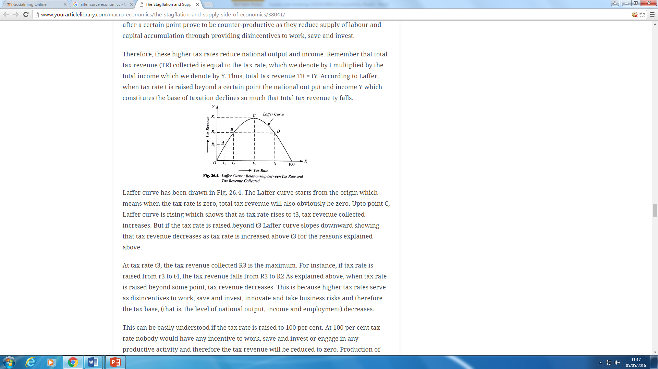
Questions on the Laffer curve
- What is the amount of tax revenue when the tax rate is 0%?
- What is the amount of tax revenue when the tax rate is 100%?
- What is the amount of tax collected when the tax rate is t2?
- What is the amount of tax collected when the tax rate is t4?
- What is the tax rate when tax revenues are maximized and how much revenue is raised?
- How might Supply-side economist use the Laffer curve to support their arguments? Write your answer in the space below.
EXTENSION
- Which is preferable, a tax rate of t4 or a tax rate of t2 (explain your answer)
- What is the value

Write the answers to question 6 and 7 in the space below:-
…………………………………………………………………………………………………………………
…………………………………………………………………………………………………………………
…………………………………………………………………………………………………………………
…………………………………………………………………………………………………………………
…………………………………………………………………………………………………………………
…………………………………………………………………………………………………………………
…………………………………………………………………………………………………………………
…………………………………………………………………………………………………………………
…………………………………………………………………………………………………………………
…………………………………………………………………………………………………………………
…………………………………………………………………………………………………………………
…………………………………………………………………………………………………………………
Summary: Laffer Curve
The Laffer Curve is a (supposed) relationship between economic activity and the rate of taxation which suggests there is an optimum tax rate which maximises total tax revenue.
The Laffer Curve concept infers that a tax rate cut could lead to an increase in tax revenue, or a decrease in tax revenue, depending whether you have already passed the ‘optimal tax rate’ (whatever % that may be)
Why might total tax revenues fall if the tax rate increases?
- Increased rates of tax avoidance – greater incentive to seek out tax relief, make max use of tax allowances
- Greater incentive to evade taxes (illegal) – i.e. non–declaration of income and wealth
- Possible disincentive effects in the labour market – depending on which taxes have been increased
- Possible “brain drain” effects – loss of highly skilled, high income taxpayers
Evaluating the Laffer Curve
- Supporters of the Laffer Curve are often those pushing for lower tax rates on higher income earners
- Lower top rate taxes might increase income inequality
- Many people are on fixed hours / zero hours contracts – so tax rates have little bearing on work incentives
- Tax rates not the only factor affecting work incentives – we must also consider the impact of the benefits system
- For some people, tax cuts will cause them to take more leisure time instead of work – a backward bending labour supply curve effect – especially at higher wages/ earnings
- There is a solid Keynesian explanation for some aspects of the Laffer Curve – cuts in direct and indirect taxes increase real disposable income and therefore lead to higher consumer spending and aggregate demand

Balanced budget fiscal expansion
This concept has become a major topic of conversation in the debate over the economic effects of fiscal austerity in many countries in the European Union and beyond. Put simply, a balanced budget fiscal expansion occurs when a change in government spending is matched by an equal change in taxation so that there is a neutral effect on the annual fiscal deficit but with the hope that real national income will expand.
Central to the concept is that the fiscal multiplier effects of say a £10bn rise in government spending are higher than the negative multiplier effects of an equivalent £10bn rise in taxes

Trade Union Reforms
Key terms
Transport for London (TFL) - is a local government body responsible for the transport system in Greater London
RMT
The National Union of Rail, Maritime and Transport Workers is a British trade union covering the transport sector. The RMT is one of Britain's fastest growing trade unions

Listen to the clip and answer the following questions
- What is a Trade Union?
- What does the term ‘collective bargaining’ mean?
- How much do tube drivers get paid?
- Other than increased pay what other benefits do train drivers get?
- What are the aims of trade unions?
- How much is the average UK salary?
- What powers do Trade Union have to bargain with?
- What is the financial impact of the RMTs actions

Write your answers below

Margaret Thatcher’s Union reforms
Margaret Thatcher's demolition job on the industrial might of the British trade union movement helped to generate an economic revolution. In the late 1970s, millions of days a year were being lost through strike action but at the end of her premiership stoppages were a fraction of what they had once been.
3
Slowly but surely the unions' strike weapon was emasculated. Strike ballots were required by law; walkouts were no longer possible on a show of hands in a car park; flying pickets and secondary action had been outlawed; and most importantly of all, a union's assets were at risk if there was "unlawful" action, as the NUM president Arthur Scargill discovered to his cost in the 1984-85 pit dispute.
7
Mr Scargill, like other union leaders of his era, had grown used under the previous Labour governments of Harold Wilson and James Callaghan to employers giving way. But Mrs Thatcher, backed by a largely supportive national press, was able to prove that the disputes of the 1980s would be won or lost not just on the picket line but also on the back of public opinion, and much of the media's coverage was turned against the unions.
11
The 1986 Big Bang and the deregulation of financial markets in the City of London only served to underline the demise of the trade unions. The end of nationalisation and the take-up of shares by workers in the newly privatised industries was a stark reminder of the shift that had taken place.
Share ownership trebled in the Thatcher decade and so did the growth in home ownership after the sale of council houses. By the late 1980s the all-out strike was history; no union could ask its heavily mortgaged members to contemplate anything more than a one or perhaps two-day strike.
17
Organisationally the killer blow for the unions was the end of the closed shop and withdrawal of "check-off" agreements that required employers to deduct union contributions.
Today union membership is half what it was: in 1979, when Mrs Thatcher became prime minister, the TUC's affiliated membership stood at just over 12 million, the highest it had ever been.
21
BBC website 10 April 2013, Nicholas Jones, former BBC industrial and political correspondent for thirty years

Question
- How did Mrs Thatcher reduce trade union power? List the actions taken? Use line numbers and quotes to support your answer

……………………………………………………………………………………………………………………………………………………………………………………
……………………………………………………………………………………………………………………………………………………………………………………
……………………………………………………………………………………………………………………………………………………………………………………
……………………………………………………………………………………………………………………………………………………………………………………
…………………………………………………………………………………………………………………………………………………………………………………….
……………………………………………………………………………………………………………………………………………………………………………………
……………………………………………………………………………………………………………………………………………………………………………………

- In the 1980s what other factors helped reduce the power of trade unions? Use line numbers and quotes to support your answer.

……………………………………………………………………………………………………………………………………………………………………………………
……………………………………………………………………………………………………………………………………………………………………………………
……………………………………………………………………………………………………………………………………………………………………………………
……………………………………………………………………………………………………………………………………………………………………………………
……………………………………………………………………………………………………………………………………………………………………………………
……………………………………………………………………………………………………………………………………………………………………………………

Limitations of Supply-side policies

Whilst it is generally accepted that Supply side policies can have the desirable effect of achieving all 4 Macro economic objectives there are limitations to the effectiveness as a policy tool.

- Supply-side Policies can often take a long time to work.
- Some Supply-side policies can be costly to implement. For example large infrastructure projects may add considerably to the PSNCR.
- Supply-side policies require enough aggregate demand in the economy to enable access to the increase in productive potential.
- Some supply side policies have a negative effect on Aggregate Demand in the short run (e.g reduction in welfare payments)

Notes

What is the relationship between the following curves (PPF, LRAS and the trend line)
Draw each in the space below
A production possibility frontier (capital goods and consumer goods)
Briefly explain how you would show SR economic growth on this diagram.

Briefly explain how you would show a negative output gap on this diagram

A business cycle (economic cycle diagram)
How would you show positive and negative output gap?

Extension: What is the relationship between the actual rate and the level of aggregate demand?

The Long Run monetarist equilibrium
How would you indicate unemployment on this diagram?

Briefly explain how you would show SR economic growth on this diagram.

Extension activity discussion: Monetarist Economist believe that economies (left alone) will correct themselves so that they will tend towards a full employment. If this is the case what is the relationship between the LRAS, PPF and trend line.

Appendix 1

Homework:
“A brief guide to the UK Public Finances” Office for Budgetary Responsibility (OBR) March 2019
https://obr.uk/docs/dlm_uploads/Brief_guide_to_the_public_finances_March_2019.pdf
This document provides a predicted fiscal outlook

Instruction

Down load ‘A brief guide to the public finances by following the link above’ and the n answer the following questions

Write your answers clearly on a separate sheet of A4 paper. Make sure you divide your response by using the questions as sub headings (see example below)

- What is the role of the OBR?
- How much money will the Public sector raise through taxes in 2019–2020
- Which 4 taxes raise the most revenue for the government, state what they are and how much they raise.
- How much will the government spend on public services in 2019 – 2020
- Which part of the public sector receives the most money? How much does it receive?
- What is the expected size of the budget deficit in 2019–2020? (in cash terms)
- What is the expected size of the budget deficit in 2019 - 2020? (As a percentage of national income?)
- What will be the expected size of the deficit in 2023-24? (in cash terms)
- Define the term ‘structural deficit’
- What is meant by the term National debt?
- What do the OBR predict will be the total value of the National Debt to be in 2019-2020 (measured as a percentage of national income)
- What will the size of the national debt be in cash terms by 2023-24? (cash terms)
- Define the term current spending
- What is the projected value of current spending by the government in 2019-2020?
- What do the OBR predict will be the value of the interest payments on the national debt in 2019 -20?
- In 2019-2020 what do the OBR predict that the total level of Capital spending by government will be?
- In the year 2019-2020 what will the total amount of money spent on pensions be?
- What year does the OBR think that the Government will Balance the Budget?
- In 2019-2020 what do the OBR predict will be the percentage Debt to GDP ratio?

Appendix 2
UK government spending (estimates) for 2017
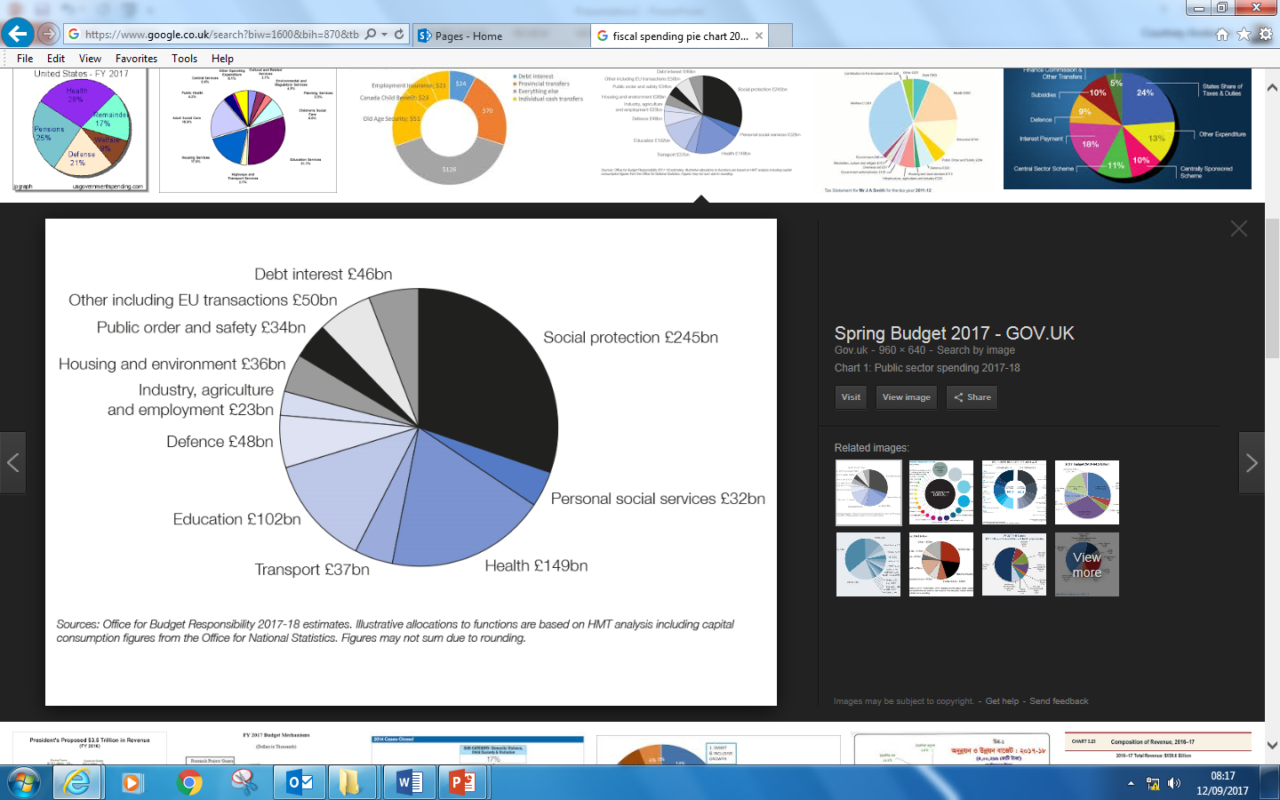

UK government tax receipt
