**Topic D: Sources of finance**

Businesses need finance for a wide number of reasons, both to fund capital and revenue expenditure. The source of finance is where this money comes from. What the money will be used for will determine which source is the most suitable.

For example, you might look for a long-term bank loan or mortgage to fund capital expenditure such as buying a factory, but this would not be appropriate for replenishing stock. Sources of finance can be short term which means they have to be paid back within one year or long term which means they are paid back in a period of time greater than one year.

**Read:** Text book pages 91 to 94 (pdf pages 33 to 36)

**Watch**: LearnLoads – Sources of Finance Explained <https://www.youtube.com/watch?v=_vpehy2vuGQ&index=5&list=PLXzd3vidJkSd1sl1EZ5sHT8FPafHtwu4y> (approx. 10mins)

**Watch**: Bee Business Bee Topic Video – Sources of Finance <https://www.youtube.com/watch?v=aFGiixmLgbI> (approx. 20mins – good for revision)

**INTERNAL SOURCES OF FINANCE:** are those available from within a business

|  |  |  |  |
| --- | --- | --- | --- |
| **Source of finance** | **Definition (inc. ST or LT)** | **Advantages** | **Disadvantages** |
| Retained profit |  |  |  |
| Net current assets (working capital) |  |  |  |
| Sale of assets |  |  |  |

**EXTERNAL SOURCES OF FINANCE:** the places where finance can be raised from outside of the business

|  |  |  |  |
| --- | --- | --- | --- |
| **Source of finance** | **Definition (inc. ST or LT)** | **Advantages** | **Disadvantages** |
| Owners capital |  |  |  |
| Loans |  |  |  |
| Crowd funding |  |  |  |
| Mortgages |  |  |  |
| Venture Capital |  |  |  |
| Debt factoring |  |  |  |
| Hire purchase |  |  |  |
| Leasing |  |  |  |
| Trade credit |  |  |  |
| Grants |  |  |  |
| Donations |  |  |  |
| Peer to peer lending |  |  |  |
| Invoice discounting |  |  |  |

**Activity: For each scenario, choose two of the MOST SUITABLE sources of finance and give reasons for your choices.**

|  |  |  |
| --- | --- | --- |
| **Client and Need** | **Suggested Source/s of Finance** | **Reasons for choice of Sources of Finance** |
| 1. A newsagent needs to cover expenditure over a short period of time. She is expecting high sales at the end of the month. |  |  |
| 1. A new business in a high tech market is looking for £100,000 to fund expenditure on equipment. The business is looking for an innovative solution to in-house design which will reduce fuel consumption. The owner is willing to consider giving up some of the control of the company. |  |  |
| 1. A dry cleaners needs to update its equipment following a series of breakdowns which have damaged its reputation. It expects the new equipment to cost approximately £30,000 and have a useful life of about 5 years. |  |  |
| 1. A self-employed builder needs a new van. |  |  |
| 1. An unemployed woman, aged 23, is hoping to set up a business designing and making greetings cards from her home. She has no finance of her own, and has been turned down by a number of High Street banks. |  |  |
| 1. A very successful, profitable business selling sports cars wants to expand and purchase a second showroom. The owner is unwilling to consider giving up any control of his business. |  |  |
| 1. Two brothers operate a partnership which does loft conversions. They are looking to expand the business in order to do a wider range of construction work. |  |  |

**Past paper questions**

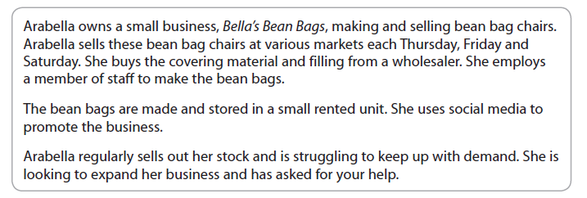

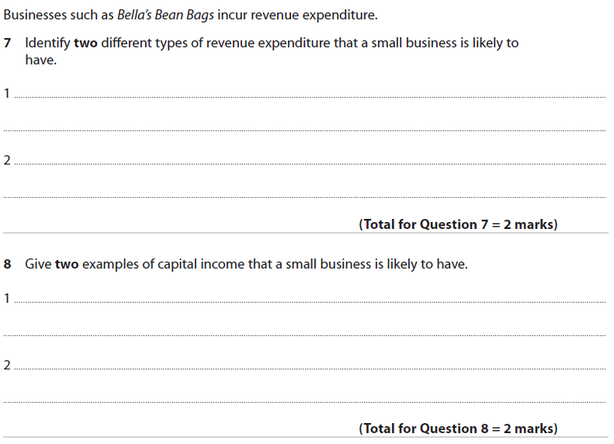 **[2 marks]**

|  |
| --- |
|  |



**[2 marks]**

|  |
| --- |
|  |

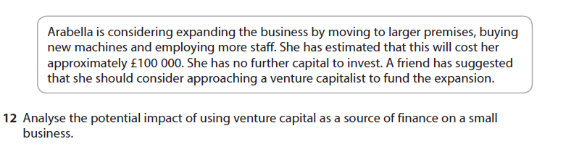

**[8 marks]**

|  |
| --- |
|  |

