**Propp’s Character theory** 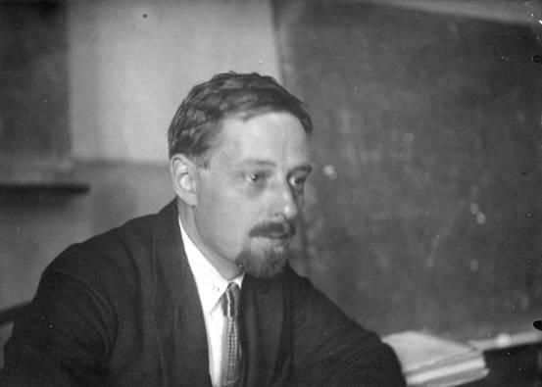

Vladimir Propp was a Russian academic who created a theory about the role of characters in narratives (stories).

By studying folk tales, he noticed similarities between the characters featured. In summary he identified over 40 different types of characters, each of which plays a different role in the narrative.

Though he came up with more than 40 character types, here are some of the main ones:

**The Hero**

The hero must overcome barriers to achieve resolution at the end. Having done so, he will be rewarded with the Princess and the villain will be defeated

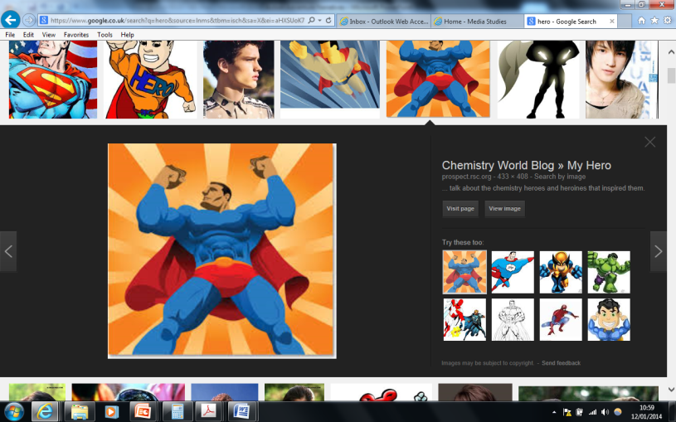

* The Hero
* The Princess

**TASK 1: EXAMPLE**

* The Villain
* The Donor
* The Dispatcher
* The False Hero
* The Sidekick

**TASK1:**

Research the theory and create a ‘Top Trump’ card or brief description in as a PowerPoint slide for each of the above seven character types.

**TASK 2:**

Apply Propp’s character theory to a well-known film or fairytale. For Level 4 you should aim to apply it to a range of media products (e.g. advert, film, TV). You should include the following:

* Name of story/film
* Main characters and what Propp character type they are
* Why you believe that they are this character type, using examples of their role in the narrative

***Challenge****: Evaluative the usefulness of this theory – what is good about it and what do you think is not so good about it?*