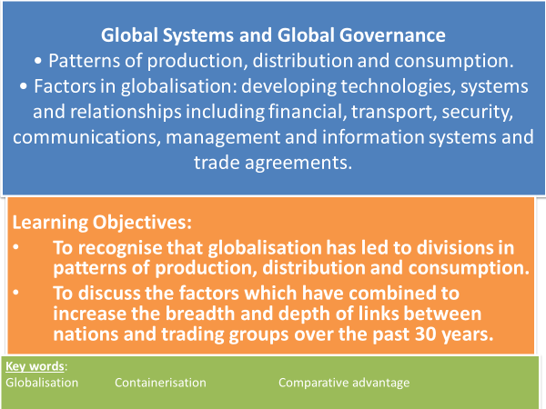

**Key Words**

* **Containerisation** - is a system of standardised transport that uses a common size of steel container to transport goods. These containers can easily be transferred between different modes of transport – container ships to lorries and trains. This makes transport and trade of goods cheaper and more efficient.
* **Comparative Advantage** - the ability of an individual or group to carry out a particular economic activity (such as making a specific product) more efficiently than another activity.
* **Maquiladora** – A manufacturing operation (plant or factory) located in free trade zones in Mexico. They import materials for assembly and then export the final product without any trade barriers.

What has enabled travel time to decrease?

What impact has reduced travel time had on globalisation?

**The interrelationship between transport and trade growth**



Watch the clip on containerisation.

<https://ed.ted.com/lessons/how-containerization-shaped-the-modern-world>

**The World’s Economic Centre of Gravity**

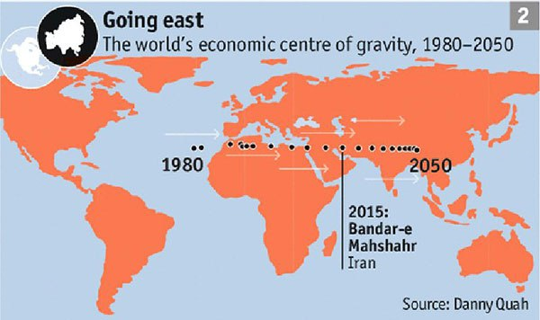**TASK: Why is the world’s economic centre of gravity shifting?**

**What is the impact of Global Shift on the countries it is moving *to* and *away* from?**

**Patterns of production distribution and consumption**

**TASK: Watch the clip** <https://www.youtube.com/watch?v=Meo0s54s1sw>

**TASK: ‘Globalisation has led to a global division of labour’. With reference to The Apple TNC supply chain explain the meaning of this statement.**

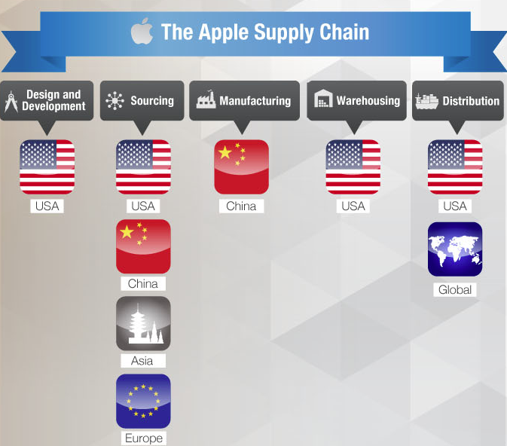

**Global Division of Labour**

* This simple division has undergone radical changes in the last 40 years.
* Many countries identified as less economically developed became newly industrialised countries (NICs).
* NICs developed their own industrial and commercial bases and their own TNCs which spread globally.
* This started with the four Asian ‘**tiger’** economies followed by the **BRIC** economies and more recently the so-called **MINT** economies.
* Development has come to regions surrounding these new ‘cores’, particularly to south east Asia and Latin America.

**TASK: Can you name the four Asian ‘tiger’ economies the BRIC economies and the MINT economies?**

Asian Tigers BRIC economies MINT economies

**TASK: Why could the MINT countries be the next emerging economic giants?**

**TASK: Can you name any TNCs that originate from the Asian ‘tigers’, BRIC or MINT countries?**

**TASK: Use your homework notes to complete the missing blanks in the text below.**

**Patters of production, distribution and consumption**

* In ______ around 95 of manufacturing was concentrated in the industrialised economies of Western Europe, North America and Japan. Products were largely consumed in country of origin.
* Decentralisation has occurred – largely as a result of foreign direct investment by _______ into developing countries able to do manufacturing tasks at a competitive price.
* Lower land and labour costs, incentives offered by governments in developing countries have encouraged TNCs to relocate _____________ abroad.
* This filtering down of manufacturing industry from developed countries to lower wage economies is known as __________________.
* The ______________________________ made by TNCs has enabled countries in the developing world to increase productivity without raising wages to levels of developed countries.
* One consequence of global shift is ______________________ in richer countries and a loss of jobs in the manufacturing sector.
* Over _______ of manufacturing jobs are in developing countries.

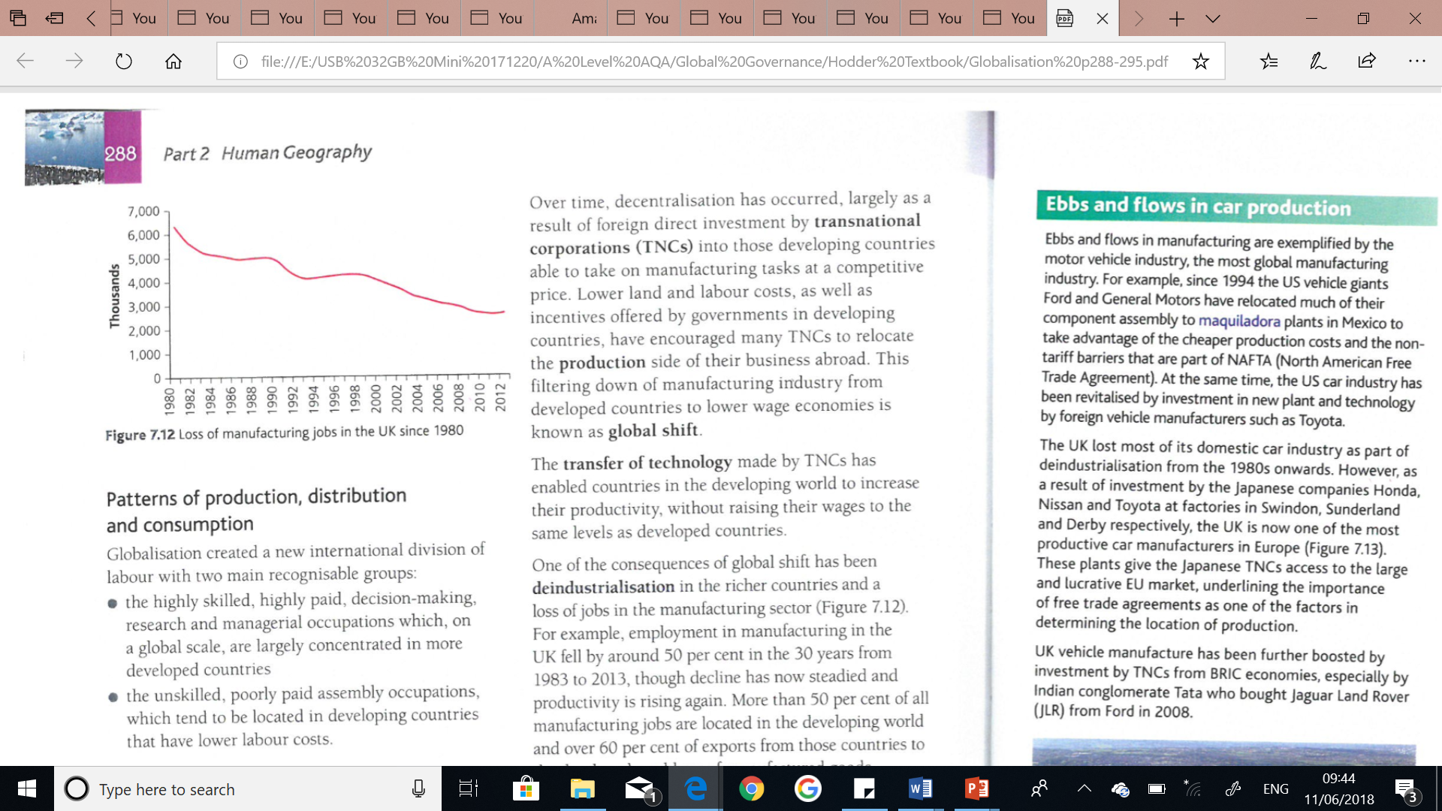

* Other factors that contributed to a decline in manufacturing in developed countries are:
  + Outmoded production methods
  + Products at the end of their life cycles
  + Poor management
* ___________ of this trend has been prompted by foreign TNCs investing in deindustrialised regions

Manufacturing transfers around the world not only because of lower costs.

Other factors include:

* The availability of a skilled and ____________ workforce.
* The opportunity to build new plant with the latest and most productive ______________.
* ____________________ in the form of tax breaks or enterprise zones to entice companies to invest and relocate.
* Access to large markets without tariff barriers, enabled through ____________________________.

**Deindustrialisation trade agreements global shift 50% 1954**

**Government incentives TNC’s transfer of technology reversal**

**95% educated technology production**

**TASK: Read the extract titled ‘Ebbs and flows in car production’ Hodder text book p289. Explain in your own words how changing patterns have affected car production in the US and UK.**

**Distribution and consumption**

* Product consumption still lies predominantly in the richer countries of the developed world.
* Products manufactured in emerging NIC economies are largely exported and sold to countries in Europe, North America and Japan.
* The pattern is changing as NICs develop their populations are becoming more affluent and starting to demand similar consumer products. A definite shift from west to east is likely to appear in future.
* Forecasts suggest that:
  + Consumption will drive trade patterns more than production location decisions. Therefore the fastest growing trade route will be between India and China
  + As Asia becomes more competitive a growing share of the region’s exports will be to other countries in Asia
  + Western companies specialising in finance have enormous potential to benefit from the expansion of trade in financial services in the Asia-Pacific region.

**Factors in Globalisation**

* The internet enabling speedy and 24/7 global communications & the emergence of English as the accepted global language of business has also eroded barriers.

**TASK: Answer the following exam questions:**

Explain how technological advances have contributed to globalisation. (4 marks)

Explain how security is a contributing factor to globalisation. (4 marks)

**Comparative Advantage**

**TASK: Watch the clip and make notes on comparative advantage** [**https://www.youtube.com/watch?v=4rUfoU04QJM**](https://www.youtube.com/watch?v=4rUfoU04QJM)

**‘The Umbrella City’ an example of comparative advantage:**

**TASK: Read the extract ‘The Umbrella City’ (Oxford text book p15 & 16). Summarise the *comparative advantages* Songxia, China has.**

**Comparative Advantage:** the ability of an individual or group to carry out a particular economic activity (such as making a specific product) more efficiently than another activity.

**TASK: Oxford text book p17 question 1) Create a line graph using the data in Figure 2. Use the x-axis for the year. Describe the graph - what do you notice about the rate of the growth of global exports?**

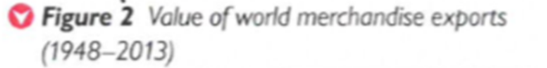

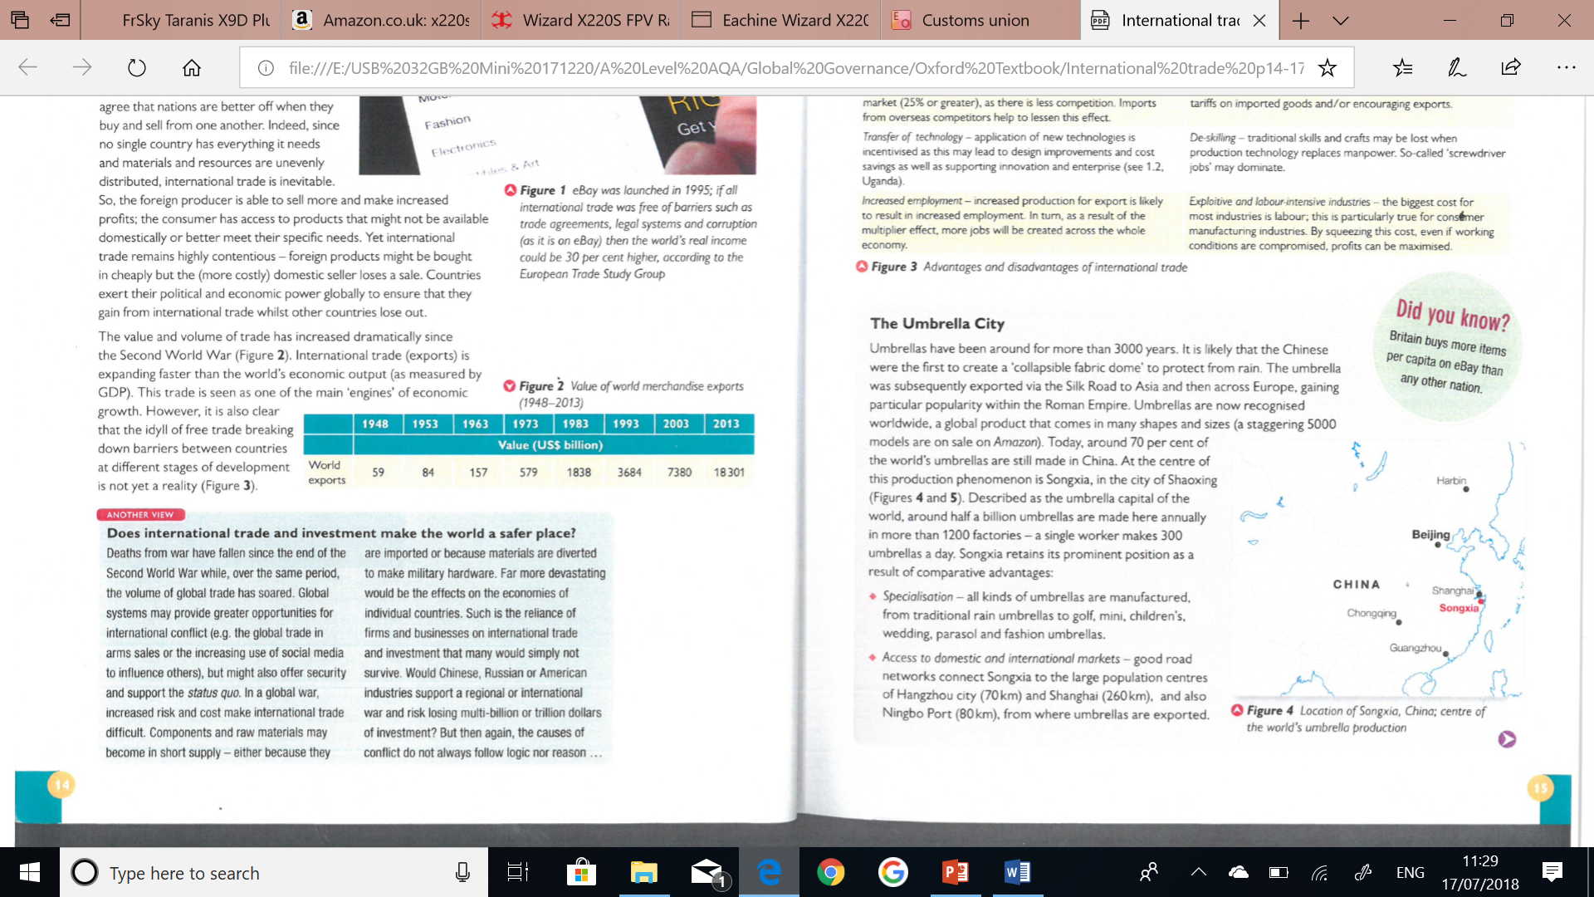



**TASK: Read course Tutor2u companion no. 52 Globalisation: dimensions, patterns and factors. (GOL, Global Systems and Global Governance Folder 4)**