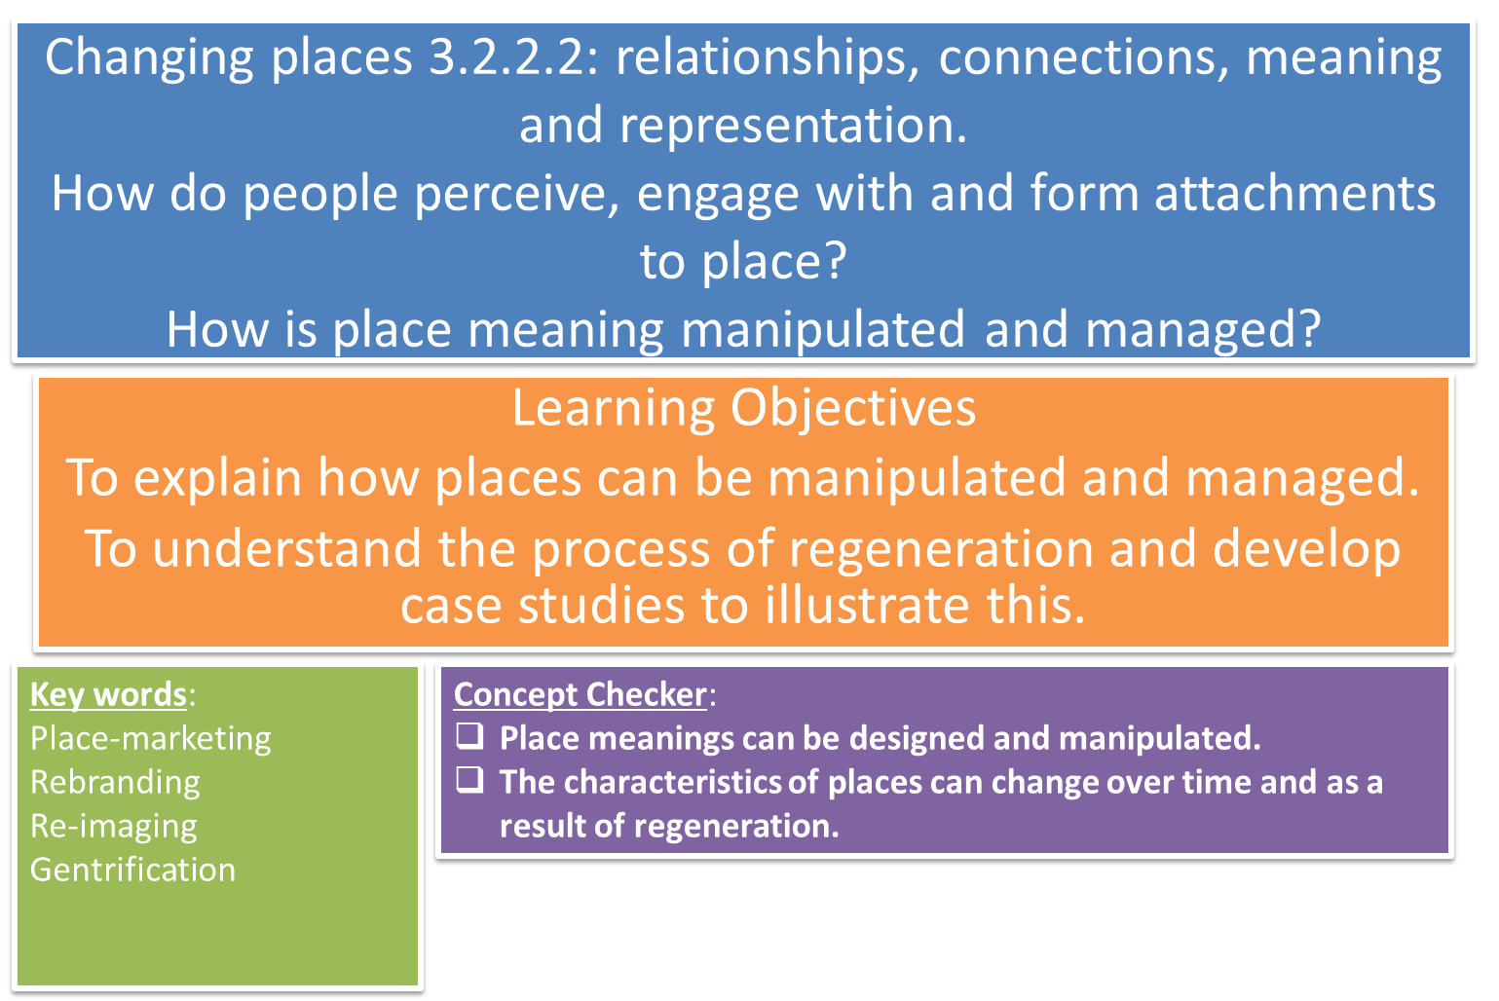

**Homework follow-up: Godalming sense of place**

What different media sources helped you establish a sense of place of Godalming?

What sense of place did you get? Why may this not be reflective of the lived experience of all people in Godalming?

**How and why do organisations manipulate perceptions of place?**

|  |  |  |  |
| --- | --- | --- | --- |
|  |  |  |  |
| To change negative stereotypes | To attract inward investment | To improve the quality of the built environment by removing derelict buildings, redeveloping wasteland, etc. | To raise the status of a place which can in turn give political gain. |
| To encourage people to move, live and work in an area | To improve job opportunities | To clean up neglected waterways and open space, making way for recreation. | To rebrand, make more attractive, possibly attract inward investment, and improve lived experience of people. |

Why might places need to be managed?

Decisions to manipulate or change the perception of a place may be motivated by a number of factors, including:

Political, social, economic or environmental?

**Agents of change** can include residents, community groups, corporate bodies, multinational corporations, the media and central and local government.

**KEY TERMS**

RE-IMAGING

REBRANDING

REGENERATION

A long-term process involving redevelopment and the use of social, economic and environmental action to reverse urban decline and create sustainable communities.

PLACE MARKETING

GENTRIFICATION

**One example of a managed place is a shopping centre.**

Developments such as Westfield in Stratford, West Quay in Southampton and the Trafford Centre in Manchester are examples of how shopping centres have evolved into highly managed spaces, ‘destinations’ where we are encouraged to spend more leisure time and money.

TASK: read the article hand-out *‘The tricks stores use to make you spend more’:*

1) How do shopping centre designers attempt to manage the movement of customers?

2) Describe two ways shopping centres now encourage people to stay for longer and spend money in the high-end shops:



***TASK: Study p.85-86 in the Oxford book and then answer these questions:***

[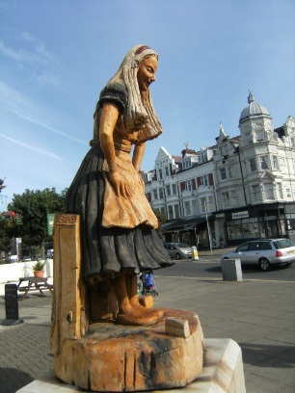](https://www.google.co.uk/url?sa=i&rct=j&q=&esrc=s&source=images&cd=&cad=rja&uact=8&ved=0ahUKEwiNzJupmMHWAhVMthQKHYe7BgEQjRwIBw&url=https://hubpages.com/literature/Alice-in-Wonderland-childrens-book-Lewis-Carroll-DVD-through-the-looking-glass-Guinness-Book-of-Records-Llandudno&psig=AFQjCNHDagdow0LzB7ff-Q2b5qo5UDqShg&ust=1506458005497438)a) How might re-publicising the link between Llandudno and Alice Liddell benefit the town?

b) How have local entrepreneurs sought to develop this link?

c) Why do you think such developments have been greeted with a mixed response from the local community?

d) Evaluate the success of this rebranding effort. Justify your argument with evidence.

The different people and groups involved in regeneration are known as **stakeholders.** They may influence the process of regeneration or be affected by it. Stakeholders may include:

* Local council;
* Central government;
* Town planners;
* Developers/construction companies;
* Local residents;
* Community and local charity groups;
* Conservationists;
* Heritage organisations;
* Retail companies.

**Features of regeneration**

This is a photo of an area in Birmingham city centre.

*Annotate the photo with features that show evidence of redevelopment.*

*High end housing and luxury apartments.*

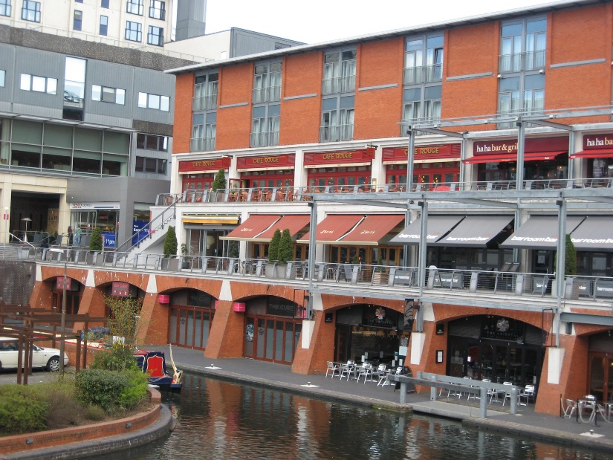

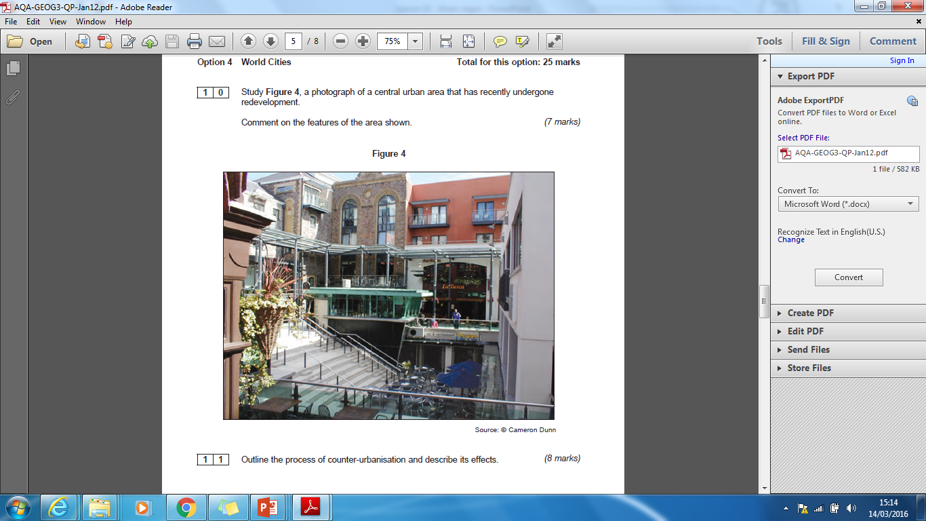

Study Figure 4, a photograph of a central urban area that has recently undergone redevelopment.

Comment on how representation of place may have changed in this area. (6 marks)