***Quality Street***

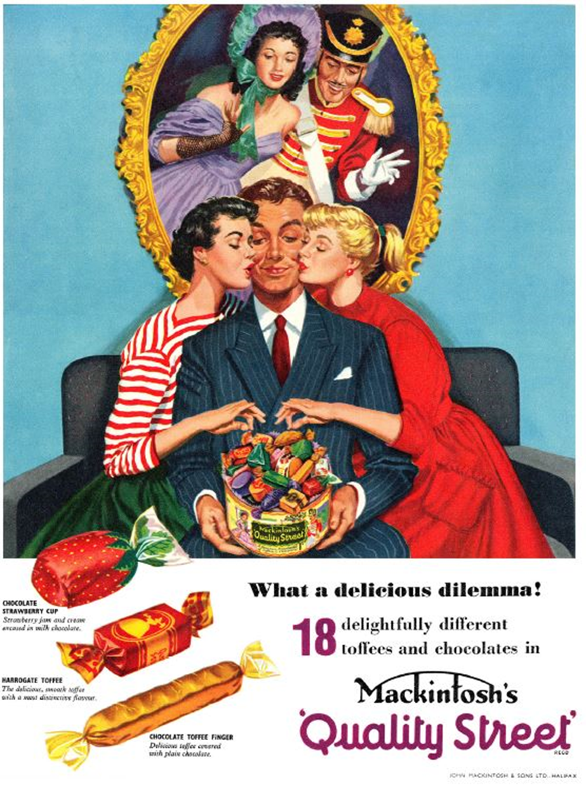

***(1956)***

**Visual Codes: Colour Palette, Dress Codes, Gesture codes, Setting**

**Typography and Language**

**Layout**