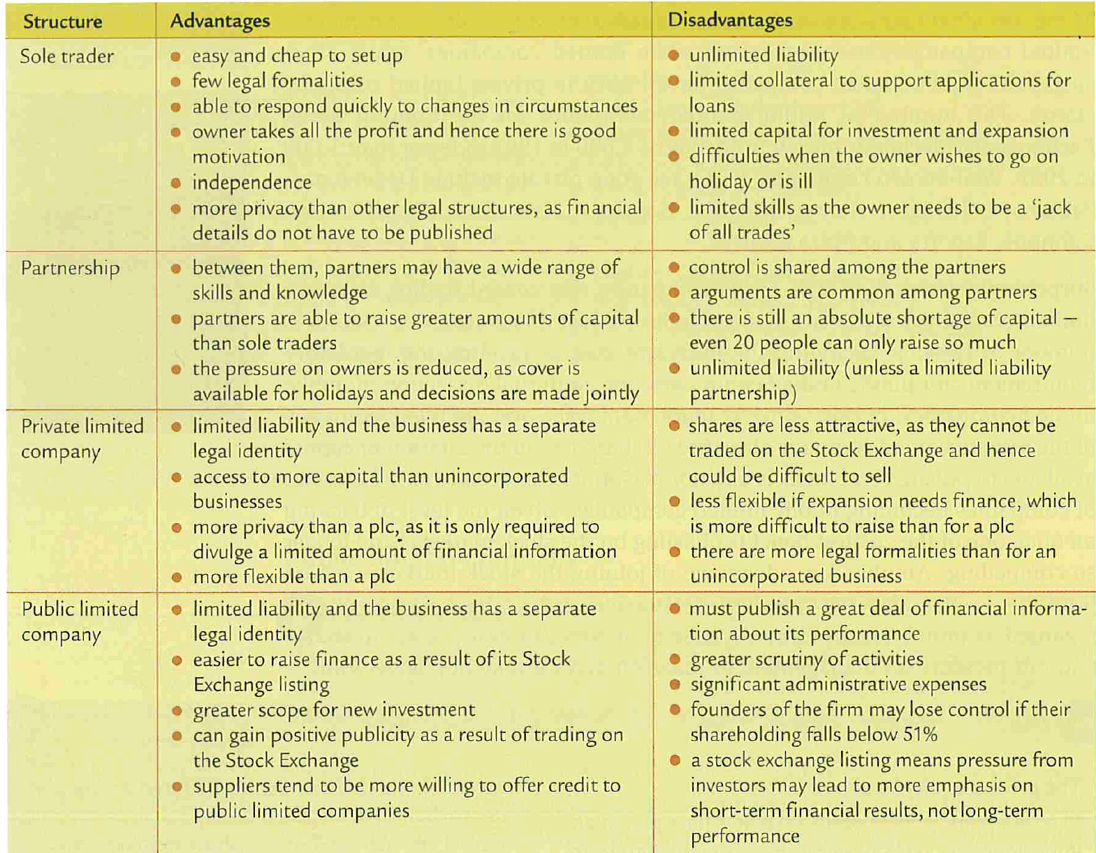

# Practice Questions

1. Explain the implications of a business having **unlimited** liability?

2. Explain the implications of a business having **limited** liability?

