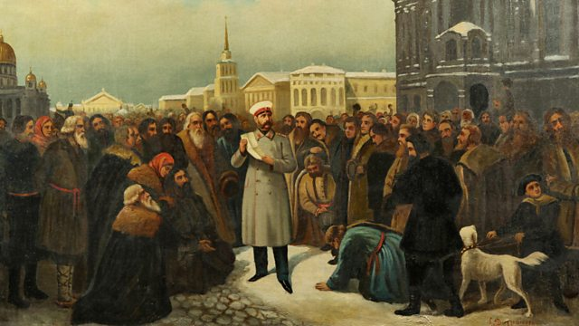**Depth Study 1: Alexander II’s Domestic Reforms**

**A-Level History Democracy and Dictatorship**

**OCR Y318/01: Russia and its Rulers 1855-1964**

NAME:

**Exam Board Content:**

**This booklet covers the following part of the OCR course:**

**Assessment**

**Depth Studies:**

1. Alexander II’s Domestic Reforms
2. The Provisional Government
3. Khrushchev in power 1956-1964

This topic is assessed on **part A** of your **Unit 3 paper**. You are assessed through **a 30-mark interpretation question**, which will cover one of the three depth studies. You will have 1 hour to write this answer.

**Past Exam Questions: (see end of booklet for passages)**

1. Evaluate the interpretations in **both** of the two passages and explain which you think is more convincing about the consequences of Alexander II’s Great Reforms. **[30] (June 2018)**
2. Evaluate the interpretations in **both** of the two passages and explain which you think is more convincing as an explanation of the reasons why Alexander II emancipated the serfs. **[30] (June 2019)**

**Recommended reading**

**Textbooks:**

* Andrew Holland, *Russia and its Rulers 1855-1964* (OCR textbook)
* Andrew Holland, *Russia and its Rulers 1855-1964* (My Revision Notes series – OCR revision booklet)
* Mike Wells and Nick Fellows, *Russia and its Rulers 1855-1964* (old OCR textbook – Heinemann series)

**History Today Articles (go to** [**www.historytoday.com**](http://www.historytoday.com) **username= godalming; password= history)**

* Carl Peter Watts, ‘The reforms of Tsar Alexander II’
* Michael Lynch, ‘The Emancipation of the Russian Serfs, 1861’

**Modern History Review (click this** [**link**](https://my.dynamic-learning.co.uk/?csid=9781471862410&uid=21e6ce43-0768-4828-90ac-a77eb5797f84&cid=17033&to=635269&gd=2019-10-04T12:39:26&ke=8415B8F99F78451F531851C575231EA9&sa=65UXrA3Pcrovplj6L371aCghDUKafk&mp=6) **then search for the issue number)**

* Shane O’Rourke, ‘Alexander II the Tsar Liberator’, April 2019 (Volume 21, Issue no. 4)
* Peter Neville, ‘Tsar Alexander II. Liberator or Traditionalist?’, September 1997 (Volume 9, Issue no. 1)
* Michael Hughes, ‘Foreign Policy and Domestic change in Tsarist Russia’, November 2004 (Volume 16, Issue no. 2)

**Books**

* E. Radzinsky, *Alexander II: The Last Great Tsar,* 2006
* R. Pipes, *Russia under the Old Regime*, 1987
* S. Sebag Montefiore, *The Romanovs: an intimate chronicle of the Russian royal family*, 2014
* L. Kochan & J. Keep, *The Making of Modern Russia*, 1997

**Podcasts and Documentaries**

* BBC *In our Time* ‘Tsar Alexander II’s Assassination’ - <https://www.bbc.co.uk/programmes/p003k9b2>
* BBC *In Our Time* ‘The Emancipation of the Serfs’ - <https://www.bbc.co.uk/programmes/b0b2gspd>
* Empire of the Tsars: Romanov Russia with Lucy Worsley (Episode 3) (Estream – search 15799)

**Timeline**

|  |  |
| --- | --- |
| **1855** | Alexander II takes power after the death of his father Nicholas I |
| **1856** | Treaty of Paris ends the Crimean War – Russia defeated |
| **1861** | The Emancipation Edict issued abolishing serfdom |
| **1863** | Polish uprising |
| **1863** | Universities given greater autonomy |
| **1864** | Local government reform creating the *Zemstva* |
| **1864** | Judicial reforms |
| **1865** | Censorship was relaxed |
| **1866** | First assassination attempt on Alexander II |
| **1866** | Alexander slows the pace of reform |
| **1867** | Second assassination attempt on Alexander II |
| **1870** | Elected town councils know as *dumas* were introduced |
| **1874** | Military reforms extending conscription to all classes and creating military colleges |
| **1874** | The Populist ‘Go to the People’ campaign |
| **1877-78** | Russo-Turkish War |
| **1879** | Terrorist organisation the ‘People’s Will’ (*Narodnaya Volya*) resolves to assassinate the Tsar |
| **1880** | Failed assassination attempt with the bombing of the Winter Palace |
| **1880** | Count Loris-Melikov restarts reforms to combat radical revolutionaries |
| **1881** | The assassination of Alexander II |

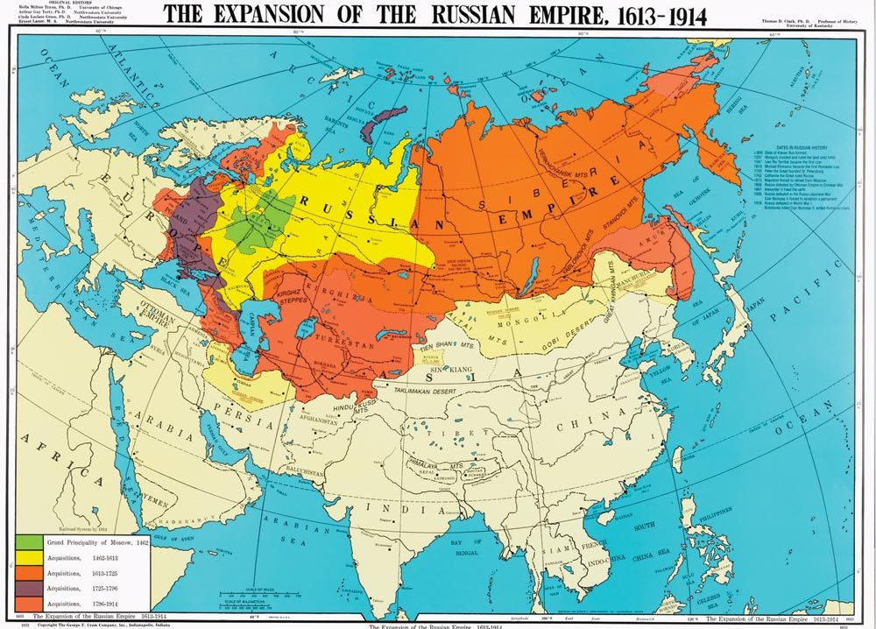

**What Caused Alexander II’s Reforms? - introduction**

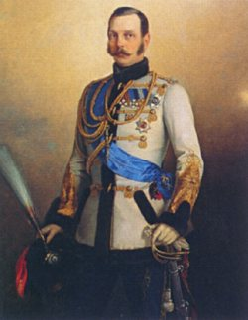

When Alexander II came to power in 1855 he inherited an empire that was in clear need of reform. Russia had failed to keep up with the advanced powers of Western Europe and its status as one of the five ‘Great Powers’ (Britain, France, Austria, Prussia and Russia) was under threat. Russia was making slow progress towards developing a modern, industrial economy and remained overwhelmingly agricultural, rural and peasant-based. Agriculture, however, was itself backwards and inefficient; the majority of peasants were state-owned **serfs** who lacked the freedom and incentive to improve their farming methods.

Added to these economic problems were a raft of long-term social issues that Alexander II faced. Peasant unrest was increasing, whilst those who wanted Russia to ‘westernise’ were frustrated by the autocratic regime of the Tsars, the lack of education and with censorship. The level of social inequality in Russia was also clear to see: an aristocratic class owned much of the land and many adopted a French style of living, completely alien to the peasant population of Russia.

Overall, in 1855 Russia was suffering from a range of economic and social problems that threatened the long-term survival of the **Tsarist regime**. Russia’s backwardness prevented it from competing with more ‘modern’ European powers, whilst it also created the conditions for growing domestic opposition that could lead to unrest or revolution. As recently as 1825, a group of liberal officers and nobles known as the ‘**Decembrists**’ had attempted to prevent Alexander’s father, Nicholas I, from taking power and to create a liberal constitution instead.

To these long-term causes of reform was added the catalyst of the **Crimean War**. Between 1853 and 1856, Russia fought the **Ottoman Empire**, who in 1854 was joined by **France**, **Britain** and the North Italian kingdom of **Piedmont-Sardinia**, and despite fighting on their doorstep, Russia was defeated and forced to accept the **Treaty of Paris** in 1856.

**TASK – Once you have read the introduction above, make a list of 3-4 bullet-points of the problems facing Russia by 1856, then put a cross next to the one that you think would be most serious**

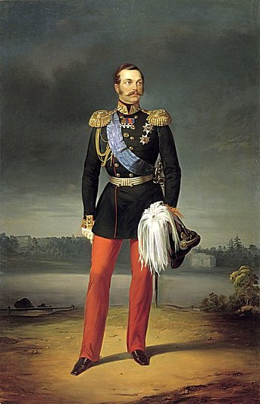**A Picture of Russia in 1855**

***The Political Situation***

* Russia was ruled as an **autocracy** in which the Tsar was ‘Emperor and Autocrat of all Russia’. Tsars were chosen by God and were also the heads of the **Orthodox Church** in Russia
* Edicts from the Tsar were law and he appointed his own advisors in the Imperial Council.
* The Russian Empire was divided into 50 provinces and Tsars relied on the **provincial nobility** to govern them. Nobles also formed the 14 ranks of civil servants who made up the Russian **bureaucracy**
* Tsars maintain control of their empire by developing deep loyalty, particularly from peasants, who viewed them as the ‘Little Father’. If this failed, Tsars controlled a **police state** which included strict censorship and the ‘**Third Section**’ or secret police
* Tsars controlled the world’s largest army of approximately 1.5 million **conscripted** serfs, who served for 25 years.
* There had been calls for democratic reforms in Russia before 1855, the most serious of which was the **Decembrist Uprising** in 1825. Tsar Nicholas I (1825-1855) suppressed these calls and followed a path of strict autocracy.
* There broadly existed two schools of thought in Russian government (and certain nobles). The first were the **Slavophiles** who rejected western style political and social reform, believing that Russia had a unique Slavic identity, built on the bond between Tsar and peasant. The second group were the **Westernisers** who wanted to adopt western-style reforms in the economy, society, education etc.

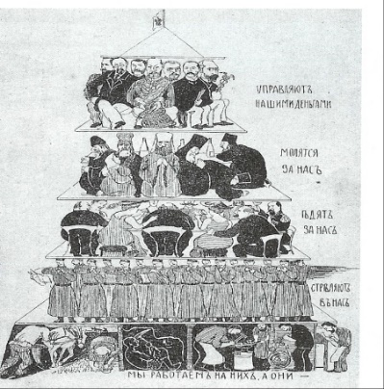

***The Social Situation***

* Russia was a sharply divided and unequal society. At the top existed the **land-owning elite**, made up of the clergy, nobility officers and government officials
* At the bottom was the largest group – the **serf** majority who worked the land of a landowner and were bound to them (i.e. they were essentially slaves)
* There was also a relatively small number of urban craftsman and manufacturers, along with professionals such as doctors and lawyers. Russia lacked, however, a ‘middle-class’ as had developed in countries like Britain
* The Russian Empire was ethnically and religiously diverse. According to the 1897 census, just under 50% of the Empire’s population was ethnically Russian, the rest being made up of over a dozen other ethnic groups

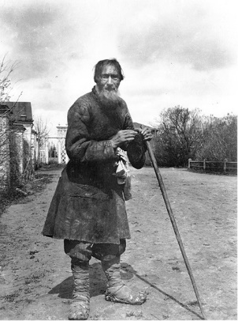

***The Economic Situation***

* The Russian economy was overwhelmingly agricultural. In Russia there were 11 people who lived in a rural village for every 1 in a town. In Britain the ratio was 2:1.
* Agriculture was **serf-based**. Serfs were men, women and children who were classified as the property of their owners. Just over half were privately owned (23.1 million according to the 1857 census) whilst the rest were ‘State serfs’
* Serfdom obstructed economic progress. Most serfs were poor and farmed to survive (subsistence). They received no wage and had no incentive to improve their farming or innovate as they wouldn’t receive the profits.
* Serfs lived in communes called **mirs** and were not free to move. This combined with their lack of purchasing power meant that there was no internal market demand, so markets and businesses remained small-scale
* The land-owning elite lived off their serf estates but serfdom as a system was becoming increasingly unprofitable as it couldn’t compete with more advanced agriculture in other parts of Europe. Many landowners had resorted to mortgaging their own serfs to pay for the upkeep of their estates.

**A Picture of Russia in 1855 - TASKS**

1. Using the notes on the page before, and any other knowledge you have gained so far, summarise in the table below what you think were the main strengths and weaknesses of Russia in 1855

|  |  |
| --- | --- |
| ***Strengths of Russia in 1855*** | ***Weaknesses of Russia in 1855*** |
|  |  |

1. Prioritise three areas that need reform and explain why you have chosen these:



1. Provide definition, in your own words, of the following terms used on the page before:

* Autocracy
* Slavophiles
* Westernisers
* Serf
* Mir

**What Caused Reform - The Impact of the Crimean War**

*(Please note that you will cover the Crimean War in more detail later when studying the ‘Impact of War and Revolution’ topic)*

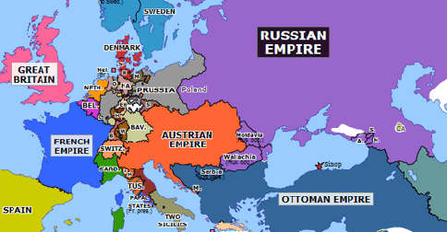**The Crimean War (1853-56)** was the first major European War fought since 1815 and its causes were complex. One of the most important was the decline of the **Ottoman Empire** (see map), which created the opportunity for Russian expansion into the Balkans (Particularly modern-day Romania). The French clashed with the Russians over the protection of Roman Catholics within the Ottoman Empire, whilst the British feared Russian expansion in general and fought to maintain the ‘**balance of power**’ in Europe.

Britain and France declared war on Russia in 1854 and landed their forces on the **Crimean Peninsula**. Poor leadership was apparent on both sides but after an allied victory at Inkerman, an eleven-month siege of Sebastopol (the main port in the Crimea) began. The British, French and Ottoman forces eventually took the city in September 1855 leading to Russian defeat in the war.

Defeat was a humiliation for Russia. Before the war, Russia was believed to have one of the most powerful armies in Europe, capable of fielding vast numbers that would overwhelm their enemies. The Crimean War had also been fought on their doorstep against powers who were not natural allies. Despite these advantages Russia had lost, and defeat exposed a series of deep-rooted problems for the new Tsar Alexander II:

* **The Serf Army –** Russian soldiers during the Crimean War were of poor quality and lacked the same level of expertise as their opponents. Most soldiers were **serfs** (peasants who were bound to the land of their landlord and effectively slaves) who were conscripted into the army for 25 years. The landlord would choose who was sent to the army and would often use it as a way to dispose of unwanted serfs. This meant that the average Russian soldier lacked motivation and had not received even a basic education. Russian Soldiers during the Crimean War were also found to be physically inadequate which limited the size of the armies Russia was able to put into the field. As Michael Lynch says, “[serfdom] had failed to provide the calibre of soldier Russia needed.”

* **Technology** – The Crimean War has been described by some historians as the first ‘modern war’. British and French soldiers fought with precision rifles that were lethal at 500 to 600 metres rather than the 110-150 metres of an old musket. Ironclad ships fought at sea and fired exploding shells to bombard coastal targets. Armies communicated using electrical telegraphs and Crimea would be the first war to be documented through photography. In the face of this technology, Russia and its forces looked backwards, still, for example, using muskets and out of date cannons.
* **Industrialisation –** Defeat in Crimea exposed the backwardness of Russia’s economy and the lack of progress that had been made towards the industrialisation of the economy, particularly when compared to more advanced western powers such as Britain and France. The clearest example of this was the lack of railway transport, which prevented Russian armies and supplies moving quickly to where they were needed. During the war it took less time for the British and French to receive reinforcements than it did the Russians, such was the limitation of the Russian transport network.
* **Local government –** One of the most worrying elements of the defeat for Alexander II was that the British and French forces had been able to develop a better system of control and infrastructure in Crimea than the Russians were. With poor communication and transport, along with local corruption and incompetence, the Russians were not able to exert the same level of local control. The war confirmed the belief that Russian regional government (essential in such a vast empire) was corrupt and inefficient.

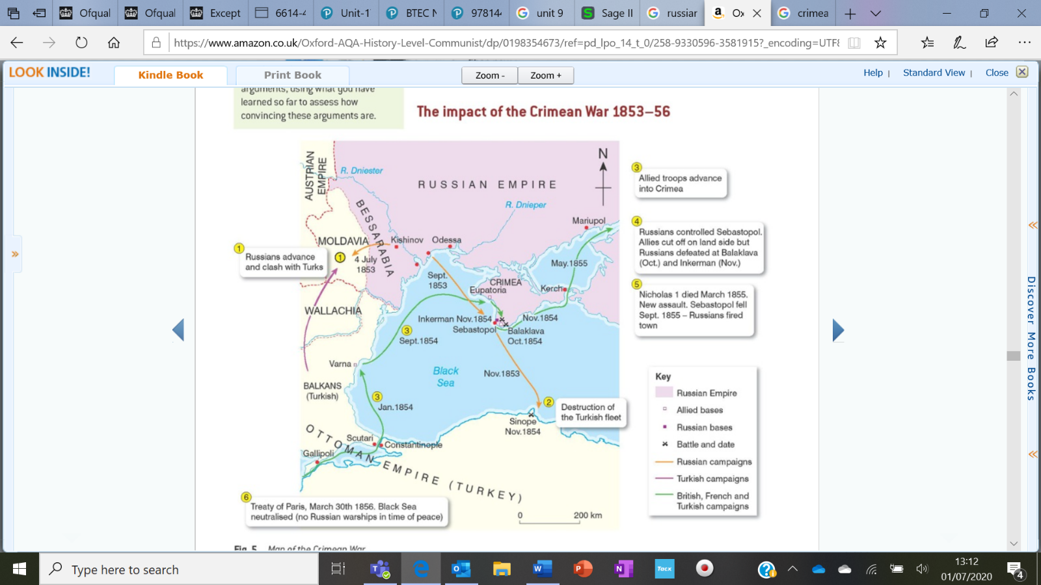

**What Caused reform - Alexander II**

One explanation for the programme of reforms Alexander II launched at the start of his reign is that he was by his own character a natural reformer who wanted to modernise Russia by adopting certain western-style reforms. Alexander II is also known as **‘Tsar Liberator’**, emphasising the idea that he brought freedom to Russians by embracing reform.

In some ways Alexander II did appear more liberal than his father Nicholas I. He had received a broad education from the best minds in Russia and had also travelled widely, both in Russia and in Europe. During his travels he had met political exiles imprisoned in Siberia and seen first-hand the system of serfdom in operation. Whilst abroad, Alexander had also seen how Russia was viewed in Europe as a backward state in need of reform. Finally, before becoming Tsar, Alexander may have been influenced by a lose group of liberal nobles known as the ‘**Party of St Petersburg Progress’**, who were linked to his aunt and brother.

When Alexander II became Tsar in 1855, he was undoubtedly seen as a move away from the oppressive reign of his father, but it is difficult to argue that Alexander II’s personality and ‘liberalism’ were major motives of reform in Russia. Alexander’s upbringing had been closely controlled by his father and he had never shown anything but obedience to the Tsar Nicholas I. Alexander’s natural instinct was to be conservative and reform would be a means to an end, namely to modernise aspects of Russia to ensure the long-term survival of autocracy. Alexander wanted selective modernisation, most importantly in the economy and army, to help support the Tsarist regime, and did not want uncontrolled reform that would introduce an open western-style society.

Alexander II was from the outset wholly committed to the autocratic principle. He was never in the least tempted by constitution mongering. Admittedly his reforms had a liberal element but that was a reluctant tribute to all-conquering Britain and France; Russia had been brought to defeat by isolationist conservatism. It had to learn from the victor countries; and what had given them their dynamic was liberal-capitalist civilisation, which had created the wealth, technology and elan that had proved unbeatable in the Crimea. The point was to borrow selectively rather than to intimate.

John Gooding, *Russia and its Rulers*, 1996

**Task** – summarise Gooding’s interpretation of Alexander II’s motivation for reform in **three points*.*** Each needs to be supported with a short quote from the passage and explained in your own words. When combined they should sum up the view of the passage

**Point one** -

**Point two** -

**Point three** -

[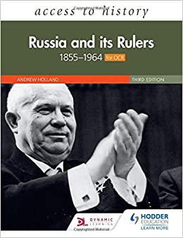](https://www.google.co.uk/url?sa=i&url=https%3A%2F%2Fwww.amazon.co.uk%2FAccess-History-Russia-Rulers-1855-1964%2Fdp%2F1510459774&psig=AOvVaw2wQmi7ckuR4WXYF_EteXr5&ust=1598449524335000&source=images&cd=vfe&ved=0CAIQjRxqFwoTCNDE7dK-tusCFQAAAAAdAAAAABAE)**How far were Alexander II’s Reforms due to the Crimean war? *consolidation***

***Task*** *– To consolidate your understanding of this question before moving on, make summary notes on this spider-diagram using the information on p. 167-168 of the Holland ‘Russia and its Rulers’ textbook.*

**Alexander II’s Reforms – The Emancipation of the Serfs**

**‘Serfdom**’ means a system whereby agricultural labourers …………………….. were bound (attached) to the …………… they worked and owed labour and other duties to their ………………………………

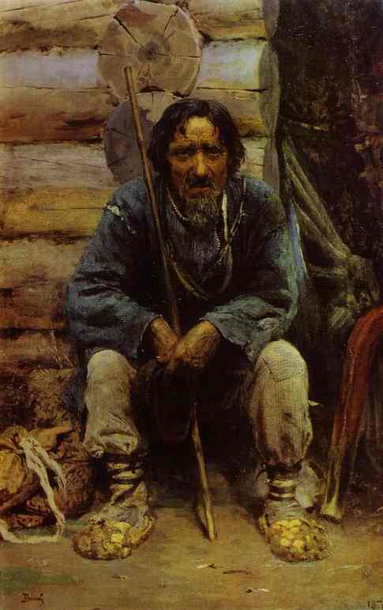

……… were not technically slaves – they were not owned by their landlord but they were required to perform certain duties and give up …………………………………………….. In reality this was a system of ……………. as serfs could not leave the land unless permitted by their landlord

**Serfs did not have basic human, political or civil rights**

Serfs were organised into communities known as *………..……* The *mir* allocated land to serfs, could physically punish them and prevented them from moving away

Landlords also acted as recruiting officers – serfs were required to perform ……………………. and could be forced to as a punishment – the term of military service was **…… …………………..**

There were two main categories of serfs – those who ……………………………..……. and gave a proportion of their produce to their landlord, and those who worked as ………..…… serfs: serving the landlord in their home

Landlords could arrange ……..…….. between serfs and would look to breed strong, healthy serfs to improves their stocks

Although technically not allowed, landlords did ……..….their serfs and often broke up families in the process. There were accounts of landlords using serfs as credit to gamble

A serf’s landlord also acted as their ……. and jury – they could administer ………………………………. to a serf, send him into the army or ………..…. him/her to Siberia. Some landlords treated their serfs well and gave them an education, others were brutal and relied on violence to exploit their serfs

**Alexander II’s Reforms – The Emancipation of the Serfs**

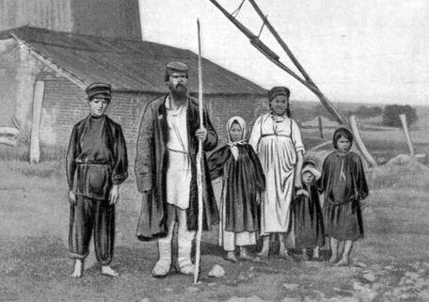***Why did Serfdom need reforming?***

**Economic Reasons:** serfdom was the backbone of the Russian economy with well over 90% of Russians living and working in rural areas in 1856. Serfdom, however was limiting the productivity of agriculture whilst also placing a brake on other forms of economic development in Russia. In terms of agriculture, the fundamental problem was that serfs were not free to keep the profits of any increases in production they might achieve, as these would go to their landowner. This meant that that serfs had no **incentive** to farm more efficiently or experiment with new techniques or equipment (if they had been able to buy them). The majority of serfs farmed to feed themselves and their families rather than to make a profit and consequently agriculture in Russia remained primitive and unproductive.

Serf-based agriculture was based around **strip-farming** methods in which land was divided up (usually by the mir) and strips allocated to serfs to work on. This method limited the amount of land available to individual farmers and was built around the control of the mir, which again limited the ability of individuals to show initiative and modernise the farming. Strips would also be cycled around serfs stopping any long-term development.

The inefficiencies of serf-based agriculture meant that little was available to sell internally or export abroad. The lack of a **surplus** in turn limited the amount of money or **capital** that could be invested in other parts of the economy, such as heavy industry. Serfdom also slowed industrial growth as it locked so many Russians to the land and left them poor. This meant that there was only a small labour forced available to work in industrial cities and that much of the population had little or no spending power that could be used to stimulate other parts of the economy.

**TASK:** sort the following statements into the flow chart to show how abolishing serfdom in Russia would, in theory, help the economy *Grain Surplus; Greater Prosperity; Export of grain providing money for landowners/state; Free peasants; Mobile peasantry moving to towns to work in industry; Greater incentive to work; Investment in industry within Russia*

**Political Reasons:** For Alexander II there were worrying signs that unrest from the serfs was growing by 1855. Between 1840 and 1844 there had been fewer than 30 outbreaks of disorder per year on priately owned estates, but the figure more than doubled over the next 15 years. In part this increased was caused by landowners placing extra demands on their serfs to produce more in an attempt to make their estates profitable (again showing how ecnomiccaly inefficient serfdom was), and also by the conscription of serfs during the Crimena War.

It is doubtful that serf uprisings posed a serious threat to the Tsar and autocracy in 1855, but their increase would have been alarming. Tsars based their autocracy on a almost religious bond with the peasants and cultivated the image of the ‘Little Father’. This was important as serfs represented such a large part of the population, and, perhaps more importantly, the army, meaning they could pose a significant risk to the Tsar’s power.

Emancipating Serfs, therefore, may have been casued by the need to reduce unrest and protect autocracy, even if this meant angering Russia’s nobility by taking away their serfs. Alexander II in 1856 made clear the potlical need to abolish serfdom, declaring to a meeting of nobles **“the existing condiiton of owning souls cannot remain unchanged. It is better to begin to destroy serfdom from above than wait until that time when it begins to destroy itself from below.”**

***Question*** – what does this quote reveal about Alexander II’s personal view of abolishing serfdom?

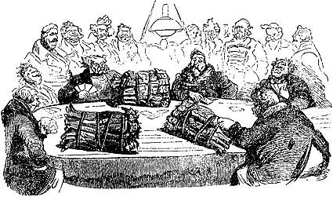**Moral Reasons:** Another possible motivation behind the decision to abolish serfdom was the need to remove an immoral system of slavery. Serfdom denied individuals basic rights; the landowner arranged marriages for them, controlled their movements and could administer punishment without trial. Serfs could also be bought and sold, and rumours spread of landowners gambling with their serfs. Abuses were common within the system with little or no regulation of how landowners treated their serfs. Serfdom was a hangover from medieval Europe and as Russia enter the second half of the nineteenth century, it looked more and more outdated and immoral when compared to other European powers.

It is worth remembering, however, that many in Russia, particularly ‘Slavophiles’ believed that the country had a unique identity that meant it couldn’t be compared to the rest of Europe. Alexander II had seen serfdom first-hand but was unlikely to have seen abolishing serfdom as a moral mission and would not have risked the opposition of the nobility for this reason alone. Pragmatic political arguments were probably much stronger

**Extension Activity** – Research the figure of **Daria Saltykova**, the most notorious serf-owner in Russia, to get a sense of the worst possible treatment of serfs. Remember that she is an extreme example and does not represent the average serf-experience.

**Crimean War:** Russia’s defeat in the Crimean War exposed the damaging impact serfdom had on Russia. The Russia army was made up of serf-conscripts who were selected by their landlords. Landlords would often use military service as a punishment for ‘unruly’ serfs, whilst the length of service for all was 25 years. This meant that Russian soldiers had little incentive to fight, viewing military service as a death sentence. Serfdom also created poor-quality recruits in other ways. Serfs were uneducated and normally illiterate. Many also had poor physical health, all of which limited their ability to fight as modern soldiers.

The defeat in Crimea exposed these problems, all of which had existed before, and made clear to Alexander II that Serfdom would need to be abolished if Russia was going to remain a Great Power.

**Wider Reforms:** A final reason for the emancipation of serfs was that it was a necessary first-step to wider reforms in Russia. Serfdom was the essential social structure of Russia, and it provided most of the social and local government functions across the empire. The serf-owner was the judge and jury of their serfs, the recruiting officer, the educator, local government official, as well as their technical owner. If Alexander wanted to modernise Russia’s economy, military, local government and judicial system, then serfdom would need to be abolished as a starting point.

***Overall***the decision to abolish serfdom in Russia and emancipate the serfs was a monumental one that had the potential to destroy the social structure and the Tsar’s autocratic power. Previous Tsars, convinced of the economic and moral problems of serfdom, had recognised the need to remove it but had not acted. Alexander II’s great-grandmother Catherine the Great saw the need to reform but did nothing. His uncle Alexander I’s had the same view but also took no steps, having been warned by one adviser that “**giving the Russian peasant freedom is like giving wine to a man who had never had alcohol. He will go mad**.” Even the conservative Nicholas I had seen the need for emancipation but only went so far as to ban the sale of individual serfs without their families.

For Alexander II the key issues in emancipating serfs were:

* How could serfs be emancipated without losing the support of the serf-owning nobility, who were needed to maintain control in Russia?
* How would serfs react when given freedom and how could some control over them be maintained to ensure the system of agriculture didn’t collapse?
* Should serfs be freed and also given land? If so, where would this land come from?
* How could the emancipation of serfs be kept as a limited reform? Alexander wanted the economic benefits he hoped would follow from emancipation but didn’t want to encourage other political demands for reform
* Would emancipating serfs upset the semi-religious bond between serf and Tsar?

**Questions**

1. Explain in your own words what Alexander II meant when he said that it was better to reform serfdom “from above than wait until that time when it begins to destroy itself from below.”
2. Why was the question of whether to emancipate serfs with land such a controversial one?
3. Can you see any problems in the argument that emancipating serfs would create a mobile workforce that could work in industrial towns and cities?

|  |  |
| --- | --- |
| 1856 | Alexander II announces his intention to abolish serfdom to a meeting of nobles |
| 1857 | A committee is formed to investigate the issue of serfdom |
| 1859 | Alexander II agrees to emancipate and give ex-serfs land |
| 1860 | The Emancipation Edict is prepared |
| 1861 | Emancipation Edict (*Ukase*) officially proclaimed |

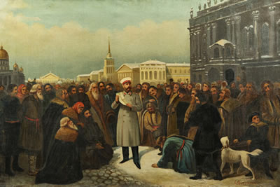**The Emancipation of the Serfs - 1861**

*Does this timeline reveal anything about the scale of the emancipation and/or Alexander’s approach towards it?*

The Emancipation Edict was formally presented by Alexander II in 1861 and was accompanied by a 360 page Emancipation statue containing 22 separate measures.

**The Terms of the Emancipation Edict:**

1. All privately-owned serfs were freed
2. State-owned serfs would receive their freedom in 1866
3. Freed serfs could own property, their own businesses, sue in courts. vote in local elections, and were free to marry who they chose
4. Ex-serfs received an allotment of land, taken from their former landowner’s estate. Landowners decided which land to give up which was then allocated by official surveyors
5. Landowners were compensated for their lost land by the state, who often valued the land generously
6. Ex-serfs paid for their allotments through **redemption payments**. These were loan payments to the government paid for 49 years with 6 percent annual interest. An ex-serf only received full rights once their redemption payments had been paid
7. Ex-serfs were given the alternative option of continuing to work on their former landowner’s land for so many days a year to pay back the compensation this way
8. The ***mirs*** (peasant villages/communes) were given responsibility for collecting redemption payments, the sale of land and what was farmed
9. Landowners kept control of meadows, woodland, and pasture
10. There was a two-year period of ‘temporary obligation’ before freedom was granted during which the allocations were sorted out

***Who did the Emancipation Edict benefit the most?***

Place each of the terms on the previous page below to show whether you think it benefitted the **ex-serfs**, **the landowners**, or was **balanced**. For each provide a simple explanation

|  |  |  |
| --- | --- | --- |
| **Terms that benefitted ex-serfs** | **Balanced/Fair Terms** | **Terms that benefitted landowners** |
|  |  |  |

1. What observations would you make from this summary?
2. Which term do you think ex-serfs were most unhappy with and why?
3. Is it fair to describe the Emancipation Edict as a conservative measure?

**The Impact of the Emancipation Edict**

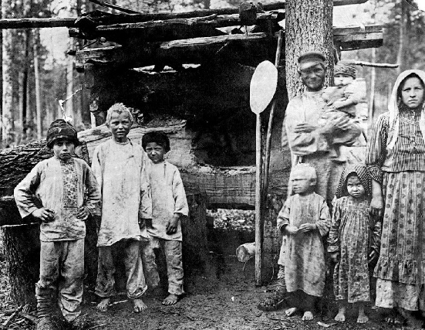The impact of the Emancipation of the Serfs on Russia, its society and economy has been much debated by historians. For those who see Alexander II as the ‘Tsar Liberator’, Emancipation is the strongest evidence of the success of his modernising reforms. For those who view him as a more conservative Tsar, Emancipation was a limited measure that disappointed the hopes of the serfs.

A key question is whether, based on the Emancipation of the Serfs, Alexander II deserves the title of **‘Tsar Liberator’**

**YES**

* Emancipation was an unprecedented reform in Russia, which gave personal freedom to over **23 million** serfs (34.4% of the population).
* The decision to emancipate serfs and give them an allotment of land was particularly important as, in theory, it gave them a means to support themselves and their families. In the USA, African American slaves were freed in 1865 but not given any land, meaning most had to continue working on the land of their former owner.
* Some peasants undoubtedly did well out of Emancipation. ***Kulaks*** (wealthier peasants) were able to exploit their land allocations, buy extra land and produce a surplus of grain to export. A number of ex-serfs were also able to sell their allotments, obtain a passport to leave the *mir* and improve their standard of living working in industrial cities
* Emancipation opened the door to a wide range of reforms in the 1860/70s. Alexander II would go on to reform local government (1864), education (1864), the legal system (1864), censorship (1865) the military (1874).

**NO**

* Ex-serfs were left deeply frustrated by the terms of the Emancipation Edict, particularly regarding the allocation of land. Landlords were able to choose which parts of their land would be given to ex-serfs and inevitably chose the worst areas, keeping the most productive land for themselves. Serfs who had worked in the household of their landowner (manorial serfs) were given no land at all. This issue of land shortage, known as ‘**Land Hunger**’ would remain one of the most serious of the Tsarist period.
* Ex-serfs were given insufficient land to support themselves and their families, let alone experiment with new farming techniques or technologies. By 1878 only 50% of the peasantry was capable of producing a surplus, showing how backward Russian farming remained.
* **Redemption payments** were unpopular with ex-serfs who had no way to pay the debts and were denied their full freedom until they had done so. 49 years of payments also meant that redemption payment would be passed on from generation-to-generation, burdening them with debt. By 1870 only 55% of peasants had been able to start paying their redemption payments.
* Fundamentally, Russian serfs believed that they already owned the land they work on and were automatically entitled to it when free. The idea that they had to buy small, poor quality allotments from their landlords was deeply unpopular, as shown by the wave of **unrest** that followed the Emancipation Edict. In the four months that followed the decree there were 647 incidences of serf riot, and between 1861-63 there were 1,100 outbreaks.
* The personal freedom of ex-serfs was limited by the powers given to the ***mir***, which technically owned the rights to the land given to the ex-serfs living within the community. The *mir* decided what crops would be grown and controlled the physical movement of peasants who needed a **passport** to leave it. It is unclear how opposed peasants were to their *mirs*; they limited their freedom by were their communities (the word means ‘world’). The decision to give the *mir* increasd power, however, was taken because Alexander II was worried that freed serfs would move too freely around the country and the State would lose control of taxation and law and order. *Mirs* would limit this but would also stop individual farmers from adopting new techniques or experimenting with new crops. In this sense, the role of the *mir* prioritised the political goal of Emancipation (reducing peasant unrest and strengthening Autocracy) over the economic goal (modernising farming and creating a mobile workforce)
* In addition to causing unrest and opposition from the peasantry, the Emancipation Edict also angered much of the landowning nobility who had lost their labour force, a portion of their land, and much of their local influence. Owners of larger estates found themselves particularly badly affected. Many had been struggling to stay profitable before Emancipation and the money from redemption payments was used to pay old debts. New debts began to mount, and many estates were broken up and sold. By 1905 the land owned by the nobility had been reduced by 40%
* The failure of the Emancipation Edit to please either side is summed up Michael Lynch: “It both frightened the privileged classes and disappointed the progressives. It went too far for those slavophiles in the court who wanted Russia to cling to its old ways and avoid the corruption that came with western modernity. It did not go far enough for those progressives who believed that a major social transformation was needed in Russia.”

**Extension Activity** – Read Michael Lynch’s article on History Today *The Emancipation of the Serfs, 1861.*

* Use this to add any extra terms to the table on p. 17
* Focus on the section ‘Betrayal of the Peasants’ to the end of the article and make a bullet-point list of why Emancipation was and was not a successful reform that modernised Russia

**Questions**

1. Can you think of any more sophisticated judgements about the Emancipation Edict other than that it was or was not a successful reform?
2. Is it accurate to say that Alexander II put the protection of his own autocracy above the success of the Emancipation of the serfs?
3. Summarise why Russian Serfs were so dissatisfied with the land arrangements of Emancipation despite being treated more favourably than black slaves in the USA
4. Read the extract below from T.Emmons and make notes where asked

The Emancipation was probably the greatest single piece of state-directed social engineering in modern European history before the twentieth century. Its ultimate aim was to strengthen social and political stability. In fact, it produced serious stresses and strains, of both a short-term and a long-term character, in the social and political make-up of Russia. Totally unaccustomed to talking directives from others, the government assumed the initiative in preparing the Emancipation and a series of related reforms, with no intention of allowing public interference in its deliberations. The epoch of the great reforms was a decisive moment in the history of the Russian landed gentry. Probably the single most important political result of the struggle between the government and the gentry over Emancipation was the disintegration of faith in enlightened despotism and the turn by many to the belief that the desired reforms could come only through popular participation in government.

Adapted from T. Emmons, *The Emancipation and the Nobility,* 1994

1. Why does Emmons mean when he calls Emancipation ‘the greatest single piece of state-directed social engineering?
2. What according to Emmons was the aim of Emancipation
3. Why in Emmons’ view did Emancipation fail to achieve its aims?
4. Write a counter-argument to Emmons’ passage in the space below. This should be 8-10 lines long and should include an overall judgement that differs to Emmons and is explained.

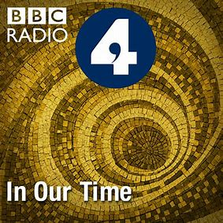**The Emancipation of the Serfs**

***Consolidation***

**TASK** – The Emancipation of the Serfs is one the most important topics you study in the Unit 3 course, so to help you understand and consolidate your understanding, listen to the ‘In Our Time’ episode [*The Emancipation of the Serfs*](https://www.bbc.co.uk/programmes/b0b2gspd) and make notes on the spider-diagram below

**Alexander II’s Other Domestic Reforms**

***RECAP****: why was it inevitable that Alexander II would continue to reform in Russia after the Emancipation of the Serfs in 1861?*

**Local Government Reform – 1864**

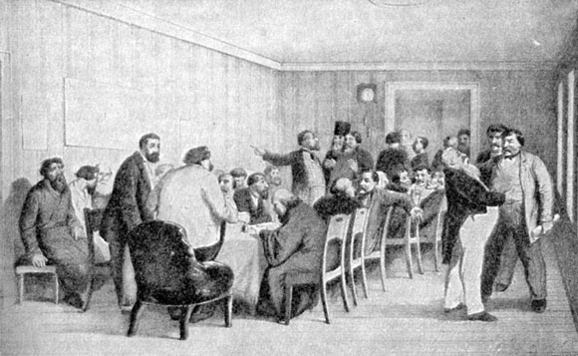Before the emancipation of the serfs the landowner/serf-owner had been the system of local government. The 50 provinces of the Russian Empire relied on land-owning nobles to rule on behalf of the Tsar on a local level. This included collecting taxes, recruiting for the army, and communicating the laws of the Tsar to his people. After emancipation, the political role of the landowner was (in theory) greatly reduced and a reformed system of local government was needed to replace it and to cope with the millions of ex-serfs.

* From 1St January 1864 new local councils, known as ***zemstva***(singular *zemstvo*) were created. The role of these councils was to look after local matters including infrastructure (i.e. upkeep of roads), agriculture, medical care, prisons, schools, and to respond to local emergencies
* In 1870 the reform was extended to towns when elected town councils called **dumas** were set up
* *Zemstva* were elected using a system of electoral colleges in which each group (peasants, nobles, merchants, ‘church families’, ‘others’) elected members of and ‘electoral college’ to vote on their behalf. This system weighted elections to *zemstva* in favour of the nobility e.g. between 1865-67, nobles made up 42% of *zemstvo* members and peasants 38%, despite the latter being well over 90% of the population
* The powers of each *zemstvo* were strictly limited. They had no control over state or provincial taxes and the Chairman of each had to be officially approved. Responsibility for law and order remained in the hands of a centrally appointed provincial governor who could overturn the decision of the zemstvo. *Zemstva* were also not allowed to act together to prevent them becoming a powerful political unit that could challenge autocracy
* Z*emstva* were seriously limited but in the context of autocratic Russia, their introduction was a major reform. It introduced a basic idea of representative democracy and the concept that all Russians, regardless of social background, were entitled to a vote. The reform also created a new layer of local government that was at times effective at dealing with local problems. For example, when a major famine struck Russia in 1891-2, it was the *zemstva* rather than the central government which provided the most effective relief.

**Education Reform – 1863-64**

Education was another area that required reform because of the emancipation of serfs – ex-serfs were now a new class of Russian peasant that needed basic literacy and numeracy if they were going to run their private farms effectively or enter the industrial workforce. More generally, Alexander II’s aim to modernise key areas of Russia’s military and economy required a more educated and skilled population. Alexander appointed **Alexander Golovnin** as Minister for Education (1862-67) who introduced the following reforms:

* Responsibility for education was transferred from the deeply conservative Russian Orthodox Church to the *zemstva*
* Universities could govern themselves and appoint their own staff
* Primary and secondary education was extended and new ‘modern schools’ were created at secondary level for those who did not want the traditional education offered in a *gimnaziya*. Students from both could continue to university
* Schools were made open to all regardless of class or sex. Girls could attend secondary school for non-vocational courses from 1870)
* Between 1856 and 1880, the number of primary schools rose from 8,000 to 23,000 and the number of children in primary education increased from 400,000 to over a million
* The number of students in university increased from 3,600 to 10,000 by the 1870s

Alexander II’s education reforms were an impressive, and in places very liberal, step forward that opened new opportunities for all Russians to learn subjects and ideas that had previously not been allowed. There were again, however, restrictions. The primary curriculum remained very traditional and aimed to ‘strengthen religious and moral notions’. More modern secondary schools, offering news subjects were established but these were occupied largely by the professional and upper classes.

One of the most important consequences of the reforms was the growth in radical thinking and opposition it caused. Students, particularly at university, were exposed to brand new ideas which seemed to challenge autocracy, and this led to a rise in radical organisations seeking change (some peacefully and others not). The education reforms can be seen as too successful in modernising the system as after 1866 Alexander reversed some reforms to reassert his control.

**Legal reform – 1864**

This was another area where reform was needed following the emancipation of the serfs. The landowner had traditionally dispensed justice for his serfs and whilst there had been judges who heard cases, before 1864 there was no jury system in Russia. Emancipation also necessitated legal reform as it had overhauled property rights through the division of land that now needed to be resolved.

* Equality before the law was established along with a single system of local, provincial and national courts. (A separate set of ***volost***courts were created in the Emancipation Edict to deal exclusively with peasant cases)
* The accused were presumed innocent until proven guilty and were entitled to employ a lawyer to defend themselves
* Criminal cases were heard before barristers and a jury, selected from lists of property owners.
* Judges were appointed by the Tsar and given improved training and pay
* Courts were open to the public and the press could report their proceedings. National trials were recorded in the government newspaper the *Russian Courier*
* Local Justices of the Peace were elected every three years by the *zemstva* and were independent from political control

The legal reforms, like in many other areas, were impressive considering what had preceded them and they undoubtedly created a fairer and less-corrupt system.

Again, however, there were significant limitations. Trial by jury was never established in Poland, the western provinces of the empire or the Caucasus. Military and ecclesiastical (church) courts were excluded from the reforms and ex-serfs still had a separate legal system through the *volost* courts, which undermined the principle of equality before the law.

Finally, reformed courts became new sources of criticism of autocracy as liberal lawyers were now given a platform to criticise the system with a public audience. Juries could also find in the favour of those who had challenged the Tsarist system (see the Vera Zasulich case later in the booklet for an example of this), which forced the Tsar to declare that ‘political crimes’ would be tried by special procedure.

**Censorship Reform – 1865**

At the start of Alexander II’s reign there was an initial relaxation in his father’s censorship, which had covered all books and newspapers

* Restrictions on publishers were reduced
* Foreign publications were allowed (with government approval)
* Newspapers could print editorial commenting on government policy

These reforms were an important part of Alexander’s aim to modernise specific areas of Russia, as the first step to reform was to allow people to discuss what was wrong with the current system and put forward ideas about how it could be improved. Relaxed censorship was also needed if a broader curriculum was going to be offered at secondary school and university. The impact of this was a short-lived growth in the publishing of books, journals newspapers etc.. In 1855, for example, 1,020 books were published in Russia whilst by 1894 this had increased to 10,691.

However, as with many of Alexander II’s ‘Great Reforms’, the initial measures were followed by a reaction and in the 1870s, government control of censorship was tightened. This again linked to the growth in radical ideas and groups that had been seen from the second half of the 1860s.

**Economic reform - 1862-1878**

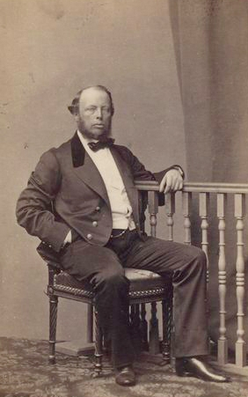One area of Russia where Alexander II was most keen to adopt western-style reforms and encourage modernisation, was the economy. Emancipation was intended to start the modernisation of agriculture whilst further reforms would kickstart industrial growth in Russia. Here Russia lagged badly behind western powers and defeat in Crimea had exposed how backward Russia was. If Alexander was to preserve Russia’s ‘Great Power’ status and strengthen autocracy, he would need to develop a strong industrial economy that could generate the wealth and resources needed to maintain a powerful military and state.

Alexander II appointed **Mikhail Reutern** as the Minister of Finance who introduced the following reforms.

* The Treasury system that collected taxes and kept government accounts was reformed making it more efficient. The practice of ‘tax-farming’, whereby the right to collect state taxes was given to private collectors who would extract their own profit, was abolished. The aim of these reforms was to maximise tax incomes, reduce corruption and encourage confidence in the Russian economy. Reutern also introduced a unified state budget to help achieve this.
* A new state bank was created along with municipal banks and savings banks. This was an important requirement for industrial growth as banks would provide the capital which could be invested into heavy industry, such as setting up a new steel factory.
* Foreign investment and expertise in Russia were encouraged. In addition to encouraging foreign companies, banks, and individuals to invest their money in newly created Russian industry or railways, Reutern also recruited foreign experts to Russia to help kickstart industrial growth. This was important as Russia lacked this expertise (due in part to its conservative education system) and therefore needed this injection of ideas to industrialise quickly. Foreign experts would also bring with them the knowledge of what did and didn’t work in areas such as railway construction, allowing Russia to leapfrog the early stages of industrialisation. One such example of a Foreign expert was the Welshman J.J. Hughes who was employed by the Russian government in 1871 as an expert in the production of armour plate and by 1884 his ‘New Russian Coal, Iron and Railmaking Company’ was the largest producer of pig iron in the Russian empire.
* Railway construction – railways were seen as the essential catalyst for industrial growth. They would allow the movement of raw materials to industrial centres to be manufactured and then to urban centres or ports to be sold or exported. The construction of railways would also provide employment for Russians and in itself create huge demand for Russian industry encouraging its iron, steel, coal, oil etc industries to grow. Reutern again used foreign experts and money to kickstart railway building. Government bonds were issued to investors along with tax exemptions, whilst foreign projects like the Manchester to Liverpool Railway were copied. This resulted in a seven-fold increase in railway construction from 2,194 miles of track in 1862 to 13,979 miles in 1878.

Overall, Reutern’s reforms helped to lay the foundations of a successful industrial economy that would be built on by his successors. During his time as Finance Minister industrial output doubled and his model of using foreign investment and expertise became standard. However, Reuturn’s reforms were relatively short-lived as he resigned in 1878 following the economic impact of the Russo-Turkish War.

**Military reform – 1865**

Like the economy, this was another area where Alexander II was keen to embrace reform and modernisation as the military (in particular the army) was seen as one of the ‘pillars’ of Tsardom. It was also an area that had been exposed as backward during the Crimean War, both in terms of the quality of the soldiers and their equipment, and, finally, it was an area that needed reform following Emancipation. Before this the landowner selected serfs to send to the army but now that serfs were technically free, a new system of **conscription** (compulsory military service was needed).

**Dmitry Milyutin** (Minister of War 1861-1881) aimed to modernise the army by creating a smaller but more professional and efficient force.

* Conscription was made compulsory for all classes from the age of 21 and the length of service was reduced from 25 to 15 years. 10 years of this would also be spent as a reserve rather than on active service
* Attempts were made to make military service less brutal – punishments were made less severe, medical care was established, and the system of military colonies whereby recruits were forced to live in separate communities was abolished
* Modern weaponry was introduced, and military colleges were established to improve the training of officers
* Mass education campaigns in the army were launched in the 1870s-90s to improve the level of literacy

The impact of these reforms was again mixed. The changes to conscription were a major change that meant it was less of the death sentence it had been before. However, wealthy Russians could pay for substitutes to be conscripted in their place meaning the burden of military service continued to fall on the peasantry. The Russian army also continued to suffer from supply and organisation problems, and struggled to defeat Turkey in the 1877-78 Russo-Turkish War, showing the limited impact of military reform.

**Loris-Melikov Constitution**

A final, area of reform to consider is the Loris-Melikov Constitution of 1881. Following the difficulty in defeating Turkey in the 1877-78 war and further attempts on Alexander’s life, including the bombing of the Winter Palace in 1880, Alexander began to review his methods to control opposition. After an earlier assassination attempt in 1866, he had slowed reform and used more repressive methods to deal with growing opposition. Now at the beginning of the 1880s, he considered returning to reform to reduce the appeal of radical groups.

Count Loris-Melikov was given responsibility for this reform and produced a limited set of reforms that would have introduced a representative element into Russia government. This was a very limited proposal but could have potentially started the process of constitutional reform in Russia. However, on the same day that Alexander II declared that he would formally discuss the proposal with his Council of Ministers, he was killed by the terrorist group the ‘People’s Will’. The Tsar’s successor Alexander III would go on to reject the Loris-Melikov ‘constitution’.

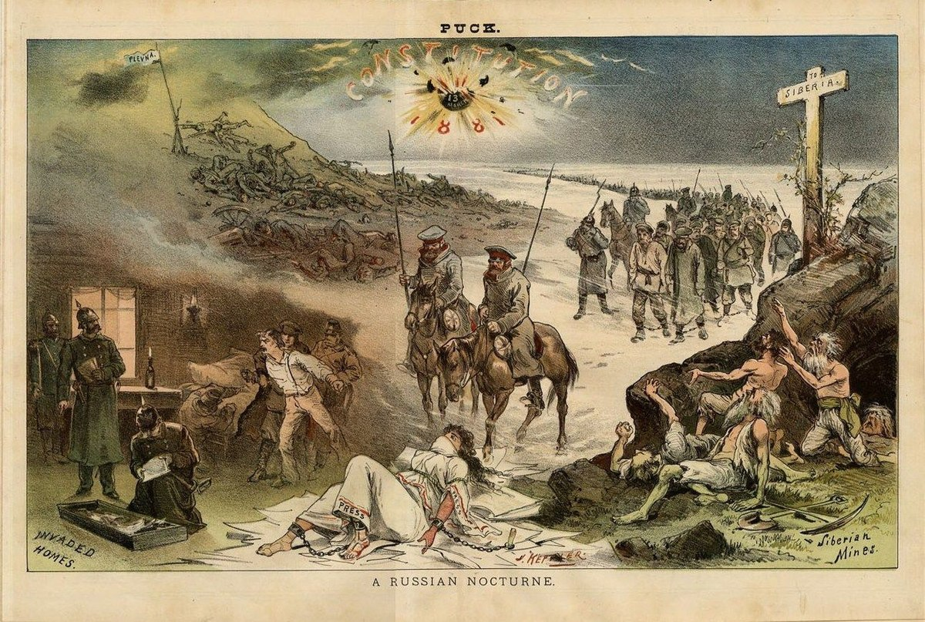

**Alexander II’s Domestic Reforms**

**Key Question – *To what extent does Alexander II deserve the tile ‘Tsar Liberator’?***

**TASK – *Complete the table below using the notes in this workbook, the Carl Peter Watts article (see below), and online research***

|  |  |  |  |  |  |
| --- | --- | --- | --- | --- | --- |
| ***Reform*** | ***Aim of Reform*** | ***Key Details*** | ***Reform was progressive*** | ***Reform was limited*** | ***Overall Judgement on impact*** |
| ***Local Government 1864*** |  |  |  |  |  |
| ***Education 1864*** |  |  |  |  |  |
| ***Legal System 1864*** |  |  |  |  |  |
| ***Censorship 1865*** |  |  |  |  |  |
| ***Military 1874*** |  |  |  |  |  |
| ***Economic***  ***1862-78*** |  |  |  |  |  |

**Key Questions**

1. Do you notice any similarities in the motives behind these reforms?
2. What appears to happen to a number of reforms from the second half of the 1860s onwards?
3. On the basis of these reforms, how far did Alexander II transform Russia’s society and economy?

**To what extent did the ‘Great Reforms’ of Alexander II transform Russia’s society and economy?**

***TASK -*** *Below are a set of judgements answering this question. Using the understanding you have gained of Alexander II’s reforms, select the most appropriate evidence to support and challenge each. The aim is not to use all the evidence you have gathered but to choose the piece that best supports/challenges the argument being made (which is exactly what you will have to do in Unit 3 interpretation questions)*

*Alexander II’s reforms were if anything too successful in starting to modernise Russia.*

*The reforms of the 1860s simply preserved the power of Russia’s nobles and the traditional social structure*

*The most significant liberal reforms of Alexander II’s reign were those in education*

*The limitations of the Emancipation Edict guaranteed that other attempts to modernise Russia in the 1860s and 70s would fail*

*Under Alexander II, the foundations of a modern economy were laid*

*Alexander II’s ‘Great Reforms’ were designed to be moderate and limited to ensure that the momentum of reform did not get out of hand and threaten the Tsarist regime*

*When viewed in the context of Russia’s backwardness before 1855, Alexander II’s reforms revolutionised Russia socially and politically*

[***The Reforms of Alexander II***](https://www.historytoday.com/archive/reforms-tsar-alexander-ii)

**Carl Peter Watts, History Review, December 1998**

**TASK: Access the article and answer the questions below:**

1. From the introduction to the article, what do you think is Watts’ overall argument about Alexander II’s reforms? (Try to sum this up in one sentence)

**Username: Godalming**

**Password: history**

1. Why did Alexander II have a particularly clear understanding of the problems of Serfdom in Russia?
2. What different areas of Russian life did Serfdom hold back?
3. How did peasants react to the Emancipation Edict?
4. What was the ‘fundamental problem’ with land distribution?
5. How have some historians (M. E. Falkus) tried to defend the economic impact of the Emancipation Edict?
6. In your own words, why had Emancipation made legal reforms essential?
7. In what ways was the independence of newly created *zemstvo* limited and why?
8. Select one statistic that summarises the impact of Alexander IIs education reforms
9. Explain what changes General Dimitry Miliutin made to conscription and the length of service in the army, and why these reforms were introduced.
10. Why was railway construction targeted as a key economic reform by Alexander II and his Minister of Finance, Mikhail Von Reutern?
11. Explain in your own words what Watts is arguing when he says that Alexander II’s reforms were “an attempt to perpetuate the existing political system”.
12. Why, according to Watts did Alexander II’s programme of reform lead to opposition from the Russian intelligentsia?

**How convincing is Watts’ interpretation of the impact of Alexander II’s domestic reforms?**

**(Interpretation Question Practice)**

When Alexander II became Tsar in 1855, the Russian state was in desperate need of fundamental reform. The programme of reforms introduced by him was radical in comparison with previous Russian experience, but it did not go far enough. The government's commitment to modernise Russia through a process of westernisation was moderated by its concern to perpetuate the interests of its ruling social class. This approach alienated the Russian intelligentsia and, in so doing, undermined the stability of the regime, compelling it to rely on repression for its preservation. This strategy succeeded for some time, but in the long term it was likely to achieve precisely the opposite of its intended effect.

Carl Watts, *History Review*, 1998

**Step One:** *Read the interpretation carefully, highlighting key words or phrases that are used*

**Step Two:** *In your own words, summarise what Watts’ overall argument about the impact of Alexander II’s domestic reforms is*

**Step Three:** *Break the interpretation down into 3-4 ‘sub-arguments’ and write each (in your own words) below, leaving space after each one*

*Argument 1*

*Argument 2*

*Argument 3*

*Argument 4*

**Step Four:** *For each argument above, provide evidence from your own knowledge to explain why it is convincing or unconvincing*

**Step Five:** *Write, separately, an overall conclusion to the question at the top. Try to make this sophisticated and avoid a simple yes or no*

**Sample interpretation question**

***Evaluate the interpretations in both of the passages and explain which you think is the more convincing as an explanation of how the policies of Alexander II impacted on the lives of the Russian people [30]***

**Passage A**

The main events of his [Alexander II’s] reign were, first and very foremost the freeing of the serfs; then, and partly in connection with this reform, real changes in local government, justice, education and the army. As so often happens, reform and relaxation were followed by protests, manifested notably by a revolutionary movement. The ‘Tsar Emancipator’ also had to cope with two burdens that had afflicted his father; cholera and the Poles. These trials led to reaction, and there was a partial return to tactics of repression. However, just before his assassination and having, as he thought, succeeded in calming the Empire, Alexander was considering a new series of reforms to relieve political pressures. Throughout the reign there was steady economic progress, expansion in Central Asia, some attempt to overcome the financial consequences of the Crimean War and continuation of railway-building, in foreign affairs there was a rather unnecessary war against Turkey but Alexander was able to avoid other large-scale conflicts.

J.N. Westwood, ‘Endurance and Endeavour: Russian History 1812-2001’, 2002.

**passage B**

In view of Alexander II’s character – he was rather indolent and indecisive and despite public displays of emotion and kindheartedness capable of maintaining a severe police regime with all its attendant cruelties – it is surprising that it was especially his reign that became associated with the period of great reforms in Russian history. To the extent that in an autocracy good deeds are credited to the autocrat personally, he earned the title ‘Tsar Liberator’. Nevertheless, his personal contribution to reforms was less positive than his more admiring biographers would have us believe. In many ways his influence impeded the practical realisation of reforms that had become law. He was indecisive and throughout his reign alternated between reforming impulses and reaction. As his advisers he selected both true reformers such as Dimitri Milyutin and extreme conservatives, men such as Dimitri Tolstoy, and kept both in office simultaneously. It was only with reluctance that Alexander took up the root cause of Russia’s social ills, the problem of the serfs. Once a programme of emancipation had been devised, the other practical reforms of his reign followed from that. The ‘great reforms’ of the 1860s did not liberate the Russian people. The process was so gradual, and the contrast between aspirations, the laws of the state and the realities of the situation were so stark, that the degree of discontent was raised more by the hope of reform than satisfied by their application.

J. Grenville, ‘Europe Reshaped’, 1999.

Own Knowledge on Passage A

* A is right to argue that “the freeing of the **serfs**” was “foremost” in Alex’s reforms: it was regarded as such both at the time & ever since. The nobles resented the loss of complete domination they had previously enjoyed over their serfs, while the peasants (at least initially) were grateful to their “Tsar Emancipator”. Previous Tsars like Nicholas I had recognised the iniquity of but done nothing about it.
* A is right again to link the abolition of serfdom with other reforms. The **zemstva** were created to replace the traditional system of noble dominated local government, with middle class people & even peasants allowed to have their voices heard. Trial by jury with magistrates elected by the zemstva & a presumption of innocence until proved guilty replaced the traditional system which left serfs totally at the mercy of their masters.
* Army reform was clearly needed after the defeat in the **Crimean War**; War Minister Milyutin made it clear that the traditional reliance on an army of uneducated peasant conscripts was no longer sustainable, so the abolition of serfdom was an essential prelude to military reform. Educational reform (the number of primary schools in Russia trebled during Alex’s reign) was also needed to create a better trained, more professional army.
* But A is also right to point out that Alex’s reforms failed to satisfy the **revolutionaries**, who tried several times to assassinate him from 1866 onwards
* This & the **Polish revolt** in 1863 provoked a conservative reaction on Alex’s part, above all in Poland (25,000 Poles died as a result of Russian repression & an aggression Russification policy was introduced), but also in Russia, where censorship was tightened & the college curriculum made more conservative.
* This was “partial”, however; Alex was so generous to the **Finns** (giving them a parliament & a currency & encouraging their language) that he is still remembered there as “the good Tsar”
* A is right to point out, however, that just before his death under the influence of his adviser Loris-Melikov A was planning to introduce “a new series of reforms” including a **national assembly**.
* The “steady **economic progress**” included the doubling of industrial production & a 7fold increase in the mileage of Russia’s rail track, both 1862-78, plus the creation of a state bank by Finance Minister Reutern to promote industrial investment. He also restored the govt.’s financial position after the Crimean War.
* During Alex’s reign Russia almost completed the conquest of **Central Asia**, overrunning Uzbekistan, until by 1885 only eastern Turkmenistan remained unconquered.
* The **war against Turkey** 1877-8 was “unnecessary” in the sense that Russia had not been attacked & chose to intervene in the Balkans; on the other hand, Russian public opinion was outraged by Turkish atrocities in Bulgaria & it was an opportunity to liberate the Balkans & even march on Contantinople. This is the only war Alex fought apart from the Crimean War which he inherited from his father.

 Own Knowledge on Passage B

* Alex’s emancipation of the **serfs** could certainly be described as “indecisive”: the serfs were theoretically freed but burdened with debts that took 49 years to pay off at 6% annual interest. The nobles could decide which land to give them so inevitably the peasants got the worst land.
* On the other hand, Alex may have been reluctant to undertake this reform (it could be argued that the Crimean War forced him to into it), but he showed less reluctance than any of his predecessors.
* Alex was “indolent” in the sense that he **left details to others**, like Nikolai Milyutin with the serfdom issue, but Milyutin praised his role: “It is impossible not to be amazed at the rare firmness of the Tsar who alone curbs the present reaction and the forces of inertia”. This contradicts B’s claim that “his personal contribution to reforms was less positive than his more admiring biographers would have us believe”.
* B’s conclusion that “it is surprising that it was especially his reign that became associated with the period of **great reforms** in Russian history” is understandable in view of the limited nature of the reforms, their partial reversal from 1866 onwards & his determination to maintain autocracy. On the other hand, they were impressive compared with the reactionary policies followed by Nicholas I & Alex III.
* It is true that he deliberately appointed both liberals like Nikolai Milyutin (another example would be Golovnin, his reforming Education Minister) & **conservatives** like Tolstoy who partially reversed Golovnin’s reforms. This was designed to reduce opposition to the reforms but inevitably had the effect of limiting their impact.
* B’s assertion that “the degree of discontent was raised more by the hope of reform than satisfied by the application” is supported by the fact that in the four months that followed the emancipation decree there were 647 incidences of **serf riot** and between 1861-63 there were 1,100 outbreaks.

**Planning grid**

|  |  |  |
| --- | --- | --- |
| **Passage A** | | |
| **Point/argument from the passage** | **Own knowledge to support or contradict the argument** | **Assessment – how convincing is the argument made in the passage?** |
|  |  |  |
|  |  |  |
|  |  |  |
|  |  |  |
| **Passage B** | | |
| **Point/argument from the passage** | **Own knowledge to support or contradict the argument** | **Assessment – how convincing is the argument made in the passage?** |
|  |  |  |
|  |  |  |
|  |  |  |
|  |  |  |

What particular points of disagreement can you find between the two passages?:

**Opposition under Alexander II**

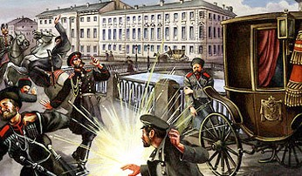Alexander II’s reign would see opposition from four main groups or areas:

1. Peasant unrest
2. The ‘Intelligentsia’
3. Radical and revolutionary opposition
4. National minorities within the empire

Alexander was assassinated in 1881 by a terrorist group known as *Narodnaya Volya* (‘The People’s Will**’**) creating the impression that opposition to his regime was widespread and dangerous. This, however, has been debated by historians, many of whom would argue that violent, radical opposition remained very limited, and that the more serious opposition came from national minorities within the empire, along with the peasants. The key questions about opposition under Alexander II are:

* How widespread was opposition under Alexander II?
* To what extent did opposition pose a serious threat to the Tsarist regime?
* Was opposition under Alexander II created by his own domestic reforms?
* What different methods did Alexander II use to combat opposition and how effective were these?
* What impact did opposition have on Alexander II’s programme of reform?

**1. Peasant Unrest**

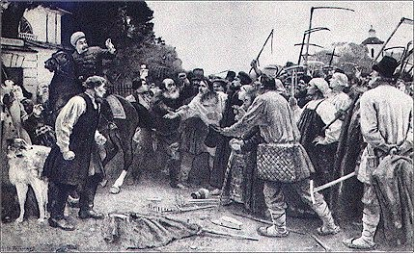As we have already seen, growing peasant unrest was one of the main motives behind Alexander II’s decisions to abolish serfdom. Between 1840 and 1844 there had been fewer than 30 outbreaks of peasant disorder per year on privately owned estates. Over the next 15 years this figure more than doubled. Opposition before emancipation had multiple causes including landowners forcing peasants to produce more to try and increase profits, along with wider conscription during the Crimean War.

Emancipation was designed to reduce opposition but in fact lead to an increase: there were 647 incidents of riot in the four months after the Emancipation decree (3rd March 1861) including major outbreaks such as the peasant riot at **Bezdna** in the Kazan area (see map) in April 1861 which was put down by the army with 70 peasant deaths.

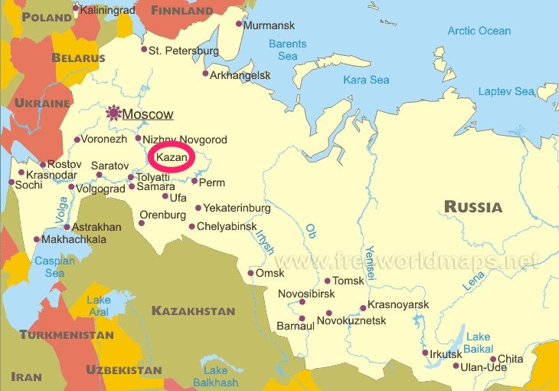Peasant opposition was a significant threat to Alexander II even if there was not one unified revolt during his reign that threatened his position. Peasants made up most of the country and were in turn the backbone of the army. If the Tsar began to lose the support of the peasants, it had the potential to undermine his power.

It is also significant that Alexander II used a combination of reform and reaction to deal with peasant unrest. Military force was used to crush unrest, but, understanding the potential threat, Alexander combined this with reforms that were meant to improve the lives of peasants, such as Emancipation, education, and military reforms.

To an extent these methods were successful. Peasants never joined radical groups in large numbers during Alexander II’s reign and the concept of the ‘Little Father’ remained strong, as shown by the outpouring of emotion on his death in 1881. However, serious peasant opposition remained, particularly to the shortage of land, and would be a long-term problem for the Tsarist regime.

**2. The Intelligentsia**

A further form of opposition that was emerging during the reign of Alexander II was the **intelligentsia**. This is more of a concept or broad group in society rather than a specific group, but it refers to a section of the small Russian middle class and nobility who were well educated and favoured the arts (e.g. philosophy, poetry, music etc.). The intelligentsia were characterised by the desire for open debate of ideas and the spreading of new ideas, often imported from western Europe across Russia.

Alexander’s reforms undoubtedly encouraged the growth of the intelligentsia in Russia, although this certainly was not his aim. The education reforms meant more Russians were able to go to university and once there could be exposed to a broader curriculum. Censorship reform meant that Russians had greater freedom to discuss controversial political, economic, social and cultural ideas, and were also made more aware of comparisons to western Europe.

Examples of the Russian intelligentsia in this period include some of the most famous cultural figures of the nineteenth century, like the writer **Dostoyevsky** and the composer **Tchaikovsky**. These figures are examples of a section of society that was better educated and more willing to question the Tsarist world around them. It is important to say, however, that the intelligentsia as a whole remained very small and most of its high-profile figures were not radicals who wanted to overthrow Tsardom. There were exceptions to this as some thinkers did introduce new and radical ideas to Russia that would go on to influence radical groups. The most important example of this is **Alexander Herzen.**

**TASK –** *do some research into Alexander Herzen (Spartacus Educational is a good place to start) and make simple notes below. Try to find: views on serfdom, his exile, role publishing ‘The Bell’, his political views in general, groups who were influenced by him*

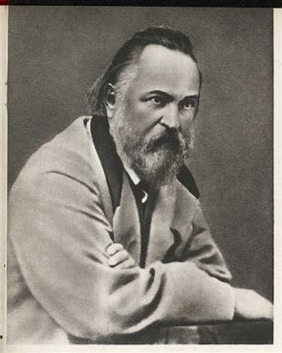**Alexander Herzen, 1812-1870**

**3. Radical Opposition**

**The Populists (*Narodniks*)**

This was a small group of intellectuals who were inspired by the ideas of Karl Marx and aimed to create their own form of popular socialism in Russia, based on the peasants. The Populists were, in part, also a product of Alexander II’s reforms; many had been educated and exposed to new ideas in his reformed universities, and were able to discuss these and criticise the Tsarist system due to his censorship reforms.

The two leading figures of the movement were **Nikolai Chernyshevsky** and **Pyotr Lavrov**. Chernyshevsky was the intellectual force behind the Populists. He argued that the peasants should form communes and rebel against the power of the landowner. If power could be taken by the peasants, he thought, they provided the best hope of creating an egalitarian social order. Chernyshevsky was imprisoned in 1862 and whilst in prison wrote a utopian novel called *What is to be Done?* that inspired many of the students who became Populists.

Pyotr Lavrov focused on direct action to try and bring about the ideas of the Populist movement and organised the **‘Going to the People’** campaign in 1873-74. Three thousand young Russians, mostly students, went to the countryside and villages to spread the ‘truth’ to the peasants:

* Russia’s hope lay in a peasant democracy
* The purity of rural life was in contrast to the corruption of cities
* Peasants had been oppressed and the land belonged to them
* All men were equal and free, and Russia should be reborn on this basis

The ‘Going to the People’ Campaigns had the potential to threaten Tsarist Russia if they could start to undermine the support of peasants for the Tsar. However, the impact was very limited. Peasants were suspicious of this wave of outsiders and in cases chased them out of their villages or handed them over to the authorities. Peasants would have welcomed the Populists’ views on the land but would have had little understanding of their belief in a peasant democracy. Some peasants were also benefitting from Tsarist reforms and the new economic opportunities opened up by Emancipation and railway construction so had little interest in radical ideas. For their part, many of the Populists who took part were quickly disillusioned by the conservatism of the peasants.

The government reacted with 700 arrests of Populists and exiled its leaders, meaning the movement collapsed. In the long-term however, the Populist idea of a building an egalitarian society based on the peasants would be picked up by Lenin and greatly influence his ideological approach.

**Land and Liberty, Black Partition & The People’s Will**

The Populist movement was short-lived and unsuccessful, but it did lead the way for a number of radical, and in cases, violent groups in the 1870s, all of which challenged the Tsarist regime.

***Task****- working in groups of three, research each of these groups. Take one each and complete the relevant section of the table on the next page, ready to explain what you have found to the rest of your group. A good place to start is* [*www.spartacus-educational.com*](http://www.spartacus-educational.com) *then look in ‘Russia’ – ‘Russian Political Groups’. Then, answer the three questions below.*

1. **Of these three groups which do you think posed the most significant threat to the Tsarist regime and why?**
2. **Would these groups have been possible without the reforms of Alexander II?**
3. **Was the assassination of Alexander II a high point for radical opposition to the Tsarist regime?**

|  |  |  |
| --- | --- | --- |
| **Land and Liberty** | **Black Partition** | **The People’s Will** |
| ***When was it formed?*** | ***When was it formed?*** | ***When was it formed?*** |
|  |  |  |
| ***Aims*** | ***Aims*** | ***Aims*** |
|  |  |  |
| ***Methods*** | ***Methods*** | ***Methods*** |
|  |  |  |
| ***Impact*** | ***Impact*** | ***Impact*** |
|  |  |  |
| ***Key Figures*** | ***Key Figures*** | ***Key Figures*** |
|  |  |  |

**4. National minorities within the empire**

Poland

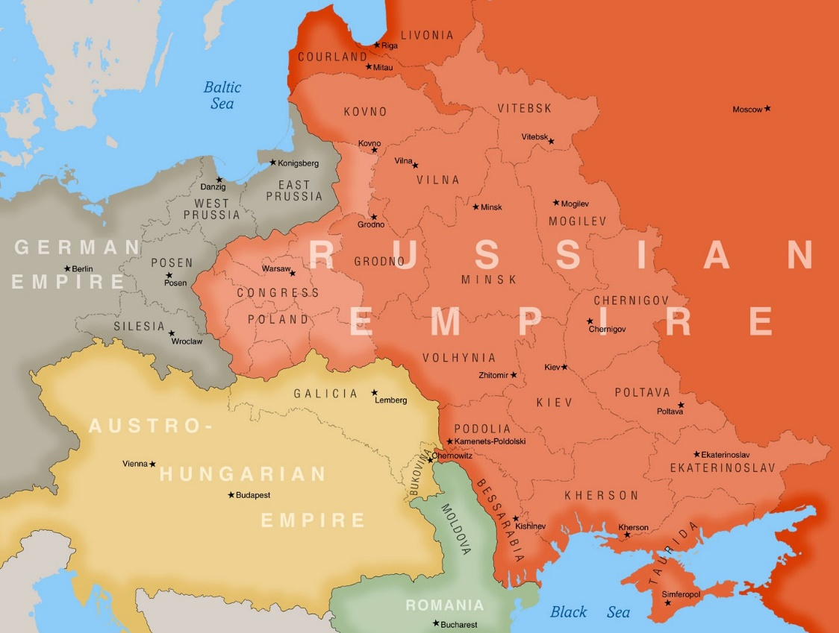The Russian Empire was a diverse, multi-national empire in which a range of ethnic and religious groups were ruled centrally by the Tsar. Opposition and revolts from national minorities, therefore, were a common feature of Tsarist Russia. The most significant national opposition during Alexander II’s reign came from **Poland** in the form of the **Polish Revolt** of **1863**.

By 1795 Poland had been divided between Austria, Prussia and Russia. The Russian section of Poland (originally known as Congress Poland) had some technical autonomy but was controlled from St Petersburg and the Poles would never accept Russian rule. There had been an unsuccessful revolt in 1830, after which Russia tightened its control over its Polish province.

The apparent weakening of Russia through defeat in Crimea, combined with Alexander II’s willingness to enact reforms, encouraged new hopes of Polish independence and in 1860 demonstrations were held to commemorate the uprising of 1830. A revolutionary committee was set up in Poland which attracted Poles ready to fight. Before 1863 Russia had launched a recruiting drive in Poland but to escape this Polish men eligible for military service had started to flee their villages and were quickly attracted to the uprising. Many Polish officers, landowners and professionals also joined the uprising, keen to restore the influence they had enjoyed before Russia tightened its control after 1830.

The uprising lasted from January 1863 into 1864. From April 1863 it also spread to Lithuania, Latvia, Belarus and Ukraine. The Russian government responded with overwhelming military force (195,000 Russian troops were stationed in Poland) and through brutal punishments including mass hangings and exile to Siberia.

Ultimately, the uprising failed because:

* It was internally divided between the ‘Reds’ who supported armed revolt and the ‘Whites’ who wanted negotiation and foreign backing. There was also division between the different regions involved in the uprising with distrust between those in Lithuania and the Ukraine and the Revolutionary Committee in Warsaw
* The uprising failed to unite different social groups in Poland. The ‘Whites’ tended to be Polish nobles whilst peasants were never fully mobilised behind the uprising. The Russian government brought in concessions for Polish serfs which undermined their support of the uprising
* The uprising failed to attract foreign support. Neither Britain or France wanted to resume conflict with Russia, whilst neighbouring Prussia returned fleeing Polish rebels to the Russians
* Russia was able to use overwhelming military force. There was also a brutal wave of executions of those linked to the uprising leading to 25,000 Polish deaths.

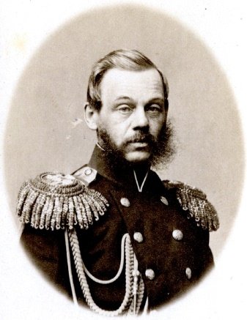After the final defeat of the uprising in June 1864 Poland was placed under the control of the Russian War Minister, Milyutin, who was determined to **“russify”** Poland (make it more Russian) & to break the power of the rebellious Polish nobility:

* 100s of Polish **nobles** were deported to Siberia. Their land was confiscated & given to Russian officials who took control of local government in Poland.
* **Serfdom** was abolished in Poland on more favourable terms for the peasants than in Russia: they were given better land & nobles as well as peasants had to pay taxes to compensate landowners whose land was redistributed.
* Rural district councils were set up (like the Russian zemstva) to represent peasants as well as nobles.
* Russian replaced Polish as the official **language** of local government & education. Poland was the first part of the Russian Empire to be “russified” with a concerted attempt to suppress Polish language & culture.
* As part of Russification & in revenge for support for the rebellion from many Catholic clergy & the Pope, the Polish **Catholic Church** was forbidden to communicate with the Pope, the Catholic Church’s influence over education was reduced & some Catholic churches were demolished or converted to Russian Orthodox worship & new Orthodox churches built in Polish cities.

This repression was **effective in the short term**: there were no further rebellions before WW1, although there was unrest in 1905. But it failed in the long term because, as Hosking has argued, it “laid the basis for a cross-class Polish civic consciousness”, i.e. **Poles of all social backgrounds became more nationalist because of the attack on their language, culture & religion**. In particular **Catholicism became a badge of Polish national identity**, its appeal strengthened by the fact that their Catholic religion linked Poles with the West & separated them from Russia. Today Poland is the most strongly Catholic country in the world for precisely this reason.

**TASK** – based on the notes above how to what extent do you think the Polish Uprising posed a serious threat to the Tsarist regime? (Write a developed paragraph in answer)

Finland & the Baltic States

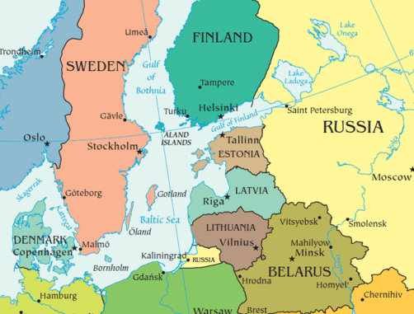Finland, Estonia & northern Latvia were **Protestant** & formerly ruled by Sweden until Russia conquered Estonia & northern Latvia in 1710 & Finland in 1809. Estonia & northern Latvia had been dominated by **German** landowners & merchants since the Middle Ages & many of the Baltic German nobles occupied high positions in the Tsarist government, especially in the diplomatic service.

**Finland** was a self governing duchy & A rewarded it for its loyalty (in contrast to the rebellious Poles) by elevating Finnish to the status of a national language (in Finland) & giving Finland its own currency. In **Finland** he is still regarded as “the good Tsar”. This policy was partly a reward for Finland’s lack of support for the Polish rebellion, partly to reduce Swedish influence & partly to encourage Finland’s economic development (it had a higher standard of living than any other part of the Russian Empire).

Lithuania & southern Latvia were **Catholic**, traditionally dominated by **Polish** nobility & formed part of the Polish/Lithuanian kingdom until being absorbed into the Russian Empire by 1795.

Like Finland the Baltic States, especially Latvia & Estonia, had **much higher educational & living standards than Russia**, to such an extent that many Russians emigrated to Latvia, especially **Riga** which became one of the biggest industrial & financial centres in the Russian Empire. This laid the foundations for future Russification.

Because **Lithuania** participated in the Polish uprising of 1863 it was subjected to Russification earlier than Estonia & Latvia, which largely escaped it during Alexander II’s reign.

The Ukraine

Of all the non-Russian nationalities, the Ukrainians & Belarussians were **the most similar to the Russians in terms of language, culture & religion** (they were Orthodox).

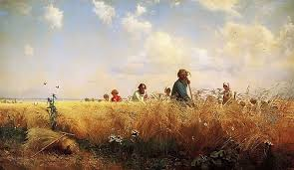Historically the eastern Ukraine had since medieval times been ruled by Russia, whereas Belarus & the western Ukraine were ruled by Poland until the partitions of 1772-95.

Tsarist Russia called the Ukrainians **“Little Russians”**, refusing to acknowledge that they were a separate nation & its response to the growing Ukrainian national consciousness in the 19th century was characteristically repressive, e.g. Alexander II issued decrees in 1863 & 1876 forbidding the import & publication of books in the Ukrainian **language**. The policy was similar in Belarus, which never seriously resisted Russification.

One reason for this repression was the Ukraine’s economic importance: it had the most fertile soil in the Russian Empire, vital for producing wheat (the Ukraine became known as “**Russia’s bread basket**”).

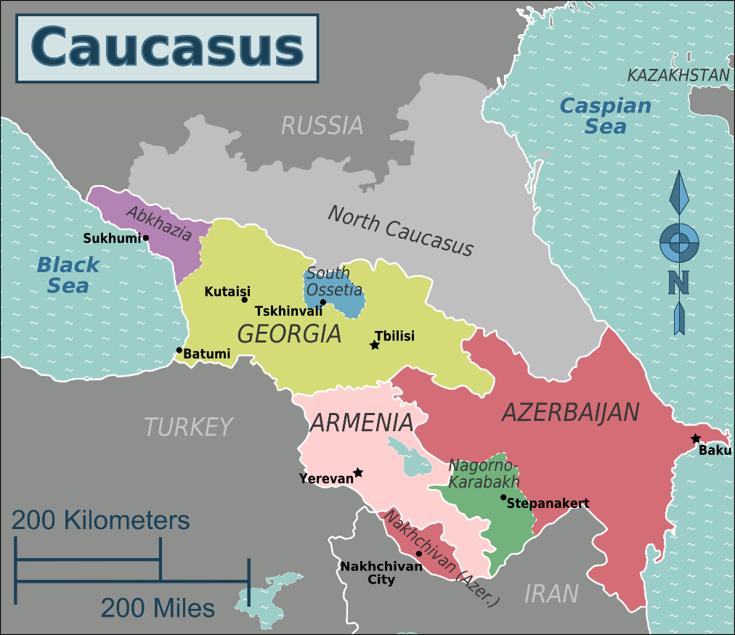Georgia, Armenia & Azerbaijan

Iran ceded Georgia to Russia in 1813, Azerbaijan & eastern Armenia (western Armenia was part of the Turkish Empire) in 1828.

The Caucasus was a **backward area economically with little industry & low literacy**. Traditionally the whole region was dominated by Armenian businessmen.

Religiously **Georgia was Orthodox** Christian (like Russia), **Armenia was Christian** with its own distinctive church & **Azerbaijan was Muslim**.

The relatively liberal **Alexander II did not try to impose Russification** in this region.

Central Asia

**Kazakhstan, Kyrgyzstan and Tajikistan** were conquests of Nicholas I early in the 19th century. **Uzbekistan** was added by Alexander II.

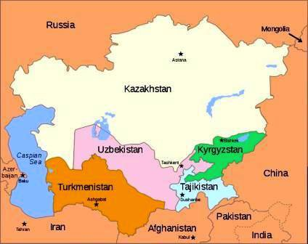The area was known collectively at that time as Russian Turkestan & remained under Russian (or later Soviet) rule until 1991 when the USSR broke up & Kazakhstan, Kyrgyzstan, Uzbekistan & Turkmenistan all gained their independence.

The motives for the Russian conquest of Central Asia were:

* To provide living & working space for Russian peasants who complained they did not have enough land.
* To cultivate raw **cotton** for the factories in European Russia.
* To strengthen Russia’s position in south central Asia, where Russia competed with GB (which at that time ruled India).

Apart from encouraging Russian settlement, Central Asia was generally **ruled with a lighter touch than other regions of the Empire**, mainly b/c the remote nature of the area, poor transport & communications & the nomadic lifestyle of local people made Russification more difficult than almost anywhere else in the Empire.

These areas accounted for the majority of Russia’s **Muslims** (most of the rest lived in Azerbaijan). 11% of the Tsar’s subjects were Muslim & little attempt was made to convert local people to Christianity.

**How liberal was Alexander II’s policy towards the nationalities?**

|  |  |
| --- | --- |
| **Liberal** | **Repressive** |
|  |  |

**Sample interpretation question**

***Evaluate the interpretations in both of the passages and explain which you think is the more convincing as an explanation of Alexander II’s treatment of minorities [30]***

**Passage A**

Russian rule brought important changes in Central Asia, but many elements of the traditional way of life scarcely changed. In the part of what is now Tajikistan that was incorporated into the Guberniya (regional government) of Turkestan, many ordinary inhabitants had limited contact with Russian officials or settlers before 1917. Rural administration there resembled the system that governed peasants in the European part of the Russian Empire after the abolition of serfdom in 1861. Local administration in villages continued to follow long-established tradition, and prior to 1917 few Russians lived in the area of present-day Tajikistan. Russian authorities also left education in the region substantially the same between the 1870s and 1917.

*(Jeffrey Hays, Russian Rule in Central Asia, 2008)*

**Passage B**

The territories of the former [Poland-Lithuania](https://en.wikipedia.org/wiki/Polish%E2%80%93Lithuanian_Commonwealth) were excluded from liberal policies introduced by Alexander ... The [martial law](https://en.wikipedia.org/wiki/Martial_law) in Lithuania, introduced in 1863, lasted for the next 40 years. Native languages, [Lithuanian](https://en.wikipedia.org/wiki/Lithuanian_language), [Ukrainian](https://en.wikipedia.org/wiki/Ukrainian_language) and [Belarussian](https://en.wikipedia.org/wiki/Belarussian_language), were completely banned from printed texts ... The [Polish language](https://en.wikipedia.org/wiki/Polish_language) was banned in both oral and written form from all provinces except [Congress Poland](https://en.wikipedia.org/wiki/Congress_Poland), where it was allowed in private conversations only.

In 1863, Alexander II re-convened the [Diet (Parliament) of Finland](https://en.wikipedia.org/wiki/Diet_of_Finland) and initiated several reforms increasing Finland's autonomy within the Russian Empire, including establishment of its own currency ... Finally, the elevation of [Finnish](https://en.wikipedia.org/wiki/Finnish_language) from a language of the common people to a [national language](https://en.wikipedia.org/wiki/National_language) equal to [Swedish](https://en.wikipedia.org/wiki/Finland_Swedish) opened opportunities for a larger proportion of Finnish society. Alexander II is still regarded as "The Good Tsar" in Finland.

*(Wikipedia Article on Alexander II of Russia)*

Neglected

* 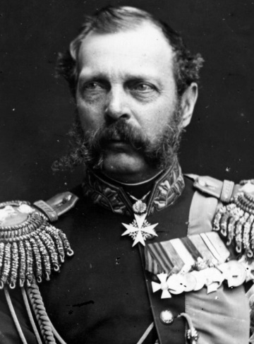**Central Asia**, most of which was conquered in A’s time, saw little immediate change b/c the thinly scattered population with its nomadic lifestyle, Muslim religion & low literacy made reform or Russification more difficult than any other part of the Empire.
* It could be argued that the abolition of **serfdom** was handled as if Russian peasants were the same throughout the Empire, which was not true, e.g. serfdom in Poland continued.
* The same could be said of the **zemstva**, which did not apply to Poland or the Baltic States.
* The territory which had belonged to **Poland-Lithuania** before 1795 was excluded from A’s liberal reforms.
* After the Crimean War **military reform** was a higher priority than minority issues.
* Reform of the **criminal justice** system on the French model was also a higher priority than minorities.
* Although he favoured reform, A was not willing to give up any of his power & his policies became more conservative after the assassination attempt against him in 1866.
* A’s liberation of Bulgaria 1877-8 showed more regard for minority rights abroad than within his own empire.
* The expulsion of many local **Muslims** (especially Circassians) from the newly conquered North Caucasian territories showed little regard for minority rights.

Not Neglected

* A paid careful attention to the objections of Polish nobles to the abolition of serfdom & A initially allowed the Polish admin. to manage this issue in its own way.
* The suppression of the Polish rebellion in 1864 was followed by a repressive russification policy under **Milyutin** coupled with the abolition of serfdom which favoured the peasants far more & the nobility far less than in the rest of Russia.
* **Russification** affected other areas too: Lithuania, Belarussian & Ukrainian as well as Polish were banned as written languages.
* Martial law was imposed in Lithuania in 1864 following the Polish revolt & a commission was set up in 1876 to investigate separatist activity in the Ukraine.
* 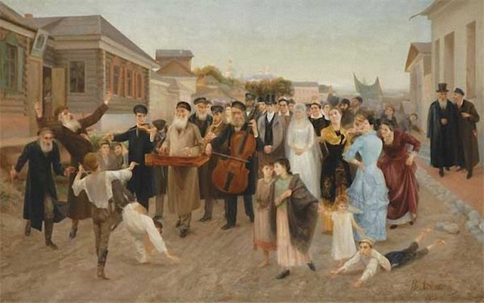By contrast, A elevated Finnish to the status of a national language (in Finland) &, gave Finland its own currency. In **Finland** he is still regarded as “the good Tsar”. This policy was partly a reward for Finland’s lack of support for the Polish rebellion, partly to reduce Swedish influence & partly to encourage Finland’s economic development (it had a higher standard of living than any other part of the Russian Empire).
* Similarly, A tolerated the German language & culture of the upper class **Baltic Germans** in Latvia & Estonia b/c he regarded them (like the Finns) as loyal to him.
* In contrast to previous & later anti-Semitic policies, A II allowed some **Jews** (right), especially doctors & merchants, to live outside the Pale of Settlement (previously Polish territory) to which they had been confined. He also ended the ban on Jews working for the govt.

**Planning grid**

|  |  |  |
| --- | --- | --- |
| **Passage A** | | |
| **Point/argument from the passage** | **Own knowledge to support or contradict the argument** | **Assessment – how convincing is the argument made in the passage?** |
|  |  |  |
|  |  |  |
|  |  |  |
|  |  |  |
| **Passage B** | | |
| **Point/argument from the passage** | **Own knowledge to support or contradict the argument** | **Assessment – how convincing is the argument made in the passage?** |
|  |  |  |
|  |  |  |
|  |  |  |
|  |  |  |

What particular points of disagreement can you find between the two passages?:

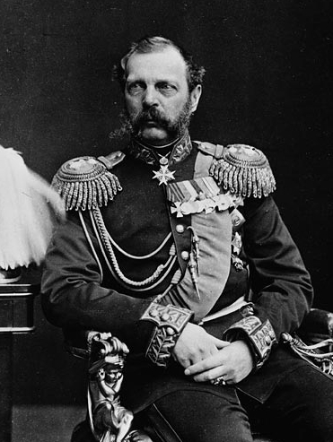**How did Alexander II respond to Opposition?**

In the later years of the nineteenth century, Russia’s internal policies hovered uneasily between two incompatible systems. Alexander II’s reforms had severely shaken the traditional personalised power structure but had not managed consistently to replace it with institutions of civil society or rule of law. To plug the resulting authority gap, the regime had nothing else at hand but the police, backed up by emergency powers. Having set out to demolish an old building and erect a new one, the regime then changed its mind and started repairing the ruins; the resultant hybrid architecture threatened the balance of the entire construction. The regime was in an insoluble dilemma, caught between perception of the need for civic institutions and inability to introduce them without undermining its own stability.

Adapted from Geoffrey Hosking, *Russia and the Russians*, 2001

1. What, according to Hosking, was the problem with Alexander II’s ‘Great Reforms’?
2. What does Hosking argue did Alexander II have to do to ‘plug the…authority gap’ created by his reforms?

As opposition To Alexander II and the Tsarist regime began to increase in the second half of the 1860s, due in part to the impact of his own education, legal and censorship reforms, Alexander responded by slowing or reversing reform, and through repression against opposition. One likely trigger for this was the 1866 assassination attempt against the Tsar which shook his confidence in reform. Alexander’s move away from reform is significant when assessing the extent to which he deserves the title of ‘Tsar Liberator’ and also the impact of his reforms on Russia, as many were cut short for political reasons before they had time to embed fully. It is also important, however, to remember that Alexander was always a firm believer in autocracy and his God-given right to rule. He did not reform for moral reasons and in many ways, the period of the ‘Great Reforms’ in the early 1860s was the odd one out, rather than the later return to reaction and repression.

**Counter Reform**

There are a number of examples where Alexander slowed or reversed his reforms:

* In **education**, the more liberal Golovnin was replaced as minster by the conservative Dimitry Tolstoy who was a staunch believer in the Russian Orthodox Church and wanted to remove Western liberal ideas
* The Church regained control of rural schools and the higher *gimnazii* were made to follow a more traditional curriculum
* More liberal courses in universities, such as Literature, Science, Modern Languages and History were forced out, whilst Maths, Latin, Greek and Theology were encouraged
* 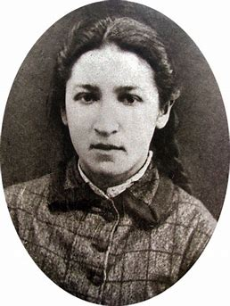The **legal system** was tightened under Konstantin Pahlen. New governor-generals were created across the empire in 1879, with the power to prosecute political crimes in military courts and exile offenders
* In 1878 political crimes were transferred from civil courts to special secret courts. This followed the case of Vera Zasulich (right) who in 1876 shot the military governor of St. Petersburg but was then acquitted by a sympathetic jury who also prevented her re-arrest. This illustrated to Alexander II the need to have tighter control of political cases, particularly when Zasulich’s trial was meant to be a ‘show trial’ to deter other radicals.

**Repression**

In addition to slowing or reversing reforms, Alexander II also used the extensive **police state** in Tsarist Russia to root out and punish opposition. At the heart of this was the ‘**Third Section of his Imperial Majesty’s Own Chancellery’**. The Third Section was the precursor to the secret police and would go on to be replaced in 1880 by the Okhrana. Its role was to investigate political opposition through a network of spies and surveillance. The Third Section was also responsible for censoring foreign and Russian publications, and also had a propaganda role in trying to influence public opinion through publication of its own. Finally, the Third Section had the power to arrest, imprison and punish those suspected of acts against the Tsarist regime.

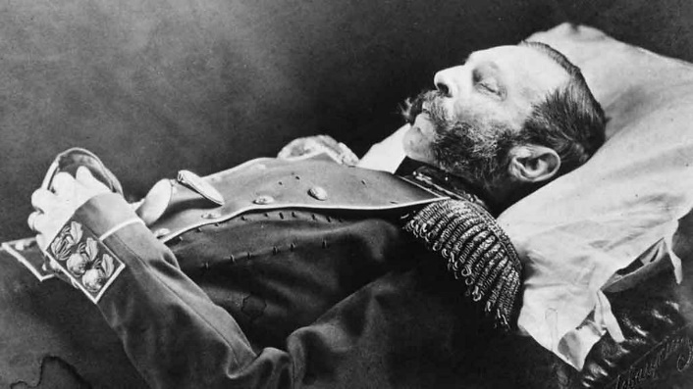Under the control of **Pyotr Shuvalov**, the Third Section had an infamous reputation and the secret police combined with the army, censorship and propaganda, gave Alexander II the apparatus to repress opposition, as was seen, for example, after the ‘Going to the People’ Campaigns. However, The Third Section was not an all-powerful organisation that dominated everyday life. It was also criticised for its failure to uncover any of the assassination attempts against Alexander, starting in 1866. This failure led to it being replaced in 1880 by the Okhrana, but neither forms of the secret police were able to prevent the assassination of Alexander II by the terrorist group the ‘People’s Will’ in 1881.

**Extension Task**

To gain a deeper understanding of the causes, events, and consequences of Alexander II’s assassination, listen to the ‘In Our Time’ episode *Tsar Alexander II’s Assassination*

<https://www.bbc.co.uk/programmes/p003k9b2>

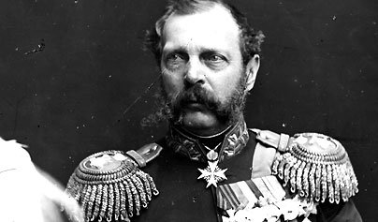**‘Tsar Liberator’**

***Consolidation***

Based on the understanding you have gained of Alexander II’s reforms, opposition to his regime, and his reaction to this, select the strongest evidence (4-5 pieces on each side) to support and challenge the view that Alexander II deserved the title of ‘Tsar Liberator’

***Challenge***

***Support***

***Alexander II was the ‘Tsar Liberator’***

**To what extent were the policies of Alexander II influenced by his advisors?**

This is debate within the bigger question of whether Alexander II deserved the title of ‘Tsar Liberator’, as at times he seems to have been heavily influenced by either ‘liberal’ minsters or relatives who encouraged reform, or, conservative figures who encouraged counter-reform and reaction.

To gain an understanding of this influence, research the figures below. For each explain who they were, their role within Alexander II’s government, whether they were a ‘liberal’ or ‘conservative’ influence, and what impact (if any) they had on Alexander’s decisions.

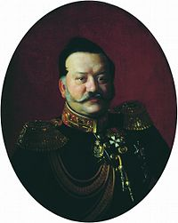

**Count Rostovtsev**

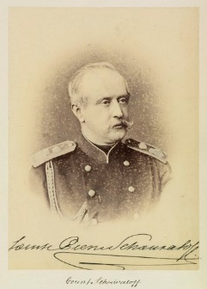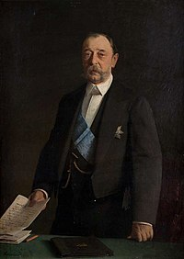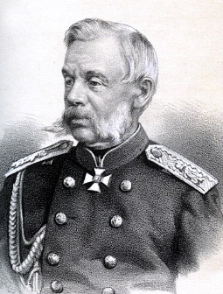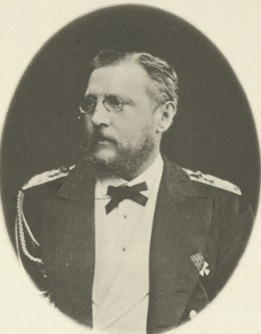

**Dmitry Milyutin**

**Pyotr Andreyevich Shuvalov**

**Dmitry Tolstoy**

**Grand Duke Konstantin**

**JUNE 2018**

Evaluate the interpretations in **both** of the two passages and explain which you think is more convincing about the consequences of Alexander II’s Great Reforms. **[30]**

**Passage A**

The Great Reforms changed the social fabric profoundly…in a manner that the legislators had not planned. The 1860s and 1870s saw a sudden explosion of culture, as towns acquired real meaning as the focus of political, legal and cultural life. The population of small towns doubled. Railroads began slowly to bridge the vast distances of European Russia with the construction of a line from St Petersburg to Warsaw and from Moscow to Nizhny Novgorod. Factories sprouted on the outskirts of towns and on ambitious landowners’ estates: industry flourished in the central industrial region, textiles in Ivanovo; mining and metallurgy underwent a revival. The drab provincial town of Livny, which before the reforms produced agricultural products, boasted eighteen major factories by the 1890s. A serious effort was made to improve the sanitary conditions in the towns and villages as pipelines and sewage systems were installed and roads were paved. The atmosphere of the towns and estates changed, as well, as energetic young scientists, priests, teachers and physicians working the countryside attended the zemstvo. The zemstvo became the cornerstone of a distinctive and original political culture. It gave people experience of politics [and it was] the defining institution of the era that followed the great reforms.

Adapted from C. Evtuhov et al, *A History of Russia*, published in 2004.

**Passage B**

It is possible to level criticisms at most of the reforms that ensued [after 1861]. Peasants remained the poorest and most heavily exploited section of the population. Those who engaged in agriculture were not only short of land but also saddled with redemption payments. By retaining the Poll Tax and introducing new courts, the government made it plain that it had no intention of granting the peasantry economic or judicial parity with the nobility. The zemstvo became the nests of the gentry. The peasantry could have played a larger part in their activities, but the former serfs were unable to rid themselves of the habit of deference. At district level, the new assemblies were too remote from the peasants’ concerns to justify the risk of throwing caution to the wind. Although the chairmen of the zemstvo were elected by the assemblies, they had to be approved by the Ministry of Internal Affairs. In the eyes of the government, the zemstvo were fundraising bodies rather than forums for political discussion yet because zemstvo lacked the power of enforcement they found it difficult to collect taxes.

Indeed, the major drawback of the reforms was the Tsar’s refusal to establish a national assembly.

There can be no doubt that this was a decision made by the Tsar himself, for his own brother and a number of highly placed officials recognised the advantages of establishing some sort of central representative body. The Tsar, however, was not to be persuaded. Since the Tsar made law on his own, it may be that the reforms of the 1860s were a grand illusion. The measures enacted by Alexander II were conceptually limited, poorly executed, incomplete, unsustained and insecure.

Adapted from D. Saunders, *Russia in the Age of Reaction and Reform 1801–1881*, published in 1992.

Evidence for A

* 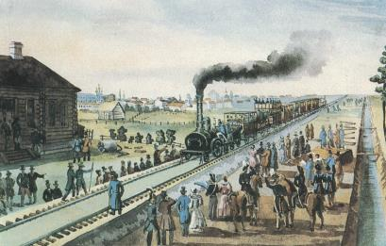A is right to stress the importance of Alex’s reign in terms of **railway** development: the St Petersburg to Warsaw Line mentioned in the source was the first to link Russia with western Europe & was not completed until 1862. Between then & 1878 the number of miles of rail track in Russia increased x7.
* The same is true of **urban** development: the modern city of Ivanovo was created by merging the old [flax](https://en.wikipedia.org/wiki/Flax)-processing village Ivanovo with the industrial [Voznesensky Posad](https://en.wikipedia.org/w/index.php?title=Voznesensky_Posad&action=edit&redlink=1) in 1871.
* 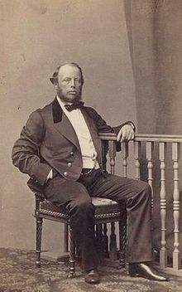Under Alex’s reforming Finance Minister Michael von **Reutern**, industrial production doubled 1862-78, laying the foundations for progress under Witte later.
* This owed much to Reutern’s policy of copying western European expertise & encouraging foreign experts to come to Russia, e.g. the Welshman J.J. Hughes was employed by the Russian government in 1871 as an expert in the production of armour plate and by 1884 his ‘New Russian Coal, Iron and Railmaking Company’ was the largest producer of pig iron in the Russian empire.
* To promote industrial development, Reutern set up a new state bank along with municipal banks and savings banks which could provide the capital which could be invested into heavy industry, such as coal mining in the Ukraine which started in 1870.
* The **zemstva**, created in 1864, did to a significant extent become “the cornerstone of a distinctive and original political culture”, giving educated people like “scientists, priests, teachers and physicians” “experience of politics”. They had 5 classes of members: large landowners, smaller landowners, wealthy townsmen, less wealthy townsmen & even peasants. They marked “the defining institution of the era” in the sense that they replaced the previous system which was corrupt, much less organised & gave almost unlimited power to the nobility.
* As well as improving sanitation & roads, the zemstva promoted education (the number of primary schools in Russia trebled during Alex’s reign), health provision & economic development.

Evidence against A

* There was significant evidence of economic development **before** Alex II’s reign, e.g. the completion of the St Petersburg to Moscow railway line & the abolition of customs barriers between Russia & Poland which stimulated economic growth in Russian Poland.
* Railway development by 1881 was too limited to have a major impact on the Russian economy.
* Although the population of small towns doubled, many of these people were migrant workers who returned to the countryside at harvest time. Even in 1881 75% of the population was still rural.
* On the other hand, the most rapid industrialisation occured **after** Alex II’s death, e.g. the oil industry in Azerbaijan didn’t take off until 1885.
* See the evidence for B for points about the **zemstva**.

Evidence for B

* 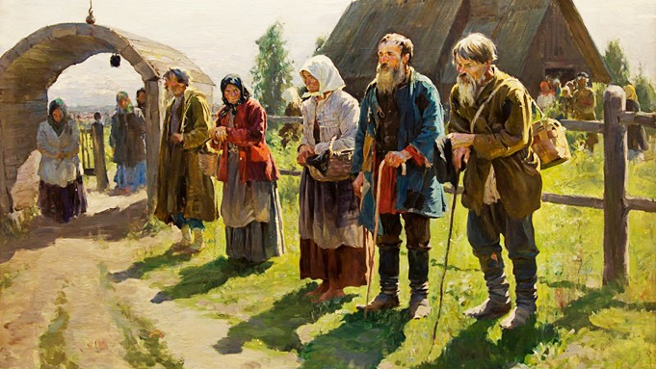Ex-serfs were left deeply frustrated by the terms of the **Emancipation Edict**, particularly regarding the allocation of land. Landlords were able to choose which parts of their land would be given to ex-serfs and inevitably chose the worst areas, keeping the most productive land for themselves. Serfs who had worked in the household of their landowner (manorial serfs) were given no land at all.
* Ex-serfs were given insufficient **land** to support themselves and their families, let alone experiment with new farming techniques or technologies. By 1878 only 50% of the peasantry was capable of producing a surplus, showing how backward Russian farming remained.
* **Redemption payments** were unpopular with ex-serfs who had no way to pay the debts and were denied their full freedom until they had done so. Redemption payment would be passed on from generation to generation, burdening them with debt & by 1870 only 55% of peasants had even been able to start making their redemption payments.
* Peasant dissatisfaction with the Emancipation Edict was shown by the fact that in the four months that followed the decree there were 647 incidences of serf riot, and between 1861-63 there were 1,100 outbreaks.
* As B also points out, the peasants still suffered restrictions like the **mir** which decided what crops would be grown and controlled the physical movement of peasants who needed a **passport** to leave it.
* Peasants were still subject to **special courts** so in that sense they still suffered legal discrimination.
* The **poll tax** referred to in B was very unfair: all male peasants had to pay it however poor they were but nobles, clergy & govt. officials were exempt.
* The **zemstva** were noble dominated (74% of members were nobles despite them constituting a tiny minority of the population) & they were not set up in the Baltic States or Poland for fearing of them being used to voice nationalist discontent.
* B is right to say that the reforms were “unsustained and insecure” as well as “conceptually limited, poorly executed (and) incomplete”. Their powers were severely restricted by a law passed by Alex III in 1890 which subordinated the zemstva to local governors appointed by the Tsar.

Arguments against B

* See the evidence for A on the **zemstva**.
* B’s claim that “the major drawback of the reforms of the reforms was the Tsar’s refusal to establish a **national assembly**” is true in the sense that none was set up until 1906; on the other hand it could be argued (as B itself suggests) that the continued discrimination in favour of the nobles & against the peasants was also a key factor & to be fair Alex II was planning to set up a national assembly but was thwarted by his assassination & by his son’s decision to cancel it.
* Emancipation was an unprecedented reform in Russia, which gave personal freedom to over **23 million** serfs (34.4% of the population), including the right to marry whom they chose.
* Some peasants undoubtedly did well out of Emancipation. **Kulaks** (wealthier peasants) were able to exploit their land allocations, buy extra land and produce a surplus of grain to export. A number of ex-serfs were also able to sell their allotments, obtain a passport to leave the *mir* and improve their standard of living working in industrial cities.
* Emancipation opened the door to a **wide range of reforms** in the 1860s and 70s. Alex would go on to reform education (1864), censorship (1865) & the military (1874), none of which B mentions.
* The **legal** reform of 1864 gave the peasants the right to trial by jury with magistrates elected by the zemstva rather than just being at the mercy of their landlord.

**JUNE 2019**

**1** Evaluate the interpretations in **both** of the two passages and explain which you think is more convincing as an explanation of the reasons why Alexander II emancipated the serfs. **[30]**

**Passage A**

Historians have long discarded the view that Alexander was a liberal whose goal to transform Russia into a modern democracy was ultimately defeated by harsh realities. They see him as a conservative, determined to preserve what was best from the old system, with a devotion to autocracy scarcely less than his father’s. In particular, he was deeply convinced of his own sacred duty and of Russia’s special identity. Like his father, at various times he expressed doubts about the loyalty of most sections of society, from the nobles to the peasants. Even his reforms reflected the wishes of his father, who had memorably admitted that serfdom was, “an evil, palpable and obvious to all”. At the same time, he craved the approval of Western monarchs, amongst whose ranks he considered himself to belong. Modern statehood and serfdom were incompatible. All this was reflected in Alexander’s role as ‘Tsar- Liberator’. As he announced to the assembly of Moscow nobles in March 1856, it was better to abolish serfdom from above than to await the time when it began to abolish itself from below. The main aim was not to free up labour and promote “capitalism” – Alexander and his contemporaries did not think in such terms – but rather to improve the condition of the peasants and reduce the risk of rural revolt.

(Adapted from: L. Hughes, *The Romanovs*, published in 2008)

**Passage B**

Alexander was an honest conservative, forced by the overwhelming logic of facts to put in the forefront of the program [of domestic reform] the liberation of the serfs. The government could best appreciate these evils when they affected the army, on which it depended entirely for its prestige not only abroad but at home. This was the lesson of the Crimean War. The military strength of Russia had been greatly exaggerated. Russia herself had thrown many more men into the war, but the wastage was enormous. The transport inflicted an enormous burden upon the population, only to achieve a small result; the medical service was as usual almost negligible, and epidemics were rampant.

The Russian infantry fought splendidly, but their commanders were incompetent. Above all, there was shown up at the front line, where there was every demand for intelligence and initiative, the standing contrast between the status of Russian serf and that of the free man of Western Europe; and it made serfdom look absurd as a basis of military power. For Russia, as soon as the Treaty of Paris was signed, the question of reform overtook all other issues. As the first step to any reform, serfdom had evidently got to be abolished. The Tsar was the only possible trustee of the peasants, and did not need to be a liberal in order to appreciate their first essential requirements and their economic importance to the country.

(Adapted from: B. Pares, *A History of Russia*, published in 1953)

Evidence for A

* Both sources see **Alex as essentially conservative in his attitude towards emancipation**; in 1856 he told the landowners, “I ask you, gentlemen, to figure out how all this can be carried out to completion”. According to Michael Lynch, his motive for doing this (he deliberately entrusted the implementation of emancipation to conservative nobles like Panin while criticising the liberal Nikolai Milyutin for being “a restless and uncompromising reformer”) was that “he made it very difficult for them either to resist his command or to blame him if their plans were subsequently shown to be faulty”. It also made it inevitable that the reform would be limited & would in many ways benefit the landowners more than the peasants.
* Privately owned serfs were freed in 1861 but **state** ones not until 1866.
* Both sources agree that Alex was embarrassed by **Russia’s backwardness in comparison with western countries** like GB & France which had just defeated him in the Crimean War & wanted to increase Russia’s international prestige. A knew from his travels abroad before he became Tsar how his father had been despised by western govts. for his reactionary (extreme conservative) policies.
* A is right to argue that Alex **genuinely wanted “to improve the condition of the peasants”** & B that “The Tsar was the only possible trustee of the peasants”. He was praised by the liberal political philosopher Boris Chicherin for genuinely wanting to help the peasants, “to abolish an age-old order founded on slavery” & “replace it with civic decency and freedom”. In that sense he deserves the title of “Tsar Liberator” (A).
* A is right to stress the desire to “**reduce the risk of rural revolt**” as a motive for abolishing serfdom: the Ministry of the Interior estimated that there had been 712 peasant uprisings in the Russian Empire 1826-54.

Evidence against A & B

* It could be argued that **both sources exaggerate how conservative Alex was**; it is true that his father Nicholas I had condemned serfdom, but unlike Alex he did nothing about it. It is true that Alex had never openly criticised his father’s reactionary policies, but Radvinsky argues that the system of autocracy did not permit him to do so & when he became Tsar he listened to liberals like Nikolai Milyutin who drafted the Emancipation Manifesto in 1861.
* Most nobles disagreed with emancipation & felt threatened by it.
* Milyutin emphasised: “It is impossible not to be amazed at the rare firmness of the Tsar who alone curbs the present reaction and the forces of inertia.”
* It could be argued that A is too dismissive of the idea that emancipation was influenced by the desire to aid the **development of a capitalist economy in Russia**, e.g. Gerschenkron argues that serfdom restricted the pool of available labour.

Evidence for B

* B agrees with A in seeing Alex as cautious & concerned with Russia’s standing abroad but places much more emphasis on the **Crimean War** as a reason for emancipation. Defeat in this war had shown that she had failed to keep up with improvements in military technology like precision rifles, ironclad ships & electrical telegraphs.
* This was linked with serfdom in the sense that Russia’s army consisted of uneducated serfs ill equipped to use this new technology even if it had been available; to avoid such defeats in future Russia needed a well equipped, well trained professional army like the French. Russian serfs were conscripted into the army against their will at the whim of their landlords, who used the army as a kind of penal system for the least hardworking & most disruptive of their serfs. General Dimitry Milutin, later Minister for War, advised Alex that **reform of the Russian army was impossible while serfdom continued to exist**.
* Michael Lynch sees the Crimean War as a decisive reason for Alex wanting to abolish serfdom: “Above all, he hoped that an emancipated peasantry, thankful for the gifts that a bountiful tsar had given them, would provide physically fitter and morally worthier recruits for Russia’s armies, the symbol and guarantee of Russia’s greatness as a nation”.
* **Defeat in the Crimean War convinced virtually everyone in the Russian ruling class that fundamental reform was needed**, not just militarily but also in terms of the law, communications & local govt. The abolition of serfdom was seen as the most urgent & far-reaching of these reforms; it was the first to be announced (in 1856, immediately after the war ended) & the first to be implemented in 1861.

Evidence against B

Although there was some connection between military reforms b/c obviously the abolition of serfdom meant that a new system of conscription had to be introduced, the fact that **Alex announced the abolition of serfdom as soon as the Crimean War ended in 1856 but the package of military reforms was not fully implemented until 1874** suggests that other reasons for the abolition of serfdom may have been more important.

**KEY TERMS**

|  |  |
| --- | --- |
| **Term** | **Description** |
| **Emancipation** |  |
| **Redemption Payment** |  |
| **Zemstva** |  |
| **Tsar Liberator** |  |
| **Mir** |  |
| **Intelligentsia** |  |
| **Kulak** |  |
| **Slavophile** |  |
| **Westerniser** |  |
| **Volost** |  |
| **Land Hunger** |  |
| **‘Tsar Liberator’** |  |
| **‘Great Reforms’** |  |
| ***Narodniks*** |  |

**KEY FIGURES**

|  |  |
| --- | --- |
| **nAME** | **Description** |
| **Alexander II** |  |
| **Mikhail Von Reutern** |  |
| **Dmitry Milyutin** |  |
| **Alexander Golovin** |  |
| **Grand Duke Konstantin** |  |
| **Grand Duchess Elena** |  |
| **Alexander Herzen** |  |

**Unit 3 Interpretations Question [30 marks]: Generic Mark Scheme**

|  |  |  |  |  |  |  |
| --- | --- | --- | --- | --- | --- | --- |
|  | **L6**  **26-30** | **L5**  **21-25** | **L4**  **16-20** | **L3**  **11-15** | **L2**  **6-10** | **L1**  **1-5** |
| ***Question focus*** | Very good focus on the question | Good focus on the question | Mostly focused on the question | Partial focus on the question | Limited focus on the question | Limited focus on the topic |
| ***Evaluation of interpretations*** | Thorough and sustained evaluation of the interpretations | Good evaluation of the interpretations | Sound evaluation of the interpretations | Partial evaluation of the interpretations | Weak evaluation of the interpretations. Parts of the answer simply describe the interpretations | Very limited evaluation of the interpretations. Mostly description |
| ***Knowledge*** | Detailed and accurate knowledge of the historical context is used to evaluate the interpretations | Relevant knowledge of the historical context is used to evaluate the interpretations | Generally relevant knowledge of the historical context is used to evaluate the interpretations | Some knowledge of the historical context is used to evaluate the interpretations. At times information from one of the two interpretations is used to support the evaluation of the other. | Evaluation relies heavily on information drawn from the other interpretation rather than knowledge of the historical context. | Very generalised knowledge of the historical context. |
| ***Analysis and judgement*** | Convincing analysis of the interpretations in relation to the question with a substantiated judgement. | Supported analysis of the interpretations in relation to the question with a judgement. | Sound analysis of the interpretations in relation to the question with a reasonable judgement. | Limited analysis of the interpretations in relation to the question. | Very limited analysis of the interpretations in relation to the question. | Lacking analysis of the interpretations in relation to the question. |



HOMEWORK RECORD

HOMEWORK RECORD

|  |  |  |  |
| --- | --- | --- | --- |
| ***Date set*** | ***Details*** | ***Date due*** | ***Done?*** |
|  |  |  |  |
|  |  |  |  |
|  |  |  |  |
|  |  |  |  |
|  |  |  |  |
|  |  |  |  |
|  |  |  |  |
|  |  |  |  |
|  |  |  |  |