**Restaurant Location Activity**

Learning Objectives

* Explain the factors that need to be considered when locating a new business
* Explain the reasons why a business may need to make a decision about location.
* Analyse these factors in relation to the needs of the business
* Evaluate the choice of different locations for a new business

**Task instructions**

*A budding chef is looking for a suitable place to open her new restaurant.*

Read each of the descriptions of the available locations and analyse the strengths and weaknesses of each location (specific to the scenario above)

You should make specific reference to at least 2 relevant location factors (e.g. costs, market and competition, infrastructure, labour, Increased choice in international location, social reasons, government influence) in your analysis/explanation (remember analysis = cause & effect / impact on the business’ activities).

Give a brief overall judgement on suitability (consider “it depends upon”) for each location.

When you have analysed all available locations, you should write a final concluding paragraph where you make a judgement as to which location the chef should choose (consider short term vs long term, “it depends on” etc.).

Remember to justify your final decision.

**** SCROLL TO NEXT PAGE FOR TASK****

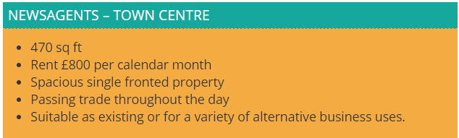

|  |
| --- |
| Analysis of newsagents location: |



|  |
| --- |
| Analysis of tearooms/café/bistro location: |

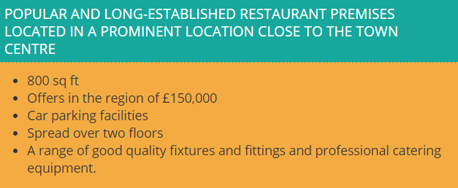

|  |
| --- |
| Analysis of popular and established restaurant location: |



|  |
| --- |
| Analysis of accommodation included location: |

|  |
| --- |
| Overall conclusion. Which location would you recommend to the chef and why? |