# Worksheet 4 Representing images Answers

# Task 1 Bit depth

Answer the following questions, showing how you arrive at your answers:

|  |  |  |  |  |  |  |  |  |  |  |  |  |  |  |  |  |  |  |  |
| --- | --- | --- | --- | --- | --- | --- | --- | --- | --- | --- | --- | --- | --- | --- | --- | --- | --- | --- | --- |
|  |  |  |  |  |  |  |  |  |  |  |  |  |  |  |  |  |  |  |  |
|  |  |  |  |  |  |  |  |  |  |  |  |  |  |  |  |  |  |  |  |
|  |  |  |  |  |  |  |  |  |  |  |  |  |  |  |  |  |  |  |  |
|  |  |  |  |  |  |  |  |  |  |  |  |  |  |  |  |  |  |  |  |
|  |  |  |  |  |  |  |  |  |  |  |  |  |  |  |  |  |  |  |  |
|  |  |  |  |  |  |  |  |  |  |  |  |  |  |  |  |  |  |  |  |
|  |  |  |  |  |  |  |  |  |  |  |  |  |  |  |  |  |  |  |  |
|  |  |  |  |  |  |  |  |  |  |  |  |  |  |  |  |  |  |  |  |
|  |  |  |  |  |  |  |  |  |  |  |  |  |  |  |  |  |  |  |  |
|  |  |  |  |  |  |  |  |  |  |  |  |  |  |  |  |  |  |  |  |
|  |  |  |  |  |  |  |  |  |  |  |  |  |  |  |  |  |  |  |  |
|  |  |  |  |  |  |  |  |  |  |  |  |  |  |  |  |  |  |  |  |
|  |  |  |  |  |  |  |  |  |  |  |  |  |  |  |  |  |  |  |  |
|  |  |  |  |  |  |  |  |  |  |  |  |  |  |  |  |  |  |  |  |
|  |  |  |  |  |  |  |  |  |  |  |  |  |  |  |  |  |  |  |  |
|  |  |  |  |  |  |  |  |  |  |  |  |  |  |  |  |  |  |  |  |
|  |  |  |  |  |  |  |  |  |  |  |  |  |  |  |  |  |  |  |  |
|  |  |  |  |  |  |  |  |  |  |  |  |  |  |  |  |  |  |  |  |
|  |  |  |  |  |  |  |  |  |  |  |  |  |  |  |  |  |  |  |  |
|  |  |  |  |  |  |  |  |  |  |  |  |  |  |  |  |  |  |  |  |

|  |  |  |  |  |  |  |  |
| --- | --- | --- | --- | --- | --- | --- | --- |
| **111** | **110** | **101** | **100** | **011** | **010** | **001** | **000** |

1. What is the resolution of the image above?

20x20 = 400 pixels

1. What is the bit depth?

3 bits

1. What is the file size in KB?

400 x 3 bits = 1,200 bits = 150 bytes / 0.15KB

1. What would be the effect of increasing the bit depth to 24 bits?

File size would be multiplied by 8, to 1.2KB

1. What are the disadvantages of increasing image quality?

File sizes increase, and therefore images would take up more space in memory and on disk. They would also take longer to transmit via a network connection and consume a greater amount of data allowances.

# Task 2 Metadata Answers

Metadata can be found by looking at the properties of a file. The process to view bitmap metadata in Windows is outlined below:

1. Browse to where the file is stored
2. Right-click on the file
3. Select ‘Properties’

Metadata will appear on both the **General** and **Details** tabs of the **Properties** window.

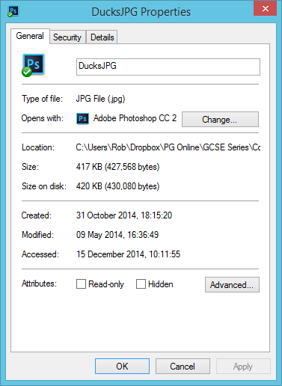 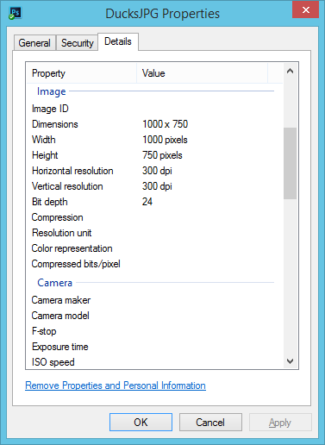

Complete the table below to find out what metadata is stored for the following files and what it is included for:

Typical answers include (but are not limited to):

|  |  |  |  |
| --- | --- | --- | --- |
| **Type of file** | **Metadata 1** | **Metadata 2** | **Metadata 3** |
| A JPEG photo from digital camera | Camera maker – company who made the camera | Dimensions – resolution of the image | Bit depth – number of bits used per pixel |
| A Bitmap image | Date created – Date the file was made | Name – the full name of the file | Size – how large the file is |
| A Word document | Author – name of person who created the file | Word count – how many words used | Revision number – how many times the file has changed |
| A PowerPoint presentation | Date created | Date last saved/accessed | File size/Attributes, e.g. Read-only |

# Task 3 Comparing vector graphics with bitmap graphics

The image below could be stored as a vector image. Its properties would be stored in a vector drawing list.

1. Give **three** properties of the circle element shown below.

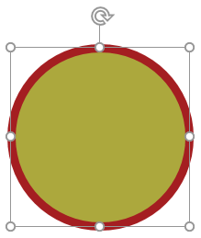

Answers include: shape type, shape position, radius, fill colour, line colour, line weight. The shape would appear in the drawing list as:

*Circle (centre = x,y, radius = r, fill = colour, stroke = colour, weight = 3px)*

1. Use the information in the drawing list below to redraw the vector shape within the 20x10 pixel screen area.

*Rectangle (position 3,2, width 13, height 7, fill = blue, stroke = red, weight = 2px)*

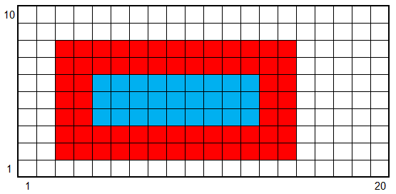

1. The vector file size, including the drawing list containing the shape properties is 100 bytes.

State the file size of the full-screen image if it were stored as a bitmap using 8-bit colour.

200 bytes.

1. Which type of graphic produces a smaller file size in this instance? Vector.
2. Explain why enlarging the vector image will not significantly affect the stored file size.

Only the height and width values are changed within the shape properties.

1. Explain how a vector file size may become much larger than its bitmap equivalent.

If each pixel in a detailed photograph was stored as its own coloured rectangle with the relevant vector properties, then the information stored to redraw each pixel would be significantly greater than the bit value for that pixel using the bitmap format.

1. For each of the examples below, state which type of graphic would be most appropriate to use.

|  |  |  |
| --- | --- | --- |
| **(i) Company logo** | **(ii) Model portfolio** | **(iii) Architect’s floor plan** |
| C:\Users\Rob\AppData\Roaming\PixelMetrics\CaptureWiz\Temp\16.png | C:\Users\Rob\AppData\Local\Microsoft\Windows\INetCache\Content.Word\shutterstock_293199389.jpg | C:\Users\Rob\AppData\Roaming\PixelMetrics\CaptureWiz\Temp\17.png |

1. Vector logo
2. Bitmap photograph
3. Vector floor plan
4. Explain why a digital camera can only produce bitmap images?

The real world, as seen through a lens, cannot be recognised as a collection of shapes by a camera.