# Worksheet 4 Representing images

# Task 1 Bit depth

Answer the following questions, showing how you arrive at your answers:

|  |  |  |  |  |  |  |  |  |  |  |  |  |  |  |  |  |  |  |  |
| --- | --- | --- | --- | --- | --- | --- | --- | --- | --- | --- | --- | --- | --- | --- | --- | --- | --- | --- | --- |
|  |  |  |  |  |  |  |  |  |  |  |  |  |  |  |  |  |  |  |  |
|  |  |  |  |  |  |  |  |  |  |  |  |  |  |  |  |  |  |  |  |
|  |  |  |  |  |  |  |  |  |  |  |  |  |  |  |  |  |  |  |  |
|  |  |  |  |  |  |  |  |  |  |  |  |  |  |  |  |  |  |  |  |
|  |  |  |  |  |  |  |  |  |  |  |  |  |  |  |  |  |  |  |  |
|  |  |  |  |  |  |  |  |  |  |  |  |  |  |  |  |  |  |  |  |
|  |  |  |  |  |  |  |  |  |  |  |  |  |  |  |  |  |  |  |  |
|  |  |  |  |  |  |  |  |  |  |  |  |  |  |  |  |  |  |  |  |
|  |  |  |  |  |  |  |  |  |  |  |  |  |  |  |  |  |  |  |  |
|  |  |  |  |  |  |  |  |  |  |  |  |  |  |  |  |  |  |  |  |
|  |  |  |  |  |  |  |  |  |  |  |  |  |  |  |  |  |  |  |  |
|  |  |  |  |  |  |  |  |  |  |  |  |  |  |  |  |  |  |  |  |
|  |  |  |  |  |  |  |  |  |  |  |  |  |  |  |  |  |  |  |  |
|  |  |  |  |  |  |  |  |  |  |  |  |  |  |  |  |  |  |  |  |
|  |  |  |  |  |  |  |  |  |  |  |  |  |  |  |  |  |  |  |  |
|  |  |  |  |  |  |  |  |  |  |  |  |  |  |  |  |  |  |  |  |
|  |  |  |  |  |  |  |  |  |  |  |  |  |  |  |  |  |  |  |  |
|  |  |  |  |  |  |  |  |  |  |  |  |  |  |  |  |  |  |  |  |
|  |  |  |  |  |  |  |  |  |  |  |  |  |  |  |  |  |  |  |  |
|  |  |  |  |  |  |  |  |  |  |  |  |  |  |  |  |  |  |  |  |

|  |  |  |  |  |  |  |  |
| --- | --- | --- | --- | --- | --- | --- | --- |
| **111** | **110** | **101** | **100** | **011** | **010** | **001** | **000** |

1. What is the resolution of the image above?
2. What is the bit depth?
3. What is the file size in KB?
4. What would be the effect of increasing the bit depth to 24bits?
5. What are the disadvantages of increasing image quality?

# Task 2 Metadata

Metadata can be found by looking at the properties of a file. The process to view bitmap metadata in Windows is outlined below:

1. Browse to where the file is stored
2. Right-click on the file
3. Select ‘Properties’

Metadata will appear on both the **General** and **Details** tabs of the **Properties** window.

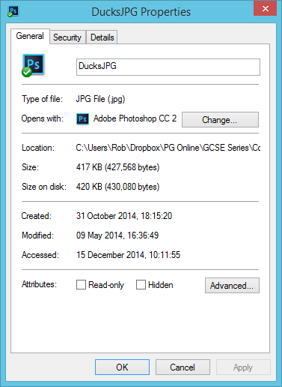 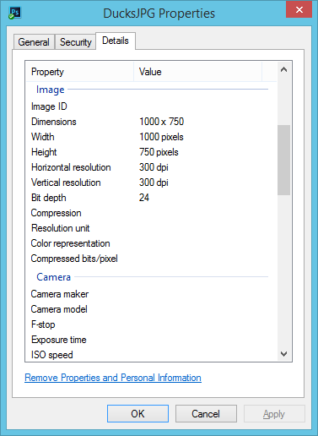

Complete the table below to find out what metadata is stored for the following files and what it is included for:

|  |  |  |  |
| --- | --- | --- | --- |
| **Type of file** | **Metadata 1** | **Metadata 2** | **Metadata 3** |
| A JPEG photo from digital camera | Camera maker – company who made the camera |  |  |
| A Bitmap image |  |  |  |
| A Word document |  |  |  |
| A PowerPoint presentation |  |  |  |

# Task 3 Comparing vector graphics with bitmap graphics

The image below could be stored as a vector image. Its properties would be stored in a vector drawing list.

1. Give **three** properties of the circle element shown below.



1. Use the information in the drawing list below to redraw the vector shape within the 20x10 pixel screen area.

*Rectangle (position 3,2, width 13, height 7, fill = blue, stroke = red, weight = 2px)*

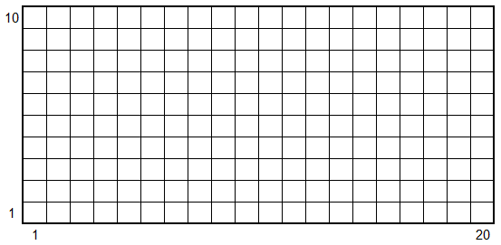

1. The vector file size, including the drawing list containing the shape properties is 100 bytes.

State the file size of the full-screen image if it were stored as a bitmap using 8-bit colour.

1. Which type of graphic produces a smaller file size in this instance?
2. Explain why enlarging the vector image will not significantly affect the stored file size.
3. Explain how a vector file may become much larger than its bitmap equivalent.
4. For each of the examples below, state which type of graphic would be most appropriate to use.

|  |  |  |
| --- | --- | --- |
| **(i) Company logo** | **(ii) Model portfolio** | **(iii) Architect’s floor plan** |
| C:\Users\Rob\AppData\Roaming\PixelMetrics\CaptureWiz\Temp\16.png | C:\Users\Rob\AppData\Local\Microsoft\Windows\INetCache\Content.Word\shutterstock_293199389.jpg | C:\Users\Rob\AppData\Roaming\PixelMetrics\CaptureWiz\Temp\17.png |

1. Explain why a digital camera can only produce bitmap images?