Cash Flow Forecasting – Past Paper Questions

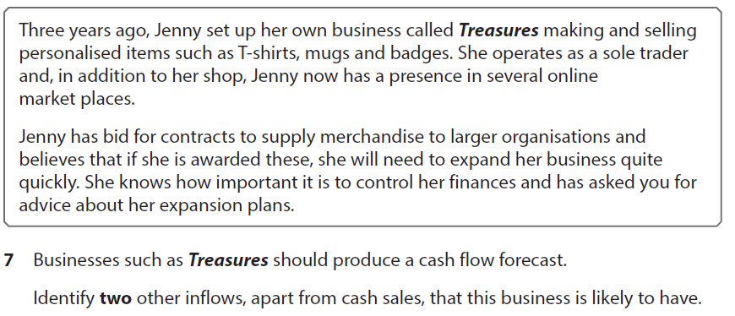

[2 marks]

|  |
| --- |
|  |

[2 marks]

|  |
| --- |
|  |

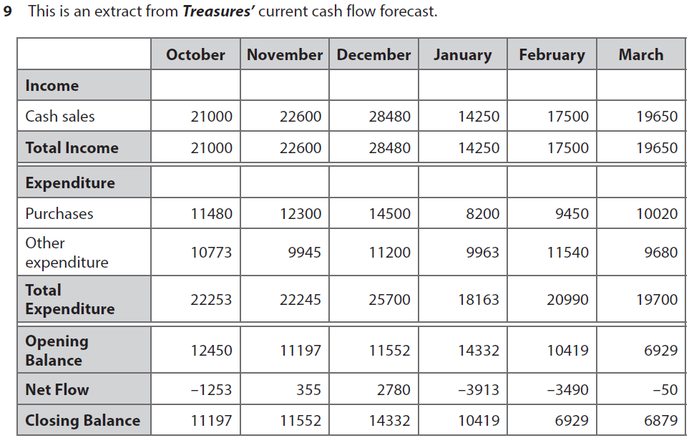

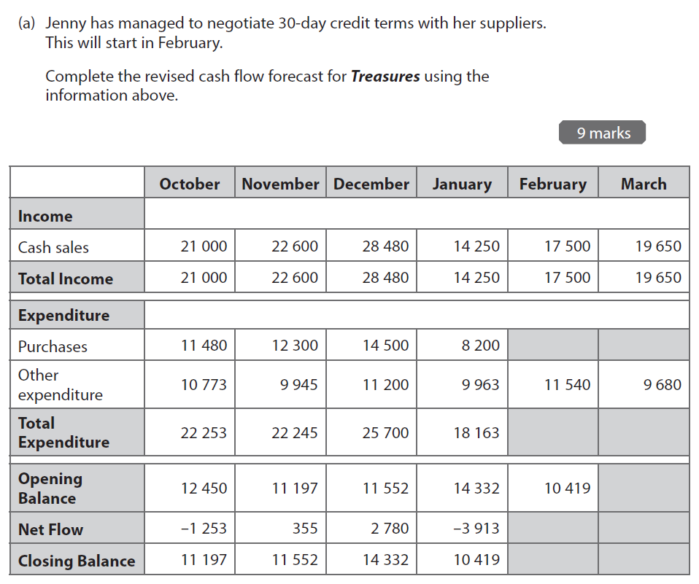

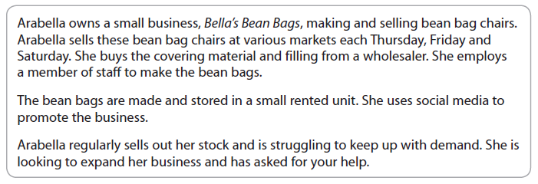

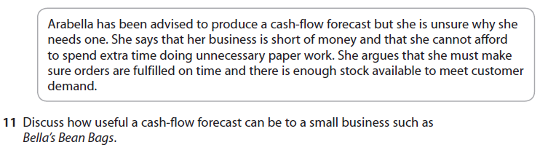

[6 marks]

|  |
| --- |
|  |