**Personal Finance**

**Understanding the importance of managing personal finance**

**A1: Functions and role of money**

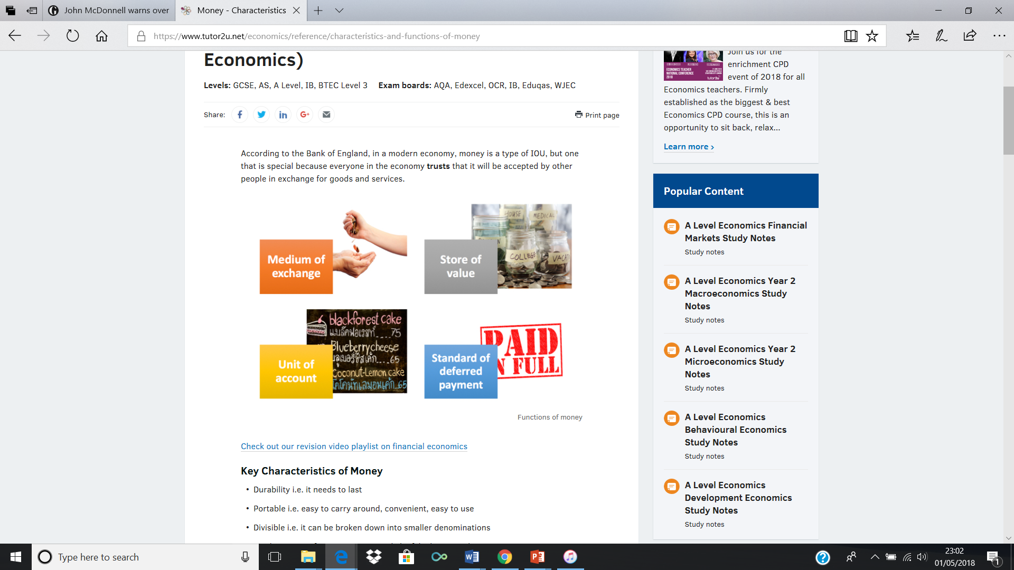

**This section covers :**

* Function of money
* Role of money
* Planning Expenditure

**Personal Finance:**

**A: Understand the importance of managing personal finance**

**A1: The functions of money:**

The functions of money are the jobs that it performs:

1. Unit of account
   1. It allows us to place a monetary value on goods and services
2. Means of exchange
   1. It allows us to trade
   2. Businesses and customers can buy and sell goods and services using money.
3. Store of value
   1. It allows us to use it in the future as it keeps its value
4. Legal Tender
   1. It is a legally recognised form of payment
   2. Money is widely recognised and used for all sorts of transactions

**Role of money:**

Different people will have different attitudes to money. An individual may also change their attitude to money based on the situation they find themselves in. The role of money is affected by a wide number of factors, including those below:

* Personal Attitudes – individuals will vary in their attitudes to risk and reward as well as saving and borrowing.
  + You may be risk averse, so you will try to avoid risk, or you may be willing to take more risks and may even enjoy risk taking as you are incentivised by the potential reward.
  + You may be more likely to save your money than spend it.
  + You will also be influenced by your attitude to borrow, or if you are happy to buy goods and services on credit.
* Life stages
  + As you grow from childhood to adulthood your financial needs and attitudes change.
* Culture
  + Different cultures, affected by tradition, religion and ethical beliefs, will have different attitudes to money.
* Life events
  + E.g. going to university, travelling abroad, getting married
* External influences
  + Factors outside your control e.g. the state of the economy, decisions made by the government
* Interest rates
  + Low interest rates -> more willing to borrow or spend on credit.
  + High interest rates -> incentive to save

|  |  |
| --- | --- |
| Interest Rate |  |

**Financial needs and implications at different life stages**

|  |  |  |
| --- | --- | --- |
| **Life stage** | **Financial needs** | **Implications** |
| Childhood |  |  |
| Adolescence |  |  |
| Young Adult |  |  |
| Middle Age |  |  |
| Old Age |  |  |

**Planning Expenditure**

When planning expenditure, it is important to consider a number of common principals.

**Common Principals**

These principals are important to ensure that you avoid over spending which will put you at risk of financial difficulties both now and in the future.

You should look to control costs to avoid getting into **debt**. Debt is expensive as interest will be charged on money owed. If debts are not paid, or not paid on time, this will affect your **credit rating.** A poor credit rating will affect your ability to borrow in the future, in extreme cases, an individual may be declared **bankrupt.**

To remain **solvent** you should set financial targets and goals that consider how much money you want to earn and place limits on how much you will spend. If you save some of your income, this can help generate future income as money saved will earn interest.

**Inflation -** Expenditure now can help counter the effects of inflation. E.g if you spent £150,000 buying a house today, the value of the house would increase. If you left £150,000 in a savings account, the amount would go up because of inflation but the spending power of the savings would go down.

|  |  |
| --- | --- |
| **Debt** |  |
| **Credit Rating** |  |
| **Bankrupt** |  |
| **Solvent** |  |
| **Expenditure** |  |
| **Inflation** |  |

**Key Terms**

|  |  |
| --- | --- |
| **Benefits of Planning** | **Risks of not Planning** |
|  |  |

**Research Questions:**

What is the current rate of inflation?

|  |
| --- |
|  |

What is the current interest rate?

|  |
| --- |
|  |

**Look on the Royal Mint Website (link on GoL)**

What is considered to be legal tender in the UK?

|  |
| --- |
|  |

Can a person pay for £100 worth of goods in 50p coins?

|  |
| --- |
|  |

**What is a credit rating? -**  using the article ‘What is a credit rating? Plus nine other things you need to know…’ and Which.co.uk (links on GoL) answer the following questions.

1. Do you have a universal credit rating?

|  |
| --- |
|  |

1. What can credit scoring affect?

|  |
| --- |
|  |

1. Why might you have a bad credit score? (which.co.uk)

|  |
| --- |
|  |

1. List four different ways you can improve your credit score. (which.co.uk)

|  |
| --- |
|  |

**Read through the articles on GOL on Household Debt**

**Exam style questions:**

Give two functions of money: (2 marks)

1. ________________________________________________________________________________________________________________________________________________________________________________
2. ________________________________________________________________________________________________________________________________________________________________________________

|  |
| --- |
| Household debt is at its highest level in a decade. Many families are struggling to pay back money they have borrowed. Shekemi has recently taken out a loan for a new car but is worried that she might not be able to keep up the repayments. (SAM’s 2) |

Discuss why it is important for Shekemi to avoid getting into unmanageable debt. (6 marks)

________________________________________________________________________________________________________________________________________________________________________________________________________________________________________________________________________________________________________________________________________________________________________________________________________________________________________________________________________________________________________________________________________________________________________________________________________________________________________________________________________________________________________________________________________________________________________________________________________________________________________________________________________________________________________________________________________________________________________________________________________________________________________________________________________________________________________________________________________________________________________________________________________________________________________________________________________________________________________________________________________________________________________________________________________________________________________________________________________________________________________________________________________________________________________________

_______________________________________________________________________________________________________________________________________________________________________________________________________________________________________________________________________________________________________________________________________________________________________________________________________________________________________________________________________________________________________________________________________________________________________________________________________________________________________________________________________________________________________________________________________________________________________________________________________________________________________________________________________________________­­

