**BTEC National Extended Certificate in Health and Social Care**

**Unit 2 – Part 2**

**B1: The roles of organisations in the health and social care sector**



**Name: ……………………………….**

**Part 2 – Settings and Sectors**

By the end of this section, you will be able to:

•Identify different types of health and care settings.

•Describe a local healthcare setting.

•Explain the types of support that specific health and care settings provide.

•Discuss the impact of these settings on the service user and service provider

The **settings** in which **health and care services** are provided vary enormously. Settings range from care provided in a person’s own home, to hospital departments providing highly technical and specialist treatment.

These settings provide services managed by a wide range of organisations which we will explore later in this workbook.

All of these settings provide a **range of health and social care services** that support and meet the individual needs of people.



**Starter Task:** List 5 different health and social care settings and briefly explain the service that they provide:

Watch this video and reflect below on the 5 main challenges in health and social care in England:

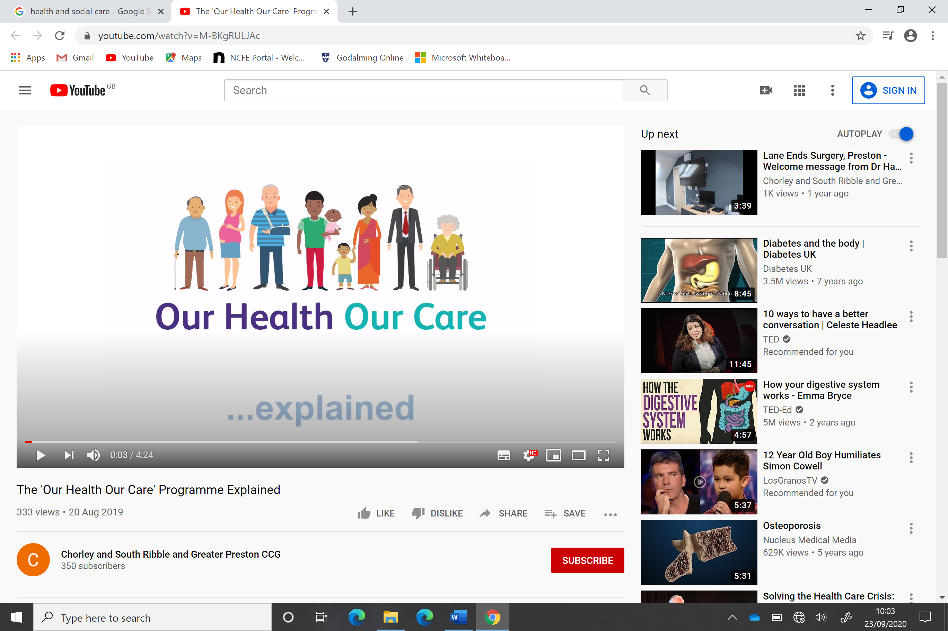

<https://www.youtube.com/watch?v=M-BKgRULJAc>

The ‘Our Health Our Care’ Programme

____________________________________________________________________________________________________________________________________________________________________________________________________________________________________________

**Hospitals**

***Task:*** Draw a plan (A4 size) of a hospital layout. Include the main departments and show the services that are provided within the hospital? *(You may research a hospital nearby or one that you know)*

Write the name of the hospital here:

Explain some of the reasons that someone could be referred for a service (i.e. treatment or a consultation) within a hospital?

If someone has a personal health concern what are the services on offer to them in the local community to seek advice and guidance?

**Hospitals provide both inpatient and outpatient services.**

**Inpatient services** include treatment for individuals whose condition requires 24-hour specialist support. Identify 3 examples of inpatient services:

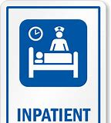

**Outpatient services** includes day surgery, regular clinics and specialist day time care. Identify 3 examples of outpatient services:



**Hospital Departments:**

**Watch this video:** Inside Britain’s busiest A&E

[**https://www.youtube.com/watch?v=QyhIBdLpQMQ**](https://www.youtube.com/watch?v=QyhIBdLpQMQ)

Hospital Departments

**Reflection notes:**

Referral to a hospital for treatment will usually be through a GP referral. Patients have the right to choose which hospital they wish to attend and which consultant they would like to see.

**TASK**: Look up the services of a local hospital in your area, then **outline** in the table below the different hospital departments and the services that they offer, such as Frimley Park Hospital using this link for more information: <https://www.fhft.nhs.uk/>

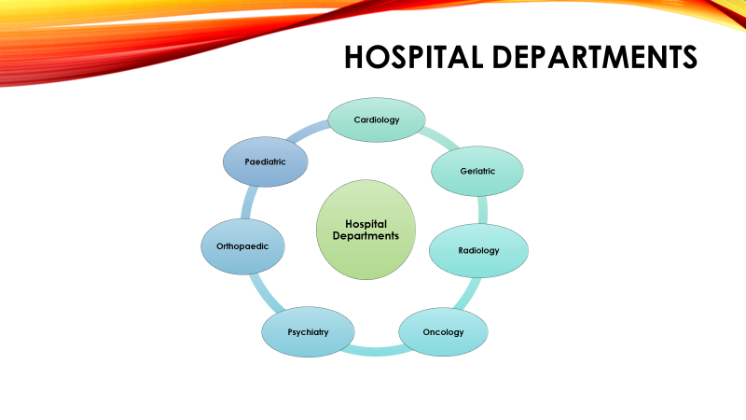

|  |  |
| --- | --- |
| **Hospital Department** | **Outline service offered** |
|  |  |
|  |  |
|  |  |
|  |  |
|  |  |

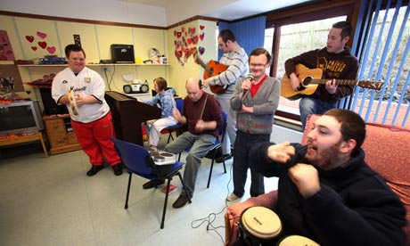

**Day care centres / units**

Day Centres are usually provided for specific client groups. They are designed to be a friendly, stimulating and supportive environment for people who would usually be socially isolated. For example, they could provide educational facilities and support to help people progress into employment.

**Task: Identify the different client groups that can attend a day care centre**

Day care is usually provided for specific client groups.

Which client groups can attend day care centres and units?

**You may have identified the following:**

* Older people
* People with disabilities
* People with learning difficulties
* People with mental health problems
* People with specific conditions e.g. dementia or visual impairment

**Watch this video about the Disability Centre in Stockport**

<https://www.youtube.com/watch?v=VnruBfZjXsc>

The day care centre unit provision is designed to be a friendly, stimulating and supportive environment for people who would usually be socially isolated. For example, they could provide educational facilities and support to help people progress into employment.

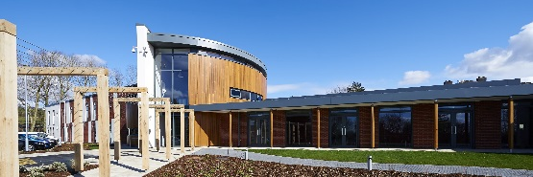

**Task:** Nina is 65 years old and has access to a local day care centre. She was assessed by the local authority social care team to attend the centre nearest to her home, five days per week. Her current health is stable however she recently had a stroke and a rehabilitation programme is in place for her to help her to improve her physical strength and movement.

Research and identify some day care activities that may be suitable for Nina during her daily visits to the centre. Outline these in a plan below:

Day Centre Plan Aim for Nina is:

|  |  |
| --- | --- |
| Day Centre Weekly Plan: | Activities / Professionals |
| Monday |  |
| Tuesday |  |
| Wednesday |  |
| Thursday |  |
| Friday |  |

**Hospice Care**

Palliative Care: Hospices aim to improve quality of life for people with an incurable, terminal illness.

**RESEARCH TASK:** Research a local hospice (e.g. Bury Hospice). Find out the answers to the following:

1. Name of the hospice: _____________________________________
2. What is the aim of the hospice?

_________________________________________________________________________________________________________________________________________________________________________________

1. Describe the care provided by the hospice for service users.

________________________________________________________________________________________________________________________________________________________________________________

______________________________________________________________________________________________________________________

1. Is there any additional support provided for the service user’s family?

_________________________________________________________________________________________________________________________________________________________________________________

______________________________________________________________________________________________________________________

Any other information:

**Reflections on Hospice Care:**

Watch these two videos and then make notes of your learning below:

<https://www.youtube.com/watch?v=c_4KEE-e9yY>

Hospice care everywhere!

<https://www.youtube.com/watch?v=F86eA-3vcYI>

Hospice Care UK

Notes:

**Residential and Nursing Care**

Residential care refers to the long-term care of adults and children needing 24-hour care, which cannot be provided adequately or appropriately in their own home.



Fairfield Residential offers residential care, short breaks, outreach and education support for children and adults with autism, learning difficulties, challenging behaviour and other complex needs.

**Watch video:**

<http://www.fairfieldresidential.co.uk/>

**Nursing care – Watch video:**

https://www.youtube.com/watch?v=UfoSv_MCRBo

**Residential care home**

Provides help with personal care such as washing, dressing and taking medication.

**Nursing home**

Provides personal care, but also provides 24-hour nursing care by a qualified nurse, who may also contribute to the planning, supervising and monitoring of healthcare tasks.

There are two types of care home. Define each below with the mission of a residential home and a nursing home from your research:

1. Residential Care Home

____________________________________________________________________________________________________________

1. Nursing Home

____________________________________________________________________________________________________________

______________________________________________________



**Domiciliary Care**

Domiciliary care is provided in a client’s home and is sometimes referred to as Home Care or Home Help.

Support can vary from one visit per day, to 24-hour care, providing support with domestic tasks as well as intimate personal care. This is provided in the person’s home so that they can live as independently as possible.

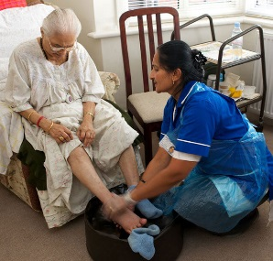****

Domiciliary care is provided in a client’s home. It may be short-term, for example following a patient’s discharge from hospital, or could be longer-term if the service user has a more complex need (e.g. a disability).

Domiciliary services can include the following domestic tasks or personal care routines:

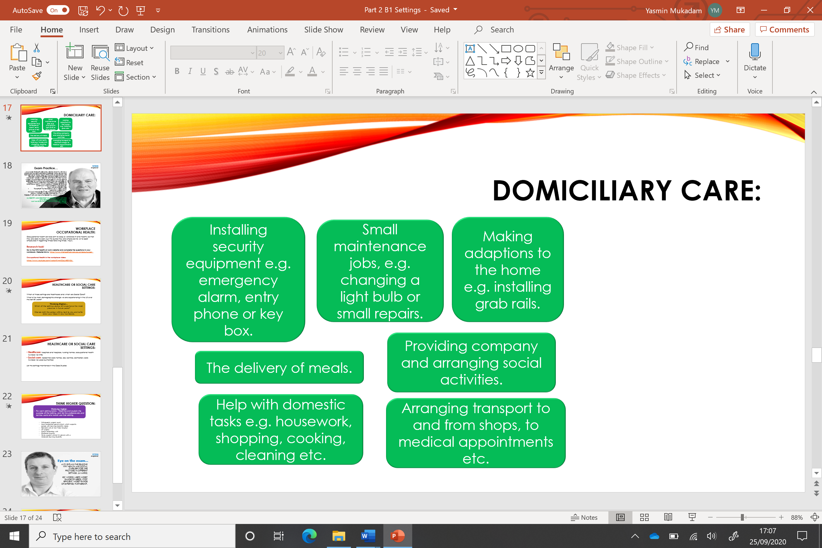

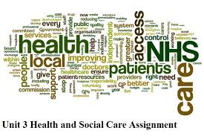

**The workplace**

Occupational health (OH) services aim to keep a workforce fit and healthy so that they can carry out the duties of which they are employed, or to assist employees in regaining fitness after illness / injury.

Services can often include access to a nurse, doctor or other healthcare professionals, including counsellors or physiotherapists.

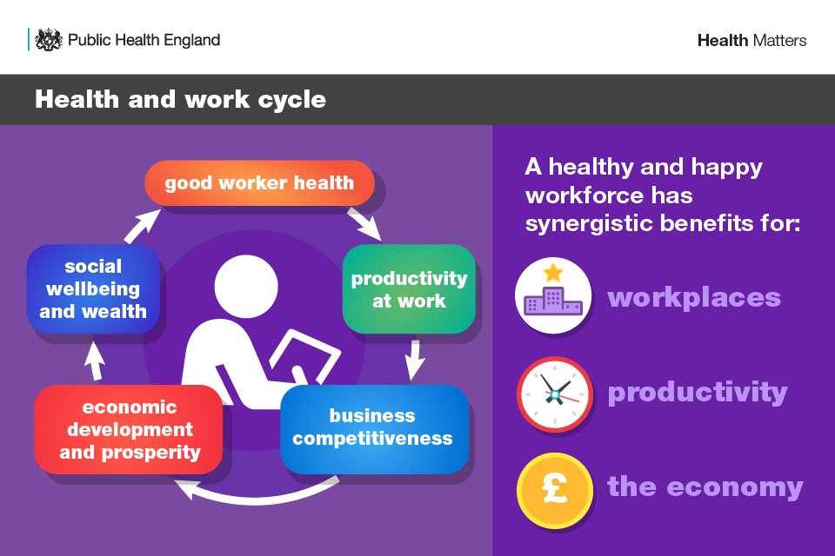

**Watch this Occupational Health in the workplace video:**

<https://www.youtube.com/watch?v=pfOcLME0W2U>

Why are health checks essential for employment?

**RESEARCH TASK:** Go to the website below and complete the following questions about the services for occupational health provided by the NHS

<http://www.nhshealthatwork.co.uk/ourservices.asp>

**Research task questions:**

1. What types of support are provided to service users?

____________________________________________________________________________________________________________________________________________________________________________________________________________________________________________

1. In what ways might this benefit the employer of the service users?

____________________________________________________________________________________________________________________________________________________________________________________________________________________________________________

1. In what ways might this benefit the NHS?

____________________________________________________________________________________________________________________________________________________________________________________________________________________________________________

**Thinking Higher Question …**

For each setting listed below **create a table to explain** the purpose of each setting and identify the professionals likely to work in that setting:

* Orthopaedic surgery ward
* Local residential special school supporting people with learning disability needs
* Neonatal unit at a Hospital
* GP surgery
* Gastro-enterology unit
* Sheltered housing
* Home support worker for person with a moderate learning disability

**Answer here:**

**Recap:**

* **Healthcare settings include** hospitals and hospices, nursing homes, occupational health (funded via NHS)
* **Social care settings include** residential care homes, day centres, domiciliary care (funded via Local authorities)

**Exam Question time:**

Explain the reasons why health and social care services are provided in different settings?

(6 marks)

* First complete a plan to outline what you will include in your answer.
* Then use the key words and phrases from your plan to write an answer to this question.

**MY PLAN:**

***(Key words to use in your answer*** *- meets widest range of needs, cost efficient, widest range of expertise, partnership)*

Answer: ______________________________________________________________________________________________________________________________________________________________________________________________________________________________________________________________________________________________________________________________________________________________________________________________________________________________________________________________________________________________________________________________________________________________________________________________________________

___________________________________________________________

___________________________________________________________

___________________________________________________________

Read the Level Mark Descriptors first to see how the marks are awarded and what knowledge and understanding is to be demonstrated in your answer.

**Level Mark Descriptor**

0 No rewardable material.

1 1–3 • Demonstrates isolated elements of knowledge and

Understanding; Generic statements may be presented rather than linkages being

Made; Lines of reasoning are unsupported.

2 4–6 • Demonstrates mostly accurate knowledge and understanding

• Answer evidences occasional linkages between the elements in

the context of the question; Lines of reasoning occasionally supported through the application

of recent evidence.

3 5–6 • Demonstrates accurate and thorough knowledge and

Understanding; Answer evidences comprehensive linkages between the elements

in the context of the question; Lines of reasoning supported

Then see the indicative content below showing what the expected answer might include.

The Exam Answer will be credited according to the learner’s demonstration of:

* knowledge and understanding of the material using the indicative

content and levels descriptors.

**The indicative content** that follows is not prescriptive. Responses may cover some/all of the indicative content but should be rewarded for other relevant answers. Answers might refer to:

* meets widest range of needs
* is appropriate, e.g. hospitals are where operations are carried out, GP surgeries are where initial diagnosis/treatment is provided
* is cost efficient
* provides widest range of expertise
* sectors often work in partnership to provide necessary services
* best way of involving services users in planning and managing
* their care.
* Accept any other valid response. **(6)**

