**Lighting** – *Consider the use of colour, isolated lighting, high key lighting, low lighting, what is being highlighted?*

*Is this lighting typical of the genre?*

**Editing** – *Continuity or non-continuity? Interesting effects and transitions? Shot Length? When does it become fast pace or slow pace?*

**Cinematography** – *Describe the cinematography-* *Is there dynamic camerawork? Shot on location or in a studio? Who are we being asked to align ourselves with? When do we see the use of POV? When are particular angles used?*

**Sound** *– Describe the musical score, non-diegetic music chosen and sound design?*

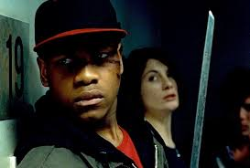

**Genre** – *What conventions do you see which are conventional to this genre? Are there any elements of iconography used?*

**Aesthetics** – *Overall mood or feelings created by the scene at certain times, when do we pause to appreciate the ‘look’ of the film?*

**Mise en scene** – *Notable* *costumes, props, locations / décor and performance?*