**Key Terminology and ideas you need to know...**

|  |  |
| --- | --- |
| **Visual codes:**   * Colour * Location * Gesture codes (Body Language) * Facial expressions * Props | **Technical codes**   * Camera shots (Long shot, mid-shot, Close up) * Lighting (Dark, shadows, bright, natural) * Language codes– written and spoken. |

**Genre:**

Genre is a way of categorising media products. The concept relates to film and television, but can be applied to many products. Generic products are defined by a set of elements that are repeated across them:

* **Visual iconography**—visual codes associated with a genre.
* **Technical codes**—different genres use different codes in specific ways.
* **Narrative**—the way in which the story is told.
* **Characters**—most genres have an expected type of character.

|  |  |  |
| --- | --- | --- |
| Key Terms: Genre  **Familiar conventions:** elements that we would expect to see in a particular genre.  **Unexpected elements:** conventions we would not expect to see in a genre.  **Technological developments**: new technologies that enable media producers to create products in a different way.  **Subgenre:** a more specific genre with two different genres (Rom-Com)  **Hybrid:** a combination of two or more different genres.  **Disruption**: an event or action that interrupts the narrative,  **Conflict**: a clash between two characters or groups of people.  **Linear narrative**: a narrative structure where all of the events happen in logical order, one after the other. |  | **Key terms: Narrative**  **Equilibrium**: at the beginning, everything is calm and balanced.  **Disruption** : an event or problem occurs to upset the balance.  **Recognition**: the characters realise that there is a problem.  **Resolution:** the problem is solved.  **New equilibrium:** everything returns to a state of balance.  **What if it is a non-linear narrative?**  It might include:  **Flashbacks—Flash-forwards** –creates suspense.  **Enigma code:** a mystery or puzzle, media products often don’t tell all elements at once but withhold information to keep audience guessing.  **Transformation**: a major change. Characters are often transformed. |

|  |
| --- |
| **Preferred reading:** audience interprets the text in the way the creator wanted them to.  **Negotiated reading**: the audience accepts some of the messages presented, but disagrees with others.  **Oppositional reading:** the audience rejects the intended meaning of the text. |

|  |
| --- |
| **Historical context:** relates to time period it was made and events happening at the time.  **Social context:** relates to society at the time. It will affect the representations in media.  **Cultural context:** concerns the elements such as style, genre and technology.  **Political context:** how a media text is affected by politics at the time. |

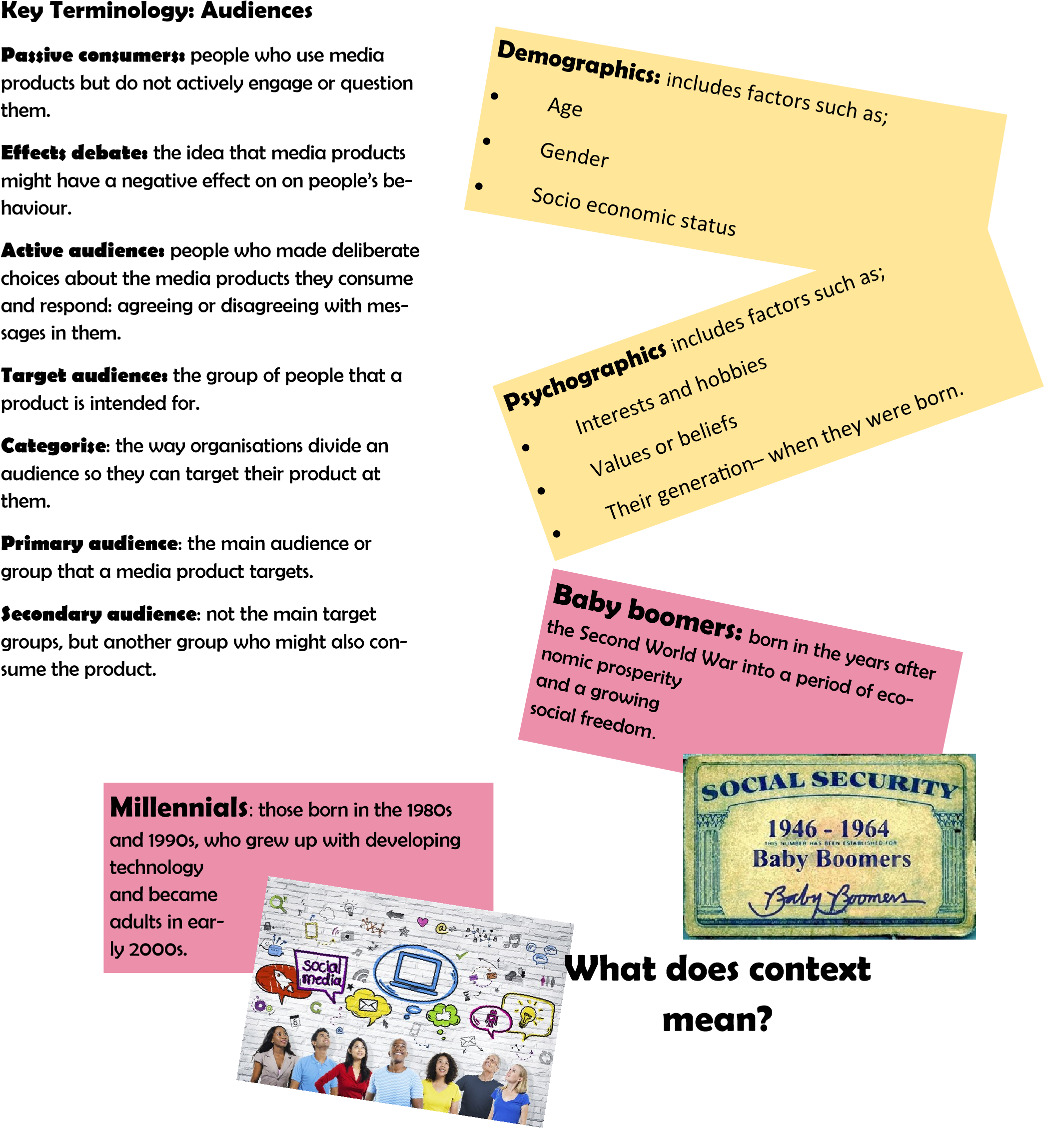

**Key Terminology: Representation**

**Construct:** put elements together to create a media product

**Version of reality:** a particular view of actual events (newspapers)

**Mediation**: the way which media producers interpret and re-present aspects of reality.

**Uphold stereotype:** reinforce a stereotypical image of a social group.

**Subvert stereotype:** to go against a stereotypical portrayal and resent a broader view o a social group.

**Masculinity:** the trains are typically associated with males.

**Femininity:** attributes that are typically associated with being female.

**Key Terminology: Industries**

This looks at the study of the production processes, ownership and funding, technology and regulation.

* **Production**: the stage where the media production is created
* **Distribution and circulation:** the way in

which the product is delivered to different audiences.

* **Consumption:** the way in which the audience ‘takes in’ the media production for example, watching TV or playing a game.
* **Production values:** the quality of technical elements of a product.
* **Public funding:** money that comes from the government or TV licence fee.
* **Convergence:** way in which products or

|  |
| --- |
| **Ethnicity:** relates to a person’s national, cultural or religious identity.  There are many ‘misrepresentations’ of ethnicity. For example:   * villains in television programs are often from ethnic minority groups * Immigrants to Britain are represented nega-   tively   * Antisocial young people are often from ethnic minority groups. |

**Technology:** Plays an important role in the production of media texts. It also:

* impacts on how product are made, distributed and circulated.
* The use of convergence allows producers to

reach wider audiences.

brands are made available to audiences on a number of platforms.

* **Ofcom: The** Office of Communication the regulator for broadcasting.
* **Video on demand:** products that are available to be streamed or downloaded.

**Ownership:** Some products are made by big

organisations (Channel 4, News Corporation, for example) Some are made by smaller companies.

* Production values may be different dependning on the ownership (more money for bigger organisations)
* A director might be down for a type of style
* An actor may be known for a type of role or genre

Funding can also impact on ownership.

**Regulation:** Most media industries are regulated. They are there to:

* offer guidance to companies about stand-

ards or codes of practice they should follow

* Monitor or control media companies. Might include responding to complained for example.