**Market Structures / Competition & Market Segmentation revision questions**

1.

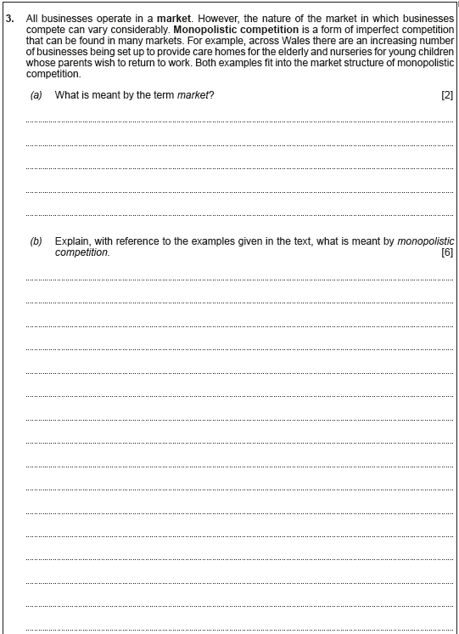

|  |
| --- |
|  |

|  |
| --- |
|  |

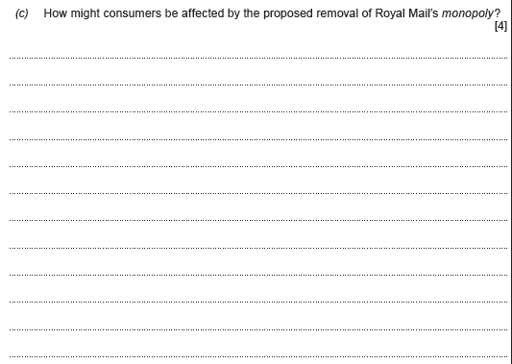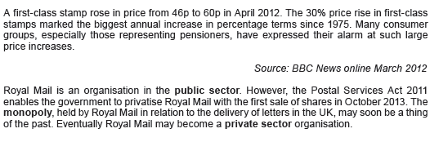2.

|  |
| --- |
|  |

3.

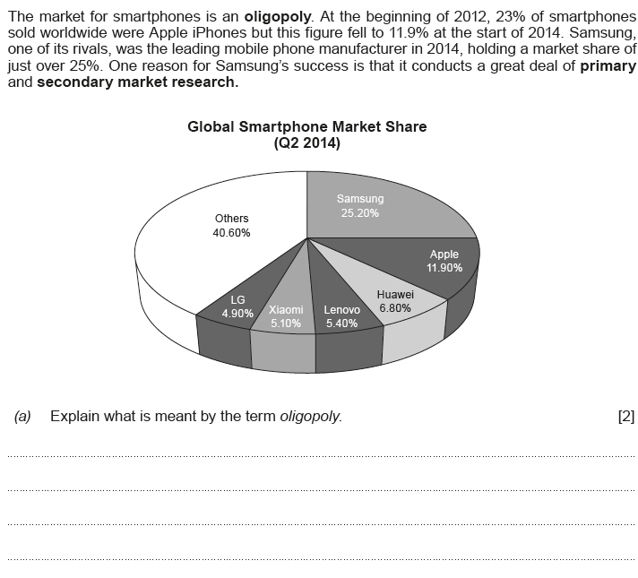

|  |
| --- |
|  |

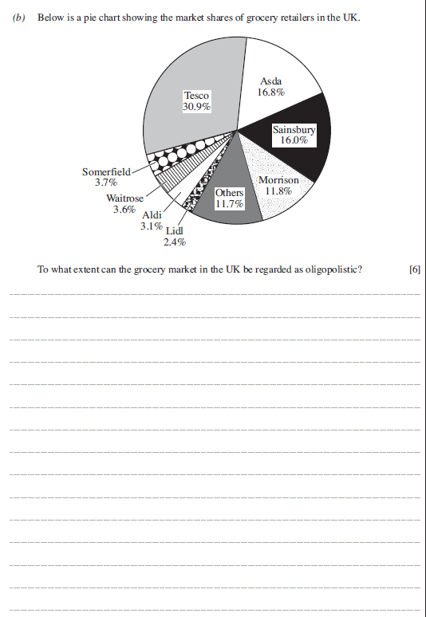

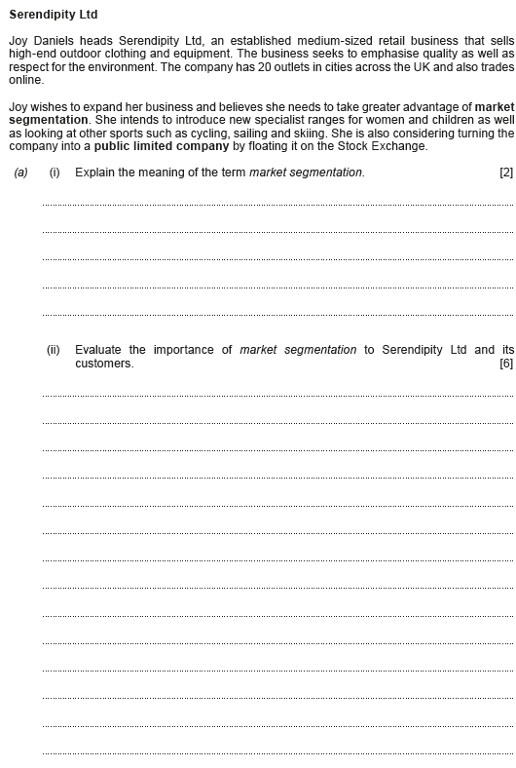4.



|  |
| --- |
|  |

|  |
| --- |
|  |