**HOW TO ADD SOUND TO PIVOT MOVIE IN ADOBE PREMIER**

**Exporting your Animation from PIVOT**

1. **Adjust the frame rate (using the slider) to the required speed**

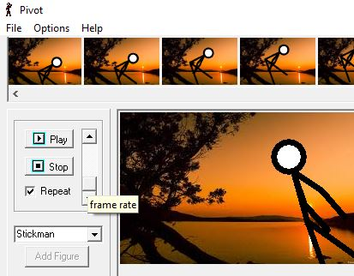

1. **Go to file and then ‘save Animation’**

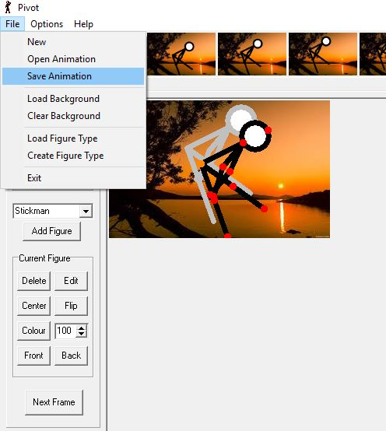

1. **Give your animation a name and change the ‘save as type’ to Gif**

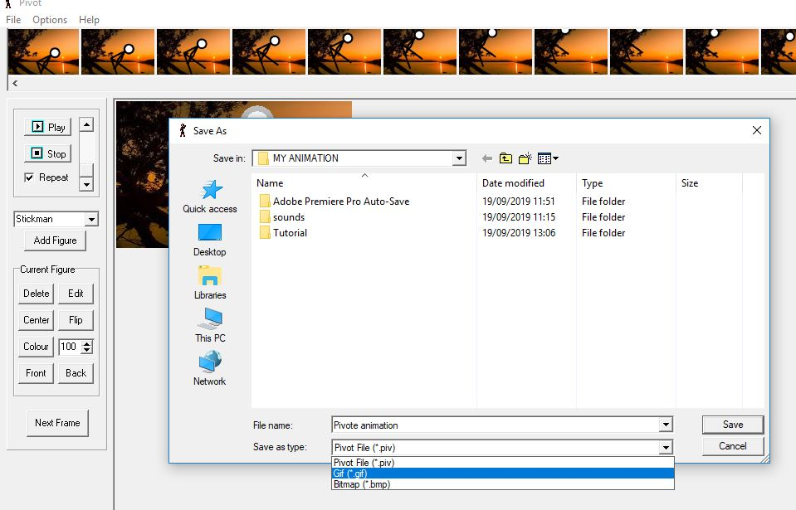

1. **You can slow your animation further by adding Frame Delay. Click OK**

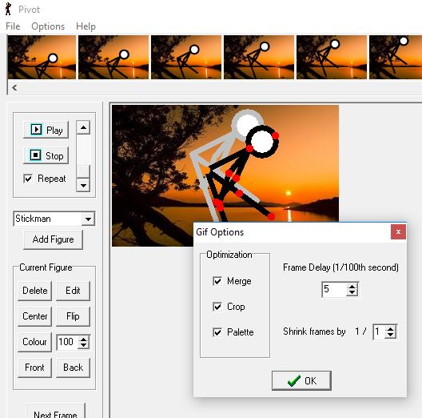

**Adding sound to your Pivot Exported Animation in Adobe Premier**

1. **Plug your headphones to the computer**
2. **Search and launch Adobe Premier Pro CC 2018**

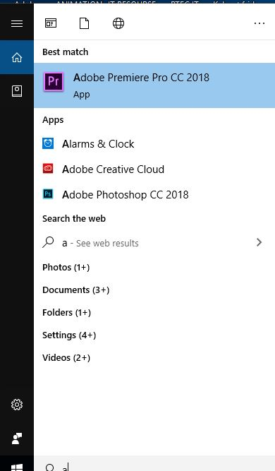

1. **Select ‘ New project’**

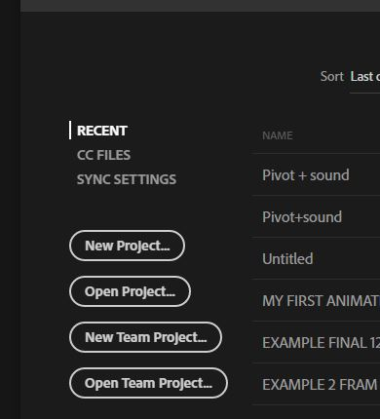

1. **Name your project, Browse and save to the right location**

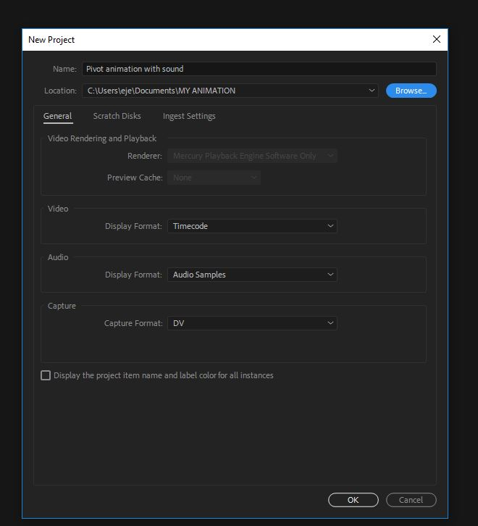

1. **Drag and drop your Pivot animation (Gif file) to create a sequence in the timeline section**

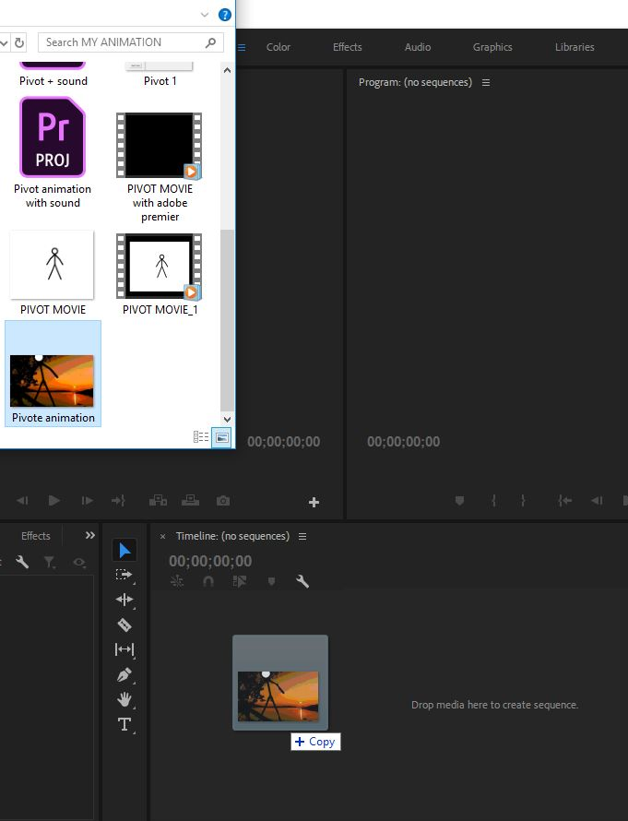

1. **It will look something like this**

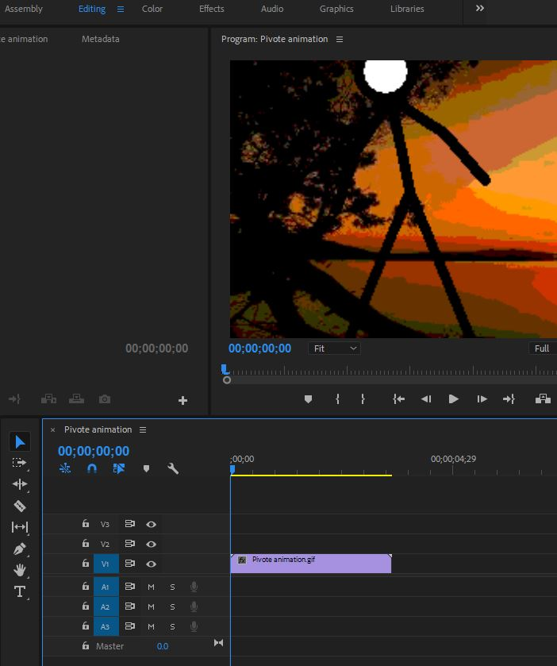

1. **Drag and drop your sound file (You can drop multiple sound files). Adjust both ends of the sound to fit the animation.**

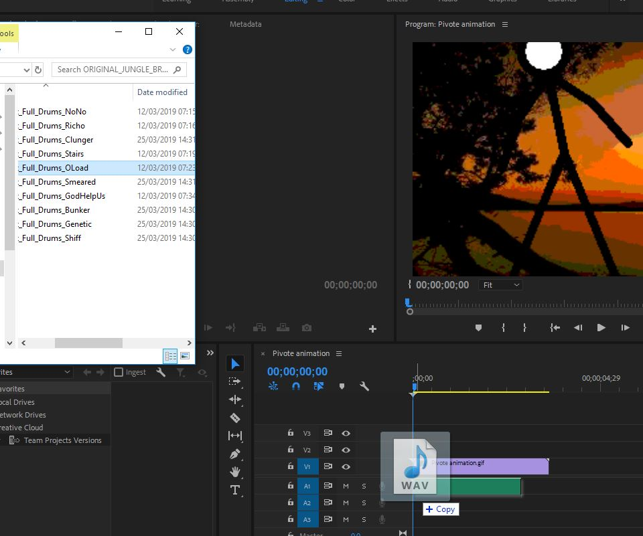

1. **When you are happy with the sequence, Go to file, select ‘Export’ and then ‘Media’**

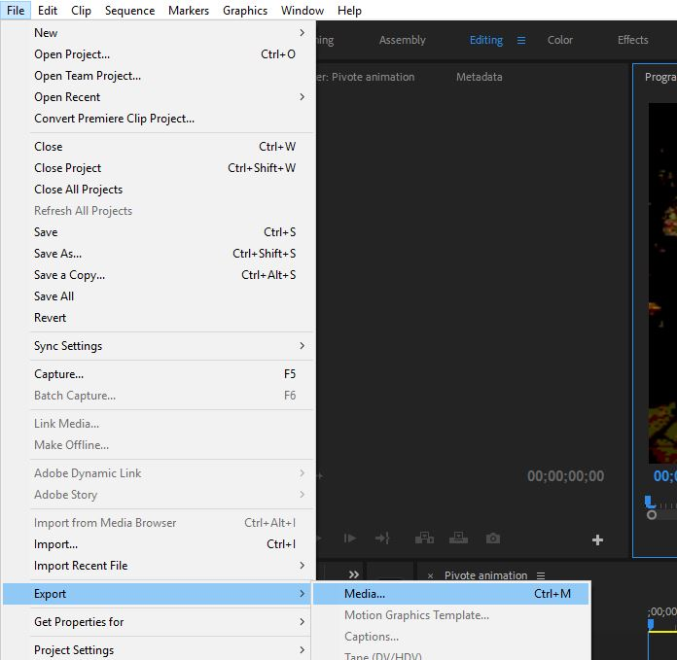

1. **Click on ‘Output name ‘if you wish to change the name and location of the export.**

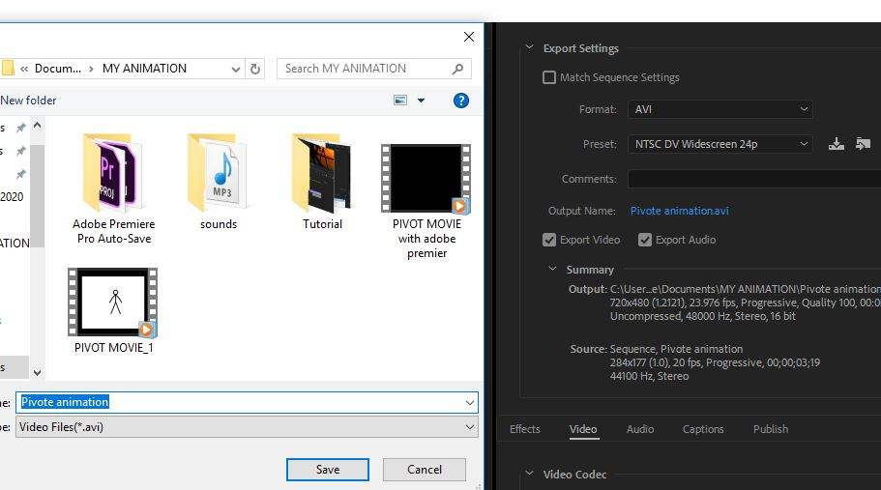

1. **Select ‘Export’**

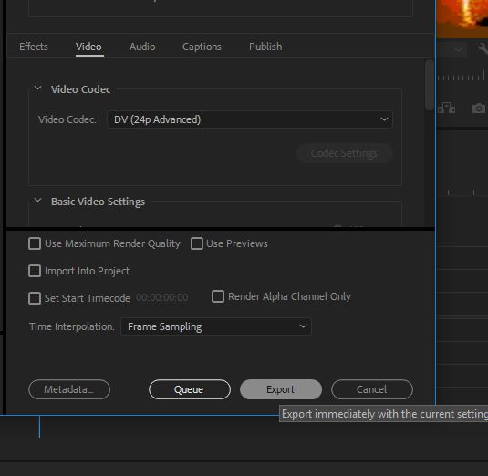

1. **You should now be able to play your Pivot (animation with sound) in windows media player.**

