Paper 3B – Mechanics

Candidates may use any calculator allowed by Pearson regulations.
Calculators must not have the facility for symbolic algebra manipulation, differentiation and integration, or have retrievable mathematical formulae stored in them.

Instructions
Use black ink or ball-point pen.
If pencil is used for diagrams/sketches/graphs it must be dark (HB or B).
Fill in the boxes at the top of this page with your name, centre number and candidate number.
Answer all questions and ensure that your answers to parts of questions are clearly labelled.
Answer the questions.
You should show sufficient working to make your methods clear. Answers without working may not gain full credit.
Inexact answers should be given to three significant figures unless otherwise stated.

Information
A booklet ‘Mathematical Formulae and Statistical Tables’ is provided.
There are 9 questions in this question paper. The total mark for this paper is 104.
The marks for each question are shown in brackets
– use this as a guide as to how much time to spend on each question.

Advice
Read each question carefully before you start to answer it.
Try to answer every question.
Check your answers if you have time at the end.
1.
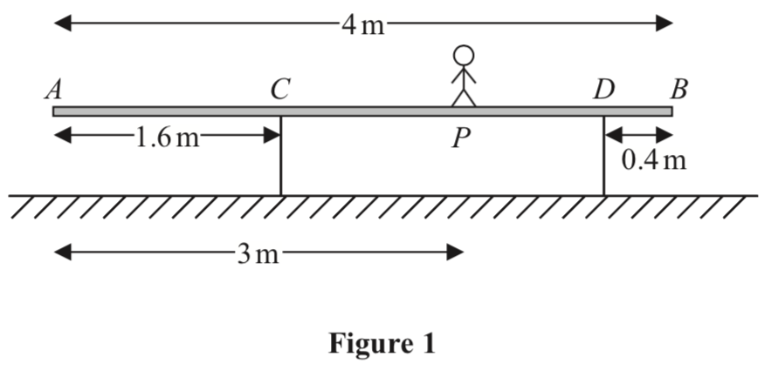
A uniform wooden beam AB, of mass 20 kg and length 4 m, rests in equilibrium in a
horizontal position on two supports. One support is at C, where AC = 1.6 m, and the
other support is at D, where DB = 0.4 m. A boy of mass 60 kg stands on the beam at the
point P, where AP = 3 m, as shown in Figure 1. The beam remains in equilibrium in a
horizontal position.
By modelling the boy as a particle and the beam as a uniform rod,
(a) (i) find, in terms of g, the magnitude of the force exerted on the beam by the support
at C,
(ii) find, in terms of g, the magnitude of the force exerted on the beam by the support
at D.
(6)

The boy now starts to walk slowly along the beam towards the end A.
(b) Find the greatest distance he can walk from P without the beam tilting.
(4)
(Total 10 marks)
____________________________________________________________________________

2. A cyclist starts from rest at the point O on a straight horizontal road. The cyclist moves
along the road with constant acceleration 2 m s⁻² for 4 seconds and then continues to
move along the road at constant speed. At the instant when the cyclist stops accelerating,
a motorcyclist starts from rest at the point O and moves along the road with constant
acceleration 4 m s⁻² in the same direction as the cyclist. The motorcyclist has been moving
for T seconds when she overtakes the cyclist.
(a) Sketch, on the same axes, a speed-time graph for the motion of the cyclist and a
speed-time graph for the motion of the motorcyclist, to the time when the motorcyclist
overtakes the cyclist.
(4)
(b) Find, giving your answer to 1 decimal place, the value of T.
(6)
(Total 10 marks)
____________________________________________________________________________

3. A rough plane is inclined at an angle α to the horizontal, where tan α . A particle of
mass 2 kg is projected with speed 6 m s⁻¹ from a point O on the plane, up a line of greatest
slope of the plane. The coefficient of friction between the particle and the plane is 0.25
(a) Find the magnitude of the frictional force acting on the particle as it moves up the plane.
(3)

The particle comes to instantaneous rest at the point A.
(b) Find the distance OA.
(5)

The particle now moves down the plane from A.
(c) Find the speed of P as it passes through O.
(5)
(Total 13 marks)
____________________________________________________________________________

4. [In this question i and j are perpendicular horizontal unit vectors and position vectors are
given relative to a fixed origin O.]
A particle P is moving in a straight line with constant velocity. At 9 am, the position vector
of P is (7i + 5j) km and at 9.20 am, the position vector of P is 6i km. At time t hours after
9 am, the position vector of P is r_{P} km.
(a) Find, in km h^{–1}, the speed of P.
(4)
(b) Show that r_{P} = (7 – 3t) i + (5 – 15t) j.
(2)
(c) Find the value of t when r_{P} is parallel to 16i + 5j.
(4)

The position vector of another particle Q, at time t hours after 9 am, is r_{Q} km, where
r_{Q} = (5 + 2t) i + (– 3 + 5t) j
(d) Show that P and Q will collide and find the position vector of the point of collision.
(5)
(Total 15 marks)
____________________________________________________________________________

5. A car pulls a trailer along a straight horizontal road using a light inextensible towbar. The mass of the car is M kg, the mass of the trailer is 600 kg and the towbar is horizontal and parallel to the direction of motion. There is a resistance to motion of magnitude 200 N acting on the car and a resistance to motion of magnitude 100 N acting on the trailer.

The driver of the car spots a hazard ahead. Instantly he reduces the force produced by the engine of the car to zero and applies the brakes of the car. The brakes produce a braking force on the car of magnitude 6500 N and the car and the trailer have a constant deceleration of magnitude 4 m s⁻².

Given that the resistances to motion on the car and trailer are unchanged and that the car comes to rest after travelling 40.5 m from the point where the brakes were applied, find

(a) the thrust in the towbar while the car is braking,
(3)
(b) the value of M,
(3)
(c) the time it takes for the car to stop after the brakes are applied.
(3)
(Total 9 marks)
____________________________________________________________________________

6.
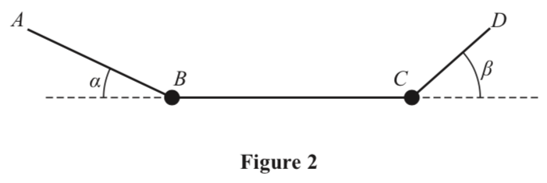
A washing line ABCD is fixed at the points A and D. There are two heavy items of clothing
hanging on the washing line, one fixed at B and the other fixed at C. The washing line is
modelled as a light inextensible string, the item at B is modelled as a particle of mass 3 kg and
the item at C is modelled as a particle of mass M kg. The section AB makes an angle α with
the horizontal, where tan α , the section BC is horizontal and the section CD makes
an angle β with the horizontal, where tan β , as shown in Figure 2. The system is in
equilibrium.
(a) Find the tension in AB.
(4)
(b) Find the tension in BC.
(3)
(c) Find the value of M.
(5)
(Total 12 marks)
____________________________________________________________________________

7.
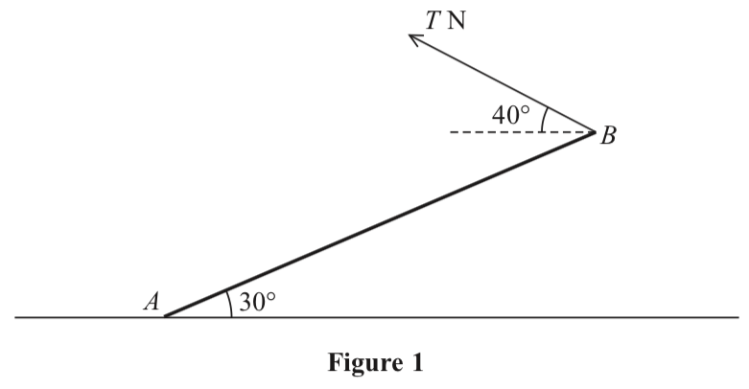
Figure 3
A uniform rod AB, of mass 6 kg and length 1.6 m, rests with its end A on rough horizontal ground. The rod is held in equilibrium at 30° to the horizontal by a light string attached to the rod at B. The string is at 40° to the horizontal and lies in the same vertical plane as the rod, as shown in Figure 3. The tension in the string is T newtons. The coefficient of friction between the ground and the rod is μ.

(a) Show that, to 3 significant figures, T = 27.1
(4)
(b) Find the set of values of μ for which equilibrium is possible.
(5)
(Total 9 marks)
____________________________________________________________________________

8. A particle P of mass 0.3 kg moves under the action of a single force F newtons. At time
t seconds (t ≥ 0), P has velocity v m s^{–1}, where
v = (3t² – 4t)i + (3t² – 8t + 4)j
(a) Find F when t = 4
(3)

At the instants when P is at the points A and B, particle P is moving parallel to the vector i.

(b) Find the distance AB.
(9)
(Total 12 marks)
____________________________________________________________________________

9. A particle P is projected from a fixed point A with speed 12 m s^{–1} at an angle α above the
horizontal and moves freely under gravity. As P passes through the point B on its path,
P is moving with speed 8 m s^{–1} at an angle β below the horizontal.
(a) By considering energy, find the vertical distance between A and B.
(4)

Particle P takes 1.5 seconds to travel from A to B.
(b) Find the size of angle α.
(3)
(c) Find the size of angle β.
(3)
(d) Find the length of time for which the speed of P is less than 8 m s^{–1}.
(4)
(Total 14 marks)

TOTAL FOR PAPER IS 104 MARKS

