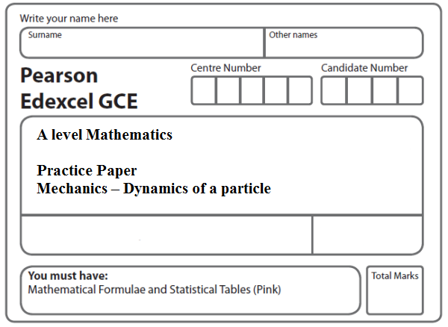
Instructions
- Use black ink or ball-point pen.
- If pencil is used for diagrams/sketches/graphs it must be dark (HB or B).
- Fill in the boxes at the top of this page with your name, centre number and candidate number.
- Answer all the questions and ensure that your answers to parts of questions are clearly labelled.
- Answer the questions in the spaces provided – there may be more space than you need.
- You should show sufficient working to make your methods clear. Answers without working may not gain full credit.
- Inexact answers should be given to three significant figures unless otherwise stated.
Information
- A booklet ‘Mathematical Formulae and Statistical Tables’ is provided.
- There are 9 questions in this question paper. The total mark for this paper is 110.
- The marks for each question are shown in brackets – use this as a guide as to how much time to spend on each question.
- Calculators must not be used for questions marked with a * sign.
Advice
• Read each question carefully before you start to answer it.
• Try to answer every question.
• Check your answers if you have time at the end.
• If you change your mind about an answer, cross it out and put your new answer and any working underneath.
1.
Figure 1

A rough plane is inclined at 40° to the horizontal. Two points A and B are 3 metres apart and lie on a line of greatest slope of the inclined plane, with A above B, as shown in Figure 1. A particle P of mass m kg is held at rest on the plane at A. The coefficient of friction between P and the plane is . The particle is released.

(a) Find the acceleration of P down the plane.
(5)
(b) Find the speed of P at B.
(2)
(Total 7 marks)
___________________________________________________________________________

2. A lifeboat slides down a straight ramp inclined at an angle of 15° to the horizontal. The lifeboat has mass 800 kg and the length of the ramp is 50 m. The lifeboat is released from rest at the top of the ramp and is moving with a speed of 12.6 m s^{–1} when it reaches the end of the ramp. By modelling the lifeboat as a particle and the ramp as a rough inclined plane, find the coefficient of friction between the lifeboat and the ramp.
(Total 9 marks)
___________________________________________________________________________

3. A particle P of mass 2 kg is moving under the action of a constant force F newtons. The velocity of P is (2i − 5j) m s⁻¹ at time t = 0, and (7i + 10j) m s⁻¹ at time t = 5 s.

Find

(a) the speed of P at t = 0,
(2)
(b) the vector F in the form ai + bj,
(5)
(c) the value of t when P is moving parallel to i.
(4)
(Total 11 marks)
___________________________________________________________________________

4.

Figure 2

A truck of mass 1750 kg is towing a car of mass 750 kg along a straight horizontal road. The two vehicles are joined by a light towbar which is inclined at an angle θ to the road, as shown in Figure 2. The vehicles are travelling at 20 m s^{–1} as they enter a zone where the speed limit is 14 m s^{–1}. The truck’s brakes are applied to give a constant braking force on the truck. The distance travelled between the instant when the brakes are applied and the instant when the speed of each vehicle is 14 m s^{–1} is 100 m.

(a) Find the deceleration of the truck and the car.
(3)

The constant braking force on the truck has magnitude R newtons. The truck and the car also experience constant resistances to motion of 500 N and 300 N respectively.

Given that cos θ = 0.9, find

(b) the force in the towbar,
(4)
(c) the value of R.
(4)
(Total 11 marks)
___________________________________________________________________________

5.
Figure 3

A particle P of mass 2.7 kg lies on a rough plane inclined at 40° to the horizontal. The particle is held in equilibrium by a force of magnitude 15 N acting at an angle of 50° to the plane, as shown in Figure 3. The force acts in a vertical plane containing a line of greatest slope of the plane. The particle is in equilibrium and is on the point of sliding down the plane.

Find

(a) the magnitude of the normal reaction of the plane on P,
(4)
(b) the coefficient of friction between P and the plane.
(5)

The force of magnitude 15 N is removed.

(c) Determine whether P moves, justifying your answer.
(4)
(Total 13 marks)
___________________________________________________________________________

6.

Figure 4

Figure 4 shows two particles A and B, of mass 2m and 4m respectively, connected by a light inextensible string. Initially A is held at rest on a rough inclined plane which is fixed to horizontal ground. The plane is inclined to the horizontal at an angle α, where tan α = . The coefficient of friction between A and the plane is . The string passes over a small smooth pulley P which is fixed at the top of the plane. The part of the string from A to P is parallel to a line of greatest slope of the plane and B hangs vertically below P. The system is released from rest with the string taut, with A at the point X and with B at a height h above the ground.

For the motion until B hits the ground,

(a) give a reason why the magnitudes of the accelerations of the two particles are the same,
(1)
(b) write down an equation of motion for each particle,
(4)
(c) find the acceleration of each particle.
(5)

Particle B does not rebound when it hits the ground and A continues moving up the plane towards P. Given that A comes to rest at the point Y, without reaching P,

(d) find the distance XY in terms of h.
(6)
(Total 16 marks)
___________________________________________________________________________
7.

Figure 5

Two particles A and B, of mass 7 kg and 3 kg respectively, are attached to the ends of a light inextensible string. Initially B is held at rest on a rough fixed plane inclined at angle θ to the horizontal, where tan θ = . The part of the string from B to P is parallel to a line of greatest slope of the plane. The string passes over a small smooth pulley, P, fixed at the top of the plane. The particle A hangs freely below P, as shown in Figure 5. The coefficient of friction between B and the plane is . The particles are released from rest with the string taut and B moves up the plane.

(a) Find the magnitude of the acceleration of B immediately after release.
(10)
(b) Find the speed of B when it has moved 1 m up the plane.
(2)

When B has moved 1 m up the plane the string breaks. Given that in the subsequent motion B does not reach P,

(c) find the time between the instants when the string breaks and when B comes to instantaneous rest.
(4)
(Total 16 marks)
___________________________________________________________________________
8.
Figure 6

Two particles, A and B, have masses 2m and m respectively. The particles are attached to
the ends of a light inextensible string. Particle A is held at rest on a fixed rough horizontal
table at a distance d from a small smooth light pulley which is fixed at the edge of the
table at the point P. The coefficient of friction between A and the table is μ, where μ < .
The string is parallel to the table from A to P and passes over the pulley. Particle B hangs
freely at rest vertically below P with the string taut and at a height h, (h < d), above a
horizontal floor, as shown in Figure 6. Particle A is released from rest with the string taut
and slides along the table.
(a) (i) Write down an equation of motion for A.
(ii) Write down an equation of motion for B.
(4)
(b) Hence show that, until B hits the floor, the acceleration of A is (1 − 2 μ).
(3)
(c) Find, in terms of g, h and μ, the speed of A at the instant when B hits the floor.
(2)
After B hits the floor, A continues to slide along the table. Given that μ = and that
A comes to rest at P,
(d) find d in terms of h.
(5)
(e) Describe what would happen if μ =
(1)
(Total 15 marks)
___________________________________________________________________________

9.
Figure 7

Two particles P and Q have masses 1.5 kg and 3 kg respectively. The particles are attached to the ends of a light inextensible string. Particle P is held at rest on a fixed rough horizontal table. The coefficient of friction between P and the table is . The string is parallel to the table and passes over a small smooth light pulley which is fixed at the edge of the table. Particle Q hangs freely at rest vertically below the pulley, as shown in Figure 7. Particle P is released from rest with the string taut and slides along the table.

Assuming that P has not reached the pulley, find

(a) the tension in the string during the motion,
(8)
(b) the magnitude and direction of the resultant force exerted on the pulley by the string.
(4)
(Total 12 marks)

TOTAL FOR PAPER: 110 MARKS

